Citation: Poppelaars M.A.; Eygendaal, D.; The, B.; van Oost, I.; van Bergen, C.J.A.; Fat Pad Consortium
Diagnosis and treatment of children with a radiological fat pad sign without visible fracture vary widely: An international online survey and development of an objective definition. Children 2022, ??
nhttps://doi.org/10.3390/xxxxx
Academic Editor: Firstname Lastname
Received: 30 May 2022
Accepted: date
Published: date
Publisher’s Note: MDPI stays neutral with regard to jurisdictional claims in published maps and institutional affiliations.

Copyright: © 2022 by the authors. Submitted for possible open access publication under the terms and conditions of the Creative Commons Attribution (CC BY) license (https://creativecommons.org/licenses/by/4.0/).
Article
Diagnosis and treatment of children with a radiological fat pad sign without visible elbow fracture vary widely: An international online survey and development of an objective definition
M.A. Poppelaars^{1*}, D. Eygendaal², B. The¹, I. van Oost³ and C.J.A. van Bergen¹
¹ Department of Orthopaedic Surgery, Amphia Hospital, 4818 CK Breda, The Netherlands; mpoppelaars3@amphia.nl (M.A.P.); bthe@amphia.nl (B.T.); cvanbergen@amphia.nl (C.J.A.B.)
² Department of Orthopaedic Surgery, Erasmus Medical Centre, 3015 CN Rotterdam, The Netherlands; d.eygendaal@erasmusmc.nl (D.E.)
³ Foundation for Orthopaedic Research, Care & Education, Amphia Hospital, 4818 CK Breda, The Netherlands; ivanoost@amphia.nl (I.O.)
* Correspondence: mpoppelaars3@amphia.nl
Abstract: Children often present at the emergency department with a suspected elbow fracture. Sometimes the only radiological finding is a ‘fat pad sign’ (FPS) as a result of hydrops or haemarthros. This sign could either be the result of a fracture, or due to an intra-articular haematoma without a concomitant fracture. There are no uniform treatment guidelines for this common population. The aims of this study were 1) to obtain insight in FPS definition, diagnosis and treatment amongst international colleagues, and 2) to identify a uniform definition based on radiographic measurements with optimal cut-off points via receiver operating characteristic (ROC)-curve. An online international survey was set up to assess diagnostic and treatment strategies, criteria and definitions of the FPS, the probability of an occult fracture and presence of the anterior and/or posterior FPS on 20 radiographs. Additionally, radiographic measurements were performed by the research team to identify cut-off values for a positive FPS, as well as test-retest reliability and interrater reliability via intraclass correlation coefficients (ICC). A total of 133 (paediatric) orthopaedic surgeons completed the survey. Definitions, further diagnostics and treatment varied considerably amongst respondents. Angle measurements of the fat pad as related to the humeral axis line showed the highest reliability (test-retest ICC, 0.95 (95% CI 0.88-0.98); interrater ICC, 0.95 (95% CI 0.91-0.98)). A cut-off angle of 16 degrees was defined a positive anterior FPS (sensitivity, 1.00; specificity, 0.87; accuracy, 99%), based on the respondents’ assessment of the radiographs in combination with the research team’s measurements. Any visible posterior fat pad was defined a positive posterior FPS. This study provides insight into current diagnosis and treatment of children with a radiological fat pad sign of the elbow. A clear, objective definition of a positive anterior FPS was identified as a >16-degree angle with respect to the anterior humeral line.
Keywords: Fat Pad Sign (FPS), Children, Elbow, Survey, Receiver Operating Characteristic (ROC), Intraclass Correlation Coefficients (ICC), Anterior Fat Pad Sign (AFPS), Posterior Fat Pad Sign (PFPS)

1. Introduction
Children often present at the emergency department with suspicion of a fracture in the elbow. The cumulative incidence of bone fracture during childhood is 40% for boys and 28% for girls between 6-16 years [1]. Approximately 28% of all paediatric fractures are elbow fractures [2]. Paediatric elbow fractures occur in approximately 25% at the distal humerus, but overall, the numbers of various types of elbow fractures vary [3,4] A prolonged time interval between injury and treatment could result in negative treatment outcomes. Unrecognized or misdiagnosed fractures presenting more than 3 weeks after the injury could result in malunion, delayed union or non-union. [5]
The standard method of imaging are radiographs in anteroposterior and lateral directions to detect a potential fracture. Sometimes the only finding is a fat pad sign (FPS) as a result of hydrops or haemarthros without a visible fracture. The FPS is an intra-articular, but extrasynovial, joint effusion, in which the fat pad becomes elevated. Physiologically, a small anterior fat pad is usually visible. In contrast, the posterior fat pad is located in the olecranon fossa and only becomes visible in case of joint effusion. The trauma to the elbow causes intra-articular bleeding, resulting in the fat pad moving away from the joint and thus becoming visible as a triangular shape on the lateral radiographic view [6]. In such a case the anterior and/or posterior FPS (AFPS, PFPS) could be a sign of an occult fracture [7,8].
Currently, there is no clear definition for the FPS, which may result in variations in diagnosis and treatment [9]. Usually, these children are treated with plaster and are scheduled for orthopaedic and possibly radiographic follow-up [10]. In a number of cases, this may lead to overtreatment. Unnecessary immobilisation has disadvantages, including disability, healthcare costs, muscle atrophy, and demineralization of the bone [10]. On the other hand, there are also fractures that require low-threshold surgical treatment, e.g., displaced lateral condyle fractures [12]. Other recent findings in the literature are the frequently missed injuries around the elbow, called the TRASH (The Radiographic Appearance Seemed Harmless) lesions [11]. Those lesions should warrant additional imaging like ultrasound, MRI or CT for correct diagnosis. Misdiagnosis is accountable for a large part of the complications [10]. The incidence and types of occult fractures in children with a positive FPS is difficult to assess as the variety of definitions of FPS in use is high [9]. A clearer definition is mandatory to formulate a proper treatment rationale.
The aim of this study was first to assess – through an international online survey – the definition, work-up and treatment of children with a positive FPS without visible fracture that are currently in use. Second, this study aimed to develop a clear, objective definition of a FPS, based on radiographic measurements and international agreement on the presence of a FPS.

2. Materials and Methods
An online international survey was set up to assess criteria and definitions of the AFPS and PFPS, the probability of occult fractures, diagnostic and treatment strategies, and presence or absence of the FPS on 20 radiographs. The survey was distributed amongst members of the European Pediatric Orthopaedic Society (EPOS) and European Society for Surgery of the Shoulder and the Elbow (SECEC), as well as national orthopaedic trauma, pediatric orthopaedic and upper limb societies. Open questions, multiple choice questions and radiographs were built into the online platform of Survey Monkey (Supplementary Material - Appendix A). The study was approved by the medical research ethic committee of Utrecht (MEC-U) on 2 April 2021 under registration number W21.087.
In addition, the respondents indicated whether the AFPS and/or PFPS was present (yes/no) on 20 radiographs. The radiographs were selected from a local database of elbow radiographs of children (10 females, 7 right side, age 7-16) between 2018 and 2021, and ranged from no visible FPS to an extreme FPS without other visible pathology. Only answers of the responders who fully completed the online survey were analysed.
Furthermore, radiographic measurements were performed on the same radiographs by the research team to identify cut-off values for a positive FPS. Three pediatric orthopaedic trauma and elbow surgeons and two trained researchers (blinded to the respondents’ answers) independently measured two possible objective measures of a FPS on each of the 20 radiographs; namely 1) the angle between fat pad and humerus, and 2) distance of the fat pad relative to the humerus diameter (Figure 1). The averages of the five researchers’ measurements were used as the final measurement of each radiograph. The radiographs were measured again eight weeks later by the first author in different order and blinded to the first series of measurements to assess test-retest reliability.

Descriptive statistics were described for the outcomes of the survey. The test-retest and interobserver reliability of the radiographic measurements were analysed with use of intraclass correlation coefficients (ICC) [12].The measurements with the highest ICCs (i.e., angle or distance measurements) were plotted against the percentages of positive answers to the presence or absence of a FPS by the respondents for each radiograph. This was performed in order to determine the measurement values at which the majority of professionals agreed about the presence of the AFPS and PFPS.

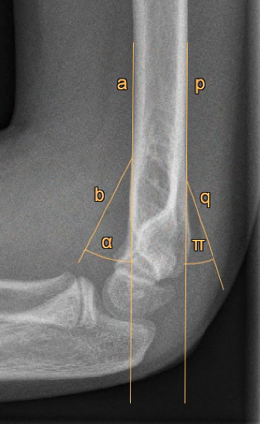 | 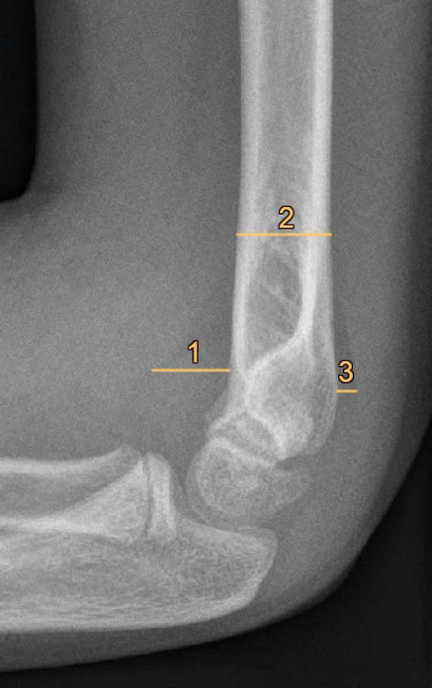
(a) | (b)
Figure 1. Radiographic measurements of the anterior and posterior fat pad signs. (a) Angle measurements. a: line along the anterior side of the humerus shaft, b: line indicating the anterior fat pad, α: angle measurement of the anterior fat pad, p: line along the posterior side of the humerus shaft, q: line indicating the posterior fat pad, π: angle measurement of the posterior fat pad. (b) Distance measurements. 1: maximum perpendicular distance of the anterior fat pad to the humerus, 2: humerus diameter measured at the proximal level of the anterior fat pad, 3: maximum perpendicular distance of the posterior fat pad to the humerus. The anterior fat pad distance was indicated by 1 divided by 2; the posterior fat pad distance by 3 divided by 2.

Further analysis was carried out with use of receiver operating characteristic (ROC) curves to determine the optimal cut-off value of a positive AFPS with corresponding sensitivity and specificity. For the purpose of the definition development, three agreement levels on the presence of a FPS were analysed with ROC curves (i.e., 50%, 60% and 70% of the respondents). The agreement level with the highest area under the curve (AUC) was chosen to determine the optimal cut-off value. All analyses were performed using the software package SPSS (IBM SPSS, version 28).

3. Results
There were a total of 198 respondents who started the survey, of whom 133 completed the survey entirely. The distribution of experience of the responding physicians was fairly widespread (Table 1). The most common subspecialty was pediatric orthopaedic surgery (n=49).

Table 1. Respondent characteristics (n=133)
Survey questions |  | Responses, n(%)
How many pediatric elbow injuries do you treat annually?
 | <10 | 36 (27.1)
 | 10-20 | 41 (30.8)
 | 20-50 | 35 (26.3)
 | >50 | 21 (15.8)
How many years have you been in practice as an (orthopaedic or trauma) surgeon?
 | 0 | 14 (10.5)
 | 1-5 | 31 (23.3)
 | 6-10 | 18 (13.6)
 | >10 | 70 (52.6)
What is your expertise?
 | Pediatric orthopaedic surgeon | 49 (36.7)
 | Orthopaedic upper limb surgeon | 28 (21.1)
 | Orthopaedic trauma surgeon | 19 (14.3)
 | Orthopaedic resident | 18 (13.5)
 | General orthopaedic surgeon | 13 (9.8)
 | General trauma surgeon | 1 (0.8)
 | Other | 5 (3.8)

Definition

The definitions of the FPS that the respondents listed varied considerably. The most commonly used terms included (sail) sign, dark shape, black shadow, elevated capsule and darkened shade.

Probability of occult fracture

The survey showed that in the case of a positive FPS, it was expected that there is an occult fracture in on average 73.3% (SD 18.2%) of cases. The estimated fracture rate was not significantly dependent on the respondents’ clinical experience.

Diagnosis and treatment

A supracondylar humerus fracture was considered the most common fracture in case of a positive fat pad sign without visible fracture, followed by radial head and neck (Table 2). Most participants used repeated radiography after 1 week in the further diagnostic work-up. Some participants replied 'other' (n=15), mostly described by ‘depending on clinical examination’. Regarding standard treatment, the majority (n = 70) used plaster or a cast, but again, a wide variety was observed.

Table 2. Diagnosis and treatment (n = 133)
Survey questions |  | Responses, n (%)
What is the most probable fracture in case of a positive fat pad sign without visible fracture?
 | Supracondylar | 87 (65.4)
 | Radial head | 18 (13.5)
 | Radial neck | 11 (8.3)
 | Lateral condyle fracture | 6 (4.5)
 | Medial epicondyle | 5 (3.8)
 | Other | 4 (3.0)
 | Olecranon | 2 (1.5)
What is your usual further diagnostic work-up?
 | Repeat radiographs after 1 week | 42 (31.6)
 | No further imaging | 35 (26.3)
 | Repeat radiographs on indication | 30 (22.6)
 | Other | 15 (11.3)
 | CT | 7 (5.2)
 | MRI | 4 (3.0)
What is your standard treatment?
 | Plaster/casting | 70 (52.6)
 | Other | 25 (18.8)
 | No standard treatment | 11 (8.3)
 | Pressure bandage | 11 (8.3)
 | Functional treatment (i.e. no immobilization) | 8 (6.0)
 | Sling | 8 (6.0)

Radiographic evaluation

The reliability of the angular and distance measurements of the AFPS and PFPS is shown in Table 3.
Table 3. Intraclass correlation coefficients (ICCs) for radiographic measurements of the anterior (AFPS) and posterior fat pad sign (PFPS)
Intraclass Correlation Coefficient 95% Confidence Interval
Anterior angle measurement (α)*
Test-retest | 0.95 | 0.88-0.98
Interobserver | 0.95 | 0.91-0.98
Posterior angle measurement (π)*
Test-retest | 0.91 | 0.41-0.99
Interobserver | 0.95 | 0.91-0.98
Perpendicular ratios AFPS (1/2)*
Test-retest | 0.76 | 0.42-0.91
Interobserver | 0.74 | 0.38-0.89
Perpendicular ratios PFPS (3/2)*
Test-retest | 0.91 | 0.47-0.99
Interobserver | 0.89 | 0.71-0.93

* See Figure 1 for corresponding measurements

As the AFPS angle measurements (α) and the PFPS angle measurement (π) were most reliable, these were used to determine cut-off values of the proposed definitions.

An overview of radiographic angle measurements and corresponding percentages of positive answers for the presence of an AFPS is shown in Figure 2.

The analysed agreement levels of 50%, 60% and 70% corresponded with an AUC of 0.84 (95% CI 0.64-1.00), 0.99 (95% CI 0.96-1.00) and 0.96 (95% CI 0.96-1.00), respectively. The 60% level of agreement was thus chosen to define cut-off values of objective FPS definitions, because of the highest AUC. For the AFPS, this resulted in a cut-off value of 16 degrees for a positive AFPS (see Figure 2).

Out of the 20 radiographs, there were five measurable posterior fat pads (angle π, 15.6– 23.9 degrees). The percentages of positive respondents for the visible posterior fat pads was high (72.9% –100%), while those of the invisible posterior fat pads were low (0,8%-34,6%). Therefore, if a posterior fat pad was visible, it was defined as positive.
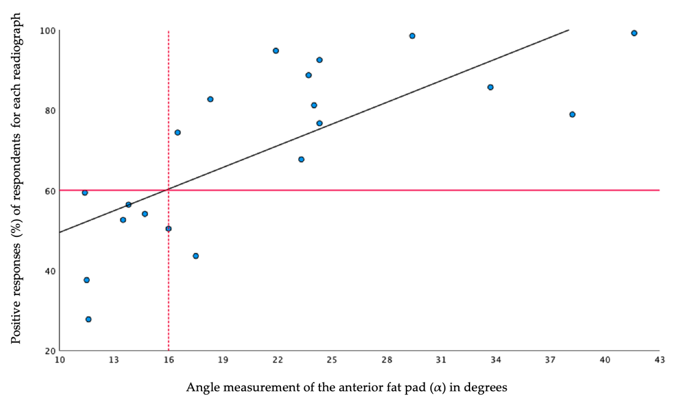
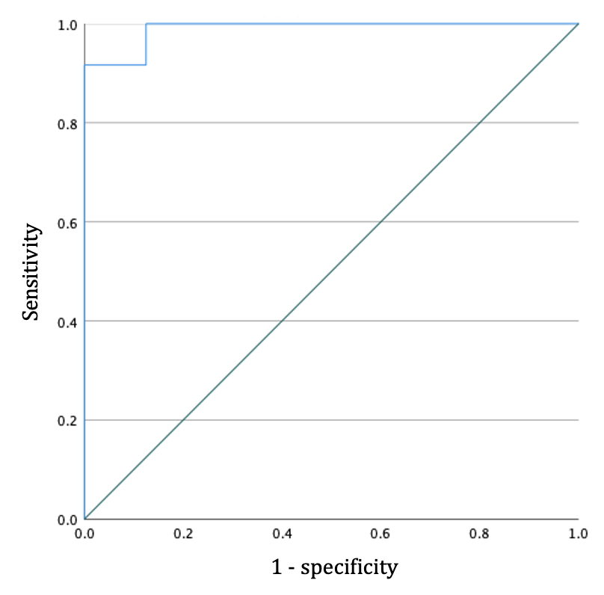
Figure 2. Scatter plot showing the mean angle measurements plotted against the percentages of positive respondents for the presence of an AFPS, assessed on the 20 radiographs. The horizontal red line indicates the 60% level of agreement of the respondents. The vertical dotted red line points the mean angle at which at least 60% of the respondents indicated the AFPS as present.
Figure 3. Receiver operating characteristic (ROC) curve for the 16-degree cut-off value of the anterior fat pad sign (α).
The accompanying ROC curve for the objective AFPS definition of 16 degrees had an AUC of 0.99 (95% CI 0.96-1.00) (Figure 3). Thus, the model will be able to classify 99% correctly in a given random selected positive AFPS and a random selected negative AFPS. The overall accuracy of determining the presence of a AFPS with a cut-off value of 16 degrees was 99% (sensitivity 1.00, specificity 0.87). The ROC curve for the PFPS had an AUC of 1.00 (95% CI 1.00-1.00) (sensitivity 1.00, specificity 1,00).

4. Discussion
The radiological fat pad sign of the elbow was first described by Norell [14] in 1954. As stated in previous research, neglected pediatric elbow fractures could result in serious long-term consequences. [5,11] Today, the FPS after a traumatic event in children is still a subject within orthopaedics that lacks clarity in terms of definition, additional imaging and guidelines for treatment. The first objective of this study was to provide more insight in the variety of definitions, work-up and treatment of children with a positive FPS in a large group of orthopaedic surgeons. The responses to the survey amongst the orthopaedic community varied widely. The results of the present study form an important basis in the process of developing more uniform diagnostic and treatment guidelines for children with a positive FPS without visible fracture.
Another notable result of the survey was the high expected probability of an occult fracture in the case of a positive FPS. The orthopaedic surgeons indicated on average that in 73.3% (SD 18.2%) of the cases with a positive FPS, they assumed the presence of an occult fracture. However, these figures are somewhat lower in the published literature. Kappelhof et al. in a meta-analysis showed that a fracture is actually present in only 45% of children with a positive FPS and no visible fracture, based on further imaging [9].
An objective definition of a positive fat pad sign is not available in the literature [9]. Likewise, the variety in answers on definitions in the survey also highlight the need for a uniform and objective definition of a FPS. Therefore, the second aim of the study was to develop an objective definition of a positive FPS. It was found that a cut-off angle of 16 degrees relative to the anterior humerus line indicates a positive anterior fat pad, with high reliability (ICC, 95%) and accuracy (AUC, 99%). A posterior fat pad sign was defined as any visible posterior fat pad on the lateral elbow radiograph. These findings are a first but important step towards more uniform diagnostic and treatment protocols.
A potential limitation of this study is that the development of the objective FPS definition is based on the judgements of experts with 60% agreement. At the start of the study a range of agreements was set up in order to determine the optimal cut-off value. As described previously, determining consensus via expert panels is still a challenging element of diagnostic research [15]. By determining a cut-off value in this way, an attempt was made to do so as accurately as possible. Because of the high number of participants (n = 133), we believe these judgements reflect the general assessment of the FPS on pediatric elbow radiographs and therefore are the best alternative to a reference standard diagnostic method. Furthermore, the 20 radiographs, with a full range from no FPS to an extreme FPS, are considered a representative sample of the actual population. The sample could therefore be used reliably to assess the degree of maximum uncertainty in order to establish the optimal cut-off value for the definition of a positive FPS.
The current study provides opportunities for future research to improve the care for the investigated population. One question is whether the projection of the radiological images will affect the appearance of the FPS. Furthermore, the severity of the FPS can be studied in relation to occult fractures in children. Finally, enhanced imaging may assist the physician in optimizing patient-specific diagnosis and treatment.

5. Conclusions
Definitions, diagnosis and treatment of children with a positive FPS vary considerably in the orthopaedic community. This study provides a clear and objective AFPS definition of a 16-degree angle relative to the humerus line.

Acknowledgment

We would like to thank the following colleagues, who kindly completed the online survey:

J. Aguilar-Gonzalez; T. Alves-da-Silva; J. Amaya; A. Andreacchio; A. Angelliaume; J. Arcângelo; H. Arro; A. Balslev-Clausen; S. Bekmez; A.T. Besselaar; J.H.J.M. Bessems; N. Boeijink; J.B. Bolder; A. Borgo; G. Casellas-Garcia; N. Catena; M. Chomicki; I. Coifman; A. Cosentino; P. Cundy; J.M. de Beus; P.B. de Witte; I. De Rus; I. Delniotis; A.M. Demirtas; L.W. Diederix; P. Domos; F.U. Verstraelen; E. Gonen; M. Grigoras; V.A. Groen; N. Guindani; V. Halvorsen; R. Houben; A.P.J. Joosten; G. Jozsa; L. Kaas; A.E.B. Kleipool; T. Kraal; M.J. Kraus; P . Lascombes; W.B. Lehman; J.K.G. Louwerens; N. Lutz; K.C. Mahabier; S. Marangoz; M. Mario; B. Marson; F. Martinez; A.K. Mosterd; E.M. Nelissen; W.H. Nijhuis; S. Nota; D.E. O'Briain; J. Ovesen; P. Paolo; A. Pitsounis; A. Popchenko; A.R. Poublon; N. Pouliart; F.T.H.G. Rahusen; R. Rolink; Y. Saglam; M. Salom; E. Samara; M.M. Scarlat; O.S. Schmidt; M. Schultz; R. Schwartz; R.M. Schwend; G. Sforza; J. Snel; D.W. Sommerfeldt; A.J. Spaans; W. Spierenburg; V. Spiteri; M. Synder; C. Thevenin-Lemoine; M. Thüsing; F. Toft; J.J. Tolk; A. van Noort; A.L. van der Zwan; C.M. van den Broek; J. van de Breevaart; J.C. van Egmond.; J.H. van Linge; J.P.J. van Dijsseldonk; L. van der Heijden; M. van der Pluijm; M.J.A. van Steijn; M.P.J. van den Bekeroml; O.A.J. van der Meijden; R.P. van Hove; S.C. van Veen; T.M. van Raaij; D.R. Rad; W.M. van Wijhe; M. van Lotten; A.M.J.S. Vervest; C.P.J. Visser; A.J.H. Vochteloo; H. Weel; S.J. Westerbos; R.L. Wimberly.

References
- N.V.V.H. (2019, March 6). Fracturen bij kinderen – Richtlijn – Richtlijnendatabase. https://richtlijnendatabase.nl/richtlijn/fracturen_bij_kinderen/startpagina.html
- Hussain S, Dar T, Beigh AQ, et al. Pattern and epidemiology of pediatric musculoskeletal injuries in Kashmir valley, a retrospective single-center study of 1467 patients. J Pediatr Orthop B 2015;24:230–237. https://doi.org/10.1097/bpb.0000000000000146
- Gogola, G. R. (2006). Pediatric Humeral Condyle Fractures. Hand Clinics, 22(1), 77–85. https://doi.org/10.1016/j.hcl.2005.09.003
- Yousefzadeh, D. K., & Jackson, J. H. (1978). Lipohemarthrosis of the Elbow Joint. Radiology, 128(3), 643–645. https://doi.org/10.1148/128.3.643
- (4.1) Trisolino, G., Antonioli, D., Gallone, G., Stallone, S., Zarantonello, P., Tanzi, P., ... & Stilli, S. (2021). Neglected Fractures of the Lateral Humeral Condyle in Children; Which Treatment for Which Condition?. Children, 8(1), 56. https://doi.org/10.3390/children8010056
- Blumberg, S. M., Kunkov, S., Crain, E. F., & Goldman, H. S. (2011). The predictive value of a normal radiographic anterior fat pad sign following elbow trauma in children. Pediatric emergency care, 27(7), 596–600. https://doi.org/10.1097/PEC.0b013e318222553b
- Skaggs, D. L., & Mirzayan, R. (1999). The Posterior Fat Pad Sign in Association with Occult Fracture of the Elbow in Children*†. The Journal of Bone & Joint Surgery, 81(10), 1429–1433. https://doi.org/10.2106/00004623-199910000-00007
- Al-Aubaidi, Z., & Torfing, T. (2012). The role of fat pad sign in diagnosing occult elbow fractures in the pediatric patient. Journal of Pediatric Orthopaedics B, 21(6), 514–519. https://doi.org/10.1097/bpb.0b013e328355e5d8
- Kappelhof B, Roorda B, Poppelaars MA, The B, Eygendaal D, Mulder T, van Bergen CJA (2022). Occult fractures in children with a radiological fat pad sign the elbow: a meta-analysis. Submitted.
- Major, N. M., & Crawford, S. T. (2002). Elbow Effusions in Trauma in Adults and Children. American Journal of Roentgenology, 178(2), 413–418. https://doi.org/10.2214/ajr.178.2.1780413
- (10.1)Patwardhan, S., & Omkaram, S. (2021). Trash lesions around the elbow: a review of approach to diagnosis and management. Indian Journal of Orthopaedics, 55(3), 539-548. https://doi.org/10.1007/s43465-020-00333-x
- Tan, S., Dartnell, J., Lim, A., & Hui, J. H. (2018). Paediatric lateral condyle fractures: a systematic review. Archives of orthopaedic and trauma surgery, 138(6), 809–817. https://doi.org/10.1007/s00402-018-2920-2
- Koo, T. K., & Li, M. Y. (2016). A guideline of selecting and reporting intraclass correlation coefficients for reliability research. Journal of chiropractic medicine, 15(2), 155-163. 10.1016/j.jcm.2016.02.012
- Norell H-G. Roentgenologic visualization of the extracapsular fat. Act Radiol 1954;42:205–210
- Bertens, L. C., Broekhuizen, B. D., Naaktgeboren, C. A., Rutten, F. H., Hoes, A. W., van Mourik, Y., & Reitsma, J. B. (2013). Use of expert panels to define the reference standard in diagnostic research: a systematic review of published methods and reporting. PLoS medicine, 10(10), e1001531. https://doi.org/10.1371/journal.pmed.1001531

