Article
High-volume hospitals’ ovarian cancer care - less individual approach or better treatment results?

Millert-Kalińska Sonja ^{1,2,}*, Pruski Dominik ², Przybylski Marcin ², Stawicka-Niełacna Małgorzata ³, Mądry Edyta ⁴ and Mądry Radosław ⁵
Citation: Millert-Kalińska, S.; Pruski, D.; Przybylski, M.; Stawicka-Niełacna, M.; Mądry, E.; Mądry, R. High-Volume Ovarian Cancer Care—Observations Based on Own
Material. Curr. Oncol. 2022, 29, x. https://doi.org/10.3390/xxxxx
Academic Editor(s):
Received: date
Accepted: date
Published: date
Publisher’s Note: MDPI stays neutral with regard to jurisdictional claims in published maps and institutional affiliations.

Copyright: © 2022 by the authors. Submitted for possible open access publication under the terms and conditions of the Creative Commons Attribution (CC BY) license (https://creativecommons.org/licenses/by/4.0/).
¹ Doctoral School, Poznan University of Medical Sciences, 61-701 Poznań, Poland
² Department of Obstetrics and Gynecology, District Public Hospital in Poznan, 60-479 Poznań, Poland; dominik.pruski@icloud.com ; nicramp@poczta.onet.pl
³ Department of Clinical Genetics and Pathology University of Zielona Góra, 65-046 Zielona Góra, Poland; m.stawicka-nielacna@cm.uz.zgora.pl
⁴ Department of Physiology, Poznan University of Medical Sciences, 61-701 Poznań, Poland;
emadry@ump.edu.pl
⁵ Department of Oncology, Poznan University of Medical Sciences, 60-569 Poznań, Poland;
radoslaw.madry@skpp.edu.pl
* Correspondence: millertsonja@gmail.com; Tel.: +48-513-220-288
Abstract: Ovarian cancer (OC) is the eighth most common cancer worldwide and is usually diagnosed in advanced stages. The relationship between treatment in high-volume hospitals (HVHs) and survival in OC has been documented by multiple studies, which showed that superior treatment and survival outcomes are associated with surgical expertise and multidisciplinary resources. To our study, 135 first-time patients treated in the years 2019–2020 in the Department of Oncology of Poznan University of Medical Sciences were enrolled. Th analysis showed a significant dependency between being treated in HVH from the beginning of one’s diagnosis and the scope of the first intervention. Additionally, among patients treated in our centre, a significant portion of patients underwent laparoscopy, and from one year to another the number of laparoscopies performed increased. This may indicate that more patients began to qualify for neoadjuvant treatment. Patients benefit the most from surgery in a centre with more experience in treating ovarian cancer. In the future, we will be able to expand this study by using data from patients treated before 2019 and analysing larger cohorts of patients. This might enable us to update the rates of overall survival (OS), objective response rate (ORR) and progression-free survival (PFS).
Keywords: epithelial ovarian cancer; high-volume hospital; oncological units; laparoscopy in oncology

1. Introduction
Ovarian cancer (OC) is the eighth most common cancer worldwide. According to GLOBOCAN, estimates suggest that in 2020, over 300,000 new cases of ovarian cancer were documented, while over 200,000 deaths were confirmed. In terms of morbidity and mortality rates, ovarian cancer ranks eighth in the world—3.4% and 4.7%, respectively. As reported by the National Cancer Registry published annually in Poland, in 2019, OC was the second most common gynaecological cancer (4.3%) after endometrial cancer, while it was the most common cause of death (6.0%). For over a decade, the trend observed in Poland has remained constant: in 2019, 3710 new cases of ovarian cancer were recorded. In line with the literature, about 70% of ovarian cancer cases are diagnosed in the advanced stages, associated with a low 5-year survival rate. According to the International Federation of Gynaecology and Obstetrics (FIGO), the 5-year survival rate in patients with OC diagnosed in stage III and IV is 30–50%, while for those with OC diagnosed in stage I and II, it is 80–90% [1]. A patient’s survival depends on, among other things, the histological type of the tumour, the stage of FIGO grading, the scope of cytoreductive surgery and the residual disease. Although the most common ovarian cancer susceptibility genes are BRCA1 and BRCA2, advancements in next-generation sequencing (NGS) analysis technology enabled the discovery of several non-BRCA genes responsible for OC. Current studies are focusing on the determination of the predisposition to developing cancer and the consideration of treatments for cancer, prevention strategies, risk diagnosis methods, and the adoption of preventive measures for relatives.
Clinicians might manage therapy by considering the time of relapse and the toxicity profile associated with the side effects of previous lines of treatment. The currently proposed regimens require attending physicians to be prudent based on their experience. This is why the long-term monitoring of patients continuing treatment in one centre is essential.
The relationship between treatments in high-volume hospitals (HVHs) and survival in ovarian cancer has been documented by multiple population-based studies, which showed that superior treatment and survival outcomes are associated with surgical expertise and multidisciplinary resources offered by both high-volume physicians and hospitals. Therefore, we present a small but reliable analysis: the two-year observation of patients treated in one centre. In our work, we compared the treatment results of patients with OC in one centre with those treated in different centres. We looked for factors that may have affected this result, and we wanted to check whether treatment in oncologic units is more beneficial. The determination of specific variables may, in the future, influence the therapeutic decisions of clinicians and the choice where the multifaceted treatment of patients should be carried out.

2. Materials and Methods
Our study received a positive opinion from the Bioethics Committee of the Poznań University of Medical Sciences regarding the lack of a medical experiment and its retrospective nature. We present a retrospective observational study that was conducted in the Clinical Hospital of the University of Medical Sciences in Poznań, Poland (abbreviated to SKPP). The material consisted of patients treated in the Department of Gynecological Oncology due to ovarian cancer. We carried out a detailed, multifaceted analysis of patients admitted to the ward for the first time in 2019–2020. First, we wanted to determine the FIGO profile of each patient and present the percentage of the prevalence of each histological type of ovarian cancer treated in our clinic. Then, we analysed the ratio of the “one roof patients” and the migration rate between different oncology centres. Subsequently, we assessed the scope of the first intervention and its radical nature—primary debulking surgery (PDS), neoadjuvant chemotherapy (NACT) and laparoscopy (LAP). Finally, we analysed the known mutations occurring in a particular group of patients using next-generation sequencing (NGS) technology.
Our study initially analysed patients referred to the Department of Gynecological Oncology ward in 2019–2020 with suspected ovarian cancer. The inclusion criteria were as follows: (i) the histopathological confirmation of ovarian cancer based on surgery with laparotomy, laparoscopy or biopsy, (ii) over 18 years of age, (iii) not pregnant and (iv) written consent to the proposed treatment, including both surgical treatment and subsequent chemotherapy. The exclusion criteria were: (i) another confirmed histopathological diagnosis—including intestinal tumours, tumours of the genital organs not derived from the ovary and benign lesions and (ii) patients transferred from other centres for the purpose of conducting subsequent lines of chemotherapy treatment. Patients who did not qualify for a specific type of chemotherapy due to their poor general condition and who did not accept the proposed treatment were rejected. The final exclusion criterion was patients undergoing fertility-conserving treatment (FCT). Figure 1 presents the process of recruiting patients for the study, and Figures 2 and 3 show the percentage breakdowns of histopathological types of OC (n=135).

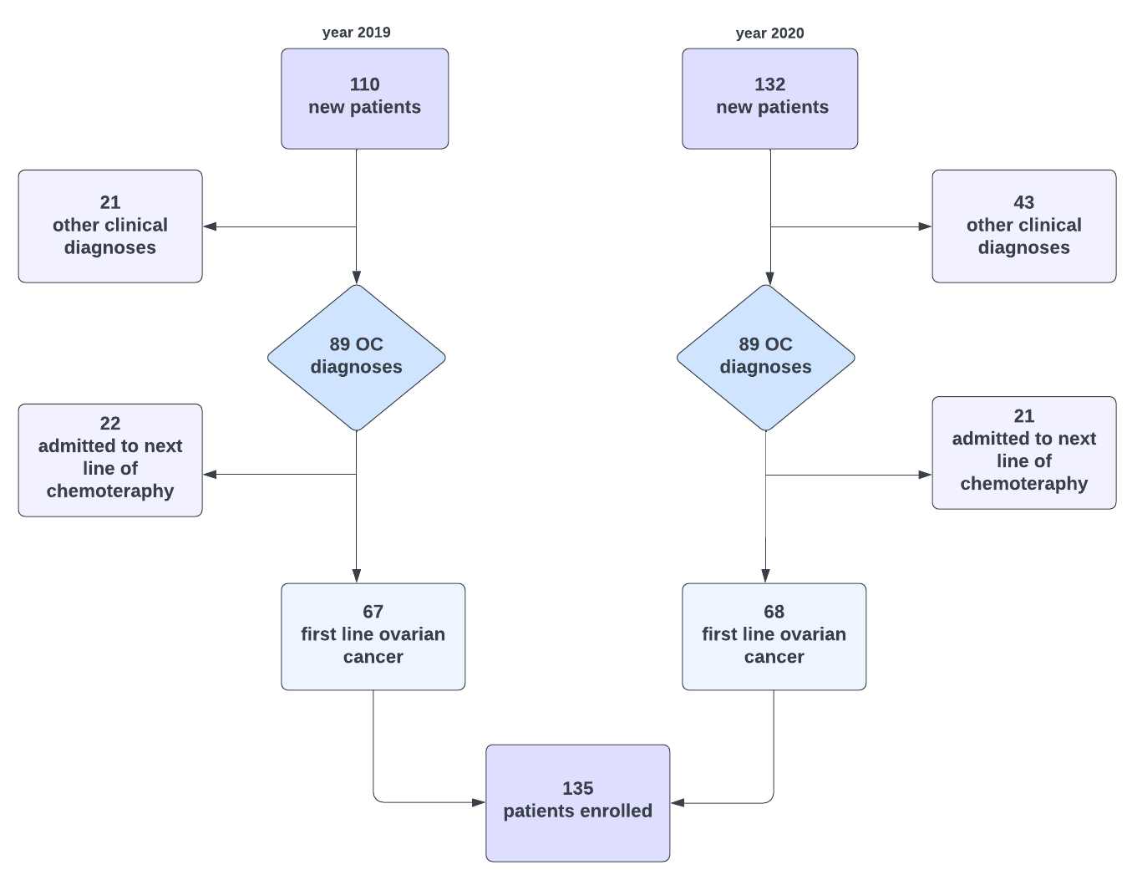
Figure 1. Flow-chart. OC—ovarian cancer.
The inclusion criteria: (i) the histopathological confirmation of ovarian cancer based on surgery with laparotomy, laparoscopy or biopsy, (ii) over 18 years of age, (iii) not pregnant and (iv) written consent to the proposed treatment, including both surgical treatment and subsequent chemotherapy

Figure 2. Histopathological types of OC in patients admitted in the year 2019. HGSC—high-grade serous carcinoma; LGSC—low-grade serous carcinoma; OCCC—ovarian clear-cell carcinoma; EOC—endometrioid ovarian cancer; MOC—mucinous ovarian cancer; SCC—squamous cell carcinoma.

Figure 3. Histopathological types of OC in patients admitted in the year 2020. HGSC—high-grade serous carcinoma; LGSC—low-grade serous carcinoma; OCCC—ovarian clear-cell carcinoma; EOC—endometrioid ovarian cancer; MOC—mucinous ovarian cancer; PPC—primary peritoneal cancer; UOC—undifferentiated carcinoma of the ovary.

3. Statistical Analysis
We conducted all analyses in statistical software R, version 4.2.1 (R Core Team 2022, R: Language and environment for statistical computing by R Foundation for Statistical Computing, Vienna, Austria). Nominal variables are presented in the tables as numbers and percent of observation, while quantitative variables are presented as the medians of quartile 1 and 3 (normality of distribution was determined with the Shapiro–Wilk test). Dependencies between two variables were analysed with the chi-square test (with Yate’s correction for continuity for 2 × 2 tables) or Fisher’s exact test. A series of univariate cox regression analysis was conducted—hazard ratios with 95% confidence intervals and p-values are presented in the tables. A multivariate cox regression model was built using a step method—variables with a p-value less than 0.250 in univariate models were predictors in the initial multivariate model [2]. The VIF value was checked while building the final multivariate model. Relapse-free survival curves were shown for all patients and broken down into smaller groups. Log-rank tests were conducted to determine the differences in the relapse rates between groups.

4. Results
In 2019, 110 subjects reported to the Department of Gynecological Oncology and were examined. Due to the study’s criteria, we rejected 22 women admitted to follow the treatment line of ovarian cancer and 21 diagnosed with a different clinical diagnosis. In 2020, we registered 132 new hospital admissions; however, we rejected 21 and 43 patients, respectively. After screening, 135 subjects fulfilled all of the inclusion criteria and fulfilled none of the exclusion criteria. At diagnosis, the median age was 60 years (range = 36–88 years), and 104 patients (78.2%) were admitted to the hospital with advanced disease. Half of the patients had stage III disease, while 26.3% had stage IV disease. Ninety-five patients started their therapeutic path in our centre, while forty patients were transferred from other hospitals. Regarding the first interventions carried out in our centre, 14 patients underwent primary laparoscopy. Women who underwent PDS constituted 36.3% of the cohort, a biopsy was performed in one-fifth of the patients, while in seven patients, no intervention was undertaken. A quarter of the patients underwent primary surgery in an external centre.
Nearly 78% of women had histopathologically diagnosed high-grade serous ovarian cancer, while other subtypes such as LGSC, clear-cell carcinoma, endometrioid cancer, etc., were observed significantly less frequently. The scope of the obtained cytoreduction was most often assessed as total (46.4%), then suboptimal (26.6%) and least often optimal (30.0%). The baseline characteristics of the groups are presented in Table 1.
Table 1. Baseline characteristics of the study group.
Characteristic | Value, n (%)
Year of measurement
2019 | 67 (49.6)
2020 | 68 (50.4)
Type of the first intervention
PDS | 49 (36.3)
LAP | 14 (10.4)
External operation | 35 (25.9)
Biopsy | 30 (22.2)
None | 7 (5.2)
Scope of the first intervention (n = 126)
PDS | 73 (57.9)
NACT | 32 (25.4)
LAP | 21 (16.7)
Place of the first intervention
SKPP | 95 (70.4)
Other | 40 (29.6)
FIGO staging system
I | 17 (12.6)
II | 6 (4.5)
III | 69 (51.1)
IV | 35 (25.9)
Non-staging | 8 (5.9)
Histopathology
HGSC | 105 (77.8)
Other types | 30 (22.2)
Stage of the cytoreduction (n = 110)
Total (R0) | 51 (46.4)
Optimal (R1) | 26 (26.6)
Suboptimal (R2) | 33 (30.0)
PDS—primary debulking surgery; LAP—laparoscopy; NACT—neoadjuvant chemotherapy; HGSC—high-grade serous carcinoma.
During the two years of observation, more than twice as many first-time patients came to our clinic than those transferred from other centres. The groups of patients had a similar age structure and did not differ in terms of the stages of their disease. In the advanced stage, 81.1 and 83.3% of patients reported to SKPP and continued treatment, respectively. There was a significant dependency between being treated in SKPP from the beginning of one’s diagnosis and the scope of the first intervention (p = 0.010). Among patients in the SKPP group, a more significant portion of patients underwent laparoscopy than among patients transferred from other places (22% vs. 0%), and a minor portion of patients underwent primary surgery (PDS)—52% and 75%, respectively. No other dependencies were observed between the original place of treatment and the selected variables (p > 0.050 for other analyses), which is presented in Table 2.
Table 2. Comparison of selected characteristics between patients from SKPP and transferred from other centres.
Characteristic, n (%) | SKPP Patients | Transferred Patients | p
FIGO
I or II | 17 (18.9) | 6 (16.2) | 0.919
III or IV | 73 (81.1) | 31 (83.8) | 0.919
Scope of the first intervention
PDS | 49 (52.1) | 24 (75.0) | 0.010
NACT | 24 (25.5) | 8 (25.0) | 0.010
LAP | 21 (22.3) | 0 (0.0) | 0.010
Nature of the treatments
R0 | 40 (46.0) | 11 (47.8) | 0.537
R1 | 19 (21.8) | 7 (30.4) | 0.537
R2 | 28 (32.2) | 5 (21.7) | 0.537
Dependencies between the group and selected characteristics were analysed using the chi-square test with Yates’ correction for continuity for two categorical variables. FIGO—the International Federation of Gynaecology and Obstetrics; PDS—primary debulking surgery; LAP—laparoscopy; NACT—neoadjuvant chemotherapy; p—p-value.
When comparing patients enrolled in 2019 and 2020, according to the FIGO classification, there was a similar number of patients in both groups who had stage I/II or III/IV of the disease. A more significant proportion of patients from the NACT group and a smaller proportion of patients treated with laparoscopy were observed among the 2019 patients than among the 2020 patients. Most of the patients in both groups were treated at the Clinical Hospital from the beginning of their diagnosis. We did not find a dependency between groups and the degree of cytoreduction, which is shown in Table 3.
Table 3. Comparison of selected characteristics between subjects admitted in the years 2019 and 2020.
Characteristic, n (%) | 2019 Group | 2020 Group | p
FIGO staging system
I or II | 14 (21.9) | 9 (14.3) | 0.379
III or IV | 50 (78.1) | 54 (85.7) | 0.379
Scope of the first intervention
PDS | 33 (55.0) | 40 (60.6) | 0.005
NACT | 22 (36.7) | 10 (15.2) | 0.005
LAP | 5 (8.3) | 16 (24.2) | 0.005
Place of the first intervention
SKPP | 43 (64.2) | 52 (76.5) | 0.169
Other | 24 (35.8) | 16 (23.5) | 0.169
Stage of the cytoreduction
Total (R0) | 27 (54.0) | 24 (40.0) | 0.181
Optimal (R1) | 8 (16.0) | 18 (30.0) | 0.181
Suboptimal (R2) | 15 (30.0) | 18 (30.0) | 0.181
FIGO—the International Federation of Gynaecology and Obstetrics; PDS—primary debulking surgery; NACT—neoadjuvant chemotherapy; LAP—laparoscopy; p—p-value. Dependencies between the group and selected characteristics were analysed using the chi-square test with Yates’ correction for continuity for two categorical variables.
Table 4. The influence of individual factors on the occurrence of relapse using the univariate cox regression model.
Variable | HR | 95% CI | p
Place of the first intervention (SKPP vs. other) | 1.89 | 1.02; 3.48 | 0.043
FIGO (I or II vs. III or IV) | 11.76 | 1.61; 85.88 | 0.015
Histopathology (HGSC vs. other) | 0.50 | 0.21; 1.18 | 0.111
Scope of the first intervention (PDS vs…)
NACT | 3.25 | 1.62; 6.52 | 0.001
LAP | 2.26 | 0.95; 5.35 | 0.064
Stage of the cytoreduction (Total—R0 vs…)
Optimal (R1) | 3.71 | 1.55; 8.88 | 0.003
Suboptimal (R2) | 2.68 | 1.12; 6.40 | 0.027
FIGO—the International Federation of Gynaecology and Obstetrics; HGSC—high-grade serous carcinoma; PDS—primary debulking surgery; NACT—neoadjuvant chemotherapy; LAP—laparoscopy; p—p-value; HR—hazard ratio. HR with a 95% CI—hazard ratio with a 95% confidence interval for the occurrence of relapse.
Almost all of the univariate cox regression models for the occurrence of relapse were significant. Having the first intervention performed in a place other than SKPP increased the risk of relapse by 89% compared to the risk for patients treated in SKPP (p = 0.043). Patients with an advanced stage of OC (III or IV FIGO stage) had an 11.76 times higher risk of relapse compared to others (p =0.015). We overlooked the significant influence of the histological types of ovarian cancer on the time of the first relapse (p > 0.05). Compared to those from the PDS group, women from the NACT group had a 3.25 times higher risk of relapse (p =0.001)—we did not detect differences between PDS and LAP patients. The result of the operation was the last significant predictor for relapse—optimal cytoreduction compared to total cytoreduction increased the risk of relapse by 3.71 times (p =0.003), and suboptimal compared to total cytoreduction increased that risk by 2.68 times (p =0,027), which is presented in Table 4.
Table 5. The influence of all variables on the occurrence of relapse using the multivariate cox regression model.
Variable | HR | 95% CI | p
Place of the first intervention (SKPP vs. other) | 1.91 | 0.81; 4.49 | 0.140
FIGO (I or II vs. III or IV) | 6.82 | 0.88; 52.61 | 0.066
Scope of the first intervention (PDS vs…)
NACT | 3.36 | 1.47; 7.66 | 0.004
LAP | 2.82 | 1.06; 7.52 | 0.038
HR with a 95% CI—hazard ratio with a 95% confidence interval for the occurrence of relapse. FIGO—the International Federation of Gynaecology and Obstetrics; PDS—primary debulking surgery; NACT—neoadjuvant chemotherapy; LAP—laparoscopy; p—p-value; HR—hazard ratio.
The multivariate cox regression model was built using a step method. All of the variables from the univariate models were put into the initial multivariate model. The variables left in the final multivariate model were the place of the intervention, the stage of the advancement of the disease and the scope of the first intervention. Two predictors in the multivariate cox regression model were significant—patients from the NACT group compared to patients from the PDS group had a 3.36 higher risk of relapse (p = 0.004), and patients from LAP groups compared to those from the PDS group had a 2.82 times higher risk of relapse (p = 0.038). We did not detect multicollinearity between the predictors (VIF < 2.00), which is shown in Table 5. The relapse-free survival curves are shown in Figures 4–9 (for all of the patients and broken down into smaller groups). The number of patients who relapsed was 43—the last patient relapsed after 956 days. The cumulative progression-free survival rate at the end of the follow-up period was 61% for all of the patients. The relapse-free survival rate for all of the patients is presented in Figure 4. The relapse rate was higher for patients treated in a place other than SKPP—the cumulative proportion of patients who did not relapse at the end of the follow-up period was 67% for SKPP patients and 50% for other patients, as shown in Figure 5. The relapse rate was highest for patients from the NACT group, then the LAP group and the PDS group. The cumulative proportion of patients who did not relapse at the end of the follow-up period was 73% for the PDS group, 41% for the NACT group and 51% for the LAP group, as shown in Figure 6. Patients with stage I or II OC according to FIGO had a lower relapse rate than patients with stage III or IV OC—the cumulative proportion of patients who did not relapse at the end of the follow-up period was 96% for FIGO grading I or II patients and 52% for FIGO grading III or IV patients, as shown in Figure 7. The cumulative proportion of patients who did not relapse at the end of the follow-up period was 57% for patients with serous cancer and 74% for patients with other histopathological cancer types. The relapse rate did not significantly differ between groups, as shown in Figure 8. Patients from the R1 group had the highest relapse rate, followed by patients from the R2 group, and patients from the R0 group had the lowest relapse rate (p = 0.006). The cumulative proportion of patients who did not relapse during the follow-up was 77% for the R0 group, 27% for the R1 group and 61% for the R2 group, as shown in Figure 9.
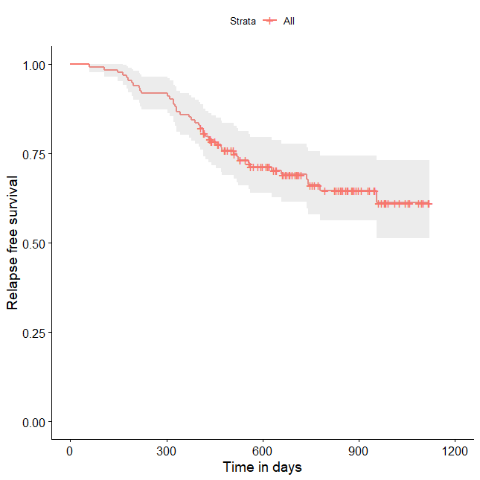
Figure 4. Relapse-free survival curve with 95% CI (darkened area) for all patients.
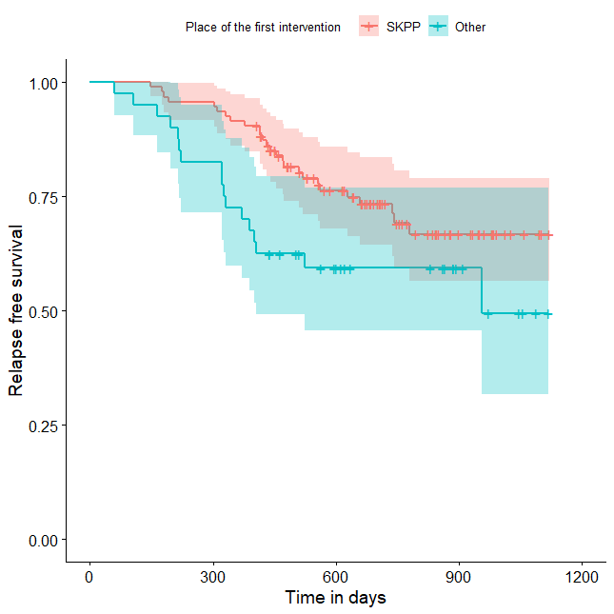
Figure 5. Relapse-free survival curve with 95% CI (darkened area) broken down by place of the first intervention.
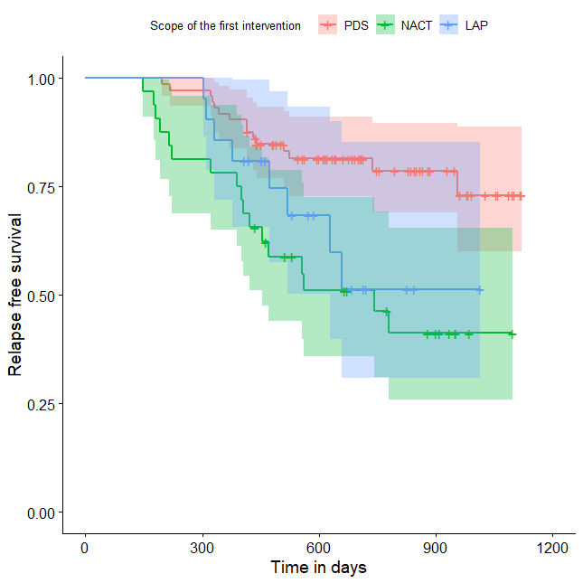
Figure 6. Relapse-free survival curve with 95% CI (darkened area) broken down by scope of the first intervention.
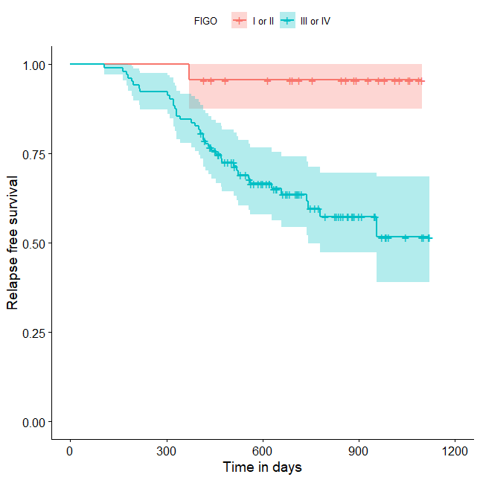
Figure 7. Relapse-free survival curve with 95% CI (darkened area) broken down by FIGO score.
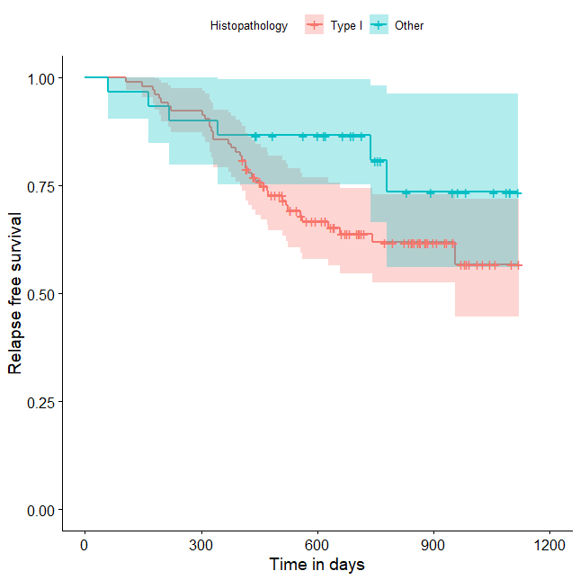
Figure 8. Relapse-free survival curve with 95% CI (darkened area) broken down by histopathology result (serous cancer vs. other types).
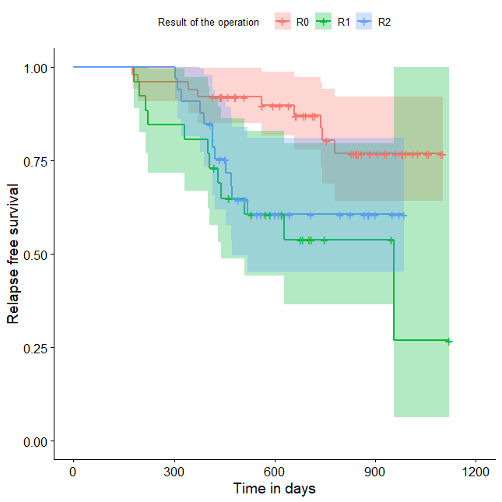
Figure 9. Relapse-free survival curve with 95% CI (darkened area) broken down by results of the operation.

5. Discussion
The analysis presented here is from our own material regarding patients with ovarian cancer in a representative group of patients who reported to the Department of Gynaecological Oncology of the University of Medical Sciences in 2019–2020. The research aimed to assess treatment results and attempted to answer questions regarding the factors that influenced those results of patients treated in one centre compared to patients who underwent treatment in different hospitals. We set progression-free survival as an end point. The analysis confirmed the superiority of treating patients from the beginning to the end of their diagnosis under one roof, not transferring them to other centres. Having the first intervention conducted in a place other than SKPP increased the risk of relapse by 89% compared to patients treated in SKPP. We did not observe this relationship in the multivariate cox regression model, which may be due to slight data gaps in individual groups, which means that part of the data was truncated. In the multivariate model, only the subjects who were not missing any data for all of the entered variables were analysed, which could have influenced the significance change. We could possibly obtain a meaningful relationship in the multivariate cox regression model by testing more subjects.
Data presented by Bristow et al. are the most extensive comparative analysis of ovarian cancer treatment across centres. The researchers included 7272 patients in their project, which significantly increased the reliability of the trial. However, factors such as race, socioeconomic status (SES) and the type of patient’s insurance were analysed, which we did not consider due to the homogeneous group of patients and the lack of differences between patients in this respect in our study. In our study, all of the patients were treated using public funds. However, it seems that some patients who live further away from the oncological unit may experience longer waiting times for admission and surgery due to individual logistical difficulties. In addition, these patients may be guided by the hospital’s proximity and not by the hospital’s volume and the number of procedures performed there.
The median ovarian-cancer-specific survival rate for all of the patients in the study provided by Bristow was 28.2 months. This suggests that we should extend the observation time in relation to the survival time of the patients.
The body of health services research regarding volume–outcome relationships for cancer care convincingly indicates that the benefit from being cared for at high-volume centres exceeds the benefit from breakthrough treatments and merits efforts to concentrate initial care for all forms of cancer [3]. Disparities in access to high-volume health care providers and hospitals have been described according to race, ethnicity and socio-demographic characteristics for different types of cancer, for example, breast, colorectal, gastric, lung, as well as cardiovascular disease and orthopaedic conditions [4,5]. Regarding ovarian cancer, a consistent volume–outcome relationship has been well documented by multiple population-based and single-institution studies, which showed that superior treatment and survival outcomes are associated with surgical expertise and multidisciplinary resources offered by high-volume surgeons and high-volume hospitals [6–15]. Disparities in ovarian cancer survival rates associated with race and SES are, therefore, thought to be largely due to unequal access to care and the administration of non-standard treatment regimens, although genetic susceptibility and a higher frequency of modifiable risk factors cannot be excluded as causative factors. In a review of the global literature, Chornokur et al. concluded that unequal access to care is primarily a consequence of lower SES and a lack of private health insurance among minority populations [16]. Indeed, single-institution and cooperative group trial studies have shown that when access to speciality providers at high-volume centres is provided equally, and all patients receive comparable treatment, racial disparities in ovarian cancer survival rates are largely mitigated.
As expected, the percentages of histological types of ovarian cancer show that the most common is high-grade serous ovarian cancer, reflecting the distribution of histological types worldwide. These data align with global reports that most ovarian epithelial carcinomas are serous. High-grade serous ovarian cancers are characterised by a high level of malignancy and are usually recognised as significantly advanced [17,18]. Similarly, according to the FIGO classification, the percentage of patients presenting with progressive disease at stages III and IV shows an accurate clinical picture of patients with ovarian cancer. Most first-time patients are diagnosed with advanced and disseminated diseases.
Our results reveal that in 2020, compared to in 2019, noticeably more operations starting with laparoscopy were performed as the first intervention. In the presented group, based on the operating protocols and available medical documentation, only patients who started treatment in SKPP underwent laparoscopy before laparotomy. This may indicate that more patients began to qualify for neoadjuvant treatment. Consequently, we observed a change in the treatment strategy aimed at the improved selection of patients before the most favourable therapeutic treatment. We believe that performing a laparoscopic resectability assessment reduces the number of unnecessary and burdensome laparotomies. This is in line with the results of the report by Vergote et al. neoadjuvant chemotherapy followed by interval debulking surgery (IDS) was not inferior to PDS followed by chemotherapy as a treatment option for patients with advanced OC (stage IIIC or IV). The complete resection of all macroscopic lesions, whether performed as PDS or after NACT, remains the objective whenever cytoreductive surgery is performed [19].
What is more, the influence of the scope of resection on OS is unquestionable. In 2009, it was proved by du Bois [20] that after radical surgery, in which total resection was achieved, i.e., R0, 50% of patients’ overall survival rate was over 90 months, in contrast to optimal (R1) and suboptimal (R2) resection, where the survival rate of 50% of patients was similar and was slightly more than 36 months. Our pilot study was too short to assess the impact of resectability, neither on 5-year nor overall survival rates. However, this might be an topic for further observation, and we should extend the research time. Interestingly, our study showed that patients from the R1 group had the highest relapse rate. The cumulative proportion of patients who did not relapse at the end of the follow-up period was 27% for the R1 group. An incorrect assessment of optimal resection might explain the observed relationship. This may be because we analysed patients operated upon in various medical centres, characterised by a different experience of oncological surgery.
Patients who cannot obtain at least optimal cytoreduction during either qualification for surgery or the resection assessment are candidates for neoadjuvant chemotherapy. It is worth noting is that a suboptimal procedure significantly reduces the time to progression and the overall survival rate. Therefore, the inability to achieve complete/optimal cytoreduction should be studied in detail [21].
Another conclusion emerging from our analysis is that patients benefit the most from surgery in a centre with more experience in treating ovarian cancer. Bristow et al. confirmed that among patients with advanced ovarian cancer, the provision of a combination of high-volume hospitals and high-volume physicians (HVPs) is an independent predictor of an improved disease-specific survival rate [22]. Although it was conducted using a smaller cohort of patients, our study drew similar conclusions. We believe that survival rate is influenced not only by the operator’s technical skills but also by a holistic, systemic approach to patients. The body of health services research regarding volume–outcome relationships for cancer care convincingly indicates that the great benefit from care at a HVH exceeds the one from breakthrough treatments and merits efforts to concentrate care for ovarian cancer.

5.1. Limitations of the Study
The major limitation of this study is the relatively small number of subjects who took part in the observation and the relatively short time frame. The main reasons for this were the rigorous inclusion and exclusion criteria. Conversely, such criteria enabled us to select a homogenous group of subjects. However, we will be able to expand the group by using data from patients treated before 2019 and analyse larger cohorts of patients in the future. This might enable us to update the rates of overall survival (OS), objective response rate (ORR) and progression-free survival (PFS).

5.2. Strengths of the Study
It is worth noting that in the analysed research, we collected a homogeneous and representative research group and compared various parameters. The inclusion and exclusion criteria were strict, which eliminated the influence of confounders. Additionally, the large share of subjects transferred to our centre is an advantage. The study’s greatest strength is its comparative nature, which allowed for a conclusion to be drawn about the benefits of holistic treatment in one centre. This approach has only been used in a few previous studies.
Author Contributions: Conceptualisation, M.-K.S. and M.R.; methodology, M.-K.S. and M.R.; software, M.-K.S. and M.R.; validation, M.-K.S. and M.R.; formal analysis, M.-K.S., M.R. and S.-N.M.; investigation, M.-K.S., M.R., P.D. and P.M.; resources, M.-K.S., M.R., P.D. and P.M.; data curation, M.-K.S.; writing—original draft preparation, M.-K.S. and P.D.; writing—review and editing, M.E. and M.R.; visualisation, M.-K.S. and M.E.; supervision, M.R., M.E. and P.M.; project administration, M.R. and S.-N.M.; funding acquisition, M.-K.S., P.D., P.M., S.-N.M., M.E. and M.R. All authors have read and agreed to the published version of the manuscript.
Funding: This research received no external funding.
Institutional Review Board Statement: Ethical review and approval were waived for this study as it lacked the features of a medical experiment.
Informed Consent Statement Written informed consent has been obtained from the patients to publish this paper.
Data Availability Statement: All data are available from the corresponding author.
Conflicts of Interest: The authors declare no conflicts of interest.

References
- Didkowska Joanna, W.U. Zachorowania i Zgony Na Nowotwory Złośliwe w Polsce; Krajowy Rejestr Nowotworów, Centrum Onkologii-Instytut im, Marii Skłodowskiej-Curie:
- Hosmer, D.W.; Lemeshow, S.; Sturdivant, R.X. Applied Logistic Regression, 3rd ed.; John Wiley & Sons, Inc.: 2013. https://doi.org/10.1002/9781118548387.
- Hillner, B.E.; Smith, T.J.; Desch, C.E. Hospital and Physician Volume or Specialization and Outcomes in Cancer Treatment: Importance in Quality of Cancer Care. J. Clin. Oncol. 2000, 18, 2327–2340. https://doi.org/10.1200/JCO.2000.18.11.2327.
- Liu, J.H.; Zingmond, D.S.; McGory, M.L.; SooHoo, N.F.; Ettner, S.L.; Brook, R.H.; Ko, C.Y. Disparities in the Utilization of High-Volume Hospitals for Complex Surgery. J. Am. Med. Assoc. 2006, 296, 1973–1980. https://doi.org/10.1001/jama.296.16.1973.
- Epstein, A.J.; Gray, B.H.; Schlesinger, M. Racial and Ethnic Differences in the Use of High-Volume Hospitals and Surgeons. Arch. Surg. 2010, 145, 179–186. https://doi.org/10.1001/archsurg.2009.268.
- Goff, B.A.; Matthews, B.J.; Wynn, M.; Muntz, H.G.; Lishner, D.M.; Baldwin, L.M. Ovarian Cancer: Patterns of Surgical Care across the United States. Gynecol. Oncol. 2006, 103, 383–390. https://doi.org/10.1016/j.ygyno.2006.08.010.
- Goff, B.A.; Matthews, B.J.; Larson, E.H.; Andrilla, C.H.A.; Wynn, M.; Lishner, D.M.; Baldwin, L.M. Predictors of Comprehensive Surgical Treatment in Patients with Ovarian Cancer. Cancer 2007, 109, 2031–2042. https://doi.org/10.1002/cncr.22604.
- Bristow, R.E.; Zahurak, M.L.; Diaz-Montes, T.P.; Giuntoli, R.L.; Armstrong, D.K. Impact of Surgeon and Hospital Ovarian Cancer Surgical Case Volume on In-Hospital Mortality and Related Short-Term Outcomes. Gynecol. Oncol. 2009, 115, 334–338. https://doi.org/10.1016/j.ygyno.2009.08.025.
- Bristow, R.E.; Palis, B.E.; Chi, D.S.; Cliby, W.A. The National Cancer Database Report on Advanced-Stage Epithelial Ovarian Cancer: Impact of Hospital Surgical Case Volume on Overall Survival and Surgical Treatment Paradigm. Gynecol. Oncol. 2010, 118, 262–267. https://doi.org/10.1016/j.ygyno.2010.05.025.
- Kumpulainen, S.; Grénman, S.; Kyyrönen, P.; Pukkala, E.; Sankila, R. Evidence of Benefit from Centralized Treatment of Ovarian Cancer: A Nationwide Population-Based Survival Analysis in Finland. Int. J. Cancer 2002, 102, 541–544. https://doi.org/10.1002/ijc.10754.
- Tingulstad, S.; Skjeldestad, F.E.; Hagen, B. The Effect of Centralization of Primary Surgery on Survival in Ovarian Cancer Patients. Obstet. Gynecol. 2003, 102, 499–505. https://doi.org/10.1016/S0029-7844(03)00579-9.
- Marth, C.; Hiebl, S.; Oberaigner, W.; Winter, R.; Leodolter, S.; Sevelda, P. Influence of Department Volume on Survival for Ovarian Cancer: Results from a Prospective Quality Assurance Program of the Austrian Association for Gynecologic Oncology. Int. J. Gynecol. Cancer 2009, 19, 94–102. https://doi.org/10.1111/IGC.0b013e31819915cb.
- Wimberger, P.; Lehmann, N.; Kimmig, R.; Burges, A.; Meier, W.; du Bois, A. Prognostic Factors for Complete Debulking in Advanced Ovarian Cancer and Its Impact on Survival. An Exploratory Analysis of a Prospectively Randomized Phase III Study of the Arbeitsgemeinschaft Gynaekologische Onkologie Ovarian Cancer Study Group (AGO-OVAR). Gynecol. Oncol. 2007, 106, 69–74. https://doi.org/10.1016/j.ygyno.2007.02.026.
- Bristow, R.E.; Chang, J.; Ziogas, A.; Anton-Culver, H. Adherence to Treatment Guidelines for Ovarian Cancer as a Measure of Quality Care. Obstet. Gynecol. 2013, 121, 1226–1234. https://doi.org/10.1097/AOG.0b013e3182922a17.
- Bristow, R.E.; Ueda, S.; Gerardi, M.A.; Ajiboye, O.B.; Ibeanu, O.A. Analysis of Racial Disparities in Stage IIIC Epithelial Ovarian Cancer Care and Outcomes in a Tertiary Gynecologic Oncology Referral Center. Gynecol. Oncol. 2011, 122, 319–323. https://doi.org/10.1016/j.ygyno.2011.04.047.
- Chornokur, G.; Amankwah, E.K.; Schildkraut, J.M.; Phelan, C.M. Global Ovarian Cancer Health Disparities. Gynecol. Oncol. 2013, 129, 258–264. https://doi.org/10.1016/j.ygyno.2012.12.016.
- Goff, B. Symptoms Associated with Ovarian Cancer. Clin. Obstet. Gynecol. 2012, 55, 36–42. https://doi.org/10.1097/GRF.0b013e3182480523.
- The Role of the Obstetrician-Gynecologist in the Early Detection of Epithelial Ovarian Cancer in Women at Average Risk. Obstet. Gynecol. 2017, 130, e146–e149. https://doi.org/10.1097/AOG.0000000000002299.
- Vergote, I.; Tropé, C.G.; Amant, F.; Kristensen, G.B.; Ehlen, T.; Johnson, N.; Verheijen, R.H.M.; van der Burg, M.E.L.; Lacave, A.J.; Panici, P.B.; et al. Neoadjuvant Chemotherapy or Primary Surgery in Stage IIIC or IV Ovarian Cancer. N. Engl. J. Med. 2010, 363, 943–953. https://doi.org/10.1056/nejmoa0908806.
- Du Bois, A.; Reuss, A.; Pujade-Lauraine, E.; Harter, P.; Ray-Coquard, I.; Pfisterer, J. Role of Surgical Outcome as Prognostic Factor in Advanced Epithelial Ovarian Cancer: A Combined Exploratory Analysis of 3 Prospectively Randomized Phase 3 Multicenter Trials: By the Arbeitsgemeinschaft Gynaekologische Onkologie Studiengruppe Ovarialkarzinom (AGO-OVAR) and the Groupe d’Investigateurs Nationaux Pour Les Etudes Des Cancers de l’Ovaire (GINECO). Cancer 2009, 115, 1234–1244. https://doi.org/10.1002/cncr.24149.
- Basta, A.; Bidziński, M.; Bieńkiewicz, A.; Blecharz, P.; Bodnar, L.; Jach, R.; Knapp, P.; Kojs, Z.; Kotarski, J.; Markowska, J.; eta l. Recommendations of the Polish Gynecological Oncology Society for the Diagnosis and Treatment of Ovarian Cancer. Curr. Gynecol. Oncol. 2017, 15, 5–23. https://doi.org/10.15557/cgo.2017.0001.
- Bristow, R.E.; Chang, J.; Ziogas, A.; Randall, L.M.; Anton-Culver, H. High-Volume Ovarian Cancer Care: Survival Impact and Disparities in Access for Advanced-Stage Disease. Gynecol. Oncol. 2014, 132, 403–410. https://doi.org/10.1016/j.ygyno.2013.12.017.
- Ratajska, M.; Krygier, M.; Stukan, M.; Kuźniacka, A.; Koczkowska, M.; Dudziak, M.; Śniadecki, M.; Dębniak, J.; Wydra, D.; Brozek, I.; et al. Mutational Analysis of BRCA1/2 in a Group of 134 Consecutive Ovarian Cancer Patients. Novel and Recurrent BRCA1/2 Alterations Detected by next Generation Sequencing. J. Appl. Genet. 2015, 56, 193–198. https://doi.org/10.1007/s13353-014-0254-5.
- Koczkowska, M.; Zuk, M.; Gorczynski, A.; Ratajska, M.; Lewandowska, M.; Biernat, W.; Limon, J.; Wasag, B. Detection of Somatic BRCA1/2 Mutations in Ovarian Cancer–next-Generation Sequencing Analysis of 100 Cases. Cancer Med. 2016, 5, 1640–1646. https://doi.org/10.1002/cam4.748.
- Ratajska, M.; Koczkowska, M.; Zuk, M.; Gorczynski, A.; Kuzniacka, A.; Stukan, M.; Biernat, W.; Limon, J.; Wasag, B. Detection of BRCA1/2 Mutations in Circulating Tumor DNA from Patients with Ovarian Cancer. Oncotarget 2017, 8, 101325–101332. https://doi.org/10.18632/oncotarget.20722.
- Bryant, H.E.; Schultz, N.; Thomas, H.D.; Parker, K.M.; Flower, D.; Lopez, E.; Kyle, S.; Meuth, M.; Curtin, N.J.; Helleday, T. Specific Killing of BRCA2-Deficient Tumours with Inhibitors of Poly(ADP-Ribose) Polymerase. Nature 2005, 434, 913–917. https://doi.org/10.1038/nature03443.
- Farmer, H.; McCabe, H.; Lord, C.J.; Tutt, A.H.J.; Johnson, D.A.; Richardson, T.B.; Santarosa, M.; Dillon, K.J.; Hickson, I.; Knights, C.; et al. Targeting the DNA Repair Defect in BRCA Mutant Cells as a Therapeutic Strategy. Nature 2005, 434, 917–921. https://doi.org/10.1038/nature03445.
- Audeh, M.W.; Carmichael, J.; Penson, R.T.; Friedlander, M.; Powell, B.; Bell-McGuinn, K.M.; Scott, C.; Weitzel, J.N.; Oaknin, A.; Loman, N.; et al. Oral Poly(ADP-Ribose) Polymerase Inhibitor Olaparib in Patients with BRCA1 or BRCA2 Mutations and Recurrent Ovarian Cancer: A Proof-of-Concept Trial. Lancet 2010, 376, 245–251. https://doi.org/10.1016/S0140-6736(10)60893-8.
- Ledermann, J.A.; Harter, P.; Gourley, C.; Friedlander, M.; Vergote, I.; Rustin, G.; Scott, C.; Meier, W.; Shapira-Frommer, R.; Safra, T.; et al. Overall Survival in Patients with Platinum-Sensitive Recurrent Serous Ovarian Cancer Receiving Olaparib Maintenance Monotherapy: An Updated Analysis from a Randomised, Placebo-Controlled, Double-Blind, Phase 2 Trial. Lancet Oncol. 2016, 17, 1579–1589. https://doi.org/10.1016/S1470-2045(16)30376-X.
- Moore, K.; Colombo, N.; Scambia, G.; Kim, B.-G.; Oaknin, A.; Friedlander, M.; Lisyanskaya, A.; Floquet, A.; Leary, A.; Sonke, G.S.; et al. Maintenance Olaparib in Patients with Newly Diagnosed Advanced Ovarian Cancer. N. Engl. J. Med. 2018, 379, 2495–2505. https://doi.org/10.1056/nejmoa1810858.

