Responses to the comments of Reviewer 2
(Manuscript ID: Sustainability-1723032)
Dear Editor:
We are pleased to read the very enthusiastic overall perspectives from the Editor and have carefully considered all comments from the reviewer 2, which is all very valuable for us to revise this manuscript. Hopefully, we believe that the manuscript has been much improved. In this response to comments from the reviewer 2, we have divided those comments into a number of items and responded one by one. The text in italics is the original comments, with the text that follows indicating our responses. Modified and added details are shown in blue both in the text and responses.

Firstly, thank you very much for the kind suggestions from editor and reviewer 2. The detailed revised contents were listed as following:

In the manuscript submitted for review, the topic discussed is important and timely, not only for China. Unfortunately, difficulty in understanding some passages due to the uneven level of English does not allow to fully appreciate this work. Especially the last section "Discussion and conclusion" needs a thorough linguistic correction by an English Native speaker. Unfortunately, the size and resolution of most of the presented figures is insufficient because they are unreadable.
(1) Difficulty in understanding some passages due to the uneven level of English does not allow to fully appreciate this work. Especially the last section "Discussion and conclusion" needs a thorough linguistic correction by an English Native speaker.
Response: We polished the manuscript by Language Editing Services of MDPI, and the Certificate of Language Editing Services of MDPI as showed below. Hopefully, the English in the manuscript can meet the publication requirements for Sustainability.

(2) The size and resolution of most of the presented figures is insufficient because they are unreadable.
Response: Sorry for the figures are not readable. We modified Figure 3 to Figure 8. Hopefully their readability has improved.
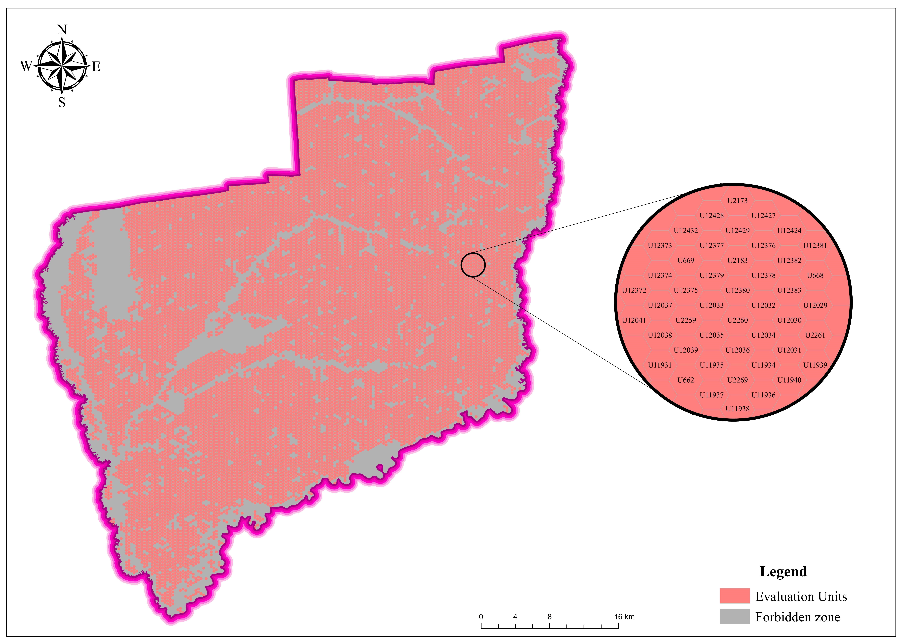
Figure 3. Distribution Map of Evaluation Units in Wangkui county
Figure 4. (a) Original value result distribution map of indexes. (b) Standardised result distribution map of index.
Figure 5. Evaluation unit clustering results. (a) SOM component plan of indexes. (b) SOM grouping diagram of indexes. (c) SOM cluster diagram of evaluation units. (d) Evaluation unit clustering spatial distribution map
Figure 6. Suitability ranking results. (a) Hasse diagram ranking results of clusters. (b) Spatial distribution map of evaluation units’ suitability grades.
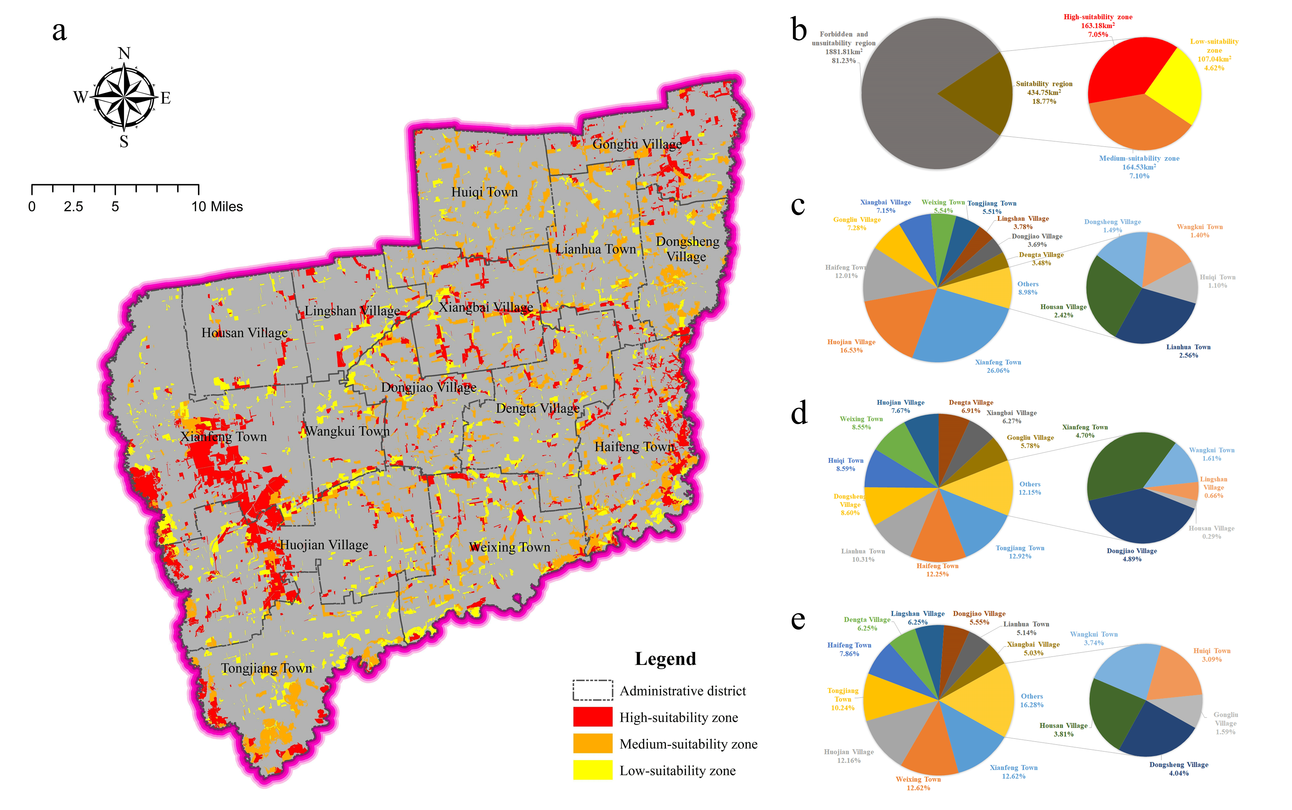
Figure 7. Results of suitable breeding region. (a) Spatial distribution of suitable breeding region. (b) Proportion of suitable region and unsuitable region. (c) Proportion of high-suitability zone in each township. (d) Proportion of medium-suitability zone in each township. (e) Proportion of low-suitability zone in each township.
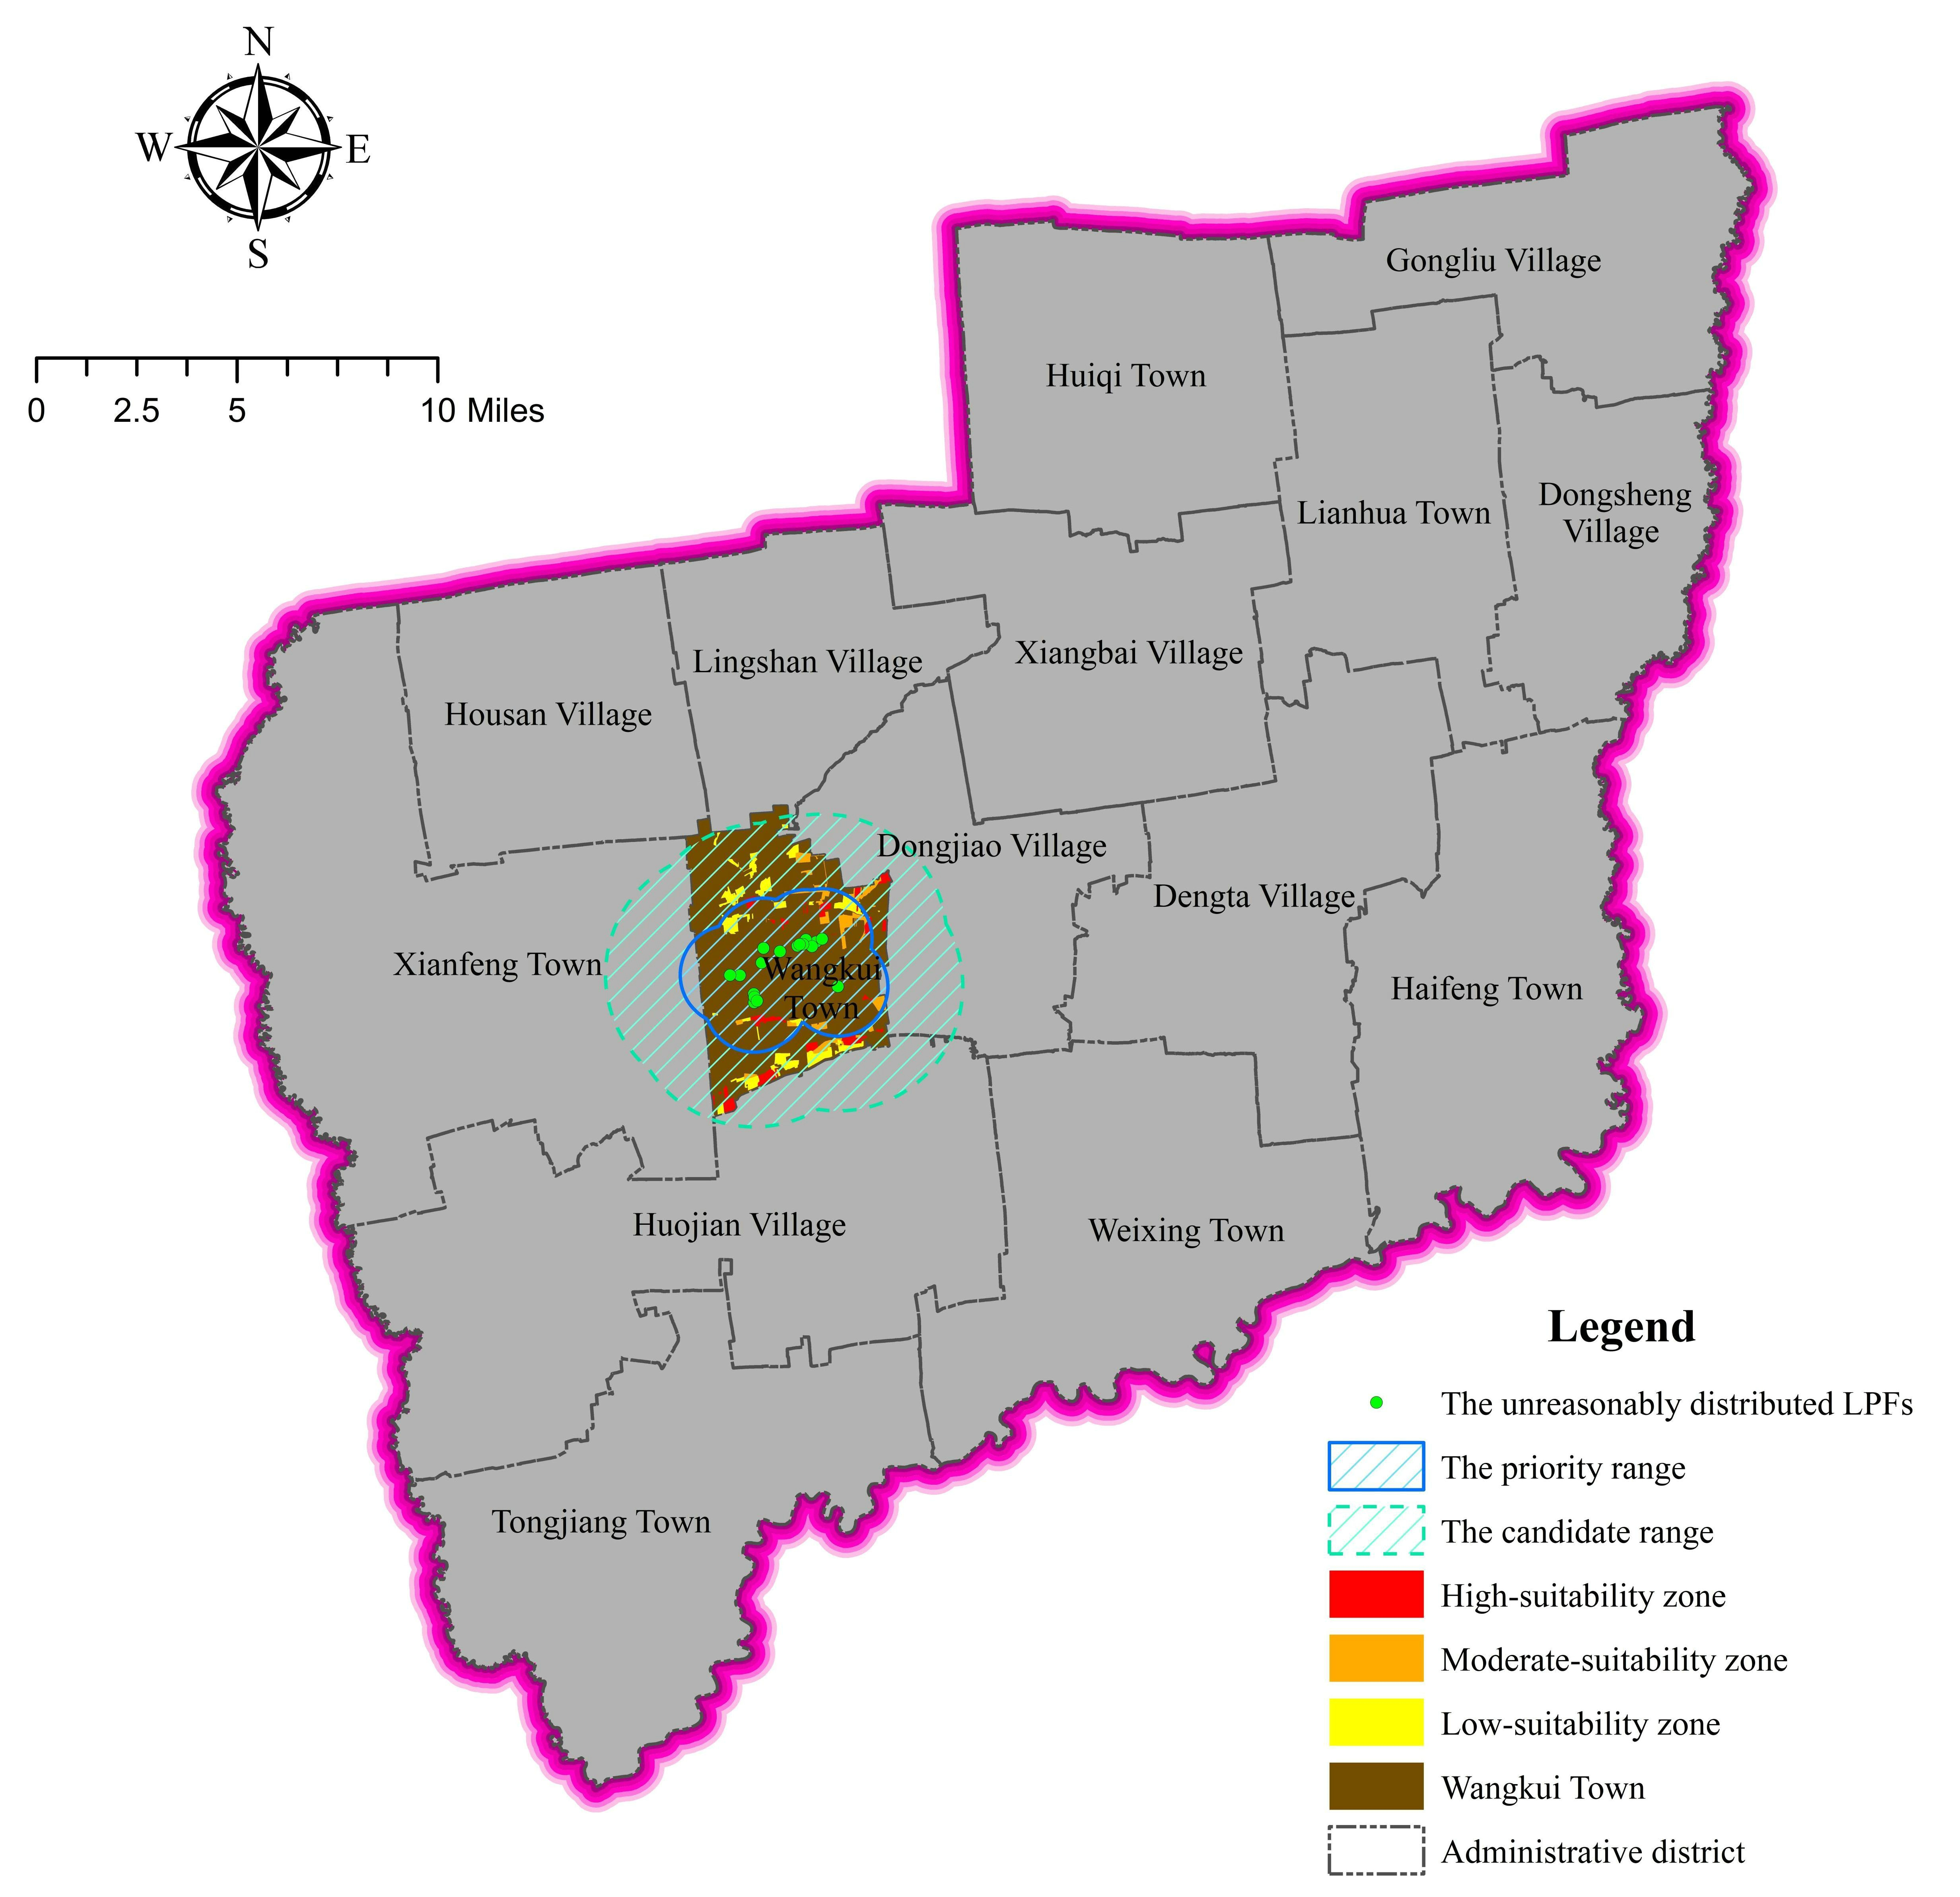
Figure 8. Relocation planning analysis results of large-scale LPFs

The manuscript has been resubmitted to the journal. We are looking forward to your positive response. With best wishes!
Sincerely
Bao-Ling Liu, Gang Li, Chun-Xue Yang, Jun Ma, Yan Zhao, Shao-Peng Yu, Jun Dong, Hong Guo

