To. Editor

Dear,
Thank you and reviewers for your kind and careful comments.
We agreed your opinions about our study and revised the manuscript to clarify every issue. We tried to improve the completeness of the paper according to your suggestions.
Again, we sincerely appreciate your time and valuable comments.
And we have gotten the editing service of MDPI for English editing and submit the certification to you.



Reviewer #2

Thank you and reviewers for your kind and careful comments.

Summary: This work collected wrist posteroanterior (PA) or anteroposterior (AP) radiographs to generate the dataset. It also proposed a method called the Fine Mask R-CNN which use Single-Shot Multibox Detector (SSD) to achieve the wrist region of interest (ROI) detection, and modify the mask head with the 28×28 input size and an encoder–decoder structure motivated by U-Net to achieve more effective prediction of the boundaries of ten wrist bones overlapping each other on an adult wrist radiograph.

Point 1 | Advantages: 1. This work is a pioneering solution to the problem of segmenting carpal borders with overlapping problems. 2. This work achieved more effective segmentation of wrist radiographs. 3. This work first carried out a Turing test on the automatic segmentation of ten wrist bones using wrist radiographs. 4. This work compared Masked R-CNN and Fine Masked R-CNN through five-fold validations to ensure the consistency of the model.
Answer | Thank you for your keen insight and comments

Point 2 | 1. The wrist radiographs used for model training were originated from a single center, the generalization ability of the trained models are yet to be considered.
Answer | We agree your careful opinion. We knew and described this problem about the generalization in limitation as follows;
Several limitations of this study should be considered. First, the data on the wrist radiographs and the patients originated from a single center, and our proposed model might not be suitable for other hospitals.

Point 3 | 2. Detection and segmentation network were trained separately, gradient cannot be shared directly.
Answer | Thank you for your opinion.  As you mentioned, since our proposed network is a 2-stage algorithm, the gradient cannot be shared directly. We agree with the reviewer’s comment and hope to improve our method as the end-to-end architecture in our future work.  We added more descriptions to explain this limitation in the discussion section.
Before |  | After
In Section 4.,  Second, we used two different neural networks—detection and segmentation networks. These two networks are trained sequentially, and the gradient cannot be shared directly between them. Therefore, our work needs to be extended to assess end-to-end networks that will establish a trainable attention module. |  | In Section 4.,  Second, our proposed method was not an end-to-end network. Since Fine Mask R-CNN consists of two different neural networks—wrist ROI detection and wrist segmentation networks, the gradient cannot be shared directly between them. Therefore, our work needs to be extended to assess end-to-end networks that will establish a trainable attention module for future work.

Point 4 | 3. Bias could not be eliminated from the Turing test because the test was performed by three radiologists from one center, without double blindness or randomization.
Answer | Thank you for your careful opinion. We knew and wrote this problem about the bias of Turing test in limitation as follows;
Several limitations of this study should be considered. First, the data on the wrist radiographs and the patients originated from a single center, and our proposed model might not be suitable for other hospitals. Second, we used two different neural networks—detection and segmentation networks. These two networks are trained sequentially, and the gradient cannot be shared directly between them. Therefore, our work needs to be extended to assess end-to-end networks that will establish a trainable attention module. Finally, bias could not be eliminated from the Turing test because the test was performed by three radiologists from one center, without double blindness or randomization.

Point 5 | 4. The enhancement of the Dice coefficient for quantitative assessment seems to be small, only about 0.01-0.02 for each type of bones, although the paper said that it cannot evaluate the accuracy of boundaries well.
Answer | We used the Dice coefficient instead of IOU for quantitative assessment and comparison with other related articles. So the difference of performance between two networks looks like small amount about 0.01-0.03 although all p-values < 0.001. The value converted as IOU has shown about 0.02-0.04 as follow;
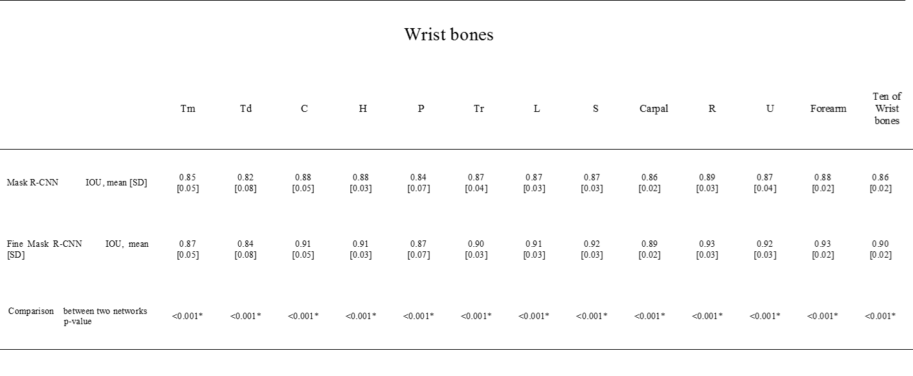

Point 6 | Question: 1. Did you consider adding supplementary comparison experiments? For example, FCN, etc.?
Answer | Thank you for your question and recommend. As you knew and we mentioned, there are currently two established neural network models specifically used for image segmentation in the computer imaging field: the fully convolutional neural network (FCN) and Mask R-CNN. When we begin our study, we investigated that the result was 0.78 [0.06] of DICE in Meng’s study using a FCN. And most adult wrist bones overlap each other, especially the eight carpal bones. So, we decided to use the mask R-CNN which is widely used for instance segmentation for our model and proposed the Fine mask R-CNN for improvement of the performance. We are sorry that we did not investigate other comparison experiments. If you want to add the supplementary comparison experiments, we are willing to do so if we could take more time for revision.

Point 7 | Question: 2. Why did you not consider joint training in the beginning? How would the inability to share gradients affect your experiments besides the increase in computational effort?
Answer | Thank you for your constructive comment.  We also considered the joint training as you mentioned, since our method has a limitation which cannot share the gradients between wrist ROI detection and wrist segmentation network. However, we just treat wrist ROI detection as a pre-processing stage of a wrist bone segmentation for this proposed method now.  In the future, we have a plan to advance this proposed method to enable end-to-end training. Therefore, we already wrote this limitation in the discussion section as follow;
Before |  | After
In Section 4.,  Second, we used two different neural networks—detection and segmentation networks. These two networks are trained sequentially, and the gradient cannot be shared directly between them. Therefore, our work needs to be extended to assess end-to-end networks that will establish a trainable attention module. |  | In Section 4.,  Second, our proposed method was not an end-to-end network. Since Fine Mask R-CNN consists of two different neural networks—wrist ROI detection and wrist segmentation networks, the gradient cannot be shared directly between them. Therefore, our work needs to be extended to assess end-to-end networks that will establish a trainable attention module for future work.

Point 8 | Question: 3. Why did you choose 28*28 as the input feature size of the Mask Head?
Answer | As the reviewer mentioned, one of our contributions to network design is a larger input size of the mask head. This advancement is motivated by the blurry contour problem mentioned in [1]. The blurry contour appears as a result of a low-resolution regular grid of segmentation method. Unlike this previous study, which consists of three main components to upsample the coarse prediction result (the original image segmentation result) and reduce the computation, we modified this process by enlarging the ROI Align output size to 28x28.  We expect that a larger input size achieves better performance, but we use a 28x28 feature size due to the limitation of the hardware resource.  To clarify this matter, we added more details about this process below:  - Kirillov, A.; Wu, Y.; He, K.; Girshick, R. Pointrend: Image segmentation as rendering. In Proceedings of the IEEE/CVF Conference on Computer Vision and Pattern Recognition, Online, 14–19 June 2020. 9799-9808
Before |  | After
In Section 2.4.2.,  First, we increased the size of the input feature of the mask head, because predicting a mask from a fixed feature of sized 14 × 14 leads to an undesired “blobby” output when segmenting a large object [32]. Therefore, we used the 28 × 28 input feature, which is larger than the original, in the Mask R-CNN, as shown in Figure 2b. Thus, the output probability map used for the segmentation model is 28 × 28 × 11, wherein 11 is the number of classes (ten wrist bones and background). |  | In Section 2.4.2.,  Our first contribution to network design was a larger input size of the mask head. We used the 28 x 28 input feature, which is larger than the original, in the Mask R-CNN, as shown in Figure 2b. This advancement was motivated by the blurry contour problem mentioned in [32], which pointed out that the blurry contour appears as a result of a low-resolution regular grid of segmentation method. In other words, in the process of resizing the size of this coarse output to the original ROI size, the details nearby object boundaries were over-smoothing. We expect that a larger input size achieves better performance, but this will depend on the limitation of the hardware resource. Since we used the 28 x 28 input feature, the output probability map used for the segmentation model is 28 × 28 × 11, wherein 11 is the number of classes (ten wrist bones and background).

Point 9 | Question: 4. As you described in 2.4.3, the baseline segmentation network was fine-tuned by the ImageNet dataset, so the wrist PA or AP radiographs dataset you collected was only used for wrist ROI detection network training? But in *2.3*, you said that normalized your input images can help fine-tune the pre-trained Mask R-CNN ? Or do you want to express "the model is pre-trained by ImageNet?"
Answer | We are sorry for our mis-leading explanation. As you mentioned, our wrist segmentation network is fine-tuned by our collected dataset. Therefore, we trained both the wrist ROI detection network and wrist segmentation network with our collected dataset.  We revised our paper to convey this information as below.
Before |  | After
In Section 2.4.3.,  The baseline network used for wrist bone segmentation was fine-tuned with the ImageNet dataset. |  | In Section 2.4.3.,  The baseline network and our proposed network were pre-trained by the ImageNet dataset and were fine-tuned with our collected wrist X-ray dataset.

