Response to Reviewer 2 Comments

Point 1: What makes the remarkable differences with/without tomoelastography in Figure 3?

Response 1: With the introduction of tomoelastography, two prominent features were related to the φ-map which and one related to the c-map, which demonstrated the importance of features extracted from tomoelastography in Ki-67 expression prediction.

Point 2: What is the reference to dividing low/high expression of Ki-67 based on 20%?

Response 2: It is according to previous studies. It is according to previous studies. One is about the evaluation of the therapeutic effect of adjuvant transcatheter arterial chemoembolization based on Ki-67 after HCC by Zhao YF et al. which was published in Frontiers in Oncology in 2021. Another study is about assessment of the microvessel density for an effective antiangiogenic treatment for hepatocellular carcinoma by Murakami K et al. which was published in Hepatology Research in 2015.
We have changed the second limitation as follows:
“Second, there is currently no standardized Ki-67 expression level threshold in HCC which varies from 10% to 30% in studies. We treated the Ki-67 prediction task as a binary classification problem (with a threshold of 20%) according to previous studies [38-39].”

Point 3: Is there any possibility to overestimate the ki-67 LI of HCC? HCC often shows inflammatory cell infiltration, and immune cells show high ki-67 LI. How did you exclude immune cells ki-67 stained in HCC only based on tomoelastography?

Response 3: Thanks for your comments. In our study, the Ki-67 expression was determined by using the percentage of immunoreactive cells from 1000 malignant cells (×400). Scoring was performed in the areas with highest number of positive nuclei (hot spot) within the tumor. Immune cells in tumor stroma were excluded for counting analysis based on the corresponding HE stained slides.

Point 4: Is tomoelastography commonly used in HCC?

Response 4: Tomoelastography is a novel MRE technique. The first and only time of tomoelastography used in HCC research was conducted by Guo J et al. which was published in Cancer Research. Some authors of that study were the co-authors of ours too. Although traditional MRE was used in quantification of liver fibrosis initially and has been developed for the detection and characterization of liver cancer, the resolution of the traditional MRE images is not high enough to reveal the detailed information inside the tumor and limited in data mining. Therefore, we used tomoelastography to ensure that the images are suitable for analysis by deep learning or radiomics models.

Point 5: How about showing me some H&E and Ki-67 stained HCC slide images of representative cases you want to?

Response 5: The H&E and Ki-67 stained HCC slide images of representative cases are as follows:
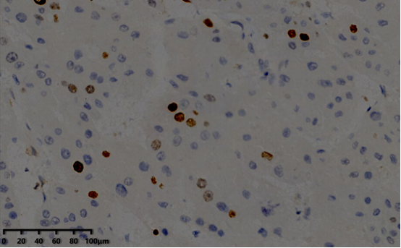
Ki-67=10%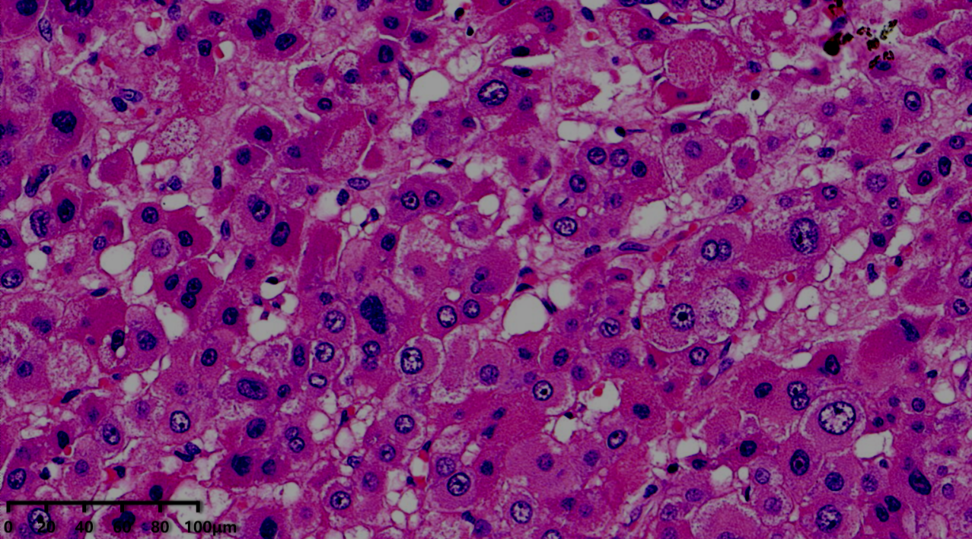

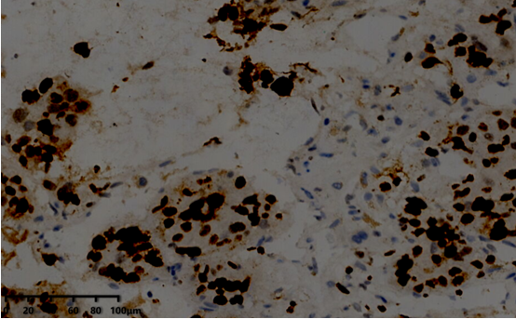
Ki-67=60%