Response to Reviewer 1 Comments

Point 1: The recommendations have been incorporated to an acceptable extent. In any case, I condition the publication by adding a legend to the images that contain texts that are not in the language of the journal, as well as by graphic design of the "screenshots" images, which contain a preview of the author's full screen. These images would need to be cropped to only a part of the relevant study, there is no need to preview the author's browser nor his bookmarks ...

Response 1: Thank you for your significant reminding. According to your comments, we readjusted some figures of this manuscript.
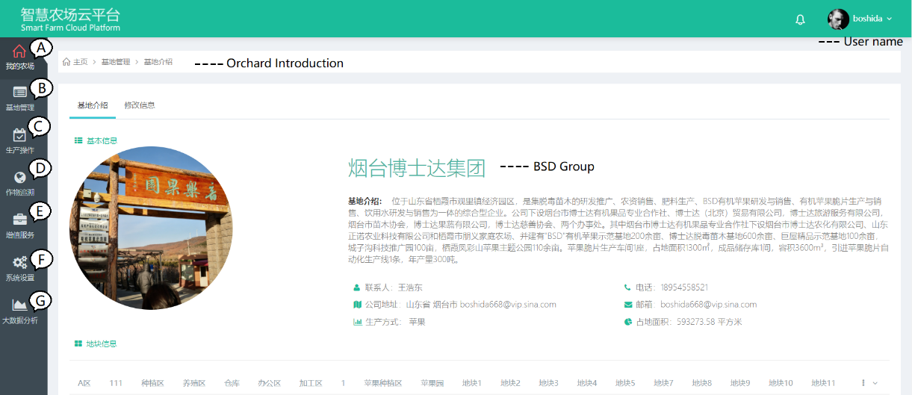
Fig.4 Interface of the web application “smart farm cloud platform”
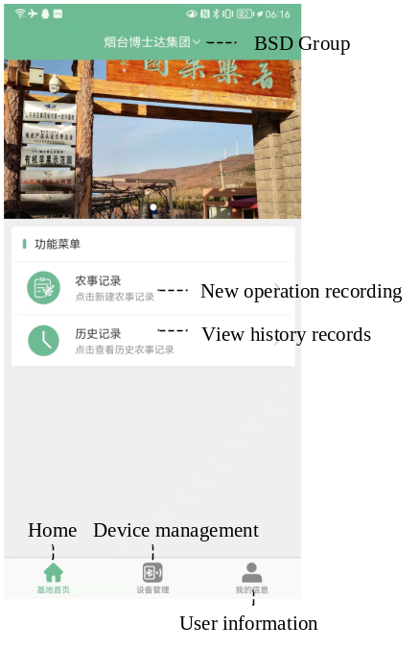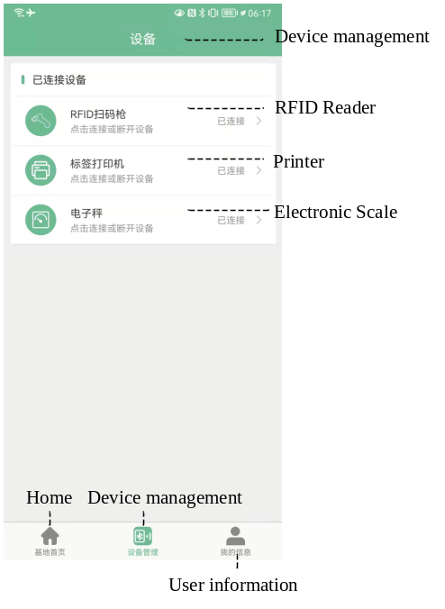
(a) (b)
Fig.5 Typical interfaces of the “Mobile orchard”: (a) Home page, (b) Device management page
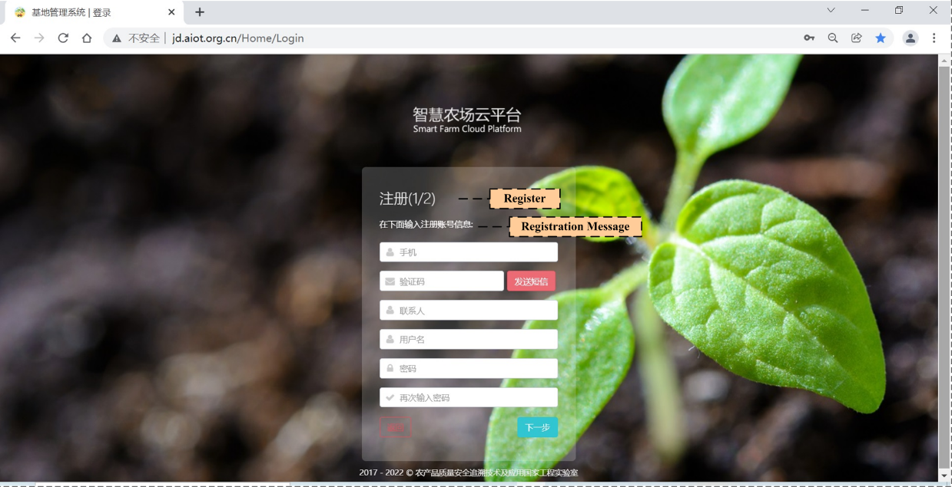
(a)
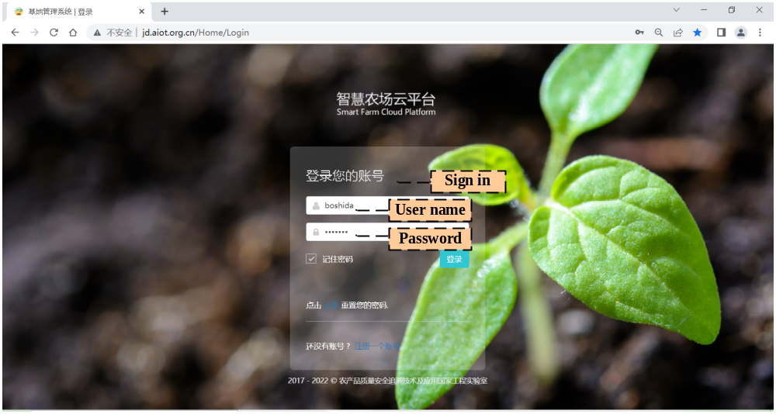
(b)
Fig.7 Registration/Login Interface: (a) Agricultural subject registration, (b) User sign in
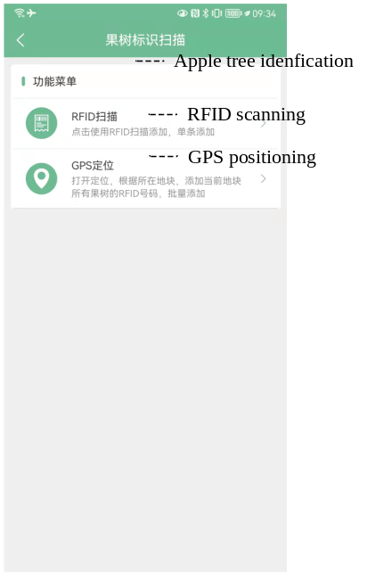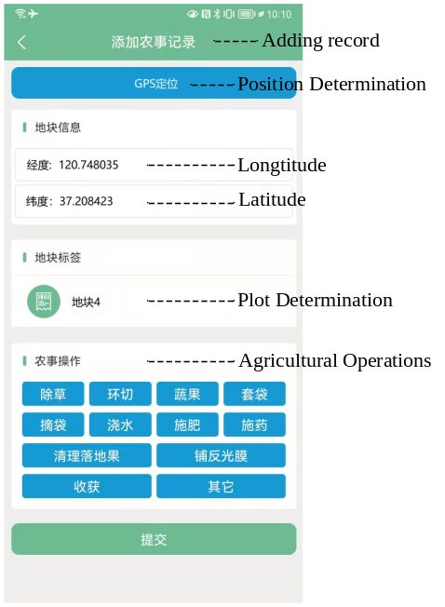
(a) (b)
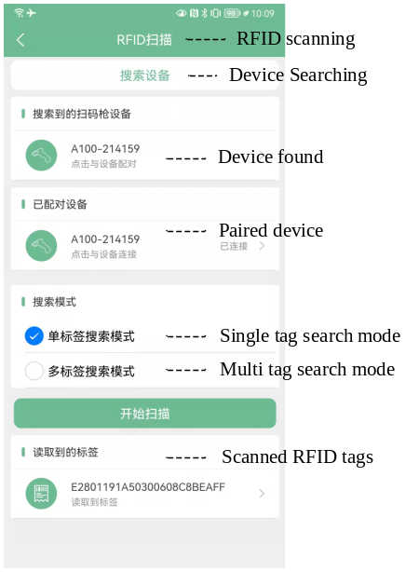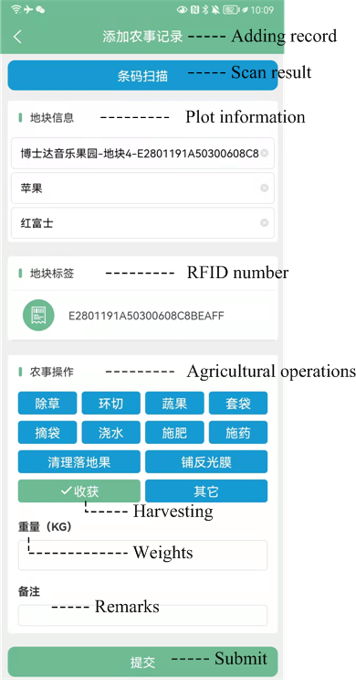
(c) (d)
Fig. 10 Mobile app interfaces of operation collection: (a) Two collection methods, (b) Collection method by batch, (c) RFID reader manage, (d) Collection method by single tree
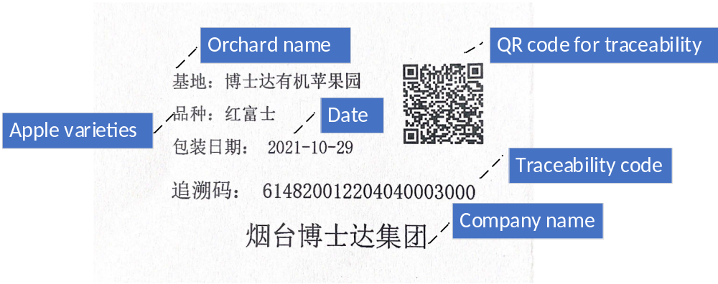
Fig. 13 Traceability label
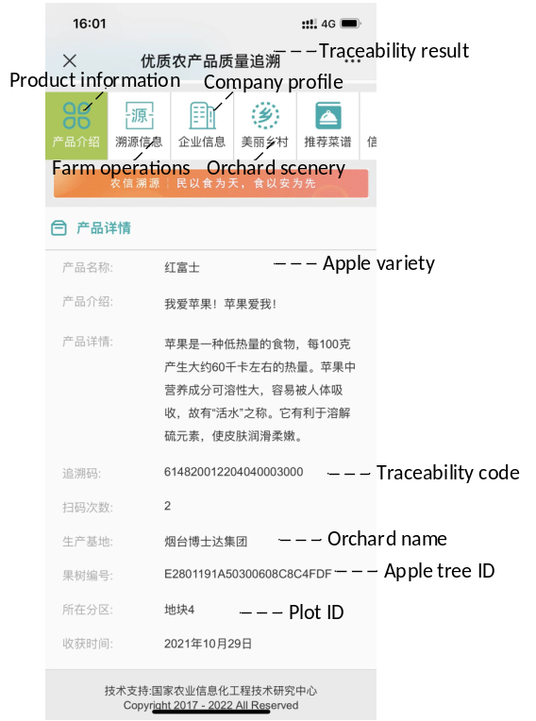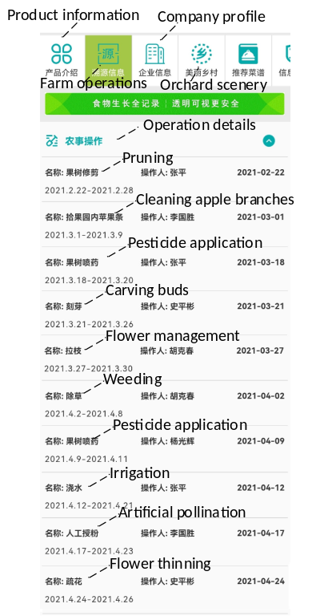
(a). (b).
Fig. 14 Apple traceability information queried by barcode scanning：(a) Apple basic information, (b) Farm operation details

