MS ID#: cimb-1610984
MS TITLE: New Insights into Evolution of the ABC Transporter Family in Plants Revealed by Unicellular Charophyte Algae M. viride

Response to Reviewer 2 Comments

We would like to thank the Editor and reviewer for the time committed in reviewing this revised manuscript, and for all the detailed suggestions on improving this manuscript. We have revised the manuscript to address the reviewer’ concerns and criticisms as follows.

Point 1: In this new version, Gong and Wang made some improvements compared to the first version.
One remark in Introduction: Since authors claim in the title that this paper focus on Charophyte Algae, it is important to state: how many charophyte algae genome were sequenced? How many were used here? This information with proper citations would be important.

Response 1: On clarification is that the title “…Unicellular Charophyte Algae” focused on the unicellular one, rather than all charophyte algae. Currently, there is only one sequenced unicellular charophyte algae, which is M. viride used in this study. We agree with the reviewer about the introduction and have added the information of sequenced charophyte genomes and relevant references in the revised manuscript.

Point 2: Regarding Response 1:
Banasiak and Jasiński paper did not give IDs, but they gave numbers. Are numbers comparable between that revision and this paper?

Response 2: In general, the ABC gene number are comparable between Banasiak and Jasiński paper and ours. Notably, the number of ABC genes in M. viride (59) is same between the two studies.

Point 3: I completely understand that phylogenetic analysis is timing consuming; however, in this paper, that was the only experiment made. So, it is important to have strong analyses in this part.
Authors want to focus their analyses in charophyte algae which is indeed a good justification. However only 2 out of 11 analysed genomes (less than 20%) were in fact charophytes. I would strongly recommend to include Chlorokybus atmophyticus genome (https://phycocosm.jgi.doe.gov/Chlat1/Chlat1.home.html) and also consider the inclusion of Mesotaenium endlicherianum (https://phycocosm.jgi.doe.gov/Mesen1/Mesen1.home.html), Spirogloea muscicola (https://phycocosm.jgi.doe.gov/Spimu1/Spimu1.home.html) and Chara braunii (https://phycocosm.jgi.doe.gov/Chabra1/Chabra1.home.html) genomes, in order to have a more "balanced" analysis in favor of neglected algal genomes. Another solution is to focus manuscript title in M. viride genome.

Response 3: We thank the reviewer for providing the two excellent solutions for improving this manuscript and listing the detailed information about the sequenced genomes of charophyte algae. We prefer the second solution since this study focused on unicellular charophyte algae. As suggested by the reviewer, we have changed the title to “New Insights into Evolution of the ABC Transporter Family in Plants Revealed by Unicellular Charophyte Algae M. viride” and revised the relevant text in the manuscript.

Point 4: Regarding response 3
Please, include pfam codes for (TMD-NBD) domain; the same for all used CDD domains.

Response 4: As suggested by the reviewer, we have included the Pfam/CDD codes in the revised manuscript.

Point 5: Regarding response 4
The analysis was expected to be done among charophyte algae.

Response 5: As suggested by the reviewer, we have performed synteny analysis of charophyte algae, including Mesostigma viride, Klebsormidium flaccidum, Chlorokybus atmophyticus and Chara braunii. The analysis was performed as described in Bavaresco et al, 2021 (https://doi.org/10.1007/s12892-021-00130-4) paper. In contrast to an overall conserved syntenic relationships in Bavaresco et al, 2021 paper, we found only few conserved syntenic relationship between M. viride and other three charophytes, and most syntenic pairs were not shared among them (Figure R1). Two factors may contribute to this result. First, in contrast to all the Panicoideae species used in Bavaresco et al, 2021 paper are chromosomal assembled genomes, genome assembly of all the charophyte algae were scaffold level. The quality of these genome assembly was relatively lower. Notably, scaffold N50 of Klebsormidium flaccidum is only 135 kb. Second, the evolutionary distance was still large among charophyte algae that includes unicellular and multicellular ones. The relative low quality genome assembly and large evolutionary distance may suggest that ABC syntenic relationship among charophyte algae could not well-resolved in the analysis.
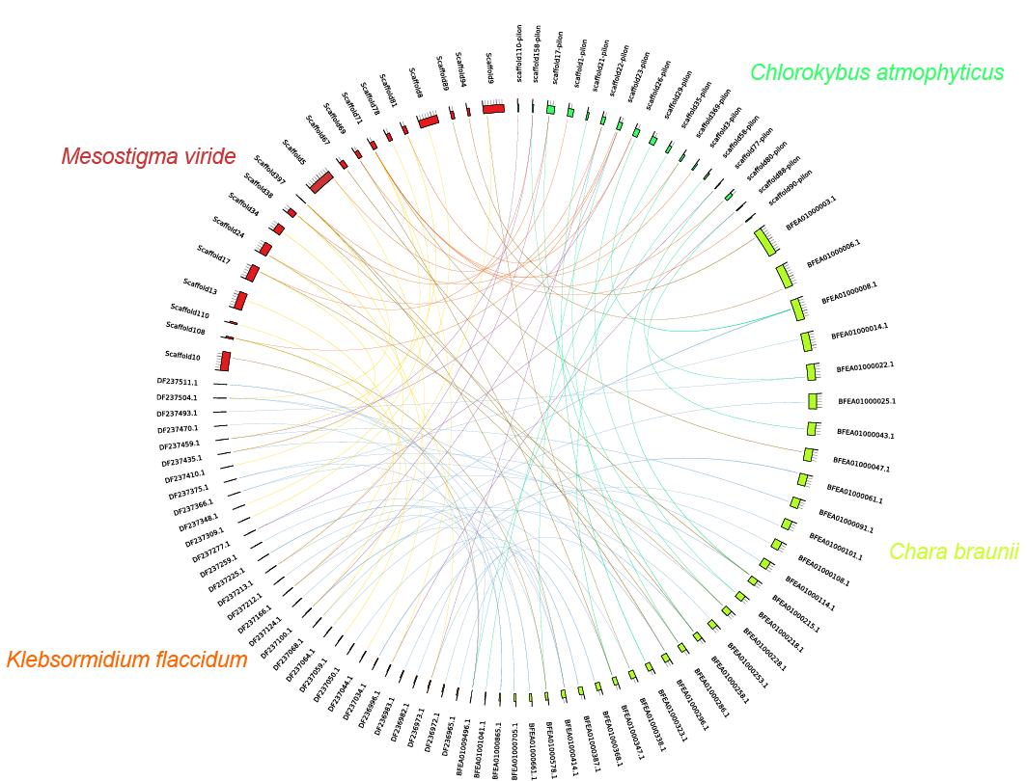

Fig. R1 Synteny between M. viride, K. flaccidum, C. atmophyticus and C. braunii. Circos plot showing ABC gene pair with a syntenic relationship was joined by the coloured lines.

Point 6: Regarding response 5
Which genes were not expressed? Which was the level of expression in RNA-seq data? Please, detail this in results and how it was analyzed in methods.

Response 6: As suggested by the reviewer, we have analyzed the previous published RNA-seq data (PMID: 31921561), and generated a heatmap (Supplementary Figure 1) showing the expression level of all the ABC genes in M. viride. We have added the relevant results and method in the revised manuscript.
Point 7: After these modifications, the paper can be reanalyzed.

Response 7: We thank the reviewer for all the detailed suggestions, and revised the manuscript based on these modifications.

