Response to Reviewer 1 Comments

Point 1: Introduction: This chapter respects the scientific character of such a paper, the general topic of the article and of the study area being well presented, but from this manuscript I cannot tell if the citations are correct or not. The “CLUB” subject has been treated in many researches, so please tell us why did you choose “CLUB” and backup your response through citations from other papers.

Response 1: Thanks for the expert opinion. Based on expert opinion, we answer the reasons for choosing the topic of CLUB in the introduction section, and further demonstrate the importance of research on this topic by citing relevant studies. Modifications in the text are as follows:
Land is the basic carrier of all social and economic activities, which can provide space and resources for human production and life [1]. As an important part of land resources, construction land mainly includes urban construction land, rural residential land, transportation land and water conservancy land and other construction land. Its utilization is not only related to the development of the secondary and tertiary industries of the national economy, but also has an important impact on the coordinated development of urban and rural areas [2,3]. Land use benefit refers to the comprehensive output of social, economic and eco-environmental benefits obtained by human capital, labor and technical input, which is related to the sustainable development of a region [4].
At present, as the rapid global urbanization, most developed countries and regions are striving to complete the simultaneous optimization of land use in society, economy and ecology, and obtained some achievements [5-7]. As the main target of urban expansion in the coming decades [8], driven by industrialization, new urbanization and modernization, the urban population of developing counties has increased rapidly, and the scale of urban construction land development has been expanding continuously. Especially in China, the urbanization rate has increased from 17.90% in 1978 to 59.58% in 2018 [9]. However, with the rapid improvement of urbanization level, the contradiction between man and land has become increasingly acute, and problems such as extensive land development and utilization, disorderly expansion and land pollution have frequently occurred, which lead to imbalance between social, economic, and eco-environmental benefits of land use, especially in urban agglomeration areas where social and economic activities are more active [10,11]. In addition, urban sprawl will inevitably affect the implementation of cultivated land protection policies and even the national food security [12]. Therefore, it is of great significance to study the development intensity and multi-dimensional use benefit of construction land for the rational and optimal allocation of land resources and the sustainable development of urban and rural areas.

- Ding, C.; Lichtenberg, E. Land and urban economic growth in China. J. Regional. Sci. 2011, 51, 299-317. [CrossRef]
- Gao, J.; O’Neill, B.C. Mapping global urban land for the 21st century with data-driven simulations and Shared Socioeconomic Pathways. Nat. Commun. 2020,11, 2302. [CrossRef]
- Krekel, C.; Kolbe, J.; Wuestemann, H. The greener, the happier? The effect of urban land use on residential well-being. Ecol. Econ. 2016, 121, 117–127. [CrossRef]
- Lu, X.; Shi, Z.; Li, J.; Dong, J.; Song, M.; Hou, J. Research on the Impact of Factor Flow on Urban Land Use Efficiency from the Perspective of Urbanization. Land 2022, 11, 389. [CrossRef]
- Ferm, J.; Jones, E. Beyond the post-industrial city: Valuing and planning for industry in London. Urban Studies. 2017, 54, 3380-3398. [CrossRef]
- Lee, J.; Jung, S. Industrial land use planning and the growth of knowledge industry: Location pattern of knowledge-intensive services and their determinants in the Seoul metropolitan area. Land Use Policy 2020, 95, 104632. [CrossRef]
- Osman, T. Land use regulations and the dispersion of the IT Industry in the San Francisco Bay area. Pap Reg Sci. 2020. 99, 1301-1316. [CrossRef]
- Hak, T.; Janoušková, S.; Moldan, B. Sustainable Development Goals: A need for relevant indicators. Ecol. Indic. 2016, 60, 565–573. [CrossRef].
- Xie, X.; Fang, B.; Xu, H.; He, S.; Li, X. Study on the coordinated relationship between Urban Land use benefit and ecosystem health in China. Land Use Policy 2021, 102, 105235. [CrossRef]
- Fu, B.; Zhang, L. Land-use change and ecosystem services: concepts, methods and progress. Prog. Geogr. 2014, 33, 441–446.
- Tang, Y.; Wang, K.; Ji, X.; Xu, H.; Xiao, Y. Assessment and Spatial-Temporal Evolution Analysis of Urban Land Use Efficiency under Green Development Orientation: Case of the Yangtze River Delta Urban Agglomerations. Land 2021, 10, 715. [CrossRef]
- Deng, X.; Huang, J.; Rozelle, S.; Zhang, J.; Li, Z. Impact of urbanization on cultivated land changes in china. Land Use Policy 2015, 45, 1-7. [CrossRef]

Point 2: Methods: This chapter is a complex one, but the multitude of formulas (around 10) makes the methodology part more difficult to follow. Also, there are many abbreviations, so please try to include them in a table. Is there any possibility where you can include a workflow chart? It would help in understanding the process better.

Response 2: Thanks for the expert opinion. In order to make the method part of the article simple and clear, we have sorted out and simplified the research method of this article. For more mature methods, we directly cite them in the form of references. Regarding the abbreviations in the article, we have sorted them out in the form of tables based on expert opinions and placed them in the appendix of the article. See Table A1 below of Appendix A for details. In addition, to make the article better understood, we have added a workflow diagram, as shown in Figure 1 below. Modifications in the text are as follows:

Method adjustment and modification section:

3.3. Methods

3.3.1. CLDI measurement
Development intensity can be used to measure the extent of land development and utilization by human activities in a certain area. As for the development intensity, 20% is generally regarded as the standard line of livable level internationally, and 30% is regarded as the warning line. According to the National Land Plan (2016-2030), China's land development intensity should not exceed 4.62%. In the paper, the ratio of construction land area to the regional total area proposed by Fan Jie in the main functional zoning is selected as the CLDI measurement index [44]. The formula is as follows:
（1）
Where, CLDI represents construction land development intensity, CLA is construction land area, and TA is total area of the region.

3.3.2. CLUB Index System
The CLUB mainly refers to the output of labor capital invested by human beings on construction land and synthesis of the social and environmental impacts caused by it. Therefore, drawing on previous studies [43,45,46], and combined with the connotation of CLUB and the scientific principle of index selection, this paper constructed a three-dimensional evaluation index system including social, economic and eco-environmental benefits (Table 1).
Table 1. Three-dimensional framework evaluation index system of CLUB
Criterion layer | Indicator layer | Attribute | Weight
Social benefits | Urbanization level (%) | + | 0.0534
Social benefits | Population density per unit construction land area (person/km²) | + | 0.0646
Social benefits | Resident per capita net income (RMB/person) | + | 0.0511
Social benefits | Employed persons per land (person 10,000/km²) | + | 0.0469
Social benefits | Per capita road area (m²/person) | + | 0.0812
Economic benefits | GDP per unit area (RMB10,000/km²) | + | 0.2377
Economic benefits | Fiscal revenue per unit of construction land area (RMB10,000/km²) | + | 0.0683
Economic benefits | GDP per unit construction land area of secondary and tertiary industries (RMB10,000/km²) | + | 0.0625
Economic benefits | Retail sales of consumer goods per unit of construction land area (RMB10,000/km²) | + | 0.0769
Economic benefits | Investment in fixed assets per unit construction land area (RMB10,000/km²) | + | 0.0593
Eco-environmental benefits | Green space coverage in built-up areas (%) | + | 0.0373
Eco-environmental benefits | Public green space per capita (m²/person) | + | 0.0506
Eco-environmental benefits | Discharge of industrial wastewater per unit construction land area (Ton/km²) | - | 0.0368
Eco-environmental benefits | Industrial waste gas emissions per unit construction land area (Ton/km²) | - | 0.0335
Eco-environmental benefits | Discharge of industrial solid waste per unit construction land area (Ton/km²) | - | 0.0399
3.3.3. CLUB Index Weight Setting and Score Calculation
(1) Data preprocessing
Because different indicators have positive and negative effects, in order to ensure the rationality of the evaluation results, it is necessary to standardize the data to ensure the uniformity of the dimensions of each indicator. The formula is as follows:
（2）
Where x'_{ij} represents the standardized value, x_{ij} is the original data value of the indicator, x_{max} and x_{min} are the maximum and minimum values in the indicator data respectively.
(2) Weight Calculation
Due to the different degrees of dispersion of different indicators, the impact on the comprehensive evaluation is also different. Therefore, we used the more objective entropy method to calculate the index weight [46,47]. The weight results are shown in Table 1.
(3) CLUB and Subsystem Score Calculation
According to the above standardized values and weights, the social benefits score (U_{soc}), economic benefits score (U_{eco}), and eco-environmental benefits score (U_{env}) of construction land use combined with composite index method were calculated respectively[46]. Then, the weighted evaluation method of the criterion layer is used to obtain the comprehensive value of CLUB of the i-th sample.
（3）
（4）
In the formula, α, β and γ are undetermined coefficients, which represent the importance of the social, economic, and eco-environmental benefits of construction land use, respectively. Because the three need to coordinate and advance together and are almost equally important, this paper takes α=β=γ=1/3.
3.3.4. Coupling Degree (CD) and Coupling Coordination Degree (CCD)
CD is usually used to describe the degree to which two or more systems interact and affect each other [48,49]. This paper constructs a CD model among the three-dimensional benefits of social, economic and eco-environmental. Based on the CD, this paper further draws on the CCD to measure the degree of harmony and consistency of the social, economic and ecological environmental benefits of construction land use in the process of change [50]. The formula is as follows:
（5）
（6）
Where, C represents coupling Degree, 0≤C≤1. D represents coupling coordination degree, 0≤D≤1. The larger the D, the higher the CCD. When C=0, the CD is extremely low, and the systems or between elements within the system are in a disordered state. C=1, the CD is the largest, and benign coordinated coupling is achieved between systems or between internal elements of the system.
On the basis of existing research, it is found that many scholars use the critical value method to classify CD and CCD. However, this paper does not subjectively carry out quantitative division, but chooses the objective quartile method. The CD and CCD are divided into four stages from low to high level: lower level, medium level, higher level and benign level.

Abbreviations added in the text:
Appendix A
Table A1. Introduction to abbreviations in this article
Full Form | Abbreviated Form
Lanzhou-Xining urban agglomerations | LXUA
Construction land development intensity | CLDI
Construction land use benefits | CLUB
Coupling degree | CD
Coupling coordination degree | CCD

Workflow chart of this study:
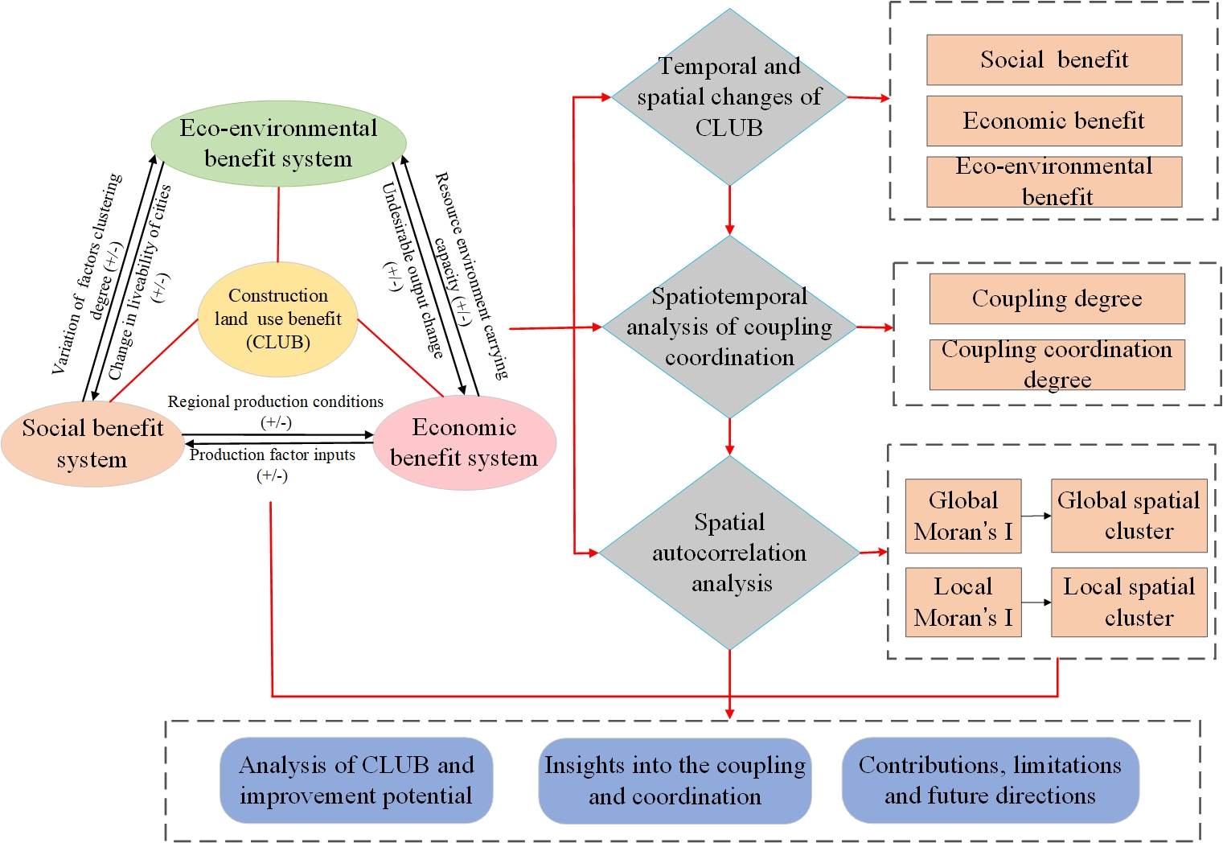

Figure 1. The coupling interaction relationship of the CLUB system and workflow chart

Point 3: Results: Try to make your maps bigger, especially figure 3. Also do that with figure 7, it is way too small to understand something from it. Compare your results with other studies. Try to resolve the problem with your citations. You have 40 bibliographic items and you mentioned in text only 2.

Response 3: Thanks for the expert opinion. We have revised relevant content in the Results section based on expert opinion. The first is to improve the map of this paper. In order to improve the contrast, self-evidence and overall beauty and harmony of the pictures and text, we have repaired the accuracy and quality of the pictures and the content of the pictures, especially the figures 3 and 7 pointed out by experts. In addition, we have refined our results and compared them with other studies in the conclusions and discussion section. The specific modifications are as follows:

Figure 3. The spatial pattern of CLDI in LXUA

Figure 7. Spatial agglomeration of the CCD of CLUB from 2005 to 2018
5. Discussion
5.1. Reasons for the change of CLUB and CCD relationship
The evaluation of CLUB is conducive to promoting the intensive and efficient use of land resources and the sustainable development of the region, especially for the northwest region where the ecological environment is relatively fragile. As an important ecological barrier support area in western of China, LXUA plays a key role in promoting the high-quality development of the Yellow River Basin, promoting the development of the western region, and ensuring the ecological security of the Northwest China [51,52]. The research results show that the CLUB of LXUA is generally low level, the polarization of difference is obvious, and the regional development imbalance is prominent problem. This is consistent with the findings of Shi et al. [53]. Especially, there are significant regional differences in the social and economic benefits. The lack of long-term spatial control measures made Lanzhou and Xining dominate place. The excessive agglomeration of low level urban functions, and the limited radiation effect of polarized regions, which restrict the urban agglomerations integration as well as the balanced economic development. In addition, the CCD among the social, economic, and eco-environmental benefits of construction land use increased from 0.48 to 0.55, and is still at a medium and low level coordination stage, which is also consistent with previous research works [54-56]. However, the northwest region is currently in a stage of accelerated urbanization. The rapid population growth in some areas has increased the development of land resources. At the same time, the economic structure of the counties is similar, the industrial level is relatively low, and there are still many traditional industries with high input, consumption and emission. Coupled with the fragile ecological background and increasing resources environment pressure caused most counties are lower level regions. This unsustainable development mode needs to be alleviated urgently.
6. Conclusion
This paper uses panel data of 39 county-level cities of the LXUA in China from 2005 to 2018 to construct a three-dimensional system of CLUB covering society, economy and eco- environment. we analyzed the temporal and spatial evolution characteristics of CLDI and CLUB, and explored the coupling coordination relationship among the benefits. The main conclusions are as follows: (1) The CLDI generally presents a dual-core spatial distribution with Lanzhou and Xining urban areas as the core. In the center of the city, the CLDI is greater. On the contrary, in edge cities, as the distance increases, the CLDI gradually decreases. (2) The social benefits of construction land use showed a "convex"-shaped spatial distribution pattern of “high in the middle and low in the east and west wings”. The economic benefits were basically the same as the social benefits in terms of spatial distribution, with great regional differences. The eco-environmental benefits were relatively high, regional differences are small. (3) The CLUB have significant spatial differences, and generally present a gradient spatial structure of “core cities>node cities>general county towns”, and the comprehensive benefits are mainly lower level and low level. (4) From 2005 to 2018, the interaction between the social, economic and eco-environmental benefits of construction land use developed in a coordinated direction in terms of time evolution and spatial correlation, but generally the CCD was still at a medium-lower level, and the spatial clustering features are significant.
This paper conducts a more comprehensive analysis of the spatiotemporal evolution of CLDI, CLUB and coupling coordination relationship of the multi-functional use benefits of construction land in LXUA, which is of great significance to the sustainable development of future land use of different types. However, there are still some deficiencies that need to be pointed out: (1) Based on the availability of county data, the selection of indicator systems still can be improved. (2) With the update of technical means such as big data, the "flow" element is becoming more and more important. However, this paper does not consider the impact of "data flow" and "feature flow" on regions. (3) Compared with other studies [57-59], this study lacks consideration of more refined data and techniques and impact mechanisms. In the future, on the basis of comparing and learning from the more mature urban agglomeration paths, a more in-depth analysis and research can be carried out in combination with the characteristics of the study area and the shortcomings of this paper.

