Response to the Reviewer’s Comments
Manuscript ID: micromachines-1591110

We thank you very much for giving us an opportunity to revise our manuscript, we appreciate to revise our manuscript, we appreciate editor and reviewers very much for their positive and constructive comments and suggestions on our manuscript entitled “Polarization Gradient Effect of Negative Capacitance LTFET” (ID: micromachines-1591110). And I will answer your questions one by one below.
#reviewer2
Comment 1： ‘SS_{ave}’ and ‘sub-threshold swing (SS)’ in this manuscript need to be clearly explained and distinguished to avoid misunderstanding.
Authors’ Response：
Thank you very much for raising this question. SS_{ave} in this manuscript are replace by “SS”, in order to avoid misunderstanding. All SSs calculated in this manuscript are average sub-threshold.
Comment 2：The equations and serial numbers in the manuscript should be aligned and centered in the article.
Authors’ Response：
All equations and serial numbers in the manuscript has been aligned and centered in the article.
Comment 3： It is suggested that pictures should be in the form of Figure instead of Fig.
Authors’ Response：
It is suggested that pictures should be in the form of Figure instead of Fig. All Fig have been revised.
Comment 4： The variables in the equation and the units of variables should be consistent with those in the manuscript. It is suggested to check carefully and modify them.
Authors’ Response：
This problem has been revised.
Origin:
The fitting coefficients of calibrated model are A_{path} = 1.63×10¹⁴ cm⁻¹s ⁻¹, B_{path} = 1.47×10⁶ V/cm, and the corresponding reduced mass is m_{r} = 0.033.
Revised:
The fitting coefficients of calibrated model are A_{path} = 1.63×10¹⁴ cm⁻³s ⁻¹, B_{path} = 1.47×10⁶ Vcm⁻¹, and the corresponding reduced mass is m_{r} = 0.033×m_{o}.
Comment 5： More detailed analysis and discussion should be made in Figure 2b, and the reasons for the inconsistency with the literature [19] should be given.
Authors’ Response：
The abstract of literature [19] is listed as follow:
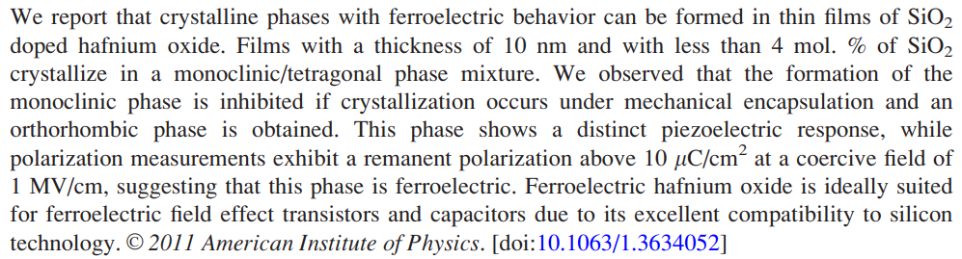
The P-E curve of literature [19] is listed as bellow:
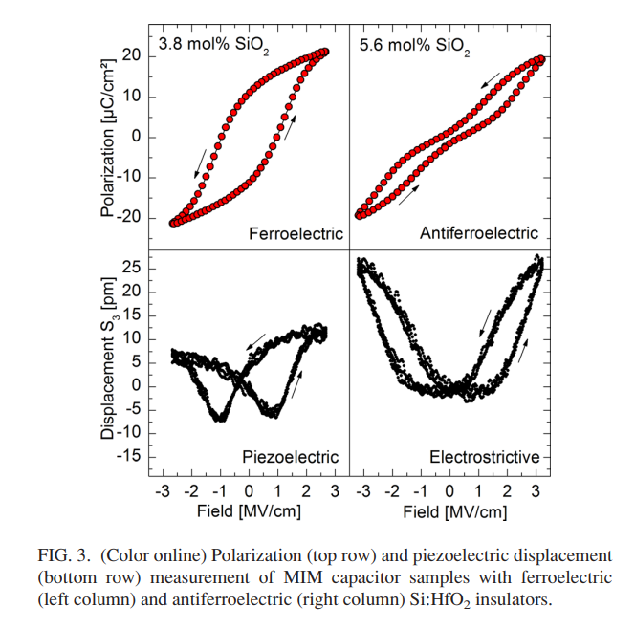
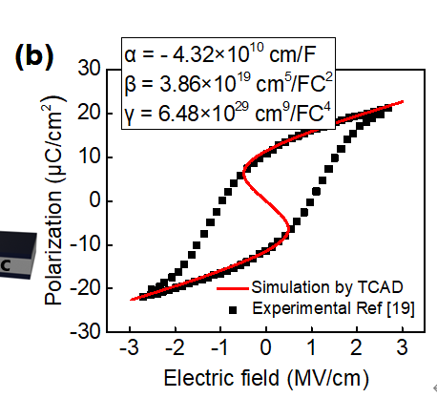
Figure 2. (b) comparison between simulated P-E curve with experimental results for Si: HfO₂ [19]
There is no doubt that a coercive field Ec = 1Mv/cm and remanent polarization is above 10μC/cm2 (~11.2μC/cm2). The parameter was obtained from Literature [19] FIG3 (3.8 mol% SiO₂). The structure is metal-oxide-metal (MFM), is consistent with simulation. We think our data is the same as Literature [19].
Reference:
[19] Böscke T S, Müller J, Bräuhaus D, Schröder U and Böttger U, "Ferroelectricity in hafnium oxide thin films," Appl. Phys. Lett., vol. 99, Sep. 2011, doi: 10.1063/1.3634052.
Comment 6： In the second part, the equations of Q ≡ P and V_{FE} need to give a detailed derivation process to make the manuscript more complete.
Authors’ Response：
It is assumed that the polarization charge at the interface between gate oxide and gate is equal to the gate charge, so the equation P = Q_{g} is obtained. At the same time, instead of P, Eqn. (5) could derivate by Eqn. (4).
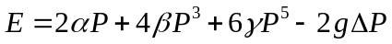 (4)
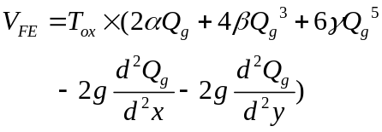 (5)
The detailed is revised as follow:
Origin:
Here, ∆ is the Laplace operator. Considering the charge 𝑄 ≡ 𝑃，the voltage across the ferroelectric materials could be expressed as bellow:
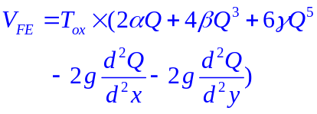 (5)
where Tox is the thickness of ferroelectric oxide.
Revised:
Here, $∆$ is the Laplace operator. Considering the gate charge is equal to the polarization near the interface between gate and gate oxide $P≡Q_{g}$，the voltage across the ferroelectric materials could be expressed as bellow [18]:
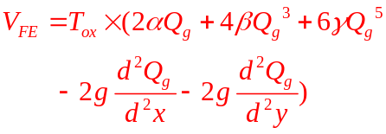
where Tox is the thickness of ferroelectric oxide.
For more detailed process, please refer to Literature [18].
Reference:
[18] M. -Y. Kao, G. Pahwa, A. Dasgupta, S. Salahuddin and C. Hu, "Analysis and Modeling of Polarization Gradient Effect on Negative Capacitance FET," IEEE Transactions on Electron Devices, vol. 67, no. 10, pp. 4521-4525, Oct. 2020, doi: 10.1109/TED.2020.3013569.
Comment 7： The experimental contents of subsections 3.1 and 3.2 are different, and it is suggested to give different titles.
Authors’ Response：
This is an obvious mistake. Thank you so much for your valuable suggestions. The title of 3.2 has been revised from “Performance and mechanism comparison of NC-LTFET with LTFET” to “The impact of polarization gradient on NC-LTFET performance”.

Comment 8： In Figure 3, (b) and (c) give the curve in A-B direction. Why is the electron band generation rate in A-B direction not given in (d)?
Authors’ Response：
Band2Bnad tunneling mainly occurs in the pocket region, and the thickness of pocket region is only 5nm, which can not clearly observe the difference in A-B direction, so we choose to follow the C-D direction, in order to represent this obvious difference to the reader.
Comment 9： The in Figure 4 (a) shows the X and Y directions, which are suggested to be marked in Figure 2 for ease of understanding
Authors’ Response：
The red axis has been added to Figure 1, and the corresponding X value and Y value in Figure 4a has been revised.
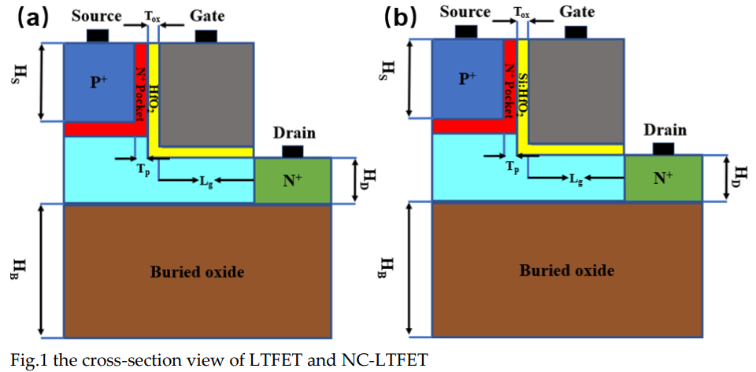

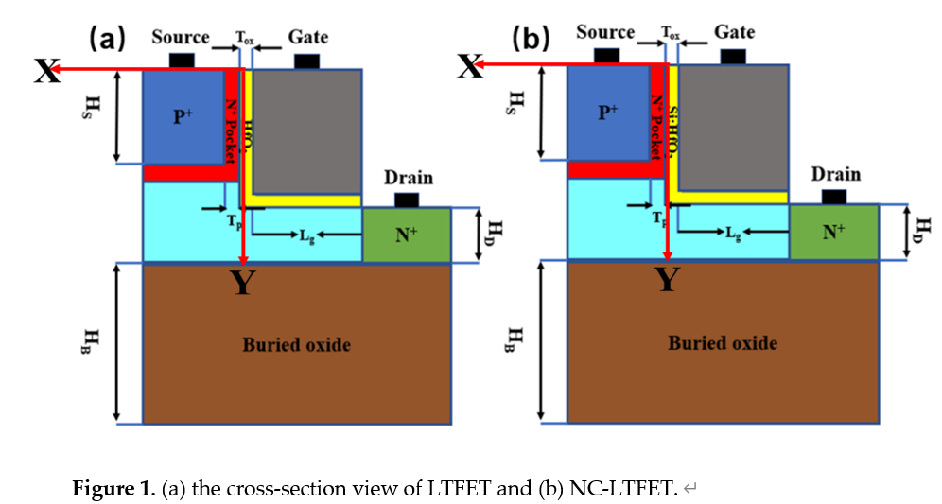

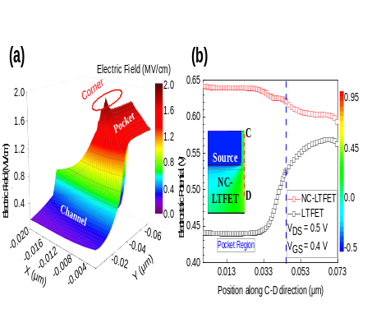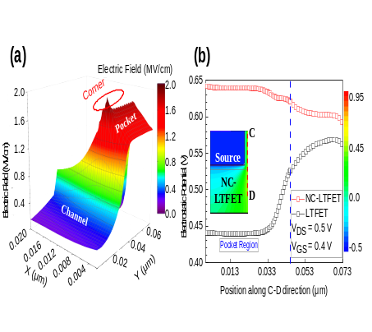
Comment 10： The conclusion of the manuscript should be summarized in the order discussed above, so as to make the manuscript more organized so that readers can see the conclusion more intuitively.
Authors’ Response：
Thank you for your valuable suggestion. The conclusion has been re-write, in order to let readers can see it more intuitively.
Origin:
The electric characteristic of conventional LTFET and NC-LTFET has been analyzed at first. Like the majority of negative capacitance TFET, the change in surface potential can help NC-LTFET have a larger current and a steeper SS. However, contrary to the diagonal tunneling mechanism of LTFET at low gate voltage, the NC-LTFET is turned on by line tunneling at low gate voltage. In addition, we investigate the impact of polarization gradient effect on the performance of NC-LTFET. The results show that NC-LTFET with higher polarization gradient parameter has the smallest line tunneling rate. As the polarization gradient parameter g increases, diagonal tunneling will play an important role at low gate voltage, and the Ion and SS will be further deteriorated.
Revised:
This article proposes an L-shaped gate tunneling field effect transistor with a ferroelectric gate oxide layer. Firstly, the characteristics of traditional LTFET and negative capacitance LTFET are compared and discussed. According to the curves obtained in A-B and C-D directions, it can be seen that NC-LTFET has higher potential in the pocket area and deeper band bending will occur, which can help NC-LTFET have a larger current and a steeper SS. In addition, by studying the relationship between voltage and potential at the corner and near the pocket region, it is found that NC-LTFET has strong voltage amplification effect near pocket region. This leads NC-LTFET turns on at first by line tunneling at low gate voltage. Finally, different polarization gradient parameters are used to study the potential and conduction band energy of NC-LTFET. The experiment shows that the higher the parameter g, the smaller the line tunneling rate will be generated, and the role of diagonal tunneling will be greater, which will further worsen I_{ON} and SS.

