2nd Respond reviewer 2
While some of the specific issues are addressed and clear errors in the manuscript are corrected, I am disappointed by the author's responses to the main points of critique. They choose to either not address the issue, or to avoid it by reproducing previously published work that is beside the point.

My main critiques remain, i.e. (i) that Dicer affects the activity of DsiRNAs was already known, hence their name; (ii) the effect of the loop on silencing efficiency was minimal; and (iii) the claim that the effect of the loop on silencing efficiency is mediated by Dicer is not substantiated by the data.
Thank you again for giving us the chance to consider your manuscript for the Genes Journal, I look forward to your revision. We agree that Dicer affects the activity of DsiRNAs was already known, but Reviewer expressed some concerns regarding the novelty to which we respectfully disagree for the following reasons: As we have mentioned in our Discussion section, line 354-376, to the best of our knowledge, ours is the first report of DsiRNA and tetra-looped DsiRNA efficiency mediated Dicer function – this is unprecedented.
- As far as Dicer knock-out HCT116 cells are concerned, although Dicer helicase mutant HCT116 cells have been used to validate the efficiency of various shRNAs in our previous studies[1]. In previous studies, Dicer helicase mutant HCT116 did not affect the mature short RNA generation of miR-23a, miR-27a, and artificial shRNAs. This has proved to be very difficult because of Dicer helicase mutant HCT116 with defects in the processing of most, but not all, endogenous pre-miRNAs into mature miRNA. Another college group showed that a stem-looped miRNA does not require a Dicer cleavage step during its biogenesis, ex. miR-451a[2,3]. The biogenesis of miR-451 occurs independently of Dicer and instead requires cleavage of the 3’ arm of the pre-miR-451 precursor hairpin by Ago2. This is evidence that not all stem-looped RNAs are affected by their efficiency by Dicer. As the Reviewer pointed out, we have published papers that DsiRNAs are affected by their effectiveness by Dicer. In this manuscript, we have developed the tetra-looped DsiRNAs, which are novel structures, we performed a siRNA efficiency of DsiRNA and tetra-looped DsiRNAs in the Dicer knock-out cell system. To our knowledge, ours is the first report of Dicer mediated tetra-looped DsiRNAs function.

- We have established the siRNA efficiency for both strands. The DsiRNAs are subjected to a dual luciferase gene-silencing assay in parallel. This assay uses different luciferase reporter plasmids to quantify the utilization of the sense or anti-sense strand and to allow a relative comparison of the silencing ability of each strand. The IC50 is determined for the DsiRNAs to compare their gene-silencing potency. ( In following figure X and table X; non-published results). We comfirmed that the IC50 values for DsiRNA II anti-sense strand is more potent conpared with sense strand. The gene silenicng by anti-sense strand of the DsiRNA I is slightly less potent. The design of DsaRNA I and II differed by only a single base pair. There are different strand selection and gene-silencing potency. The RNAse III family member Dicer initiates RNAi by processing double-stranded RNAs into 21 - 23 nt double-stranded RNAs (either miRNAs or siRNAs) generating a two-base 3’-overhang. In association with Dicer, the siRNA products are loaded into RISC such that only one of the original strands is incorporated and used as a guide for the sequence-specific post-transcriptional silencing of cognate genes. The remaining strand, known as the passenger strand, is degraded. Previous studies have demonstrated in mammals that the PAZ domain of Dicer is a single-stranded RNA-binding module that has preference for two-base single-strand overhangs produced by another RNAse III family member Drosha, which processes primary miRNAs into pre-miRNAs [4-6]. The PAZ/PIWI domains of the Ago2 protein serve as anchors to spatially orient the bound RNA substrates in the enzyme active site. Therefore, DsiRNAs with two-nucleotide 3′-overhangs that are favorable for Dicer binding/cleavage and subsequent Ago anchoring is believed to enhance RNAi potency. Our hypothesis is that the inclusion of tetra-loop in stem-loop design of DsiRNAs improves their gene silencing activity. So, we have challenged the strand selectivity of DsiRNAs in HCT116 and H2-2. Not in passenger strands in Figures 6D and E, but the guide-strand of tetra-looped DsiRNA I and DsiRNA II improved their efficiency compared with original DsiRNAs in figures 6C and F. The passenger strand is fastly degraded by the RISC complex on canonical small RNA biogenesis. These results supported that the tetra-looped DsiRNAs increased efficacy for gene silencing.
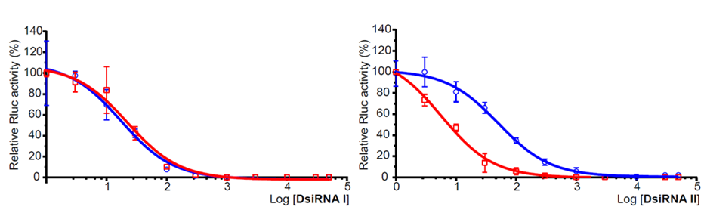
Figure X. Gene-silencing activity of DsiRNAs. Gene silencing is assessed by dual luciferase assay using plasmids that report the DsiRNA activity of the sense (blue) and anti-sense strands for DsiRNA I and DsiRNA II. Assay was performed in HCT116 cells. All data points are normalized to an equimolar amount of non-targeting siRNA. Triplicates, mean ± SD. IC50 values for each strand of each dsiRNAs are included as insets.
Table X. IC50 value in DsiRNA I and DsiRNS II.
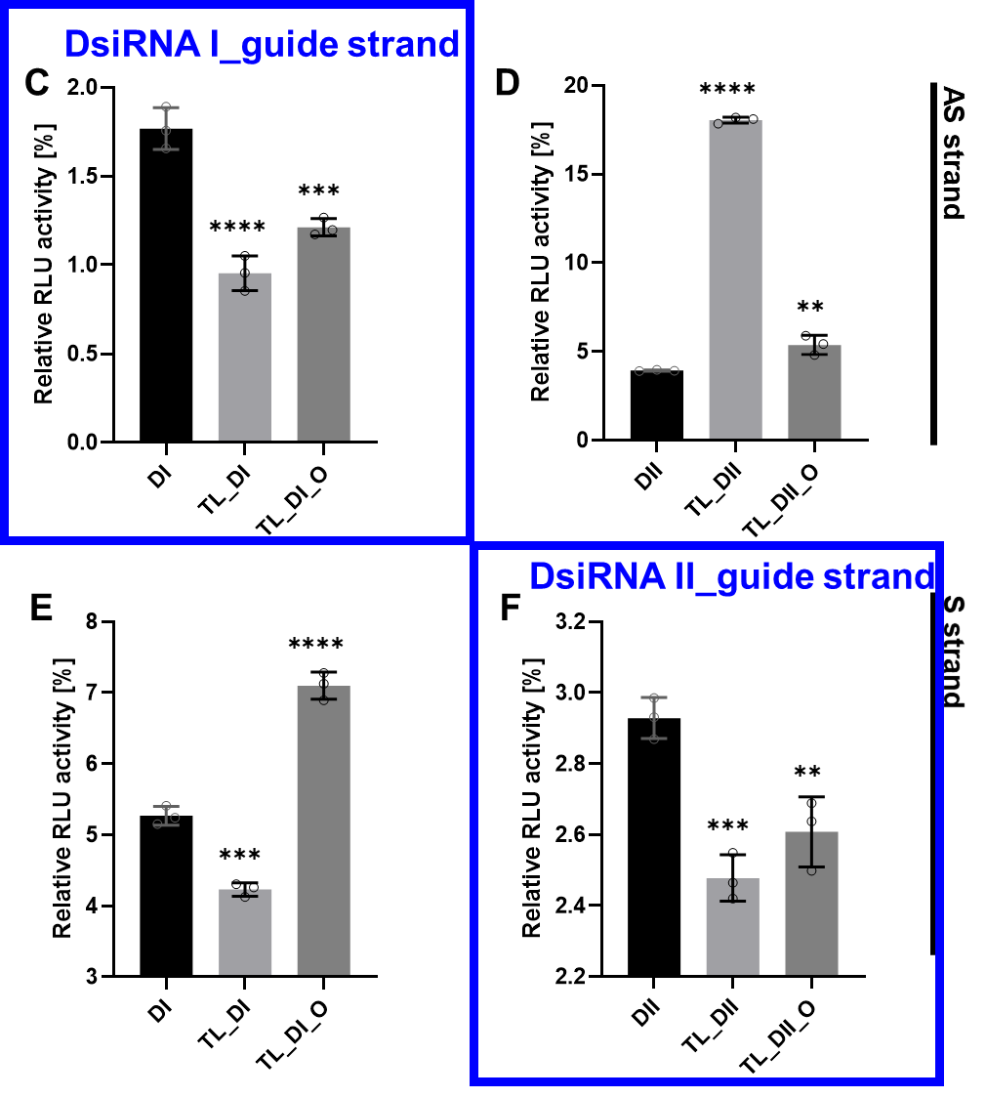
Figure 6 C-F. DsiRNAs efficacy in HCT116
We are hopeful that this amended version is now suitable for publication in the Genes Journal.
Reference
1. Soifer, H.S.; Sano, M.; Sakurai, K.; Chomchan, P.; Saetrom, P.; Sherman, M.A.; Collingwood, M.A.; Behlke, M.A.; Rossi, J.J. A role for the Dicer helicase domain in the processing of thermodynamically unstable hairpin RNAs. Nucleic Acids Res 2008, 36, 6511-6522, doi:10.1093/nar/gkn687.
2. Yoda, M.; Cifuentes, D.; Izumi, N.; Sakaguchi, Y.; Suzuki, T.; Giraldez, A.J.; Tomari, Y. Poly(A)-specific ribonuclease mediates 3'-end trimming of Argonaute2-cleaved precursor microRNAs. Cell reports 2013, 5, 715-726, doi:10.1016/j.celrep.2013.09.029.
3. Cifuentes, D.; Xue, H.; Taylor, D.W.; Patnode, H.; Mishima, Y.; Cheloufi, S.; Ma, E.; Mane, S.; Hannon, G.J.; Lawson, N.D.; et al. A Novel miRNA Processing Pathway Independent of Dicer Requires Argonaute2 Catalytic Activity. 2010, 328, 1694-1698, doi:doi:10.1126/science.1190809.
4. Kim, D.H.; Behlke, M.A.; Rose, S.D.; Chang, M.S.; Choi, S.; Rossi, J.J. Synthetic dsRNA Dicer substrates enhance RNAi potency and efficacy. Nat Biotechnol 2005, 23, 222-226, doi:10.1038/nbt1051.
5. Snead, N.M.; Wu, X.; Li, A.; Cui, Q.; Sakurai, K.; Burnett, J.C.; Rossi, J.J. Molecular basis for improved gene silencing by Dicer substrate interfering RNA compared with other siRNA variants. Nucleic Acids Res 2013, 41, 6209-6221, doi:10.1093/nar/gkt200.
6. Sakurai, K.; Amarzguioui, M.; Kim, D.H.; Alluin, J.; Heale, B.; Song, M.S.; Gatignol, A.; Behlke, M.A.; Rossi, J.J. A role for human Dicer in pre-RISC loading of siRNAs. Nucleic Acids Res 2011, 39, 1510-1525, doi:10.1093/nar/gkq846.

