Article
The role of prolactin and its receptors in diagnostics of benign breast tumors
Olena Kolomiiets ^{1,2}, Oleksandr Yazykov ^{2,3}, Artem Piddubnyi ^{1,4,5}, Mykola Lyndin ¹, Ivan Lukavenko ^{2,3}, Volodymyr Andrushchenko ^{2,3}, Anatolii Romaniuk ¹ , Roman Moskalenko ^{1,5,}*
Citation: Kolomiets, O.;Yazykov, O.; Piddubnyi,A. The role of prolactin and its receptors in diagnostics of benign breast tumors J. Clin. Med. 2021, 10, x. https://doi.org/10.3390/xxxxx
Academic Editor: Firstname Lastname
Received: date
Accepted: date
Published: date
Publisher’s Note: MDPI stays neutral with regard to jurisdictional claims in published maps and institutional affiliations.

Copyright: © 2021 by the authors. Submitted for possible open access publication under the terms and conditions of the Creative Commons Attribution (CC BY) license (https://creativecommons.org/licenses/by/4.0/).
1 – Department of Pathology, Sumy State University, Sumy, Ukraine
2 – Private Clinic “MRIYA”, Sumy, Ukraine
3 – Department of Surgery, Sumy State University, Sumy, Ukraine
4 – Department of Medical biochemistry and biophysics, Umeå University, Umeå, Sweden
5 – Ukrainian-Swedish research center SUMEYA, Sumy State University, Sumy, Ukraine
* Correspondence: r.moskalenko@med.sumdu.edu.ua; +380979802731
Abstract: The role of prolactin (PRL) and its receptors in the initiation and development of benign breast tumors (BBT) has not been sufficiently studied. An imbalance in the system of hormone homeostasis is crucial in the development of BBT.
Our study showed no significant difference between PRL receptors (PRL-R) expression in BBT tissue under normal and elevated serum PRL levels. There was also no significant correlation between age, PRL-R expression in BBT tissue, intact tissue and PRL level in the serum. There was a strong significant correlation (p<0.01; r = 0.92) between PRL-R expression in BBT samples and intact breast tissue which did not depend on the serum PRL level. There was also no significant difference in the expression of the proliferative marker Ki-67 in BBT tissues from women with normal and elevated levels of serum PRL (p> 0.05). No signs of PRL and its receptors were detected in the BBT cystic fluid women with elevated serum PRL levels.
In summary, our prospective study showed that the level of serum PRL had no correlation with the expression of PRL-R in both BBT and physiological breast tissue.
Keywords: prolactin; prolactin receptors; benign breast tumors.

1. Introduction
Development of the breast is related to the regulation of hormones such as estrogen, progesterone, prolactin and growth factors. An imbalance in the system of hormone homeostasis is crucial in the development of its pathology [1, 2]. Recently, scientists have focused on the role of prolactin receptors (PRL-R) and circulating prolactin (PRL) levels in carcinogenesis, prognosis and metastasis of breast cancer (BC) [3].
It was found that secretion of prolactin also occurs outside the pituitary gland, namely by the endometrium, lymphocytes, decidual membrane, breast, prostate. In these organs, PRL acts as a cytokine, binding to PRL-R on the cell surface and cytoplasm, activating the signaling pathways Jak2 / Stat5, Map Kinase [4, 5].
There are physiological and pathological increase of PRL. Physiological causes include: pregnancy, childbirth and the postpartum period. Pathological causes of increased PRL are adenomas, inflammatory conditions, pituitary surgery [6]. Hereditary idiopathic hyperprolactinaemia, which is not associated with pituitary adenoma, has also been reported [7].
A. Alyson et al shown an important role of PRL-R-induced global gene expression for cell proliferation [8]. A. Sutherland et al found that the normal level of PRL in the serum is associated with the risk of BC and an increased incidence of metastasis [9]. Some patients with BC had elevated PRL levels and PRL-R expression, which might be associated with resistance to therapy and bad prognosis [9].
S. J Howell have shown that exogenous prolactin causes proliferation, migration, and invasion of BC cell lines in vitro and that the majority of breast cancer cells express PRL-R. It also increases the clonogenicity of primary human BC cells in soft agar [10]. Excess prolactin has also been shown to increase the frequency and rate of tumor growth in many rodent models of spontaneous and carcinogenic induced breast tumors [10].
S. Gill et al showed no correlation between PRL-R expression and tumor grade score, size or axillary lymph node status, suggesting that the assessment of PRL-R would not be useful as a prognostic factor [11].
C. Manhès et al shows that local over-expression of PRL in developing mammary glands induces dramatic functional and morphological lesions, but is not related to carcinogenesis [12]. But M. Nicol et al concluded that the great majority of patients with operable breast lesions have normal serum levels of PRL. The elevation of serum PRL levels has the same incidence in both groups of patients – with benign and malignant breast tumors [13].
However, the latest studies have controversial results. K.A. O'Leary et al demonstrated that PRL can modulate the incidence and phenotype of breast tumors and by so doing elevates the risk of breast cancer [14]. From other hand, I.Y. Hachim et al showed that PRL has anti-tumorigenic properties in HER-2 positive BC through the induction of ALDH^{hi} stem-like cells differentiation and limits their stem-like aggressive properties [15].
This prospective study was aimed to detect the relationship between the serum PRL level and tissue expression of PRL-R in a consecutive series of patients with BBT.

2. Materials and Methods

The Ethics Committee

The study was approved by the ethics committee of the Medical Institute of Sumy State University (protocol №3 / 02, 09.02.21).

Research design

The study used biological materials (blood serum, tumor tissue and adjacent intact tissue of breast, cystic fluid) from 16 female patients with benign breast tumors (BBT). The mean age of women was 27.9 ± 1.55 years, the age ranged from 19 to 39 years. Surgical interventions and blood sampling were performed at the private clinic "MRIYA" after informed patients consent.

Evaluation of serum PRL level

Blood sample for PRL test were collected in the morning at least two hours after patient awakes to reduce the sleep-induced peak level of PRL. No restriction of food, fluid, and physical activity were required. Patient relaxed at least for 30 min before the sample collection [16]. Venous blood was collected from each patient, centrifuged and stored at freezer. Serum samples were ECLIA tested for PRL with a Cobas immunoassay analyzer system. The threshold level of PRL in serum was considered to be 444.78 mU/L (or 21.18 ng/ml) [16].

Based on the level of serum PRL, 8 patients (group I) with high (more than 444.78 mU/L) and 8 patients (group II) with low (less than 444.78 mU /L) were selected for study. During the study, both tissue samples of intact (subgroup A) and benign breast tumors (BBT) (subgroup B, contain fibroadenomas (FA) and fibrous cystic disease (FCD)) from each person were studied (Fig. 1).

At the same time, 6 fluid samples from cysts taken from patients of group II were examined to detect the presence of PRL and PRL-R (taken in cases of cystic changes). Cystic fluid was collected by ultrasound-guided fine-needle aspiration, centrifuged (13,000 rpm for 5 min) and the supernatant was stored in a freezer.

Fig. 1. Distribution of breast tissue samples.

Histology and immunohistochemistry

Breast tissue was fixed for 24 hours in a 10% solution of neutral buffered formaldehyde, dehydrated and embedded in paraffin. For immunohistochemistry (IHC), sections with a thickness of 4 μm were subjected to standard deparaffinization and dehydration in xylene and ethanol of decreasing concentration. After antigen retrieving in citrate buffer (pH 6.0) at a temperature of 97-98 ° C, indirect IHC was performed:

I stage – incubation with primary antibodies for 30 minutes (t = 37˚C);

II stage – incubation with secondary antibodies (UltraVision ONE HRP Polymer, Thermo Scientific, USA) – 10 min (t = 37˚C). Diaminobenzidine (Thermo Scientific, USA) – 5 min (t = 37˚C). Nuclei were counterstained with Mayer's hematoxylin.

For this study we used antibodies: anti-prolactin receptor mAb (clone B6.2, dilution 1:200, Thermo Scientific, USA), anti-Ki-67 mAb (SP6, dilution 1:600, Thermo Scientific, USA). All photos were captured with a digital visualization system based on a Zeiss Primo Star microscope with a Zeiss Axiocam ERc 5s digital camera and software package “Zen 2.0” (Carl Zeiss, Jena, Germany). Generally, immunohistochemical staining of tissue was performed according to the method, previously described in our works [17]. At least 6 different fields of view were analyzed for each sample. The IHC results were presented as a mean number of PRL-R- and Ki-67-positive cells per field of view (FOV) with a diameter 1 mm.

Western-Blot

The total protein concentration was measured with a ULTROSPEC 2100 Pro uv-visible spectrophotometer (Biochrom US, USA) at the wavelength 280 nm.

All proteins were separated by SDS-PAGE (Tris-HCl 7.5% gels). Cyst content was mixed with 2% β-mercaptoethanol containing 2x loading buffer and pre-heated at 95⁰C for 5 min. Each well was loaded with equal protein amount. SDS-PAGE gels were stained with a Coomassie brilliant blue R-250 stain.

Proteins were blotted to PVDF membrane (Bio-Rad, USA), blocked with 5% skimmed milk solution. Separate membranes were probed with anti-human prolactin mAb (clone PRL02, dilution 1:1000, Invitrogen, USA) and anti-prolactin receptor mAb (clone B6.2, dilution 1:1000, Thermo Scientific, USA) primary antibodies followed by goat-anti-mouse HRP-conjugated secondary antibodies (dilution 1:2000, Thermo Scientific, USA). Membranes were developed with Pierce ECL Western Blotting Substrate (Thermo Scientific, USA). All captures were made with a Kodak Digital Image station 2000R (Eastman Kodak Company, Rochester, NY).

Statistical analysis

The normality of data distribution was checked by Shapiro-Wilk test. Student’s t-test was applied for analysis of data with a normal distribution. Mann-Whitney’s U-test was applied for nonparametric data-sets. The results were considered statistically significant with a probability of more than 95% (p < 0.05). Pearson correlation was used to correlate age, PRL level, PRL-R expression in tumor and intact tissue. Statistical analysis was performed in Microsoft Office Excel 2016 with addon AtteStat (version 12.0.5). All graphs were made with GraphPad Prism 8.0.

3. Results

Macroscopic study of breast tissue

Macroscopically, fibroadenoma (FA) had the form of a rounded node surrounded by a capsule, with clear edges, dense consistency, grayish-white color, sized from 0.5 to 3.5 cm (Fig. 2). Fibrous cystic disease (FCD) in section was whitish in appearance with the presence of fibrous bands that intertwine with each other and with adipose tissue. There were cysts of different size and number, their surface was smooth and had a gray-pink color.

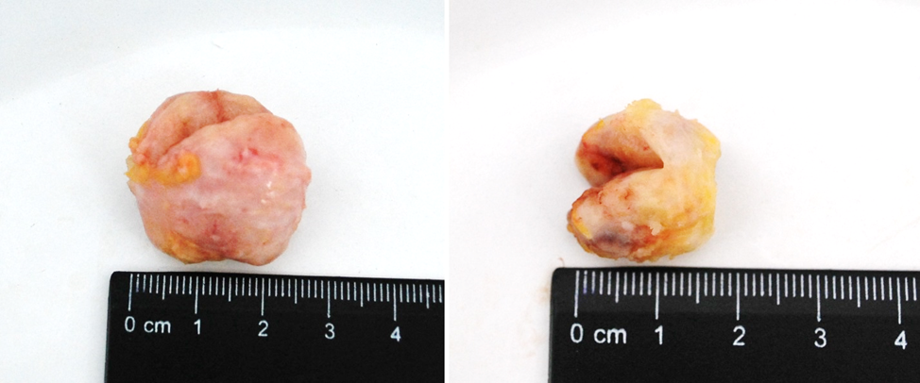

Figure 2. BBT (fibroadenoma) of the breast in section.

Histology and immunohistochemistry

The intact tissue adjacent to the BBT was characterized by the presence of dense fibrous and loose connective tissue around the lobe (Fig. 3A, general background). The epithelium of the lobe had signs of functional activity – in the lumen of individual glands and ducts eosinophilic secretion was revealed. Interlobular and intralobular connective tissue had no significant differences. Ducts had different sizes and unevenly spaced. Duct epithelium had a mature appearance and signs of secretion (Fig. 3A, inset).

PRL-R was expressed with a mixed membrane-cytoplasmic pattern in the glandular and ductal epithelium (Fig. 3B). The level of expression of the proliferation marker Ki-67 was moderate, it was found in some epithelial cells of glands and single fibroblasts (Fig. 3C).

Fibroadenoma tissue (Fig. 3D) consisted of stromal and glandular tissue. The stromal component was represented by fibrous tissue with a reduced number of cells. Glandular structures were partially compressed by connective tissue, had an enlarged lumen and were lined by monomorphic cubic and prismatic epithelium (Fig. 3D, inset). FCD regions had a change in the ratio between the glandular and stromal component, fibrosclerosis, cystic changes in the ducts with areas of simple ductal hyperplasia.

IHC of BBT tissue with antibodies against PRL-R revealed their moderate presence in some cells of the glandular epithelium with fibroadenoma and FCD tissue (Fig. 3E). The number of cells with a positive Ki-67 nuclear staining was insignificant with a prevalence in epithelial cells of the glandular component of BBT (Fig. 3F).

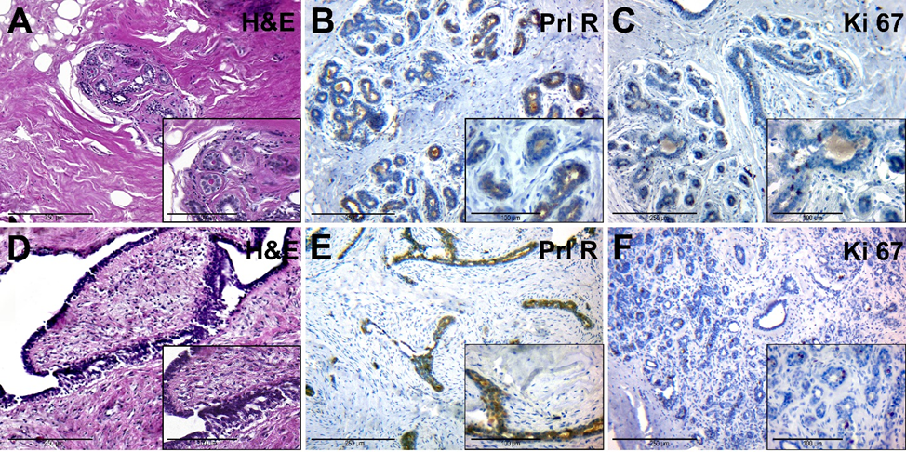
Figure 3. A – C – Intact breast tissue of patients with normal levels of PRL in blood serum (group IA). A – hematoxylin-eosin staining; B – IHC detection of PRL-R expression; C – IHC expression of Ki-67. D–F – BBT tissue (fibroadenoma) of patients with normal levels of PRL in blood serum (group IB). D –hematoxylin and staining; E – IHC detection of PRL-R expression; F – IHC expression of Ki-67. Magnification (including inserts) is indicated in the lower left corner of the image as a marker.

Intact breast tissue of patients from the second group had an increased amount of connective tissue around lobes. The glandular epithelium had dark nuclei and a rich cytoplasm, and there were signs of edema and hyperaemia (Fig. 4A). This tissue had a moderate expression of PRL-R in a glandular epithelium (fig. 4B). The number of Ki-67-positive nuclei in the epithelial cells of the glands was low (Fig. 4C).
Microscopically, FCD was manifested by stromal fibrosis and a reduction of the number of glandular structures, focal lymphocytic infiltration, which was localized near cysts and dilated ducts (Fig. 4D). There were also found cysts, lined with cubic epithelium with a weak light cytoplasm and rounded nuclei. The contents of the cysts were represented by eosinophilic fine-grained or homogeneous secretion.
The IHC of PRL-R revealed their moderate expression in the glandular epithelium and connective tissue (Fig. 4E). The marker Ki-67 was expressed mainly in the nuclei of epithelial cells of glands and ducts. Some areas of increased proliferative activity of the tissue were detected (Fig. 4F).
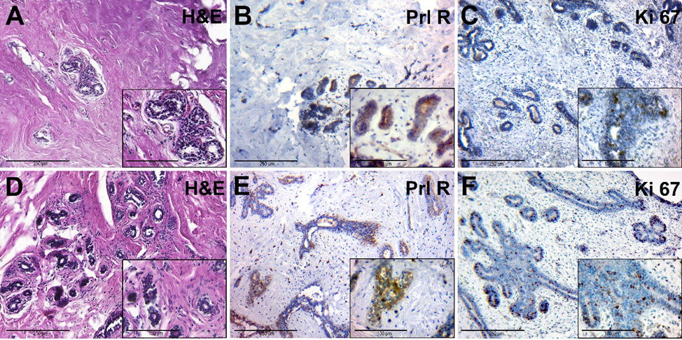
Figure 4. A–C – Intact breast tissue of patients with elevated levels of serum PRL (group IIA). A – hematoxylin-eosin staining; B – IHC detection of PRL-R expression; C – IHC expression of Ki-67. D–F – BBT tissue of patients with elevated levels of serum PRL (group IIB). D – tissue of fibrocystic mastopathy, hematoxylin and staining (group 2B); E – IHC detection of PRL-R expression; F – IHC expression of Ki-67. Magnification (including inserts) is indicated in the lower left corner of the image as a marker.

Statistical analysis
The mean number of PRL-R-positive cells per field of view in group II (39.97 ± 2.1) was higher than in group I (35.56 ± 3.6), but no significant difference between both groups was detected (р>0.05) (Fig. 5A).
We also detected no significant difference in Ki-67 expression in BBT tissues of women with normal and elevated PRL levels – group I showed 16.6 ± 4.63 cells with positively stained nuclei per field of view, in group II – 17.96 ± 2.84 positive cells (p> 0.05) (Fig. 5B). 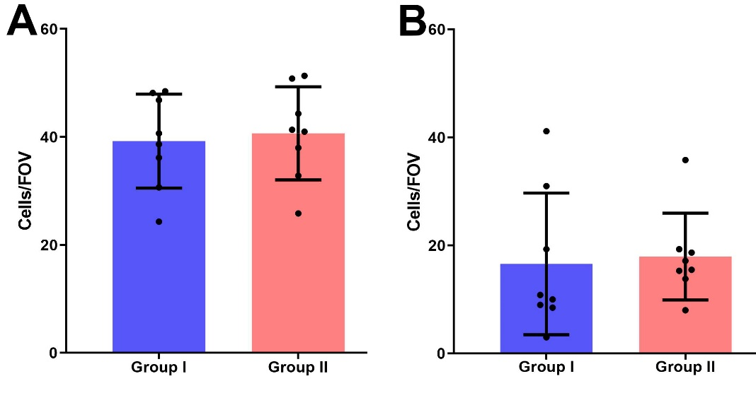
Figure 5. IHC expression of PRL-R (A) and Ki-67 (B) in BBT tissues of I and II groups.

Pearson's correlation analysis did not reveal a significant correlation between age, PRL-R expression in BBT tissue, intact tissue and serum PRL level of patients of both groups (Fig. 6). There was a moderate nonsignificant association (r = 0.31) between the expression of PRL-R in the tissue of BBT and intact breast tissue of patients, as well as a weak relationship (p = 0.29) between the expression of PRL in intact breast tissue and the serum PRL level (for all – p> 0.05).
Correlation analysis in group I revealed a strong positive correlation between the expression of PRL-R in the tissue of BBT and the level of PRL in patients with its non-elevated level (p <0.05; r = 0.8).
In addition, there was a strong positive nonsignificant correlation between the age of patients and the expression of PRL in the tissue of BBT (p> 0.05, r = 0.64), a moderate positive nonsignificant correlation between age and the expression of PRL-R in intact breast tissue and serum PRL (p> 0.05; r = 0.37 and r= 0.33, respectively). In the group of patients with normal PRL levels, there was a nonsignificant weak positive correlation between PRL-R levels in intact tissues and serum PRL levels.
Interesting result showed correlation analysis of data from group II. A strong significant correlation was found (p <0.01; r = 0.92) between PRL-R expression in BBT tissue and intact breast tissue. Analysis of other values of this group did not show strong reliable correlations, but there was a tendency to a negative relationship of moderate strength between age and PRL-R expression in BBT tissue and intact tissue (p = -0.31 and r = -0, 43). There was also a weak positive relationship between PRL-R expression in breast tissues (tumor and intact) and serum PRL levels. Therefore, the younger the patient, the higher was an expression of PRL-R in the tissue of BBT, intact tissue and the level of serum PRL. In general, the results were caused by the age-related physiological changes of prolactin production in women.

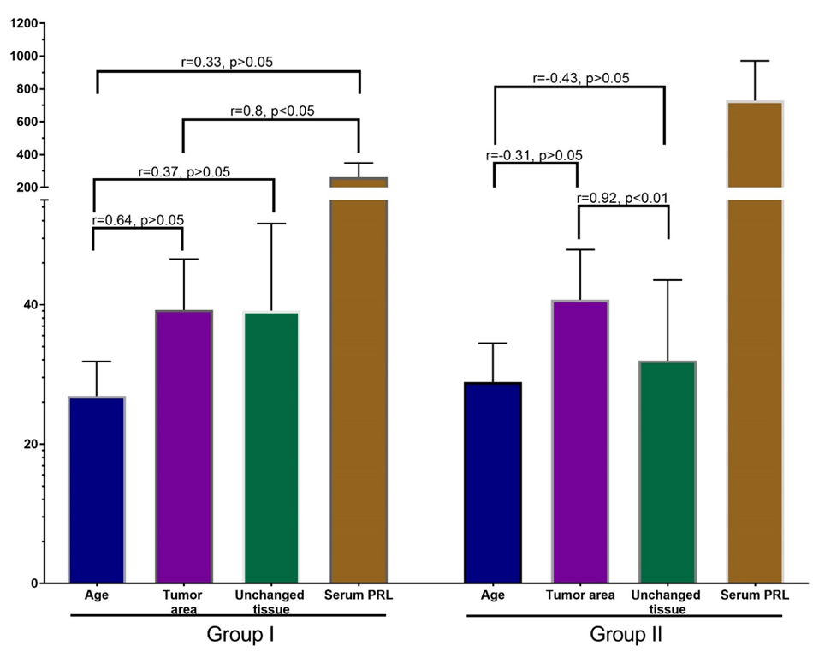
Figure 6. Correlation analysis of patients' age, PRL-R expression in BBT and intact tissue and serum prolactin levels. Values: age – years, PRL-R – IHC-positive cells per field of view, Serum PRL – mU/L.

Western-Blot
The cyst liquid contained 3.5-12.7 mg/ml of proteins. At the SDS-PAGE a similar protein composition was found in a majority of samples. Only one sample consisted predominantly of proteins with a molecular weight approximately 55kDa. Based on that, this sample was excluded from further experiments.
On Western-Blot, we did not reveal the presence of protein of interest (PRL-R and PRL) in all samples (Fig. 7).
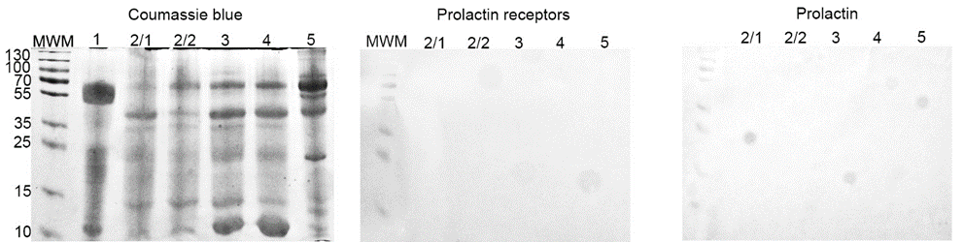
Figure 7. SDS-PAGE and Western-blot of cyst liquid from group IIB. SDS-PAGE gel stained with Coomassie brilliant blue; Western-blot with anti-PRL-R and human PRL mAbs respectively.

4. Discussion

Recent studies don’t provide a clear picture of the PRL role and its receptors in the differentiation, growth and development of breast tumors. [18, 19]. There are a number of studies on the association of PRL and its receptors with malignant and benign breast tumors [19, 20]. On the other hand, in studies by Hachim I et al, it was found that the expression of PRL-R is reduced in invasive BC (21.4%), compared with BBT (80%) and carcinoma in situ (60%) (P=0,003498) [21]. There was also no association between gene polymorphism of PRL-R PRLRI146L and PRLRI176V variants with breast tumor growth and proliferation [22].

Despite the significant amount of information about the role of PRL in the development of oncopathology of the breast, our data didn’t show an obvious connection between this hormone and the expression of its receptors with the development of BBT.

In this study, we compared groups of tissue samples from benign tumors and intact adjacent breast tissues taken from women with normal and elevated serum PRL levels by PRL-R expression level and Ki-67 proliferation marker. To further verify the presence and possible role of PRL and its receptors in the development of BBT, the cyst fluid of BBT from a group of patients with elevated serum PRL levels was examined.

We found no significant difference between the expression of PRL-R in samples of BBT obtained from patients with normal and elevated levels of serum PRL (p> 0.05). Correlation analysis of group II data (with elevated serum PRL) revealed a strong significant correlation (p <0.01; r = 0.92) between PRL-R expression in BBT tissue and intact breast tissue. This result is rather natural, because in patients with elevated serum PRL, the number of its receptors also increases not only in tumors but also in adjacent healthy tissues. This shows the absence of an exclusive effect of PRL on the tissues of BBT in relation to intact tissues.

The association of PRL with breast epithelial proliferation has been proven and it’s beyond doubt [23]. However, the comparison of the expression level of Ki-67 in samples of groups I and II in our study does not show a significant difference between them (p> 0.05) (Fig 6). Therefore, elevated serum PRL levels do not lead to increased epithelial proliferation in BBT tissue.

On Western-blot we did not detect the presence of PRL and PRL-R in cystic fluid from BBT group II (with elevated serum PRL) (Fig. 7). It seems that the increased level of PRL in the serum does not lead to its automatic increase in body fluids. On the other hand, the correlation analysis of the results of group I revealed a strong positive significant relationship between the expression of PRL-R in the tissue of BBT and the normal level of PRL (p <0.05; r = 0.8).

5. Conclusions

Our study shows no significant difference between PRL-R expression values in BBT tissue under normal and elevated serum PRL levels. There is also no significant correlation between age criteria, PRL-R expression in BBT tissue, intact tissue and PRL level in the serum of the studied patients. In women of both study groups, there was a strong significant correlation (p <0.01; r = 0.92) between PRL-R expression in BBT tissue samples and intact breast tissue. There was also no significant difference in the expression level of the proliferative marker Ki-67 between groups of tissue samples of BBT obtained from women with different levels of serum PRL (p> 0.05). No signs of PRL and its receptors were detected in the cystic fluid samples of BBT from women with elevated serum PRL levels.

In summary, our prospective study shows that the expression of PRL-R in BBT and physiological breast tissue do not correlate with the serum PRL level in patients with normal and elevated levels of this hormone.

In the future, it is planned to study the effect of PRL-R expression on the development, prognosis and metastasis of BC.

Author Contributions: Conceptualization R.M., A.R; methodology A.P.; investigation O.K., O.Y., I.L., A.P., resources A.R., V.A., R.M.; data curation O.K.; writing—original draft preparation R.M, O.K., O.Y.; writing—review and editing A.P., R.M., M.L; visualization A.P., O.K., R.M.; supervision A.R., R.M.; project administration A.R., V.A., R.M.; funding acquisition A.R., O.V., R.M. All authors have read and agreed to the published version of the manuscript.
Funding: This research has been performed with the financial support of grants of the Ministry of Education and Science of Ukraine No. 0117U003937 “The development of tumor diagnosis method of reproductive system organs using cellular adhesion molecules of cancer-embryonic antigen” and No. 0118U003570 “The efficiency of “liquid biopsy” and tissue biopsy in the diagnosis and treatment of malignant tumors”, Erasmus+ Project 2017-1-SE01-KA107-034386 between Sumy State University and Umea University.
Institutional Review Board Statement: The study was conducted according to the guidelines of the Declaration of Helsinki, and approved by Ethics Committee of the Medical Institute of Sumy State University (protocol 3/02, 09 February 2021).
Informed Consent Statement: Informed consent was obtained from all subjects involved in the study.
Data Availability Statement: Data available within the article
Conflicts of Interest: The authors declare no conflict of interest.

References
- Holloran SM, Nosirov B, et al. Reciprocal fine-tuning of progesterone and prolactin-regulated gene expression in breast cancer cells. Mol Cell Endocrinol 2020; 511: 110859.
- Dan Zhao, Gui Ma, et al. Zinc Finger Homeodomain Factor Zfhx3 Is Essential for Mammary Lactogenic Differentiation by Maintaining Prolactin Signaling Activity. Biol Chem 2016; 291: 12809-12820.
- Karayazi Atıcı Ö, Govindrajan N, et al. Prolactin: A hormone with diverse functions from mammary gland development to cancer metastasis. Semin Cell Dev Biol 2021; 114: 159-170.
- Edita Aksamitiene, Sirisha Achanta, et al. Prolactin-Stimulated Activation of ERK1/2 Mitogen-Activated Protein Kinases is Controlled by PI3-Kinase/Rac/PAK Signaling Pathway in Breast Cancer Cells. Cell Signal 2011; 23: 1794-1805.
- Grible JM, Zot P, et al. The human intermediate prolactin receptor is a mammary proto-oncogene. NPJ Breast Cancer 2021; 7: 37.
- Sylwia Pałubska, Aneta Adamiak-Godlewska, et al. Hyperprolactinaemia – a problem in patients from the reproductive period to the menopause. Prz Menopauzalny 2017; 16: 1-7.
- Paul J. Newey, Caroline M. Gorvin, et al. Mutant Prolactin Receptor and Familial Hyperprolactinemia. N Engl J Med 2013; 369: 2012-2020.
- Alyson A. Fiorillo, Terry R. Medler, et al. The Prolactin Receptor Transactivation Domain Is Associated with Steroid Hormone Receptor Expression and Malignant Progression of Breast Cancer. Am J Pathol 2013; 182: 217-233.
- Ashley Sutherland, Amanda Forsyth, et al. The Role of Prolactin in Bone Metastasis and Breast Cancer Cell–Mediated Osteoclast Differentiation. Natl Cancer Inst 2016; 108: 338.
- Sacha J Howell, Elizabeth Anderson, et al. Prolactin receptor antagonism reduces the clonogenic capacity of breast cancer cells and potentiates doxorubicin and paclitaxel cytotoxicity. Breast Cancer Res 2008; 10: 68.
- Gill S, Peston D, Vonderhaar BK, Shousha S. Expression of prolactin receptors in normal, benign, and malignant breast tissue: an immunohistological study. J Clin Pathol. 2001 Dec; 54(12):956-60. doi: 10.1136/jcp.54.12.956.
- Nicol M, Willis C, Yiangou C, Sinnett D, Shousha S. Relationship between serum prolactin levels and histology of benign and malignant breast lesions: a detailed study of 153 consecutive cases. Breast J. 2002 Sep-Oct;8(5):281-5. doi: 10.1046/j.1524-4741.2002.08506.x.
- Manhès C, Kayser C, Bertheau P, Kelder B, Kopchick JJ, Kelly PA, Touraine P, Goffin V. Local over-expression of prolactin in differentiating mouse mammary gland induces functional defects and benign lesions, but no carcinoma. J Endocrinol. 2006 Aug;190 (2):271-85. doi: 10.1677/joe.1.06829.
- O'Leary KA, Rugowski DE, et al. Prolactin synergizes with canonical Wnt signals to drive development of ER+ mammary tumors via activation of the Notch pathway. Cancer Lett 2021; 503: 231-239.
- Hachim IY, López-Ozuna VM, Hachim MY, Lebrun JJ, Ali S. Prolactin hormone exerts anti-tumorigenic effects in HER-2 overexpressing breast cancer cells through regulation of stemness. Stem Cell Res. 2019 Oct;40:101538. doi: 10.1016/j.scr.2019.101538.
- Hyznyak O, Mykytiuk M, Gogitidze T. Age norms of the serum prolactin level in blood of healthy volunteers. Problems of endocrine pathology, 2015, 2: 76-84.
- Romaniuk, A., Lyndin, M., Moskalenko, R., Kuzenko, Y., Gladchenko, O., & Lyndina, Y. Pathogenetic mechanisms of heavy metals eff ect on proapoptotic and proliferative potential of breast cancer. Interventional Medicine and Applied Science 2015; 7(2), 63-68. doi:10.1556/1646.7.2015.2.4
- López-Ozuna VM, Hachim IY, et al. Prolactin modulates TNBC aggressive phenotype limiting tumorigenesis. Endocr Relat Cancer 2019; 26: 321-337.
- Shams A, Binothman N, et al. Prolactin receptor-driven combined luminal and epithelial differentiation in breast cancer restricts plasticity, stemness, tumorigenesis and metastasis. Oncogenesis 2021; 10: 10.
- Kavarthapu R, Dufau ML. Essential role of endogenous prolactin and CDK7 in estrogen-induced upregulation of the prolactin receptor in breast cancer cells. Oncotarget 2017; 8: 27353-27363.
- Hachim IY, Hachim MY, et al. Prolactin Receptor Expression is an Independent Favorable Prognostic Marker in Human Breast Cancer. Horm Cancer 2014; 5: 42-50.
- Chakhtoura Z, Laki F, et al. Touraine P. Gain-of-function Prolactin Receptor Variants Are Not Associated With Breast Cancer and Multiple Fibroadenoma Risk. Clin Endocrinol Metab 2016; 101: 4449-4460.
- Chen WY. The many faces of prolactin in breast cancer. Adv Exp Med Biol 2015; 846: 61-81.

