Response to Reviewer 2 Comments

* The serial number of the Figure is the same as that in the revised manuscript; Fig. is the picture appears only in this document; The line number refers to that with “Track Changes” function open.

Point 1: The introduction is very detailed presenting the general area of interest, stating the current knowledge regarding mesh simplification methods, polyhedral structures, optimization strategies based on valid topological relations and plane extraction and outlining the strengths and limitations of previous studies. It also, establishes the originality of the presented research. However, I would suggest to enhance the literature with a reference to meshing techniques exploited by open-source, free and/or commercial photogrammetric and 3D modelling software, like MeshLab which was actually used, Geomagic Studio (Wrap), VisualSFM, AliceVision, AgisoftMetashape etc, after SfM and MVS.

Response 1: Thanks for your good comment. The authors are sorry for missing the important related works. The authors carefully revised the relevant part and add some important related works concerning the meshing techniques (lines 35-37).

Point 2: The authors should illustrate their workflow or specific processing phases with a flow-chart .

Response 2: Thanks for your good comment. To better present the context of the article and the logical relationship of the sections, we redesign the flow chart as shown in Figure 1 and change its explanation (lines 169-173). In addition, we have added a flowchart (Figure 5) to explain section 2.2.

Point 3: Due to the technical scope of the article, the following should be mentioned: i) the set of technological tools used for development/evaluation like programming software and language , as well as ii) the compatible graphics APIs, hardware platform and the minimum CPU/GPU specifications for attaining the optimal performance results.

Response 3: Thanks for your good comment. The comment includes two points, and we will respond to them in sequence.
- The technological tools have been added in lines 556-557.
- We had listed the hardware platform in lines 555-556. Our work was implemented without using high-performance computing technologies such as multi-threading acceleration or GPU acceleration. It’s hard for us to assign the minimum CPU/GPU specifications. We used to run it on an Intel(R) Core (TM) i5-2500k CPU with 16GB RAM. We don't think our algorithm has particular limitations on hardware.

Point 4: Consider to mention some (or all) of these aspects: i) potential supported file formats (.obj, .ply, .gltf, .dae, .fbx etc), ii) precision of storing the final mesh data and iii) size (MB) of the final 3D models based on the naively stored position and normals (index/vertex buffers for normals)

Response 4: Thanks for your good comment. The comment includes three points, and we will respond to them in sequence.
- We have added relevant descriptions according to your suggestion (lines 517-519). Our project currently supports three types of file formats (.obj, .off, .ply). It will no doubt support more file types in the future, such as .gltf and .dae.
- We had been hesitant to add precision to the description, but the experimental results were not satisfactory. Your suggestion points this out, and we want to clarify here why we are doing this. Hausdorff distance is generally used to evaluate the accuracy of mesh simplification. Many scholars use the distance between the sample point of the simplified model and the original model to evaluate the accuracy. This method cannot reflect the degree of detail loss of the simplified model. Therefore, our work uses the Hausdorff distance from the original model sampling point to the simplified model to reflect the important structure retention capability of the method presented in this paper as shown in Figure 13 (original Figure 12). The distance from the vertexes of the simplified model to the original mesh is more suitable for expressing the precision of the result. However, as Fig.1 shows, the calculated results are not very good. The RMS values of different models vary greatly, and comparison with the SABMP method is not always advantageous. Our analysis suggests that this result is mainly influenced by the number of vertices and the quality of the original data. Since the simplified result is a polyhedron model, the model consists of a small number of vertices with strong structural information. A smaller number of vertices in this case can avoid some of the effects of lower quality on accuracy. Model (e) also shows this effect where the result of SABMP (82 vertices) has a lower RMS value while in our result we use more vertices to get a more detailed model and higher RMS value. Another phenomenon is that more unstructured-aware vertices mean a lower RMS value. When we subdivide model (b) into 6284 faces and 3186 vertices, the RMS value drops to 0.43. In the case that we have not found a more appropriate precision evaluation method, we choose not to add relevant descriptions temporarily.
- We have added relevant descriptions according to your suggestion (lines 517-519). We have previously shown a comparison of the face amounts after mesh simplification in Table 1. We think it would be easy to infer the size of other model files from the combination of these two data, so we don't list them all. Thank you again for your instruction.
Model | (a) | (b) | (c) | (d) | (e) | (g)
SABMP | 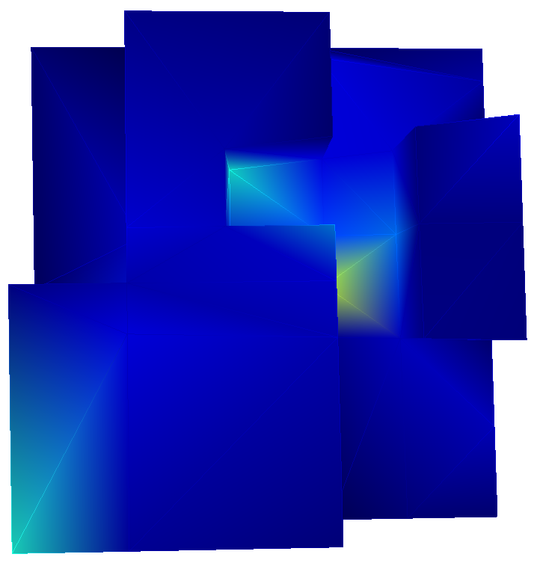 | 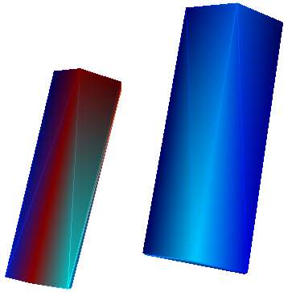 | 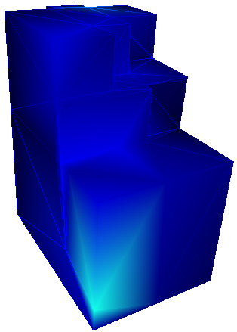 | 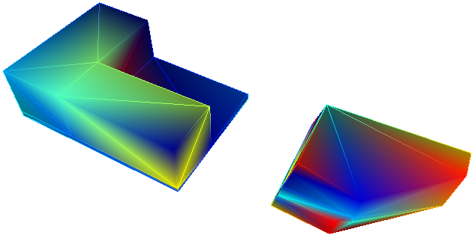 | 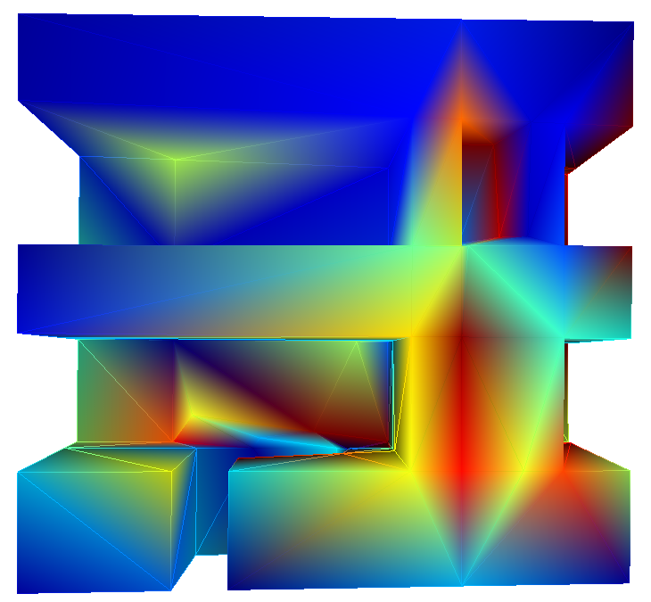 | 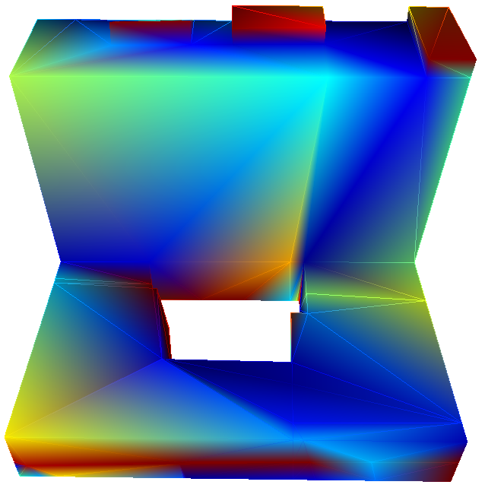
RMS | 0.30 | 0.83 | 0.11 | 0.56 | 2.07 | 1.61
Ours | 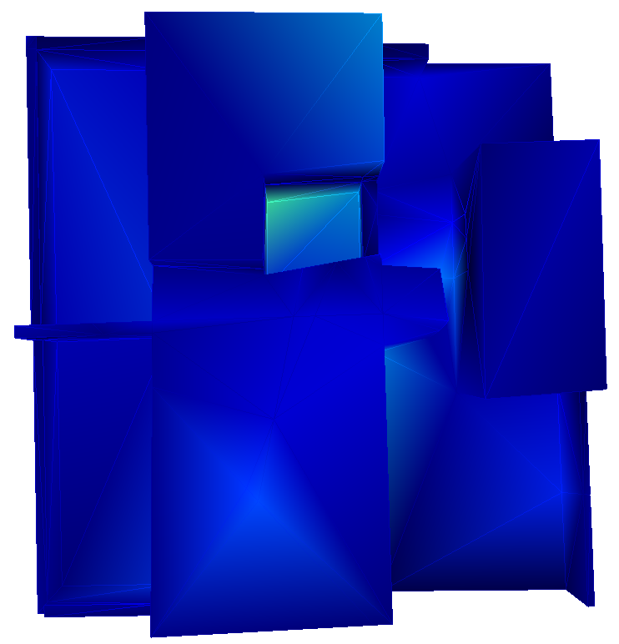 | 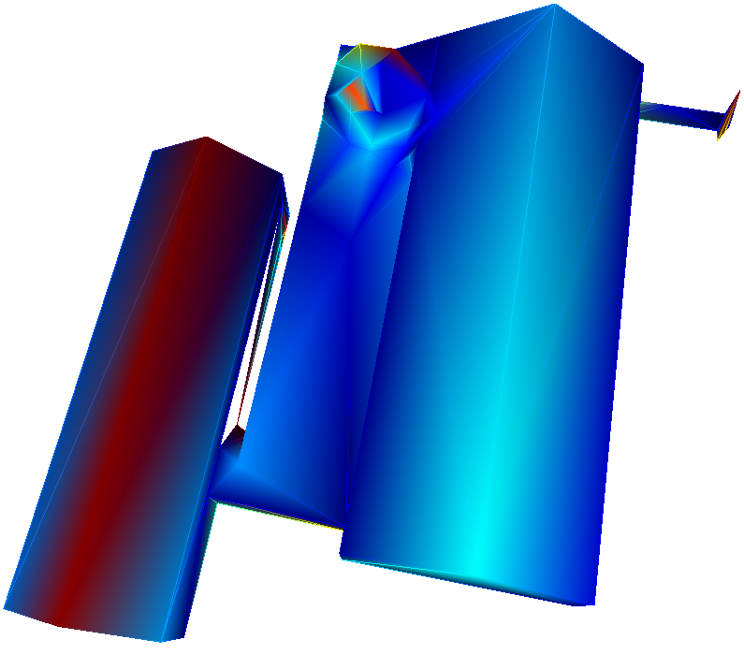 | 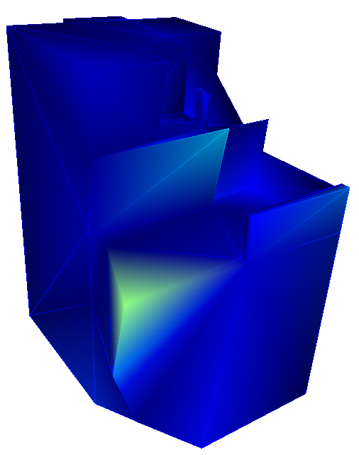 | 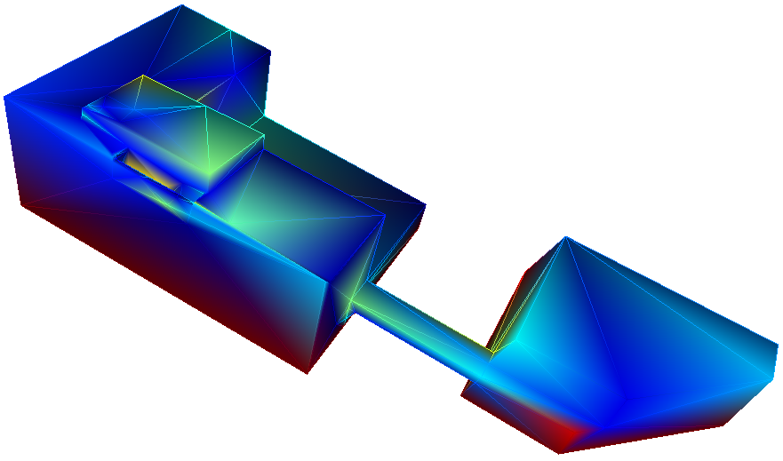 | 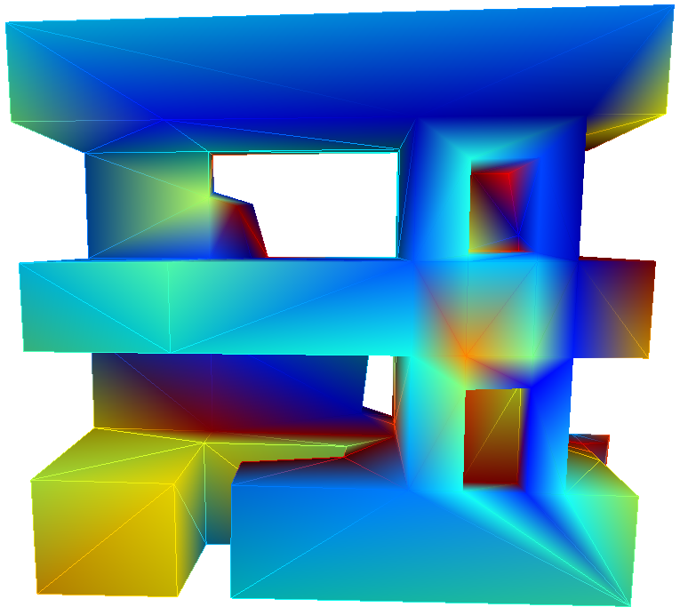 | 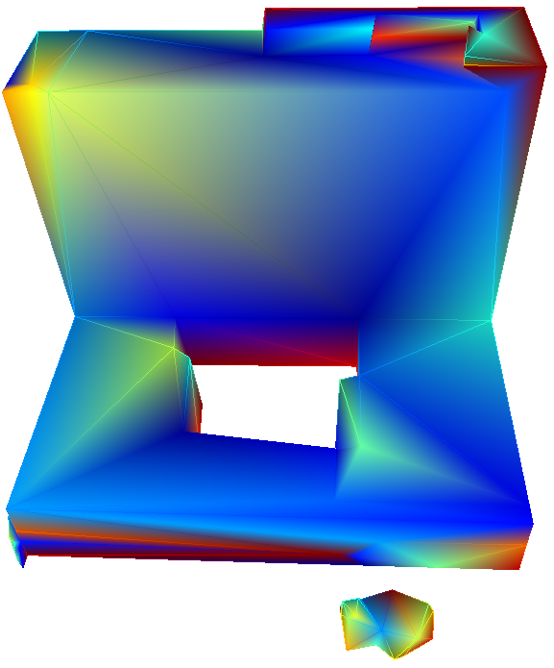
RMS | 0.10 | 0.65 | 0.13 | 0.70 | 1.37 | 1.00
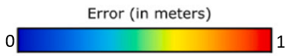
Fig. 1. The comparison between the distance from the output mesh to the original mesh.

Point 5: line 220. Consider splitting the long sentence into two sentences.

Response 5: Thanks for your good comment. The authors have carefully revised the long sentence and split it into two sentences (present line 262).

Point 6: line 307. Please rephrase: ‘Since the regional growth is realized according to…”

Response 6: Thanks for your good comment. The authors are sorry for the mistakes. We have carefully revised the relevant part and replaced it with the word performed in line 353.

Point 7: line 402: Reduce the figure caption and/or include these details on the main body.

Response 7: Thanks for your good comment. The authors are sorry for the inappropriate writing. We've rearranged some of it to the lines 439-442.

Point 8: line 547. Consider omitting ‘boring’

Response 8: Thanks for your good comment. The authors are sorry for the inappropriate description. We’ve deleted this word in line 605.

Point 9: line 595: Please specify the source of data/technology (image-based , laser scanning, LiDAR etc.) for the generation of your 3D models

Response 9: Thanks for your good comment. The authors are sorry for the missing information. We’ve added the introduction about the data source (line 655).

