Comments and Suggestions for Authors

The authors developed a network-based algorithm for diseases gene prediction by considering two perspectives, the cold and the warm genes for disease gene prediction.

In section 3.1, where RWR also outperforms MOSES, can the authors give a possible explanation why this could be the case for the datasets this occurs for especially because MOSES considers two opposing sets of genes for its prediction? As a follow-up from above, is using this two gene perspective for prediction only significant for some diseases? Which ones and what are the general characteristics? Basically, is there a pattern?
We really thank the Reviewer for the overall positive judgment on our study and for offering points for reflection in trying to understand the suitability of one method over another.
Our hypothesis is that MOSES is less affected by the incompleteness of both interactome and disease-gene associations as it is based on the integration of interactome topology and functional features. In particular, these two aspects of incompleteness affect the topology of the disease module and, indeed, it can result extremely sparse, for example with a high number of isolated disease genes. Many network-based disease gene prediction algorithms focus on or start moving from the neighbourhood of the disease genes and thus they can suffer from the sparsity of the disease module. Instead, it is worth noting that MOSES exploits the interactome topology also in term of farness from what is most likely involved in the disease under examination by means of the definition of the cold seeds.
To test our hypothesis, we tried to identify a possible relation between the sparsity/connectiveness of the original disease module (i.e. the disease module composed of warm seeds only) and the difference between MOSES and RWR performances. In particular, we defined a measure of the sparsity/connectiveness of the original disease module computing the following index S:
$$S=\frac{\left|{LCC}_{WS}\right| }{\#WSs }$$
where $\left|{LCC}_{WS}\right|$ is the size of the largest connected component (LCC) consisting of warm seeds only and #WSs is the number of warm seeds.
We explored the existence of a relation between the index S and the difference between MOSES and RWR performances (shown in the figure 4 of the manuscript). The scatterplot in Fig.A seems to suggest that RWR outperforms MOSES when the original disease module is connected “enough”. More precisely, when few warm seeds are connected (e.g for S<0.15) the performances of the two algorithms are similar. In particular, the dot in the top-left of the scatterplot (highest value of S) represents blood coagulation disorders, disease for which RWR obtained the best performances in all the cross-validation iterations. On the other hand, the dot in the bottom-right (S=0.1778, PerfDiff = 0.415) of the scatterplot represents lysosomal storage diseases, case for which MOSES outperforms RWR in all the cross-validation iterations.

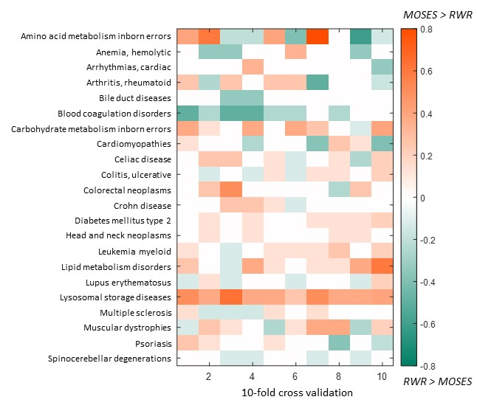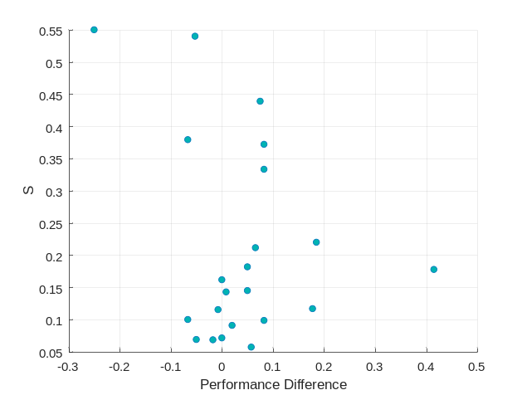
Figure A. Left panel: Figure 4 of the manuscript. Right panel: scatterplot of S (measure of the sparsity of the disease module) against the difference between MOSES and RWR performances (for this index we considered the average across the cross-validation iterations).

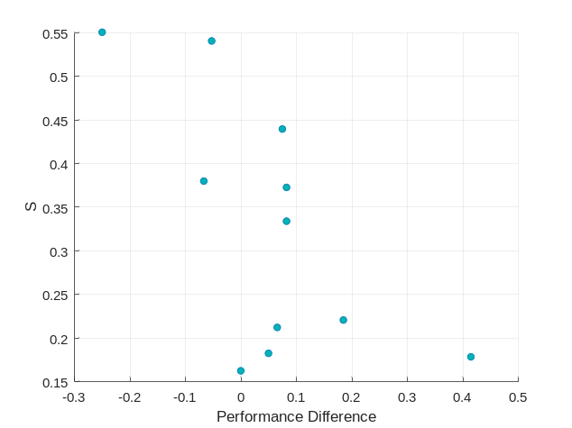
Figure B. Scatterplot of S (measure of the sparsity of the disease module) against the difference between MOSES and RWR performances (for this index we considered the average across the cross-validation iterations) focusing only on diseases for which S≥0.15. Pearson Correlation Coefficient R=-0.6437.

Can the authors make the source code for the MOSES algorithm open source?
Yes of course. We already planned to make the source code open source, now it is available in the repository: https://github.com/ManuelaPetti/MOSES.git

Also, the data preprocessing method is not described. This should be added to the improved manuscript
We thank the Reviewer for this comment. For the sake of clarity, we added in the manuscript the new section 4.Data and preprocessing where we describe the criteria of diseases selection and the preprocessing of functional features.

