Response to Reviewer 1 Comments

Reviewer 1

The aim of the research was to compare the foaming and structural properties of table egg white protein being hydrolyzed by lipase and phospholipase A2. The number of eggs must be clearly stated in the Abstract and Materials and Methods chapters. The test methods used are correct. The chapter "Introduction" requires some additions. The discussion is well carried out and exhausting. References well chosen but must be revision according to instructions for authors. The paper requires additions and corrections. The list of proposed changes is given below:

We thank the referee for positively evaluating the manuscript. We have considered all the comments and excellent inputs provided by the reviewer, and have revised our manuscript accordingly.

General comments:

Point 1: For affiliates, the first name and surname initials for each co-author (also Yue-Meng Wang and Yan-Jun Yang) of the article should be provided, the same as given in the "Author Contributions" chapter.

Response 1: We thank the referee for pointing this out. We have provided the first name and surname initials for each co-author in the affiliates and “author contributions” given in the revised manuscript.

Point 2: Missing chapters "Author Contributions", "Funding" Data Availability Statement, “Conflicts of Interest” must be added.

Response 2: We thank the referee for pointing this out. We have added chapters “author contributions”, “funding” and “conflicts of interest” at the end of the revised manuscript.

Point 3: The references chapter must be prepared in accordance with the instructions: abbreviated name journal in italic, publication year in bold, volumen number in italic.

Response 3: We thank the referee for pointing this out. We have revised the reference list and all the journal names/ volume numbers are now in italic and publication years are in bold in the revised manuscript.

Detailed comments:

Point 4: L34 Please add something about the use of egg white in the cheese industry (ripened cheese), meat industry, wine and beer production, oil industry. How is the production of egg products (liquid egg, white powder, yolk powder, egg powder) in China.

Response 4: We thank the referee for this comment and understand the concern of the referee. Lines 34-38 in the revised manuscript now read as “Therefore, these two indexes (foamability and foam stability) are key standards for determining the quality of foamed products. Apart from that, egg white is also popular in other industries, including cheese, meat, wine, beer and oil for other properties. Egg products (liquid egg, white powder, yolk powder and egg powder) were quite popular in China, thus meaningful for investing.”

Point 5: L37 please add information about other functional properties of egg white: apart from creating and stabilizing foam, these include: gelling, coagulating, keeping water. Egg white also has antioxidant properties

Response 5: We agree with the referee and have added a sentence in Lines 41-42, which read as “Egg white has a lot of functional properties, including gelling, coagulating, keeping water and antioxidant properties.”.

Point 6: L46 + what is the effect of disinfecting table eggs on the freshness and quality of the liquid egg content. What is the effect of egg storage length and temperature on egg foaming capacity? The importance of de-saccharification of egg white in the production of egg products on foaming of egg white

Response 6: We thank the referee for this comment since it will be interesting to research on the freshness and quality of liquid eggs. But in this article, we mainly focus on the foaming properties of EWP (egg white protein), the reduction of foaming properties of EWP when contaminated by egg yolk, and the positive effects after hydrolysis, instead of the freshness and storage length of eggs. For this reason, we would like to thank the referee for this valuable idea and consider to do something in our further work.

Point 7: L70 "Fresh hen eggs" is when from laying eggs? 2-3 days or 2-3 weeks. On the packages was the use-by dates.

Response 7: We fully agree with the reviewer to add explanation for the “fresh hen eggs” and have added in Line 75 as “Fresh hen eggs (less than 5 days after laying)”.

Point 8: L70 when done post-purchase research how eggs were stored pending testing

Response 8: We thank the referee for this comment. In 2.1, only materials were referred in this section and we have introduced that the freshly purchased eggs would be broken to extract the egg white from the yolk in chapter 2.2.1 “preparation of egg white protein dispersion”. In order to be clearer, we have added the words “immediately when arrived in the lab”, as stated in Lines 88-90 as “Egg white was manually extracted from the yolk of freshly purchased eggs immedi-ately when arrived in the lab and then homogenized under magnetic stirring (500 rpm speed) for 2 h, as reported previously [6]”.

Point 9: L170 [16,17] instead of [17,16]

Response 9: We thank the referee for pointing this out. We have changed [17,16] to [16,17] in Line 177.

Point 10: L184 “Particle” with capital letter

Response 10: We thank the referee for noticing this mistake and have revised this to “Particle” in the revised manuscript in Line 191.

Point 11: Figure 2 - larger size, one on one level, larger font for legend

Response 11: We thank the referee for this comment and we have taken Figure 2 to a larger size in the revised manuscript, just as showing bellow:

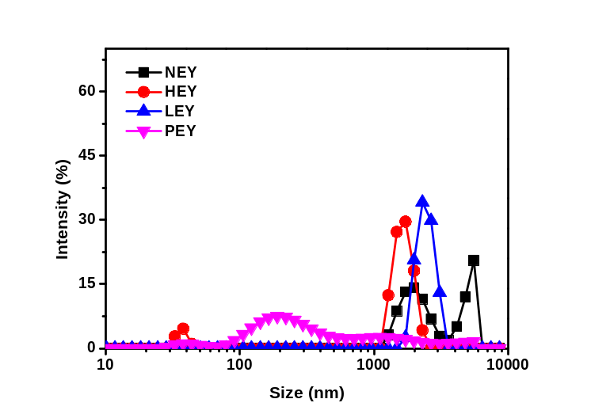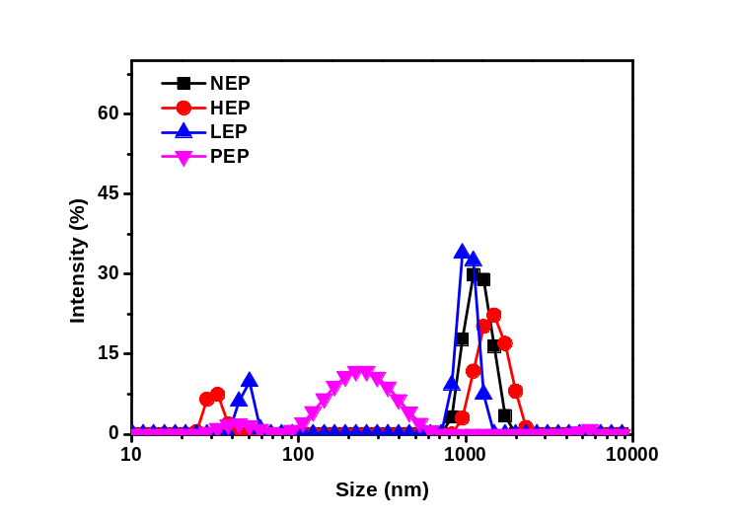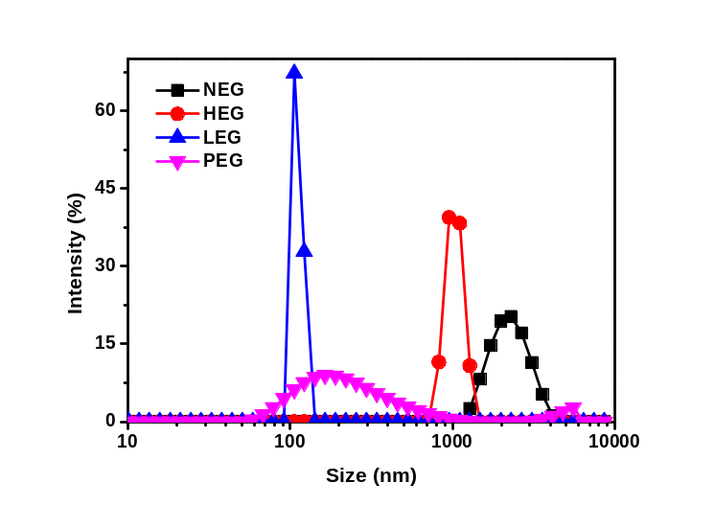
b
a
c

Point 12: Conclusions should refer to the title of the article and the purpose of the research, Lack information about foaming properties of egg white?

Response 12: We thank the referee for this nice comment and have rephrased the conclusions in the revised manuscript. Lines 341 to 343 now read as “EWP was taken as a standard. Our findings seem to validate the fact that both lipase and phospholipase A2 could increase the foaming properties of yolk fractions, even higher than EWP itself when combined with EWP.”.

Point 13: References as instructed, no [J], no double spaces, but with abbreviated name journal in italic, publication year in bold, volume number in italic.

Response 13: We thank the referee for pointing this out. We have revised the reference list thoroughly in the revised manuscript.

