Dear Ms. Timar Monica:
Thank you for conducting the review processing on the manuscript entitled “Evaluation of the J-OFURO3 sea surface net radiation and inconsistency correction” (ID：remotesensing-1193513). All comments and suggestions are helpful to improve the quality of this manuscript. All comments have been studied carefully and this manuscript has been revised thoroughly according to these comments, including the following three major revisions:
(1) All text and figures related to the inconsistency correction method description in the “result” section in the original manuscript has been moved into the “Methodology” section (according to the suggestion from reviewer3).
(2) According to the suggestion made by reviewer??, the spatio-temporal analysis results made by MK test (Fig.14 in the original manuscript) were replaced with the results calculated by the linear regression method (Fig.14), which were very similar to the one from MK test and could provide more numerical information on trends.
(3) The measuring index “RMSE” was replaced with “RMSD (root-mean-squre difference)” to emphasize the difference between the J-OFURO3 and in situ sea surface R_{n}, which cannot be measured at sea surface directly. And all related text, figures were revised accordingly.
We responded to all comments made by all reviewers one by one and highlighted and annotated in the revised manuscript. For clarify, all responses are in red.
Best

Hongkai Chen and Bo Jiang, on behalf of all authors

Reviewer #1
Summary (Reviewer #1):
The paper “Evaluation of the J-OFURO3 sea surface net radiation and in-2 consistency correction” access the sea surface net radiation product whit observation of 55 moored buoy from 1988-2013 at both daily and monthly scales. An inconsistency in the J-OFURO3 sea surface net radiation was found and corrected. Finally, a spatiotemporal trend analysis based on corrected J-OFURO3 was carried out.
The draft is in general well. The information is relevant for evaluate the energy balance of the Earth system. The organization of the manuscript is correct; however minor comments are highlighted in the manuscript.
Response: We thank the reviewer for providing the useful comments, and we revised according to these comments one by one:
1) We revised line 112 as ‘Rn value was obtained according to Eq. (1) –(3).’
2) The title of Figure 5 is revised according to same order of the legend.
3) The flow chart (Fig. 8 in the original manuscript) has been revised according to the advice (Fig.2 in this revised manuscript).
4) The ‘X’ and ‘Y’ in Eq. (4) are all the daily radiation components. Revised in line 112.
5) The extra word 'were' in line 265 has been deleted.
6) The sentences in lines 285-286 have been revised as ‘the increased sea surface ${\text{R}}_{\text{n}}$ in this region was possibly caused by the increased ${\text{R}}_{\text{ns}}$, which were resulted from the decreased cloud amounts and the enhanced aerosol distributions or reduced water vapor droplet size’.

Reviewer #2
Summary (Reviewer #2):
Review of "Evaluation of the J-OFURO3 sea surface net radiation and inconsistency correction" by Chen et al.
This paper evaluates the sea surface net radiation product from the satellite-based Japanese Ocean Flux Data Sets with Use of Remote Sensing Observations, version 3 (J-OFURO3). The product was evaluated by using 55 global buoy sites. The overall daily and monthly accuracy was satisfactory. In addition, a correction method was developed and conducted in the long-term variations. This correction had a beneficial impact on the daily product.
The paper is clear and reasonably well written, and the methodology and evaluation are rigorous. The weakness of the model has been identified, analyzed and a correction is proposed. I recommend a minor revision to address the following comments:
Response: Thank you for your positive and constructive comments. We have responded to all comments.
Specific comments
- L96-97: I suggest giving a couple of examples of those "other studies".
Response: Thanks for your comment. We have given a couple of references (see below) on “other studies” and highlighted in line 97:
[17] Cheng, J.; Cheng, X.; Meng, X.; Zhou, G. A Monte Carlo Emissivity Model for Wind-Roughened Sea Surface. Sensors (Basel) 2019, 19, doi:10.3390/s19092166.
[18] Hogikyan, A.; Cronin, M.F.; Zhang, D.; Kato, S. Uncertainty in Net Surface Heat Flux due to Differences in Commonly Used Albedo Products. Journal of Climate 2020, 33, 303-315, doi:10.1175/jcli-d-18-0448.1.
- L167: Do Jiang et al. arrive to the same conclusion based on the same scores? Please be more precise here.
Response: Thanks for your comment. Actually, we and Dr. Jiang were in one group, so we shared the same data. Jiang et al. [2021] also validated the J-OFURO3 sea surface ${\text{R}}_{\text{n}}$ with RMSD of 24.712 Wm⁻², which were similar to the one obtained in our work. The sentence has been added in lines185-186 as “ …which were similar to the results obtained by Jiang et al.[36] with RMSD of 24.712 Wm⁻²”.
- L292. The sentence is incomplete.
Response: Sorry for the careless. The sentence is revised as ‘ …which were resulted from the decreased cloud amounts and the enhanced aerosol distributions or reduced water vapor droplet size.’ in lines 286-287 (highlighted and annotated).
- L295-297: This explanation is not clear. I think the reason why Rn is decreased is partially because the enhancement of the reflected shortwave radiation.
Response: Thank you for the comment. According to the study by Brown [2014], the explanations were revised as: “The decreased sea surface ${\text{R}}_{\text{n}}$ would enhance the sea surface cooling and then enhance TOA albedo, therefore further enhancing the reflected shortwave radiation and reducing the net downward energy flux radiation.… “in lines 290-293 (highlighted and annotated).
- L303-307: Check and rewrite these sentences. It is confusing.
Response: We are very sorry for the confusing. The sentence has been revised as’’ … the sea surface ${\text{R}}_{\text{n}}$ over the tropical Indian Ocean has shown a rise trend in the recent decade because of the increased SST in this region caused by the anomalous cyclonic circulations on either side of equator and anomalous easterlies along the tropical Pacific Ocean resulted from the weakened relation between the Indian Ocean and the Pacific Ocean…’in lines 298-302 (highlighted and annotated).
- The figures appear to have poor resolution. Please check that the figures have the sufficiently high resolution (minimum 1000 pixels width/height, or a resolution of 300 dpi or higher).
Response: All the figures have been enhanced with a resolution higher than 300 dpi. Thank you.
Minor comments
- L101: Use superscript for the units of radiation (Wm-2).
Response: Revised in line 101. Thank you.
- Figure 1: Use the 90oN and 90oS limits in the Y-axis.
Response: Revised in Figure 1. Thanks.
- L141-142: Write the meaning of R2 in the same way as it was done for RMSE.
Response: Revised as “…coefficient of determination (R²)” in line 141. Thank you.
- Figure 2: Use subscript for the sea surface net radiation (Rn).
Response: Revised in Fig. 3. Thanks.
- Figure 4a and 4b. Same as Figure 1.
Response: Revised (Figure 5a-b in the revised manuscript). Thanks.
- L185. "black line" instead of "black dotted line"
Response: Revised in line 204. Thanks.
- Figure 7, 10, 11. Please use subscripts for Rns, Rli, and Rn.
Response: Revised(Figure 8, 10 and 11 in the revised manuscript).
- L287. "ERA5" instead of "EAR5".
Response: Sorry for the mistake, revised in line 273.
- Figure 14/1. The color for the significant decrease does not match the color in the map.
Response:. Sorry for the careless. However, the spatio-temporal analysis results shown in Fig. 14 have been replaced with the results from linear regression analysis according to the comments from reviewer 3. The two results were very similar, and the one from the linear regression method could provide more numerical information.
- Figure 14/2. I think the authors meant "Non-significant decrease" instead of "Nonsignificant increase".
Response: See the reponse to Point 15. Thanks.
- L332. "J-OFURO3" instead of "J-OFUOR3".
Response: Revised. Thanks.

PART 3: Response to Reviewer #3
Summary (Reviewer #3):

Dear Authors,

The manuscript titled 'Evaluation of the J-OFURO3 sea surface net radiation and inconsistency correction' has interesting work but minor changes are required.
Response: Thank you for your providing positive comments.
Major:
- Please explain more about the procedure in the 'Methodology' chapter instead of explaining it in results.
Response: Thanks for the suggestion. The text related to the inconsistency correction method description and the flowchart figure have been moved into the “Methodology” section in lines 138 (highlighted and annotated).
- Discuss more about the results in results itself under the chapter 'results and discussions' instead of doing it in conclusions.
Response: By considering the few contents needed to be discussed, we revised the title of the last section as “Conclusions” and moved some discussions into Section 3.2.2 instead of doing it.
- Make conclusions shorter by giving only the crispy points of your study.
Response: The key points were shortened and revised in lines 315-326.
- Please also use confusion matrix for evaluation. If not possible, explain why?
Response: Thanks for the suggestion. However, only one product (J-OFURO3) was evaluated in this study, hence, the three commonly used measuring indexes (R², RMSD, and bias) were enough.
- please compare three figures (14a, 14b & 14c) with numerical instead of just giving the explanation.
Response: Thank you for the suggestion. The results by the MK method and the linear regression method were both shown as below. It was seen that the two tempo-spatial analysis results were similar. By considering more specific numeric information about the trends variation could be provided from the one by the linear regression method, the results by the MK test in Fig.14 were replaced with the one from the linear regression method, and original manuscript “Specifically, based on the results obtained from the corrected J-OFURO3 and EAR5, the sea surface ${\text{R}}_{\text{n}}$ has an increasing trend over most regions of the western and central tropical Pacific” in lines 286-287 revised as “ Specifically, based on the results obtained from the corrected J-OFURO3, the sea surface ${\text{R}}_{\text{n}}$ increased at a mean rate of 0.257 Wm⁻² over most regions of the western and central tropical Pacific” in lines 282-284, and original manuscript “It was also seen that the sea surface ${\text{R}}_{\text{n}}$ over the eastern tropical Pacific mostly showed a decreasing trend” in lines 292-293 revised as “ It was also seen that the sea surface ${\text{R}}_{\text{n}}$ over the eastern tropical Pacific mostly decreased at a mean rate of 0.316 Wm⁻² per year,” in lines 287-289, and original manuscript “where J-OFURO3 sea surface ${\text{R}}_{\text{n}}$ variations trend changed from decrease to increase after correction and similar to ERA5.” in lines 299-300 revised as “ where the mean trend in the J-OFURO3 sea surface ${\text{R}}_{\text{n}}$ changed from decreasing at a rate of 0.395 Wm⁻² per year to increasing at a rate of 0.288 Wm⁻² per year after correction and this was similar to ERA5 and more reasonable.” in lines 295-297.
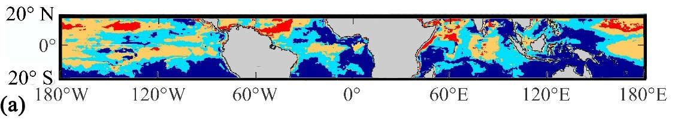
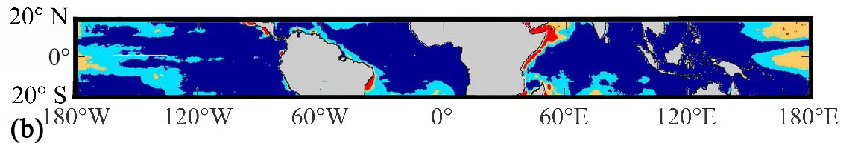
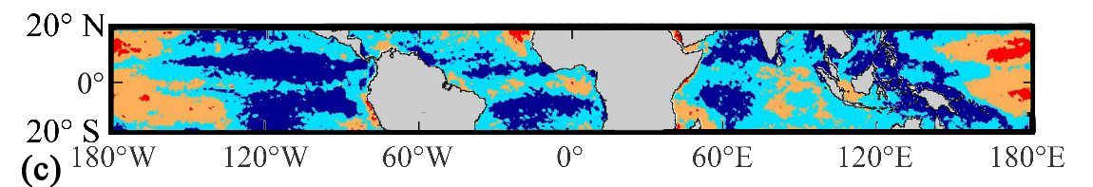
Figure Spatio-temporal variations in the annual mean sea surface ${\text{R}}_{\text{n}}$ during 1988 to 2013 by MK test method for (a) the corrected J-OFURO3, (b) the original J-OFURO3, and (c) the ERA5.

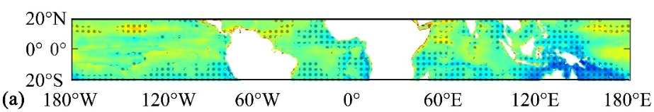
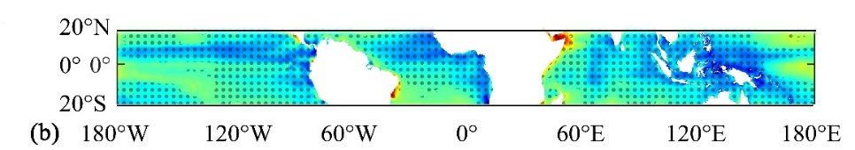
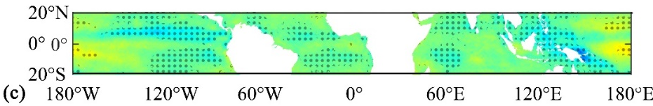
Figure Spatio-temporal variations in the annual mean sea surface ${\text{R}}_{\text{n}}$ during 1988 to 2013 by Linear regression test method for (a) the corrected J-OFURO3, (b) the original J-OFURO3, and (c) the ERA5. The pixels marked with a dot indicate their statistical significance, with p-values <= 0.1.

PART 4: Response to Reviewer #4
Summary (Reviewer #4):
Dear Authors,
The manuscript is purely technical and deals with the inconsistency of J-OFURO3 sea surface net radiation and correction.
The authors show some convincing arguments (e.g. plots in Fig.5) for this inconsistency. The method of the correction is very simple, based on the regression of data Rns or Rli value from the corresponding CERES-3A dataset from 246 2001 (predictor variable, dependent variable)to 2009 and Rns or Rli value from the ISCCP-FD dataset from 2001 to 245 2009 (independent variable). This way the Authors calculate the linear regression parameters and apply them correct J-OFURO3 data from 1988 to 1999. It is worth noting that the period of the observations was changed. However, the authors validated their correction methodology using observations from 55 global moored buoy sites. In this light their statement "The objective of this paper is to inform the data users of the comprehensive performance of the J-OFURO3 sea surface Rn data and present an effective inconsistency correction scheme for this product." is fully justified.
The sea surface net radiation is an important parameter worth studying. This is why, on reflection, I decided to accept the paper for publishing after a minor revision. In general, the paper is tidy and well written.
Response: We thank the reviewer for the positive comments.
Major:
- In one place author write "sea surface net radiation (Rn )" and in another place "sea surface Rn values" or the like.
Response: In this manuscript, "sea surface net radiation (Rn)" is the abbreviation, while "sea surface Rn values" emphasized the magnitude of the "sea surface net radiation (Rn)".
- In line 355 there is a word PATENTS and nothing about them.
Response: Deleted. Thank you.

Thank you again for all the comments.

