Article
Alginite-rich Layers in the Bazhenov Deposits of the Western
Siberia
Timur Bulatov ¹*, Elena Kozlova¹, Evgeniya Leushina¹, Ivan Panchenko², Natalia Pronina³, Andrey Voropaev⁴,
Nikita Morozov⁵ and Mikhail Spasennykh¹
¹ Center for Hydrocarbon Recovery, Skolkovo Institute of Science and Technology (Skoltech), Skolkovo
Innovation Center, Bolshoi Boulevard 30, bld.1, 121205, Moscow, Russia; e.kozlova@skoltech.ru (E.K.); e.leushina@skoltech.ru (E.L.); m.spasennykh@skoltech.ru (M.S.)
² MiMGO, Entuziastov highway 21, 111123, Moscow, Russia; panchenko@mimgo.ru (I.P.)
³ Lomonosov Moscow State University, GSP-1, Leninskie Gory, Moscow, 119991, Russia; nvproncl@geol.msu.ru (N.P.)
⁴ HYDROISOTOP GmbH, Woelkestr. 9, 85301, Schweitenkirchen, Germany; av@hydroisotope.de (A.V.)
⁵ Gazprom Neft Science & Technology Centre, Moika River emb. 75-79 liter D, 190000, Saint Petersburg, Russia; morozov.nv@gazpromneft-ntc.ru (N.M.)
* Correspondence: timur.bulatov@skoltech.ru (T.B.)
Citation: Bulatov, T.; Kozlova, E.; Leushina, E.; Panchenko, I.; Pronina, N.; Voropaev, A.; Morozov, N.; Spasennykh, M. Alginite-rich layers in the Bazhenov deposits of the Western Siberia. Geosciences 2021, 11, x. DOI:10.3390/xxxxx
Academic Editor: Firstname Lastname
Received: date
Accepted: date
Published: date
Publisher’s Note: MDPI stays neutral with regard to jurisdictional claims in published maps and institutional affiliations.

Copyright: © 2021 by the authors. Submitted for possible open access publication under the terms and conditions of the Creative Commons Attribution (CC BY) license (https://creativecommons.org/licenses/by/4.0/).
Abstract: In the current study, we have identified the luminescent layers containing a significant amount of alginite in the Upper Jurassic-Lower Cretaceous Bazhenov Formation named “the alginite-rich layers”. Lithological and geochemical methods were used to determine distinctive features of these layers and to evaluate their impact on the total petroleum generation potential of the Bazhenov Formation. We have shown that the composition of the alginite-rich layers differs significantly from the organic-rich siliceous Bazhenov rocks. Rock-Eval pyrolysis, bulk kinetics of thermal decomposition, elemental analysis, and composition of pyrolysis products indicate type I kerogen as the predominant component of the organic matter (OM). Isotope composition of carbon, nitrogen and sulfur was used to provide insights into their origin and formation pathways. The luminescent alginite-rich layers proved to be good regional stratigraphic markers of the Bazhenov Formation due to widespread distribution over the central part of the Western Siberia. They also can be applied for maturity evaluation of the deposits from immature to middle of the oil window, since the luminescence of the layers change the color and intensity during maturation.
Keywords: the Bazhenov Formation; alginite-rich layers; macerals; type I kerogen; algal organic matter; marker horizon; Rock-Eval pyrolysis; kinetics; isotope composition

1. Introduction
Hydrocarbon production motivates the studies of unconventional source rock formations all over the world. The Bazhenov Formation discovered more than 50 years ago is considered as one of the primary oil-prone unconventional formations in the world. Deposits of the Bazhenov Formation are extended over an area of about 1 million km² and are buried at depths of 2.0 to 3.5 km. In spite of the long research period and high number of studies, many questions relating to effective technology of hydrocarbon exploration and production still remain to be addressed.
The Upper Jurassic-Lower Cretaceous Bazhenov Formation deposits have been formed in marine environment. The major part of solid organic matter in the Bazhenov Formation is represented by type II kerogen, which is characterized by common marine genesis. Total organic carbon (TOC) concentration vary considerably from less than 1 up to 30 wt.% for different lithological units within the cross-section. TOC variations are usually accompanied by considerable variations of the hydrogen index (HI), chemical and isotope composition and level of organic matter thermal maturation [1–4]. These variations reflect the changes in sedimentation conditions, including the rate of sedimentation, diversity of marine biota and bioproductivity, redox conditions, and others [5–7]. In case of the Bazhenov Formation, the effect of these factors on hydrocarbon formation process and hydrocarbon productivity is not yet fully understood and requires additional studies, based on detailed analysis of OM composition, properties and sources for different areas.
In this study, we focus on the layers containing luminescent organic matter and characterized by high TOC values and extremely high HI values, distinguishing them from the other Bazhenov Formation rocks. We have discovered these intervals in more than 20 wells located in the central parts of the Western Siberian petroleum basin [8]. We have performed their detailed lithological and geochemical analysis. The layers show bright yellow to orange luminescence under ultraviolet (UV) light most probably due to their OM algal genesis. Their properties differ from other luminescent layers in the Bazhenov cross-sections, including oil saturated intervals and luminescent tuffs described in [9–11], which do not contain high amount of organic carbon. Using comprehensive analysis, we have proven the presence of type I kerogen in these layers, which is unique for the Bazhenov Formation. Therefore, extensive study of these specific layers is important for understanding of the sedimentation process in the Bazhenov paleobasin. The presence of luminescent layers in visually homogeneous Bazhenov cross-sections could become a tool for correlation of wells at least in the central part of the Western Siberia where such layers have been found.
The identified alginite-rich layers were analyzed in terms of their lithological and geochemical characteristics, including their occurrence in the Bazhenov sequence, genesis and potential application for well correlation and hydrocarbon exploration and production. The study comprises the existing data on this type of the layers found in the Bazhenov Formation, and contains novel results of the lithological investigation, Rock-Eval pyrolysis, CHNS analysis, stable isotope composition analysis, and other geochemical methods.

2. Geological Setting
The Bazhenov Formation and its facial and stratigraphical analogues Tutleimskaya (lower part), Maryanovskaya, Yanovstanskaya, and Golchikhinskaya Formations make up the single Bazhenov horizon that corresponds to the largest Mesozoic global black shale event. Figure 1 shows the Bazhenov Formation and indicates wells location where the alginite-rich layers have been found.
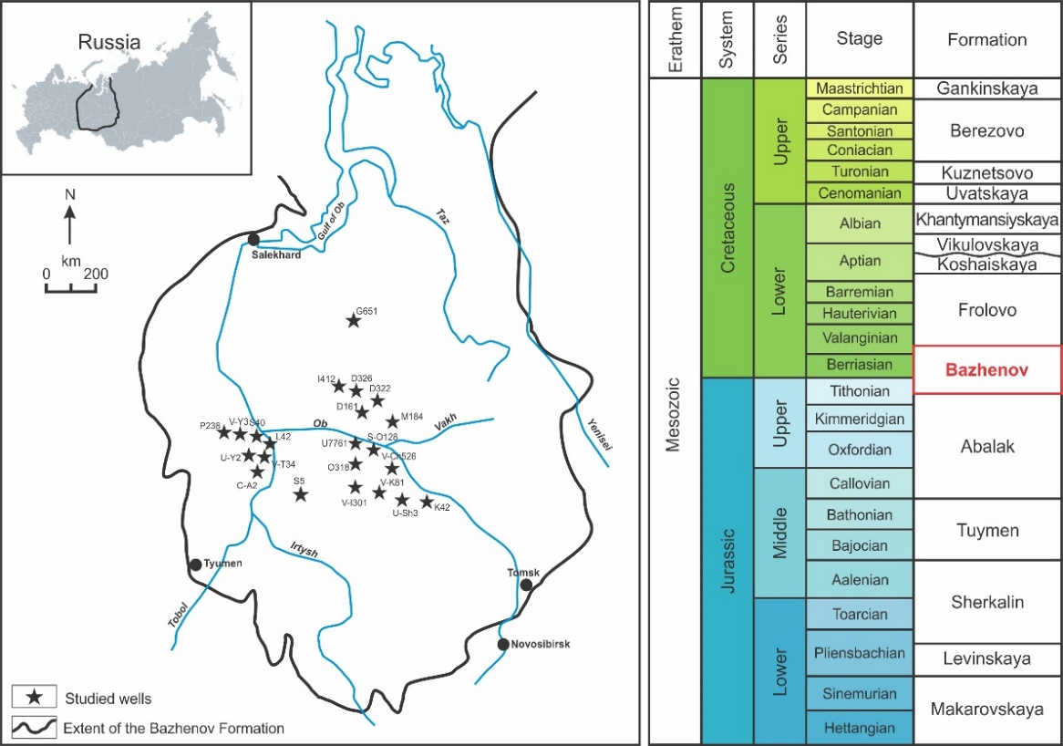
Figure 1. Map of the Bazhenov Formation with studied wells where the alginite-rich layers have been discovered (left) and stratigraphy of Mesozoic deposits of the Western Siberia (right, modified from [12]).
The sedimentation period covers the late Tithonian-early Valanginian time [13,14]. The Bazhenov epicontinental paleosea had extremely low deposition rates. High level of bio-productivity and anoxic depositional environments were favorable for OM accumulation and preservation [15–17]. There is a number of publications that integrate the paleontological findings and other proxies of the paleoenvironment conditions that controlled its deposition at different stages of geological history [18-21]. In general, the Bazhenov Formation rocks properties, organic matter and its transformation into petroleum make object of numerous studies since 1960-s [22–29].
Stratigraphic units of the Bazhenov Formation are not unified, and different research groups subdivide the horizon according to different criteria. Nonetheless, most of the researchers accept the division of the Bazhenov Formation into the Upper part and the Lower part due to lithological characteristics and concentration of OM, which is higher in the Upper Bazhenov. In this publication, we adopt the stratigraphic units reported in [30]. According to Panchenko and co-authors, the Bazhenov Formation is divided into two parts, each consisting of three distinct units. Thus, the Bazhenov section comprises six units, possessing a certain paleontological, lithological, geochemical characteristics, and identified based on well logging data (Figure 2). Such integrated approach allows one to establish units that reflect event-driven changes in the sedimentation conditions during the late Tithonian-early Valanginian time.
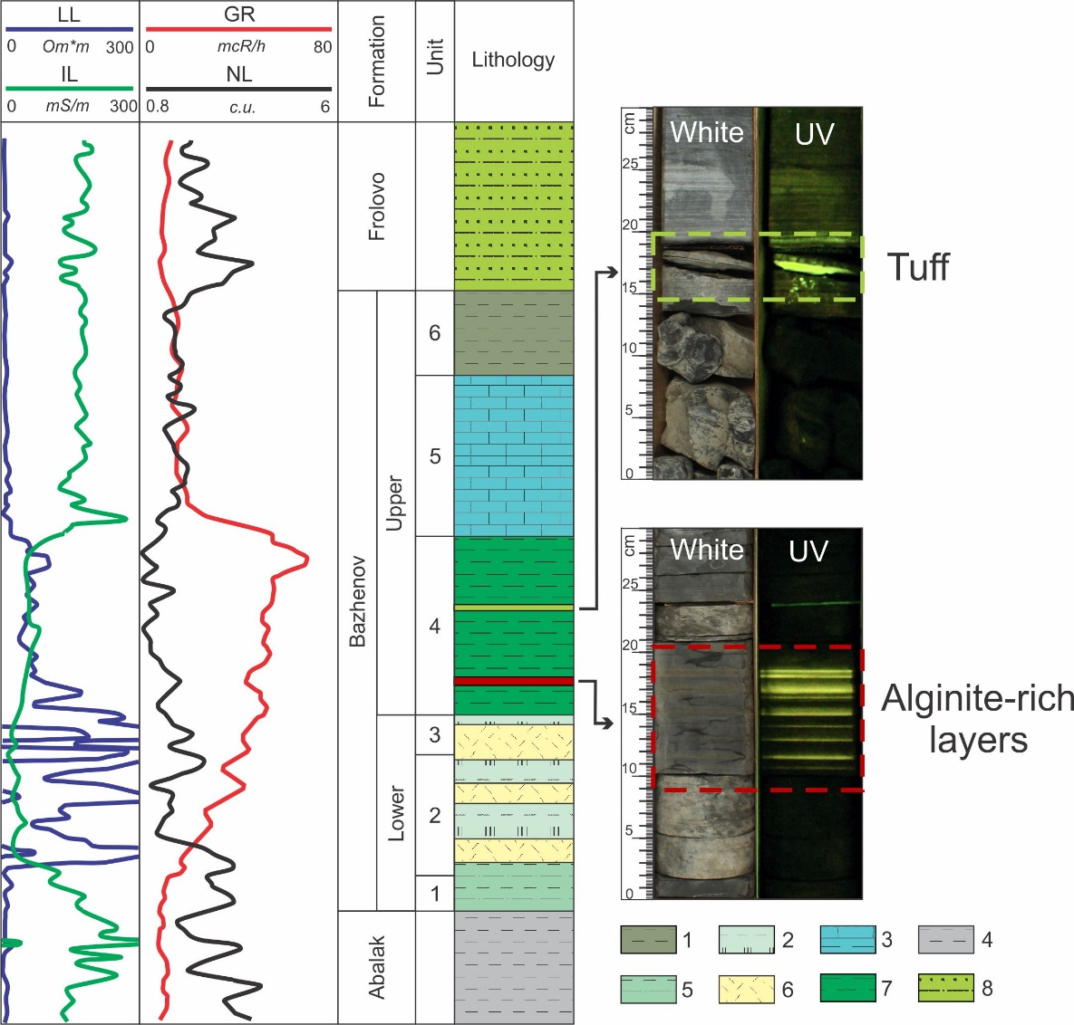
Figure 2. Example of the Bazhenov Formation cross-section (Well M184). Core photographs under white and UV light. Lithology: 1 – siliceous claystone; 2 – siliceous rocks with low clay content; 3 – organic-rich calcareous rocks; 4 – claystone; 5 – organic-rich claystone; 6 – radiolarite; 7 – organic-rich siliceous rocks; 8 – alternation of siltstones, claystone and sandstones. Well-logs: LL – laterolog; IL – induction log; GR – gamma-ray log; NL – neutron log.
The Bazhenov section is mainly composed of organic-rich siliceous rocks with varying admixtures of clay and carbonate minerals. Quantities of siliceous rocks composed of radiolarites and carbonate rocks (limestones and dolomites) differ in every cross-section of the Bazhenov Formation. The rock-forming minerals are quartz, clay (mixed-layer, kaolinite and chlorite) and carbonate (calcite and dolomite) minerals. Sulfides are disseminated within the deposits predominantly in a form of pyrite. Pyrite can reach high concentrations up to 15 wt.%. Apatite and glauconite are also observed within thin lenses and layers.
As many other black shales deposited in marine environment, the Bazhenov Formation rocks contain higher concentration of transitional metals compared to ordinary shales, e.g. Ni, Co, Cd, Mo, Ba, V, Cu, Zn, U and others. The Bazhenov Formation is of particular interest due to high uranium content [15,17,31], which is detected as an anomaly in gamma-ray logs [32].
The Bazhenov Formation organic matter, its generalized structure and composition was analyzed in a range of previous studies [33–37]. Total organic carbon concentration varies from one to 25–30 wt.% (mean 8–9 wt.%) and the initial hydrogen index (HI₀) values range between 650 and 715 mg HC/g TOC [38–40]. The organic matter is type II kerogen with maturity varying along the region from immature (protocatagenesis stage PC3) in the Nyurolskaya Depression to the end of the oil window (mesocatagenesis stage MC3) in the Salym Arch [39,41,42]. Catagenesis stages are named according to [43], tectonic zoning is suggested by [44]. Type I kerogen in the Bazhenov deposits was mentioned previously in recent publications, but the detailed characterization was never presented [38,39].
Depending on the thermal maturity advance, the properties and characteristics of the Bazhenov Formation OM change, which is reflected in Rock-Eval pyrolysis parameters [45–47], molecular, and isotope composition [4,48,49]. In general, areas with higher maturity of OM show better hydrocarbon productivity.
Luminescent alginite-rich layers are located in the lower part of the Upper Bazhenov, in unit 4. There are other luminescent layers present in unit 4 – tuffs (Figure 2, Figure 3). Tuffs appear as highly fractured greenish-gray or brown rocks with a relict volcaniclastic microstructure. They are mostly composed of devitrified volcanic glass, which has been subjected to hydration activity. The alginite-rich layers and tuffs have a different nature of luminescence. Luminescence of tuffs by various authors is associated with the mineralogy of clay minerals [10] or barite concentrations [11], whereas the alginite layers have organic nature of luminescence. Since the luminescence of the alginite-rich layers and tuffs are very close visually, in the results section we provide their comparative characteristics in order to determine the strict criteria to distinguish them from one another.

3. Materials and Methods
Luminescent alginite-rich layers were observed in the core material from 22 wells (Figure 1). All of the alginite-rich layers occur in the lower part of the Upper Bazhenov Formation (unit 4, see Figure 2).
For this study, we have chosen samples of the alginite-rich layers and host rocks representing mostly organic-rich siliceous rocks. The sampling distance between the alginite-rich layers and the host rocks did not exceed 5 cm.
The samples for thin section petrographic examination were cut perpendicular to the bedding planes, oriented down-up, 0.03 mm thick, polished, and coverslipped. The thin sections were examined using a Zeiss Axioskop 5 polarizing microscope equipped with an Axiocam 506 color digital camera.
Polished whole-rock blocks were prepared and examined. Maceral analysis was performed using a QDI-300 Craic micro-spectrophotometer with a LeicaP 2500 base microscope under indecent white light and UV light illumination in air [50]. A quartz halogen lamp (12 V, 100 W) was used for white light. A high pressure mercury lamp (100 W HBO®) was used for UV light. The maceral nomenclature used in this publication follows the International Committee for Coal and Organic Petrology [51-53].
X-ray diffraction (XRD) analysis was performed on selected samples for bulk mineral composition analyses. XRD analyses were carried out with ARL X’TRA X-ray diffractometer (Thermo) using CuKα radiation, operated at 40 kV and 40 mA and analyzed over the 2-60°2θ angular range. Siroquant software package was used for indexing of diffraction peaks and identification of mineral phases. We used the Rietveld refinement procedure and obtained data through a concerted theory-experiment comparison.
X-ray fluorescence (XRF) analysis was performed using ARL Perform’X spectrometer (Thermo) according to the fundamental parameters method. The samples were prepared as pressed powder pellets on a boric acid substrate.
Rock-Eval pyrolysis was performed using HAWK Resource Workstation (Wildcat Technology). We have determined the main pyrolysis parameters: thermovaporized free hydrocarbons (S0 and S1), pyrolysis products from cracking of kerogen and heavy petroleum fractions (S2), CO₂ generated from the OM during the pyrolysis step (S3), CO₂ generated from the organic matter during the oxidation step (S4), CO₂ generated from mineral source during the oxidation step (S5), the temperature at which the maximum amount of hydrocarbons are generated (T_{max}). Using these parameters enables the calculation of TOC, generative organic carbon (GOC), non-generative organic carbon (NGOC), hydrogen index (HI), oxygen index (OI), production index (PI), and proportion of generative kerogen (K_{goc} = GOC/TOC×100).
Kinetic studies of organic matter thermal decomposition were carried out using HAWK Resource Workstation. The extracted rock samples were subjected to non-isothermal pyrolysis at temperature from 300 to 650 ºC at three heating rates (3, 10, 30 ºC/min). The Kinetics 2015 software was used to determine the discrete distribution of activation energies (Ea, kcal/mol) for a fixed frequency factor A = 1×10¹⁴ s⁻¹.
The CHN628 elemental analyzer (LECO) was used to determine the carbon, hydrogen and nitrogen content via combustion (at 950°C) into CO₂, H₂O and NO₂, respectively. Helium carrier gas sweeps the combustion gas to separate infrared cells utilized for the detection of H₂O and CO₂, while a thermal conductivity cell is used for the detection of nitrogen. The 628 S module (LECO) was used to determine the sulfur content. Sulfur is evolved (at 1350°C) from the sample and forms SO₂. From the combustion system, the gases flow through the sulfur infrared detection cell. Combustion occurs in pure oxygen for CHN and S analyses.
Pyrolysis gas chromatography analyses (pyro-GC×GC-FID/TOFMS) was performed using Pegasus 4D (LECO) equipped with a cryo-modulator and injection modules for thermal desorption and pyrolysis (Gerstel). Chromatographic separation of the products was carried out using a reverse-order column set. Samples were heated to a final temperature of 500°C. Pyrolysis products were detected simultaneously using FID and time-of-flight mass spectrometer detectors.
Isotope and elemental analysis of carbon, nitrogen and sulfur was performed on a DELTA V Plus mass spectrometer (Thermo) equipped with a Flash HT elemental analyzer. The validation of analytical procedures was established using international standards: oil NBS 22, ammonium sulfate IAEA-N-2, and barium sulfate NBS 127 for carbon, nitrogen and sulfur, respectively, as well as of the laboratory standards, whose elemental and isotope composition was determined during interlaboratory comparison measurements. In accordance with the generally accepted rules, all the measured isotopic ratios were recalculated and are given in δ values characterizing the deviation of the isotopic ratio of the sample from the isotopic ratio of the standard (in ‰): PDB, AIR and CDT for carbon, nitrogen and sulfur, respectively. The absolute error of measurement for δ values is ± 0.3‰ for carbon, ± 0.5‰ for sulfur and nitrogen. The relative error of element content measurements is ±10%.

4. Results

4.1. Visual Core Description Under White and UV Light
The individual alginite-rich layers thickness varies from 1 to 50 mm, total thickness is up to 1 m in the cross-section. The studied cross-sections of the Bazhenov Formation have a thickness of about 20-30 m. Alginite layers usually constitute about 1-5% of the entire cross-section. They can be macroscopically distinguished by their bright yellow or orange luminescence under UV light and less often by lighter coloring in comparison to darker host rocks (organic-rich siliceous rocks) under white light (Figure 3). Usually, the alginite-rich layers pass gradually to the organic-rich siliceous rocks. This gradation gives the rocks a banded appearance under UV light. Another interesting feature of the alginite-rich layers is their plasticity and flexibility, as well as their low density.
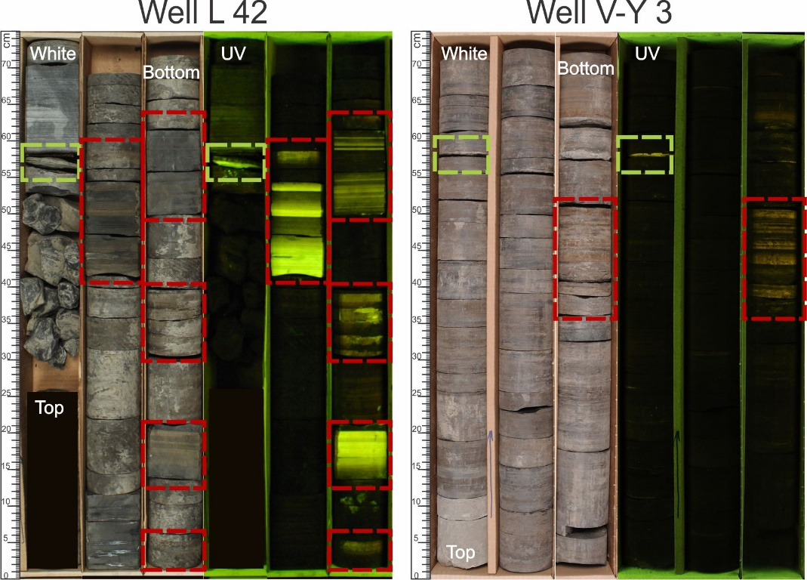
Figure 3. Core layout showing typical appearance of the Bazhenov Formation organic-rich siliceous rocks with presence of the alginite-rich layers (marked in red) and tuffs (marked in light green). Core photographs under white and UV light.

4.2. Lithology and Mineral Composition
According to petrographic description, the luminescent alginite-rich layers are mainly composed of OM and quartz aggregations (Figure 4a,b). Remains of fish bones, calcispheres and radiolarians are rare. Pyrite is present either in the form of framboids, evenly distributed over the rock, or replaces radiolarian shells. The boundaries between the alginite-rich layers and the underlying rocks are sharp (Figure 4c), while the upper contacts are gradually replaced by the overlying rocks.
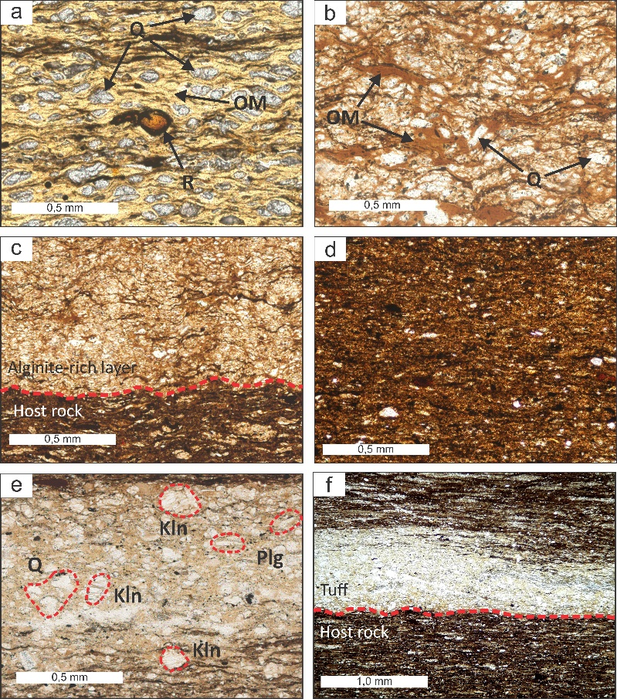
Figure 4. Typical thin section photomicrographs of the alginite-rich layers, host rocks and tuffs. (a,b) Alginite-rich layers, predominantly containing organic matter (OM) and aggregates of quartz (Q), radiolarians (R) are rare; (c) Alginite-rich layer and host rock that are separated by wavy surfaces (highlighted by red short-dashed line); (d) Host rock shows the distribution of mineral matrix with organic matter along beddings; (e) Tuff shows former glassy ash matrix devitrified to crystals of plagioclase (Plg), quartz (Q), kaolinite (Kln), and clay matrix; (f) Host rock contains thin tuff layer. All photomicrographs are taken under parallel nicols. Corresponding magnification of (a-e) 20× and (f) 10×.
From XRD results it is clear that mineral part of the alginite-rich layers mainly consists of quartz (70–90 wt.%). The content of clay minerals, including kaolinite and mixed-layer clays, usually does not exceed 17 wt.%. Carbonate minerals and pyrite are present in minor amounts. The results of XRF confirm the mineral composition data and indicate a predominance of the siliceous component (SiO₂ values range 65-90 wt.%) in an inorganic part of the alginite-rich layers.
The host rocks are organic-rich siliceous rocks. Thin sections show lamination of organic-rich rock, generally pyritic, with organic matters along bedding axis (Figure 4d). This rock is generally non-calcareous. Pyrite occurs as microcrystals, framboidal aggregates, or as nodules formed within the rocks. The organic-rich siliceous rocks contain rare phosphate fish bone remains oriented parallel to the layering.
The major part of organic-rich siliceous rocks is quartz (60–70 wt.%) besides clay minerals (15–20 wt.%), calcite (0–10 wt.%) and pyrite (3–10 wt.%) due to XRD. The most abundant oxides are SiO₂, Al₂O₃, CaO, and Fe₂O₃, whereas MgO, TiO₂, MnO, K₂O, P₂O₅, and Na₂O are present in minor quantities. For hosting organic-rich siliceous rocks SiO₂ values are in the range of 50–70 wt.%, Al₂O₃ values are in the range of 5–15 wt.% and CaO values are in the range from 0.5 to 15 wt.%. The average of Fe₂O₃ content is 4.6 wt.%.
For comparison, we present photomicrographs of the thin sections of the luminescent tuffs (Figure 4e,f). The tuffs consist of volcanic glasses, almost completely transformed into clay minerals. In the petrographic thin sections, we observed plagioclase and zircon grains. The tuffs are significantly different from the alginite-rich layers and from the host siliceous rocks by the almost complete absence of OM and by substantially clayey mineral composition.
According to XRD, tuffs are essentially composed of clay minerals (up to 60-80 wt.%). The predominant clay minerals of all the tuffs are mixed-layer clays and kaolinite. The minor minerals are quartz, plagioclase, mica, albite, and pyrite. The XRF results of tuffs show that SiO₂ values range between 45 and 55 wt.%. Similarly, Al₂O₃ contents vary between 20 and 30 wt.%. The average of Fe₂O₃ content is 2.4 wt.% and of CaO is 1.2 wt.%. Sum of Na₂O and K₂O is 3-6 wt.%. The chemical composition of tuffs corresponds to the basaltic andesitic source of intermediate magma.

4.3. Organic Petrography
The organic petrography shows that alginite is a major organic component. Shape of OM has fan, lumps and clots morphology. Alginite has a distinctive external form and, in most cases, an internal structure of specific recognizable algal remains. Under indecent white light alginite is brownish (Figure 5a,c,e). During analysis in incident fluorescence mode (under UV light), alginite is greenish-yellow to bright yellow color (Figure 5b,d,f). Therefore, alginite is separated from amorphous material, i.e., bituminite, which lacks distinctive morphology and originates from the various precursors.
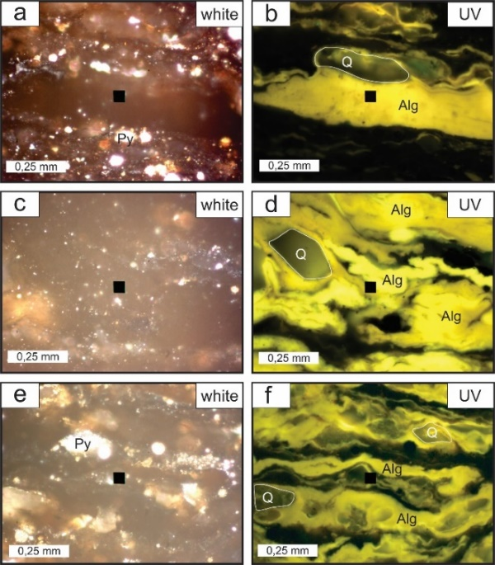
Figure 5. Photomicrographs illustrating a typical maceral composition of the alginite-rich layers. (a,c,e) Samples under indecent white light shows enrichment of organic matter in mineral matrix. Many colonies contain pyrite; (b,d,f) Same samples under UV light shows high intensity yellow luminescence of alginite. Air, magnification of 50× for all photomicrographs. Alg – alginite, Q – quartz, Py – pyrite.
The absolute predominance of alginite (40–50 vol.%) in the maceral composition confirms the algal origin of the organic matter in these layers. As compared to the samples from the host rocks, alginites are less abundant and only small amounts of bituminite were detected.

4.4. Characterization of Organic Matter
Since the petrographic data allow us to state that OM in the alginite-rich layers has algal nature, we have further analyzed quantity and composition of OM to prove this hypothesis. The geochemical characterization included Rock-Eval pyrolysis, pyro-GC-TOF MS/FID analyses, kinetic studies of OM thermal decomposition, elemental analysis and isotope composition measurements.

4.4.1. Rock-Eval Pyrolysis
In Table 1, we report Rock-Eval pyrolysis data for the studied samples from the alginite-rich layers and host rocks. To emphasize the difference, we provide Rock-Eval pyrolysis data for tuffs sampled during the study.
The most distinctive feature of organic matter of the alginite-rich layers is the value of hydrogen index. HI in the alginite-rich layers of a low maturity degree reaches 1053 mg HC/g TOC, which is 350–400 mg HC/g TOC higher than that for host rocks. In the modified van Krevelen diagram, the alginite-rich layers are located in the area typical for type I kerogens, while the Bazhenov Formation OM of the host rocks is characterized as type II kerogen (Figure 6a). TOC concentration of the low mature alginite-rich layers reaches 25 wt.%. The amount of pyrolyzed hydrocarbon compounds in the studied intervals reaches 260 mg HC/g rock. In S2-TOC plot (Figure 6b), the alginite-rich layers have significantly better petroleum generation potential than the host rocks [54, 55]. There is a minor difference in oxygen index between the alginite-rich layers and host rocks (1–11 mg CO₂/g TOC). At the same time, in tuffs OI sharply increases and reaches 59 mg CO₂/g TOC. The maturity parameters of the alginite-rich layers are inconsistent with each other. At very low PI we observe very high T_{max} values. These values exceed the corresponding values in the host rocks by 6–14 °C, which reflects the difference in the OM maturation pathways for different kerogen types, provided the OM type remains comparable [56].
Table 1. Rock-Eval pyrolysis data for the alginite-rich layers, host rocks and tuffs.
Well | Sample | S0+S1,  mg HC/g | S2  mg HC/g | PI  (S1/S1+S2) | TOC,  wt.% | K_{goc},  % | T_{max},  °С | HI,  mg HC/g TOC | OI,  mg CO₂/g TOC
V-K 81 | Alginite-rich layer | 2.15 | 241.65 | 0.01 | 22.94 | 91 | 445 | 1053 | 1
V-K 81 | Host rock | 4.64 | 133.90 | 0.03 | 17.81 | 67 | 431 | 751 | 4
V-Ch 526 | Alginite-rich layer | 1.06 | 219.02 | 0.01 | 21.56 | 87 | 443 | 1015 | 1
V-Ch 526 | Host rock | 5.12 | 74.52 | 0.06 | 10.72 | 67 | 430 | 682 | 3
M 184 | Alginite-rich layer | 0.53 | 259.24 | 0.00 | 25.25 | 88 | 451 | 1026 | 3
M 184 | Host rock | 1.36 | 46.21 | 0.03 | 8.77 | 48 | 438 | 527 | 11
S-O 128 | Alginite-rich layer | 2.49 | 110.48 | 0.02 | 12.20 | 79 | 450 | 905 | 6
S-O 128 | Host rock | 2.99 | 71.05 | 0.04 | 13.20 | 49 | 444 | 538 | 4
O 318 | Alginite-rich layer | 1,36 | 103.14 | 0.53 | 12,19 | 74 | 447 | 846 | 4
O 318 | Tuff | 0.22 | 2.08 | 0.10 | 0.77 | 34 | 436 | 269 | 36
O 318 | Host rock | 5,65 | 66,43 | 0.45 | 13,9 | 48 | 436 | 478 | 3
S 40 | Alginite-rich layer | 1.79 | 140.25 | 0.01 | 16.21 | 76 | 440 | 865 | 2
S 40 | Host rock | 2.81 | 51.93 | 0.05 | 10.69 | 46 | 430 | 485 | 3
V-I 301 | Alginite-rich layer | 0.50 | 66.78 | 0.01 | 8.19 | 72 | 439 | 815 | 4
V-I 301 | Host rock | 3.44 | 54.25 | 0.06 | 11.03 | 48 | 431 | 491 | 5
D 541 | Tuff | 0.16 | 1.88 | 0.08 | 0.71 | 28 | 454 | 264 | 28
M 14 | Tuff | 0.25 | 2.03 | 0.11 | 0.60 | 37 | 421 | 339 | 59
J 177 | Tuff | 0.34 | 1.89 | 0.15 | 0.79 | 28 | 437 | 240 | 29
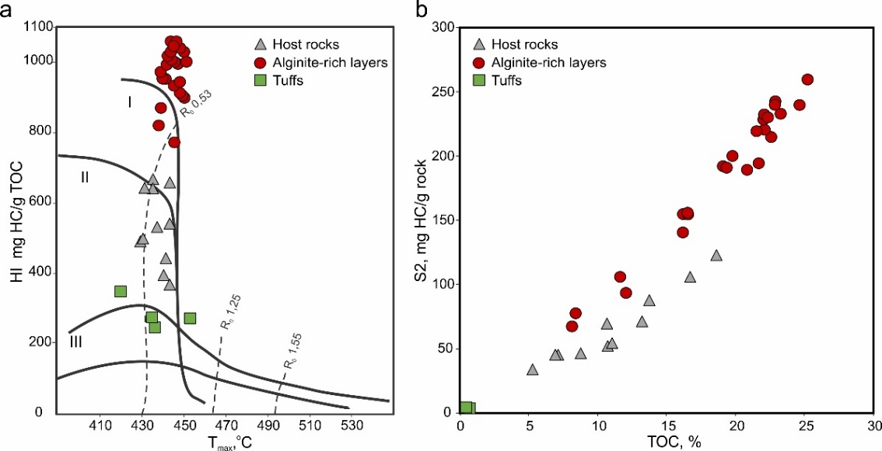
Figure 6. Modified van Krevelen diagram (a) and S2 vs. TOC plot (b) for the studied samples.
Organic matter in the alginite-rich layers has a higher quantity of pyrolyzable carbon compared to the background along the section. Generative organic carbon to TOC ratio (K_{goc}) reaches 91% and decreases with the increase of OM maturity (Table 1).
Figure 7 illustrates section of a core sample (7 cm thick) with alternating layers of bright and dull luminescence intensities, related to alginite contents. The samples were analyzed by Rock-Eval pyrolysis, and we observed significant variations of the parameters even in such a small interval.
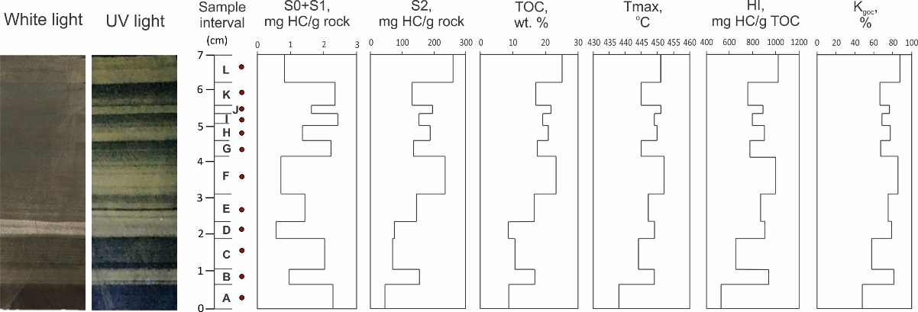
Figure 7. Detailed (layer-by-layer) Rock-Eval pyrolysis for core sample with interbedding of the alginite-rich layer and hosting organic-rich siliceous rock from well V-K 81. А-L – sampling points.
Rock-Eval pyrolysis parameters obtained for the first background point A (Figure 7) are common for the Bazhenov Formation rocks, for darker non-luminescent layers TOC is 8–11 wt.%, and for the luminescent alginite-rich layers TOC is 13–25 wt.%. For the luminescent layers, we observe a significant increase of T_{max} by 5–11 °C over for darker ones. Difference in HI for nearby layers reaches 450 mg HC/g TOC. The amount of thermally desorbed light hydrocarbons (S0+S1) changes inversely to S2 and TOC, i.e. for luminescent rocks S2 is high and S0+S1 is low, and vice versa for the darker layers. Thus, layer-by-layer Rock-Eval pyrolysis emphasizes the heterogeneous saturation of the Bazhenov Formation rocks with type I kerogen, which interbeds and mixes with different types of OM (type I and type II of kerogen).

4.4.2. Organic matter thermal decomposition
The presence of type I kerogen in the alginite-rich layers is confirmed by the bulk kinetic characteristics of OM thermal decomposition. In Figure 8, we provide the activation energy distributions for two pairs of samples: from the alginite-rich layer and from the adjacent host rock. The spectrum for the alginite-rich organic matter is narrow and consists of a single energy Ea = 53 kcal/mol (Figure 8b,d), which is a feature of type I kerogen [57, 58]. For the host rocks, the activation energy distributions (with the maximum at 52 kcal/mol) have the typical shape for the Bazhenov kerogen, and characterizes the host rocks OM as type II kerogen (Figure 8a,c). The upper pair of samples (Figure 8a,b) was taken from the section of the Bazhenov Formation with moderately immature OM (MC1). The lower one (Figure 8c,d) was taken from the section in the early oil window (MC1-2).
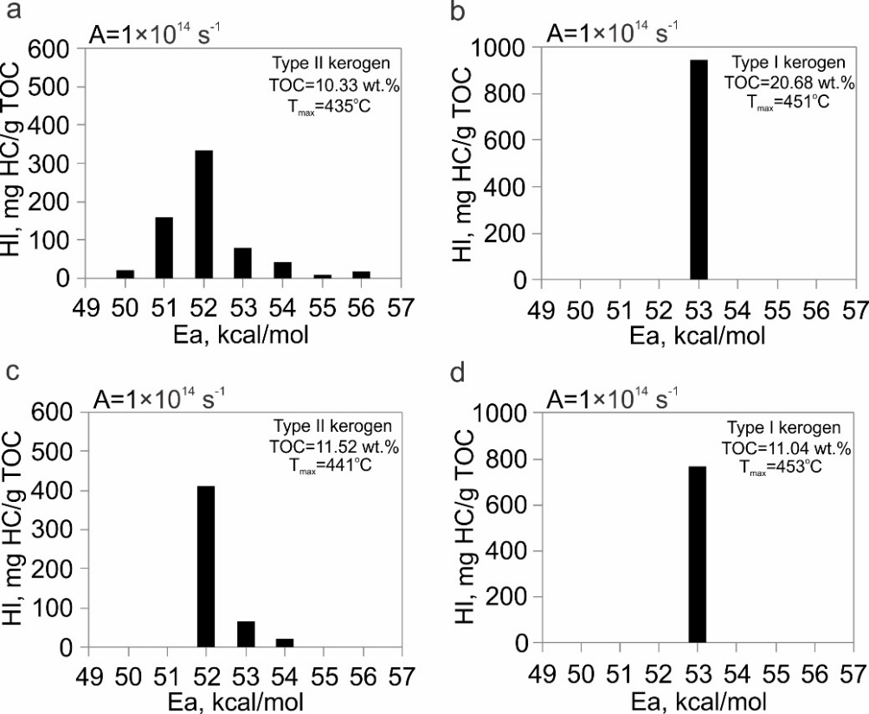
Figure 8. Activation energy distribution of organic matter thermal decomposition for the host rocks (a,c) and for the alginite-rich layers (b,d). Frequency factor A is fixed to 1×10¹⁴ s⁻¹.
Results of pyrolysis-gas chromatography/mass spectrometry give us information about the quantitative and qualitative chemistry of the thermal decomposition products from the cracking of kerogen [59]. This method provides a direct indicator for the geochemical typing of kerogens and types of hydrocarbons that can be generated during thermal maturation. Comparison of the aliphatic and aromatic nature of kerogens has been previously described in publications [57, 59-61].
Numerous compound hydrocarbon classes have been found in pyrolysis products of kerogen, including light hydrocarbons C1-C7, n-alkanes C8-C40, unsaturated HС, naphthenes, mono-, di-, tri- and poly-aromatic compounds (Table 2). Type I kerogen of the alginite-rich layers produces dominantly long-chain n-alkanes and n-alkenes, whereas type II kerogen of host rocks produces more unsaturated HС, naphthenes and aromatic compounds (Figure 9a,b). These differences are also reflected in elemental composition. Type I kerogen of the alginite-rich layers has high atomic H/C up to 1.88 and low atomic O/C (0.05-0.07). Kerogen of host rocks characterized by high atomic H/C (1.09-1.19) and low atomic O/C (0.06-0.09).
High aliphaticity (at least 90 wt.%) of pyrolysis products suggest that type I kerogen of the alginite-rich layers is dominated by lipid-rich and protein-rich algal material that has undergone extensive bacterial reworking in reducing conditions. Aliphatic to aromatic ratio of pyrolysis products show that type II kerogen of host rocks originates from various precursors (mixed phytoplankton, zooplankton and bacterial material).
Table 2. Distribution of HC classes from Pyro-GC×GC-TOF MS/FID and elemental analysis data for the alginite-rich layers and host rocks.
Hydrocarbon Classes (% w/w) | Well S-O 128 |  | Well V-I 301
Hydrocarbon Classes (% w/w) | Host Rock | Alginite-Rich Layer | Host Rock | Alginite-Rich Layer
Light HC C1-C7 | 7 | 6 | 19 | 8
n-alkanes С8-40 | 8 | 25 | 25 | 33
Unsaturated HС and naphthenes | 37 | 64 | 29 | 53
Mono-aromatic compounds | 21 | 4 | 19 | 4
Di-aromatic compounds | 15 | 1 | 7 | 1
Tri- and poly-aromatic compounds | 12 | 0 | 1 | 1
Aliphatic/aromatic | 52/48 | 95/5 | 73/27 | 94/6
H/C | 1.09 | 1.88 | 1.19 | 1.69
O/C | 0.06 | 0.07 | 0.09 | 0.05

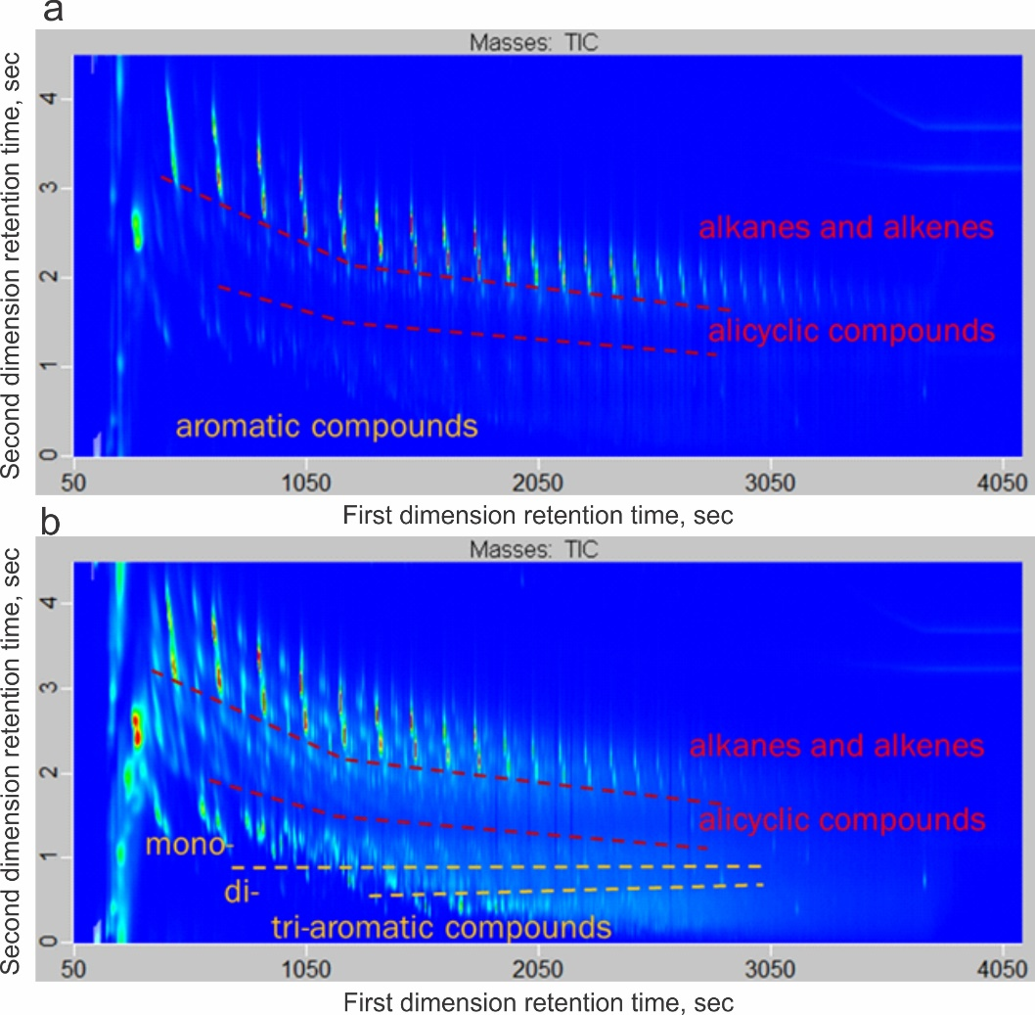
Figure 9. Two-dimensional total ion chromatograms (TIC) of kerogen cracking products for the alginite-rich layers (a) and host rocks (b).

4.4.3. Isotope composition of C, N, S
Among geochemical data, isotope composition of carbon, nitrogen and sulfur in rocks is enables genesis estimation of organic matter. In Table 3, we provide the results of stable isotope studies of carbon, nitrogen and sulfur.
Table 3. Bulk C, N and S elemental and isotope composition for the alginite-rich layers, host rocks and tuffs.
Well | Sample | Сorg/Ntot | δ¹³С_{org}, ‰ PDB | N_{tot}, wt.% | δ¹⁵N_{tot}, ‰ AIR | S_{tot}, wt.% | δ³⁴S_{tot}, ‰ CDT | C_{org}, wt.%
V-K81 | Alginite-rich layer | 93.37 | −31.5 | 0.21 | 5.9 | 2.31 | −6.0 | 22.12
V-K81 | Host rock | 43.84 | −31.4 | 0.37 | 0.9 | 4.36 | −17.3 | 17.81
S-O 128 | Alginite-rich layer | 103.28 | −31.8 | 0.11 | 7.7 | 1.61 | −18.5 | 12.20
S-O 128 | Host rock | 43.54 | −30.5 | 0.34 | 3.2 | 3.71 | −24.9 | 12.30
V-I 301 | Alginite-rich layer | 109.57 | −31.8 | 0.07 | 17.5 | 2.75 | −11.2 | 8.19
V-I 301 | Host rock | 42.23 | −31.9 | 0.24 | 5.4 | 4.18 | −26.0 | 11.03
V-C 526 | Alginite-rich layer | 155.50 | −31.1 | 0.15 | 25.7 | 1.37 | −9.3 | 21.56
V-C 526 | Host rock | - | - | - | - | - | - | -
L 42 | Alginite-rich layer | 76.83 | −31.9 | 0.21 | 13.0 | 2.10 | −7.1 | 19.79
L 42 | Host rock | - | - | - | - | - | - | -
D 541 | Tuff | 2.70 | −28.8 | 0.45 | 2.4 | 1.89 | 4.4 | 0.71
М 14 | Tuff | 4.38 | −29.0 | 0.21 | 1.5 | 0.69 | 4.5 | 0.60
J 177 | Tuff | 4.11 | −28.9 | 0.23 | 2.1 | 0.63 | 2.4 | 0.79

Carbon isotope composition for the alginite-rich layers varies in the range from −31.1 to −31.9‰, while for the host rocks δ¹³С_{org} takes values from −30.5 to −31.9‰. In contrast, tuffs contain 10–30 times less organic carbon than host rocks and the alginite-rich layers. Tuffs are enriched in heavy carbon isotope, and δ¹³С_{org} is from −29.0 to −28.8‰.
Nitrogen concentration in the alginite-rich layers and in host rocks vary from 0.07 to 0.37 wt.%. For all the samples from the alginite-rich layers, we observe 1.5–2 times lower nitrogen content compared to the host rocks. Concentration of nitrogen in the host rocks takes values from 0.24 to 0.37 wt.%, and δ¹⁵N_{tot} varies from 0.9 to 5.4‰. Nitrogen content in the alginite-rich layers is from 0.07 up to 0.21 wt.%, and organic matter is enriched in ¹⁵N (δ¹⁵N_{tot} is from 5.9 to 25.7‰). С_{org}/N_{tot} ratio correlates with the heavier nitrogen isotope composition (Figure 10a). Tuffs are characterized by С_{org}/N_{tot} ratio from 2.7 to 4.38, and by δ¹⁵N_{tot} values from 1.2 to 2.4‰.
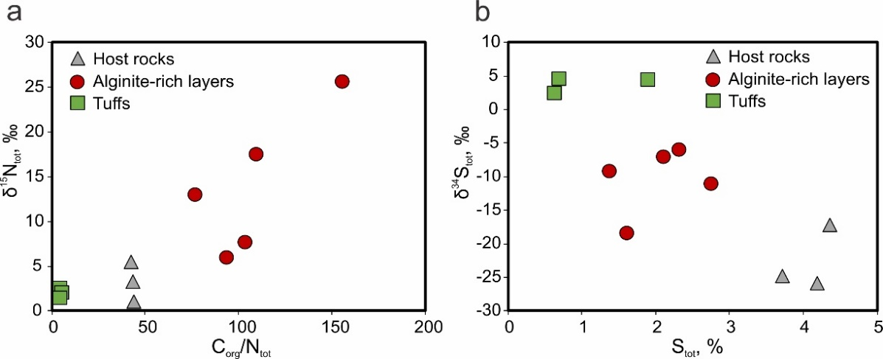
Figure 10. Comparison of δ¹⁵N_{tot} values and С_{org}/N_{tot} ratio (а), and comparison of δ³⁴S_{tot} values and S_{tot} content (b) in the alginite-rich layers, host rocks and tuffs.
Content and isotope composition of the total sulfur is also different for the rocks from the alginite-rich, host deposits and tuff. For the alginite-rich layers δ³⁴S_{tot} values range from −6.0 to −18.5‰ with a total sulfur content of 1.37 to 2.75 wt.%. For the host rocks, we detect a predominance of lighter sulfur: δ³⁴S_{tot} varies from −17.3 to −26.0‰ for S_{tot} from 3.71 to 4.36%. Tuffs demonstrate the heaviest sulfur isotope ratio (Figure 10b).

5. Discussion

5.1. Occurrence
Alginite-rich layers discovered throughout the Bazhenov sequence within the central part of the Western Siberia in unit 4, where the Jurassic-Cretaceous boundary situated between Upper and Lower Bazhenov Formation. Variably-sized algae remains are regularly microscopically recorded in rock samples, particularly in fine-grained organic-rich siliceous rocks that occur throughout the Bazhenov sequence, but pure and concentrated algae found only in the alginite-rich layers. According to results, the alginite-rich layers widely extend for more than 455,000 km² area (Figure 1). Studied wells located in different regions of the Western Siberia and confined to the various tectonic elements: the Frolovskaya Megadepression, the Krasnoleninsky Arch, the Surgut Arch, the Nizhnevartovsky Arch, the Yugansk Megadepression, and the Nyurolskaya Depression and others.

5.2. Key Characteristics of the Alginit-Rich Layers
Considering visual characteristics and obtained mineralogical and geochemical data key features that can be used in identifying the alginite-rich layers from host rocks are: macroscopically visually lighter coloring in comparison to darker host rocks; luminescence under UV light; low density and plasticity; matrix consists mainly of algal OM and quartz aggregations; Rock-Eval pyrolysis data, kinetics parameters and elemental composition indicate on type I kerogen in the alginite-rich layers; high С_{org}/N_{tot} ratio and δ¹⁵N_{tot} values.
The Rock-Eval pyrolysis parameters of the alginite layers significantly exceed those in host rocks. Values of K_{goc} reach 90%. Hydrogen indices are 400–500 mg HC/g TOC higher, T_{max} higher by to 5–10 °C compare to host rocks. Atomic H/C ration up to 1.88. Rock-Eval pyrolysis parameters, bulk kinetics data and elemental composition confidently describes OM as type I kerogen.
The mineral composition of alginite-rich layers mainly consists of quartz grains (60–90 wt.%), which is not typical for the Bazhenov Formation rocks. In general, abnormal quartz concentrations within unit 4 can indirectly show the occurrence of the alginite-rich layers.
Carbon isotope composition of OM indicates the source of organic matter. The δ¹³С_{org} values of the alginite-rich layers (from −31.1 to −31.9‰) are similar to host rocks (from −30.5 to −31.9‰). The resulting values are typical for marine OM of the Bazhenov Formation previously reported [4,62].
According to mineralogical studies, the main chemical form of sulphur in investigated samples is, according to mineralogical studies, the sulphide sulphur fixed as pyrite. Organic sulphur presents in a very subordinate amount, the sulphur content in organic matter in sedimentary rocks of West Siberia is generally low and does not exceed 5 wt.% [62]. Sulfur isotope composition of sulphide sulfur indicates the changes in redox conditions during sedimentation and the sulfate-reducing bacteria activity. Intensive sulfate reduction in euxinic conditions results in higher sulfur content and its “lighter” isotope composition [63], which is observed in the host rocks with δ³⁴S_{tot} from -17.3 to −26.0‰. The alginite-rich layers are characterized by intermediate values of sulfur content and δ³⁴S_{tot} from −6.0 to −18.5‰, which reflects suboxic conditions of sedimentation compared to the host rocks. The tuff samples are quite different with low sulfur content and relatively high δ³⁴S_{tot} from 2.4 to 4.5‰. The sulfur isotope composition of tuffs is possibly affected by the admixture of volcanic sulfur from pyroclastic material [64,65].
Low nitrogen concentration (0.07–0.21 wt.%), high С_{org}/N_{tot} ratio (70–155 and above) and δ¹⁵N_{tot} values (up to 25.7‰) are characteristic features of the alginite-rich layers. Host rocks have С_{org}/N_{tot} from 3 to 50 and δ¹⁵N_{tot} from 1 to 5.4‰ that show the same values as the black shales of various ages [66-68]. Low nitrogen content and heavy isotope composition corresponds to initial predominance of lipid components and/or significant microbial alteration of OM at the diagenesis stage. The process of bacterial transformation is known to be common for the sapropelic OM formation, and it is usually accompanied by destruction of proteins and carbohydrates [69]. Nitrogen isotope fractionation occurs due to amino acids destruction resulting in the loss of amino groups, and kinetic isotope effect is directed towards the accumulation of lighter ¹⁴N in the products of biochemical reactions and enrichment of the residual substrate by ¹⁵N [70].
For comparison, luminescent tuffs exhibit relatively high nitrogen and low organic carbon concentrations, indicating the presence of inorganic nitrogen in the rocks. In detailed mineralogical study of tuff layers of the Bazhenov Formation, Shaldybin and co-authors have found the illite/tobelite/smectite mixed-layered mineral compounds, where ammonium partially replaces potassium in the crystal structure of tobelite [10, 71]. We attribute formation of these minerals to transformation of pyroclastic material at the diagenesis stage in the presence of ammonium, formed during the OM decomposition in the pore waters. High nitrogen content and low δ¹⁵N_{tot} values, obtained for tuff samples in this study, are consistent with this concept.

5.3. Origin of the Alginite-Rich Layers
The obtained results show extensive environmental changes occurred during the short-term, in the geological timescale, period of sedimentation in paleobasin on the territory of modern Western Siberia. Due to these changes, a considerable amount of organic-matter-rich algal sapropel has been accumulated in most parts of the paleosea. Observed thickness of lithified material corresponds to the sedimentation of 5–10 m of mud enriched with algae, which most probably was formed as a result of algal blooms.
Algae are known to occur in a variety of depositional environments and have been described from ancient deposits to recent times. The environment must have had a regular and ample nutrient supply, enough light intensity, and optimal water temperature. Algal blooms happen regularly in the Black and the Mediterranean [72,73]. The source of nutrients in the middle of paleosea potentially stimulating algal blooms could be volcanic ash [74–76], eolian processes [77-79], upwelling [80], or run-off from the eroding land areas, and currents, concentrating stock of living plankton. The occurrence of large amount of quartz in the alginite-rich layers is associated with the release of silica or input from an external source. The source of silica most commonly includes biogenic debris (radiolarians, diatoms, sponge spicule and others), the transformation of clay minerals and the vitrification of volcanic ash. Eolian processes can produce a large amount of quartz-rich dust from coastal deserts [81,82].

5.4. Stratigraphy and Hydrocarbon Potential
In the Bazhenov Formation, the luminescent alginite-rich layers occur beside with luminescent tuffs in unit 4 (Figure 11). They have different nature of luminescence and can be distinguished by the listed above criteria. The widespread distribution over the entire area of the central part of Western Siberia makes both the alginite-rich layers and tuffs useful for correlating the Bazhenov sequence.
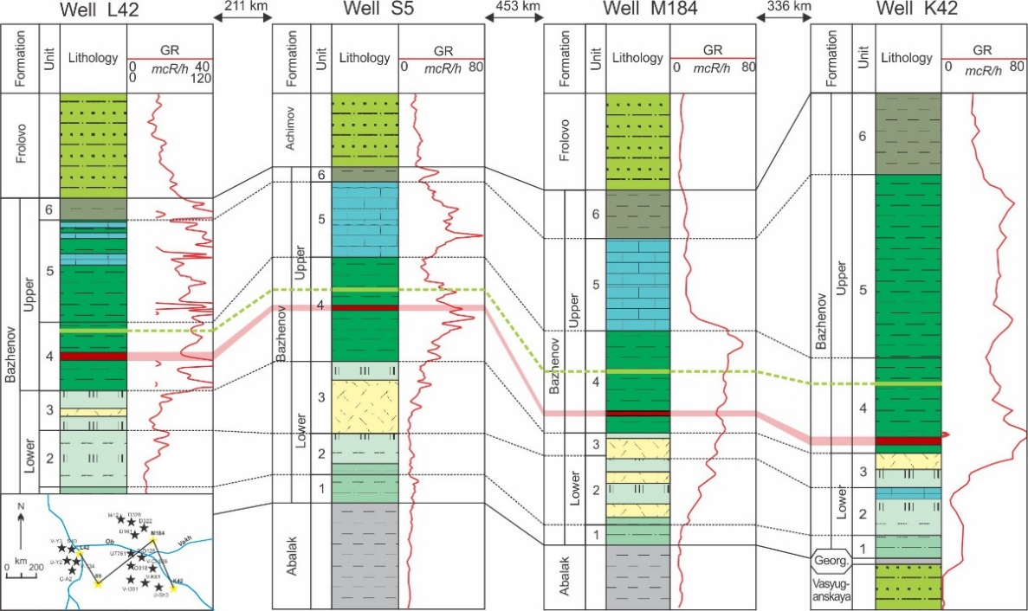
Figure 11. Stratigraphic cross-section showing the position of the alginite-rich layers (marked in red) and tuffs (marked in light green) through the Bazhenov sequence. Location of the well and correlation line are in the map. The legends of lithology are the same with those in Figure 2. GR – gamma-ray log.
Luminescence of the alginite-rich layers is associated with significant amount of luminescent alginite in theirs composition. During the study, we have not found any luminescent alginite-rich layers in wells with the degree of OM maturity after the middle of the oil window. This observation allows us to suggest that at a certain thermal maturity degree during realization of the generation potential of OM, the luminescent alginite-rich layers lose their luminescence. Speight and Huc have described samples of type I kerogen containing algobacterial material that luminescent under UV light at low maturity stages, and the intensity of luminescence gradually decreases and disappears with maturation [83,84]. Therefore, since OM reaches the middle of the oil window the luminescence of the alginite-rich layers extinguished and they can be distinguished by geochemical data.
Luminescence of the alginite-rich layers can be used to confirm the thermal maturity parameters of Rock-Eval pyrolysis or biomarker analysis of Bazhenov deposits from immature conditions (PC3) up to the early to middle oil window (MC1-2). Generally, luminescence colors of the alginite-rich layers change from greenish-yellow to bright yellow to orange under UV light before luminescence is mostly extinguished at the middle oil window (Figure 12). Decreasing of alginite luminescence of high maturity level is due to decreasing of the ratios of both hydrogen and oxygen to carbon and increased molecular aromatization [85-88].
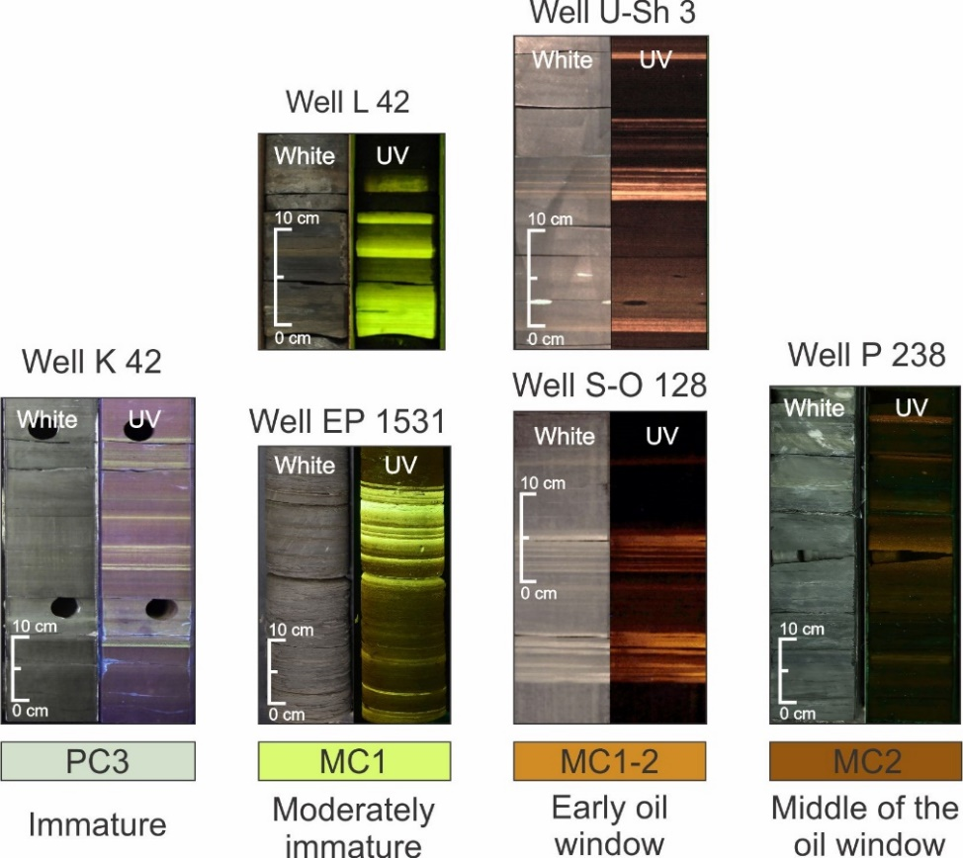
Figure 12. Color of the luminescent alginite-rich layers in the Bazhenov deposits of different maturity.
Hydrocarbon generation potential of the alginite-rich layers significantly higher than in the host rocks enriched in type II kerogen. Value of S2 for the alginite-rich layers is 2–2.5 times higher than in the host rocks and reaches 250 mg HC/g rocks. The prevalence of aliphatic compounds in generated hydrocarbons by type I kerogen propose the high quality of the produced crude oils. Therefore, the alginite-rich layers improve the petroleum generation potential of the Bazhenov Formation and suggested to be a significant contributor to hydrocarbon formation. Since type II kerogen exhausted its petroleum generation potential at high maturity level of the Bazhenov Formation, type I kerogen of the alginite-rich layers still holds its high hydrocarbon potential and are capable of producing light oils. In the oil fields within Western Siberian basin with a high OM maturity (Verkhnesalymskoye, Krasnoleninskoye, Sredne-Nazymskoye) type I kerogen is possibly the major source of petroleum derived from the Bazhenov strata.
High content of type I kerogen is concentrated in luminescent Stellarites of Late Carboniferous within the Stellarton basin in Canada [89,90]. OM-rich sediments of the Late Jurassic-Early Cretaceous age were found in the southern part of the Barents Sea [91,92]. The Blackstone layer of the Late Jurassic Kimmeridge Formation consist primarily of algal origin OM [93,94]. The other records of abundant algae confirm that they can be important contributors of OM to source rock deposits.

6. Conclusions
The luminescent alginite-rich layers were discovered in many wells of the Western Siberia petroleum basin, distributed over the area of 0.5 million km². They situated stratigraphically in the Upper part of the Bazhenov Formation. Individual laminas have the thickness from 1 to 50 mm, total thickness of the layers in one cross-section reaches 1 m.
We have determined the key characteristics during the comparative analysis of the alginite-rich layers with host rocks and luminescent tuffs. For the alginite-rich layers, luminescence under UV light associated with algal OM. Obtained for the alginite-rich layers abnormally high HI values, high atomic H/C and the single activation energy of thermal decomposition are typical for type I kerogen. The stable isotope composition of carbon has close values for the alginite-rich layers and host rocks, whereas tuffs have higher and more positive values. More significant differences were found in the elemental and isotope composition of nitrogen and sulfur compared to host rocks and tuffs.
The obtained results show extensive environmental changes during short-term in the geological timescale period occurred during sedimentation in paleobasin on the territory of modern Western Siberia. Due to these changes, considerable amount of algal-rich OM had been accumulated in most parts of the paleosea, most probably as a result of algal blooms.
For practical purposes, the described alginite-rich layers can become a tool for correlation of the Bazhenov sequence. An exceptionally high generation potential of the alginite-rich layers organic matter and the composition of thermal destruction products are to be taken into consideration during basin modeling of the Western Siberian petroleum basin.

Author Contributions: Conceptualization, methodology and manuscript preparation – T.B.; E.K. and E.L.; supervision – E.K. and M.S.; petrographic, XRD and XRF analysis – T.B.; Rock-Eval pyrolysis, bulk kinetics and elemental analysis – E.K. and T.B.; maceral analysis – N.P.; pyro-GC×GC-TOF MS/FID – E.L.; isotope analysis – A.V.; writing – original draft preparation, T.B., E.K., E.L. and M.S.; writing – review and editing – T.B., E.K., M.S., E.L., A.V., I.P., N.P. and N.M. All authors have read and agreed to the published version of the manuscript.
Funding: This work was supported by the Ministry of Science and Higher Education of the Russian Federation under agreement No. 075-10-2020-119 within the framework of the development program for a world-class Research Center.
Acknowledgments: The authors would like to thank the Center for Hydrocarbon Recovery Laboratory members for technical support. The authors thank anonymous reviewers, whose constructive comments and suggestions greatly improved this manuscript.
Conflicts of Interest: The authors declare no conflict of interest.

References
- Kontorovich, A.E.; Ponomareva, E.V.; Burshtein, L.M.; Glinskikh, V.N.; Kim, N.S.; Kostyreva, E.A.; Pavlova, M.A.; Rodchenko, A.P.; Yan, P.A. Distribution of organic matter in rocks of the Bazhenov horizon (West Siberia). Russian Geology and Geophysics 2018, 59, 285–298. DOI:10.1016/j.rgg.2018.03.007.
- Krasnova, E.A.; Yurchenko, A.Yu.; Kalmykov, A.G.; Fomina, M.M. Isotopic-geochemical peculiarities of the distribution of gas hydrocarbons in the Bazhenov formation section (South part of the Western Siberia). Georesources 2019, 21(2), 153–158. (In Russian). DOI:10.18599/grs.2019.2.153-158
- Goncharov, I.V.; Samoilenko, V.V.; Veklich, M.A.; Zherdeva, A.V.; Shadrina, E.S. 2019. Carbon Isotopic Composition of Extracts from the Rocks of the Bazhenov Formation of Various Catagenesis. In Proceedings of the 29th International Meeting on Organic Geochemistry, Gothenburg, Sweden, 1–6 September 2019. DOI:10.3997/2214-4609.201902916.
- Goncharov, I.V.; Samoilenko, V.V.; Graas, G.W., Trushkov, P.V.; Oblasov, N.V.; Fadeeva, S.V.; Veklich, M.A.; Kashapov, R.S.; Sidorov, D.A. Petroleum generation and migration in the southern Tyumen region, Western Siberia Basin, Russia. Org. Geochem. 2021, 152, 104178. DOI:10.1016/j.orggeochem.2020.104178.
- Kontorovich, A.E.; Fomin, A.N.; Krasavchikov, V.O.; Istomin, A.V. Catagenesis of organic matter at the top and base of the Jurassic complex in the West Siberian megabasin. Russian Geology and Geophysics 2009, 50(11), 917–929. DOI:10.1016/j.rgg.2009.10.001.
- Kontorovich, A.E.; Yan, P.A.; Zamirailova, A.G.; Kostyreva, E.A.; Eder, V.G. Classification of rocks of the Bazhenov Formation. Russian Geology and Geophysics 2016, 57, 1606–1612. DOI:10.1016/j.rgg.2016.10.006.
- Eder, V.G. Pyritization of rocks in black shale/host rock transition zones: Evidence from the Bazhenov Formation, Western Siberia. Lithology and Mineral Resources 2020, 55(3), 218–230. DOI:10.1134/S0024490220030025.
- Bulatov, T.D.; Kozlova, E.V.; Leushina, E.A.; Pronina, N.V.; Panchenko, I.V.; Kostina, Y.V.; Spasennykh, M.Yu. Specific layers containing highly oil-prone organic matter in the Bazhenov Formation. In Proceedings of the 29th International Meeting on Organic Geochemistry, Gothenburg, Sweden, 1–6 September 2019. DOI:10.3997/2214-4609.201902828.
- Bulatov, T.D.; Oksenoyd, E.E.; Semechkova, L.V.; Vtorushina, E.A.; Vtorushin, M.N.; Bashirov, R.I.; Nesterova, L.L. Tuffaceous interlayers in the sediments of the Bazhenov Formation in the central part of West Siberia. In Proceedings of the XXI Scientific conference “Ways of realizing the petroleum and mineral potential of the KhMAO-Yugra”, Khanty-Mansiysk, Russia, 13–17 November 2017. (In Russian)
- Shaldybin, M.V.; Wilson, M.J.; Wilson, L.; Lopushnyak, Yu.M.; Brydson, R.; Krupskaya, V.V.; Kondrashova(Deeva), E.S.; Glotov, A.V.; Goncharov, I.V.; Samoilenko, V.V.; et al. The nature, origin and significance of luminescent layers in the Bazhenov Shale Formation of West Siberia, Russia. Marine and Petroleum Geology 2019, 100, 358–375. DOI:10.1016/j.marpetgeo.2018.11.022.
- Panchenko, I. V.; Sobolev, I. D.; Rogov, M. A.; Latyshev, A. V. Volcanic tuffs and tuffites at the Jurassic-Cretaceous boundary beds (Volgian–Ryazanian stages) of Western Siberia. Lithology and Mineral Resources 2021, 2, 144–183. (In Russian). DOI:10.31857/S0024497X21020051.
- Amon, E.O.; Alekseev, V.P.; Glebov, A.F.; Savenko, V.A.; Fedorov, Y.N. Stratigraphy and paleogeography of the Mesozoic-Cenozoic sedimentary basin of the Shaim petroleum region (Western Siberia); Izd. UGGU: Yekaterinburg, Russia, 2010; p. 257. (In Russian)
- Bulynnikova, S.P.; Golbert, A.V.; Klimova, I.G.; et al. Paleobiofacies of Volgian and Neocomian oil and gas deposits of the West Siberian plate; Nedra: Moscow, USSR, 1978; p. 87. (In Russian)
- Braduchan Yu.V.; Gurari F.G.; Zakharov V.A.; et al. Bazhenov horizon of Western Siberia (stratigraphy, paleogeography, ecosystem, petroleum system); Nauka: Novosibirsk, USSR, 1986; p. 217. (In Russian)
- Golbert, A.V.; Markova, L.G.; Polyakova, I.D.; Sachs, V.N.; Teslenko, Yu.V. Paleolandscapes of West Siberia in Jurassic, Cretaceous, and Paleogene; Nauka: Moscow, USSR, 1968; p. 152. (In Russian)
- Rovnina, L.V.; Rodionova, M.K.; Sadovnikova, V.M.; Mazur, V.M.; Zhiltsova, N.N. Comprehensive studies of the Jurassic and Lower Cretaceous stratigraphy in Western Siberia; Nauka: Moscow, USSR, 1978; p. 140. (In Russian)
- Filina S.I., Korzh M.V., Zonn M.S. Paleogeography and oil-bearing capacity of the Bazhenov formation in Western Siberia; Nauka: Moscow, USSR, 1984; p. 36. (In Russian)
- Amon, E.O. Radiolarians in the Bazhenov Formation (Volgian Stage) of the Latitudinal Ob region, Western Siberia. Trudy IGG UrO RAN 2011, 158, 3–8. (In Russian)
- Baraboshkin, E.Yu.; Panchenko, I.V.; Nemova, V.D.; Shchepetova, E.V.; Smirnova, M.E.; Zuikova, M.V. To the ichnology of Abalak and Bazhenov Formations (Western Siberia). In Proceedings of the 8th All-Russian lithological Symposium, Moscow, Russia, 27-30 October 2015, 60–63. (In Russian)
- Vishnevskaya, V.S.; Ovechkinab, M.N.; Ustinovaa, M.A. Biostratigraphy and paleogeography of the Bazhenovo Formation (Upper Jurassic and Lower Cretaceous) based on radiolarians, nannoplankton and calcareous dinocysts. Paleontological Journal 2019, 53(9), 916–921. DOI:10.1134/S003103011909017X.
- Yurchenko, A.Yu.; Potapova, A.S.; Bumagina, V.A.; Vilesov, A.P.; Cherina, K.N.; Balushkina, N.S.; Kalmykov, G.A.; Khotylev, O.V. Morphological and Lithogenetic Classification of the Carbonate Rocks of the Abalak-Bazhenov Complex. Moscow University Geology Bulletin 2019, 3, 44–50. DOI:10.3103/S0145875219040136.
- Galimov, E.M. Carbon isotopes in oil and gas geology; Nedra: Moscow, USSR, 1973; p. 384. (In Russian)
- Kontorovich, A.E.; Nesterov, I.I.; Salmanov, F.K; et al. Oil and gas geology of Western Siberia; Nedra: Moscow, USSR, 1975; p. 680 (In Russian)
- Neruchev, S.G. Uranium and life in the Earth history; Nedra: Leningrad, USSR, 1982; p. 208. (In Russian)
- Dorofeeva, T.V.; Krasnov, S.G.; Lebedev, B.A.; Petrova, G.V.; Pozinenko, B.V. Oil reservoirs of the Bazhenov Formation in Western Siberia; Nedra: Leningrad, USSR, 1983; p. 131. (In Russian)
- Goncharov, I.V. Geochemistry of Oil in Western Siberia; Nedra Pub. House: Moscow, USSR, 1987; p. 181. (In Russian)
- Lopatin, N.V.; Emets, T.P. Pyrolysis in oil and gas geology; Nauka: Moscow, USSR, 1987; p. 143. (In Russian)
- Gurari, F.G.; Weitz, E.Ya.; Melenevsky, V.N.; Moskvin, V.I.; Perosio, G.N.; Predtechinskaya, E.A.; et al. Formation conditions and methods of searching for oil deposits in mudstones of the Bazhenov Formation; Nedra: Moscow, USSR, 1988; p. 199. (In Russian)
- Zubkov, M.Yu.; Zubareva, N.M.; Sayfullina, A.Kh. The Bazhenov Formation organic matter of the Salym field. Oil and Gas Geology 1988, 5, 19–25. (In Russian)
- Panchenko, I.V.; Nemova, V.D.; Smirnova, M.E.; Ilyina, M.V.; Baraboshkin, E.Yu.; Ilyin, V.S. Stratification and detailed correlation of Bazhenov horizon in the central part of the Western Siberia according to lithological and paleontological core analysis and well logging, Oil and Gas Geology 2016, 6, 22–34. (In Russian)
- Zanin, Yu.N.; Zamirailova, A.G.; Eder, V.G. Nickel, molybdenum, and cobalt in the black shales of the Bazhenov Formation of the West Siberian basin. Geochem. Int. 2017, 55(2), 195–204. DOI:10.1134/S0016702917010116.
- Nesterov, I.I. Oil and gas content of bituminous clays of the Bazhenov Formation in Western Siberia. Soviet geology 1980, 11, 3-10. (In Russian)
- Melenevsky, V.N. Genesis of the organic matter of the Bazhenov Formation. Geology and Geophysics 2000, 41(1), 71–79. (In Russian)
- Goncharov, I.V.; Samoilenko, V.V.; Oblasov, N.V. 2014. Prospects of Shale Oil Bazhenov Formation in the South-East of Western Siberia. In Proceedings of the SPE Russian Oil and Gas Exploration & Production Technical Conference and Exhibition, Moscow, Russia, 14-16 October 2014. DOI:10.2118/171170-MS.
- Dakhnova, M.V.; Mozhegova, S.V.; Nazarova, E.S.; Paizanskaya, I.L. Evaluation of reserves of shale oil using geochemical parameters. Oil and Gas Geology 2015, 4, 55–61. (In Russian)
- Kozlova, E.V.; Fadeeva, N.P.; Kalmykov, G.A.; Balushkina, N.S.; Pronina, N.V.; Poludetkina, E.N.; Kostenko, O.V.; et al. Geochemical technique of organic matter research in deposits enrich in kerogen (the Bazhenov Formation, West Siberia). Moscow University Geology Bulletin 2015, 70(6), 409–418. DOI:10.3103/S0145875215050075.
- Kalmykov, G.A.; Balushkina, N.S. Model of oil saturation of the pore space of the Bazhenov Formation rocks within Western Siberia and its use for assessing the resource potential; Geos Publ.: Moscow, Russia, 2017; p. 247. (In Russian)
- Volkov, V.A.; Oleinik, E.V.; Oksenoid, E.E.; Solopakhina, L.A. On the type of organic matter in the rocks of the Bazhenov Formation. Subsoil User Bulletin 2016, 28. (In Russian)
- Goncharov, I.V.; Samoilenko, V.V.; Oblasov, N.V.; Fadeeva, S.V.; Veklich, M.A.; Kashapov, R.S.; Trushkov, P.V.; Bahtina, E.S. Types of organic matter and catagenesis of the Bazhenov formation and its same-aged analogues. Oil Industry 2016, 10, 20–25. (In Russian)
- Kozlova, E.V.; Spasennykh, M.Yu.; Kalmykov, G.A.; Gutman, I.S.; Potemkin, G.N.; Alekseev, A.D. Balance of the petroleum hydrocarbon compounds in pyrolyzed organic matter of the Bazhenov Formation. Oil industry 2017, 3, 18–21. (In Russian)
- Fomin, A.N. Catagenesis of organic matter and petroleum potential of Mesozoic and Paleozoic deposits of the West Siberian megabasin; IPGG SB RAS: Novosibirsk, Russia, 2011; p. 331. (In Russian)
- Kalmykov, A.G.; Karpov, Yu.A.; Topchiy, M.S.; Fomina, M.M.; Manuilova, E.A.; Sheremeteva, E.V.; et al. The effect of catagenetic maturity on the formation of reservoirs with organic porosity in the Bazhenov formation and peculiarities of their extension. Georesources 2019, 21(2), 159–171. (In Russian). DOI:10.18599/grs.2019.2.159-171.
- Vassoevich, N.B. Geochemistry of organic matter and origin of petroleum; Nauka: Moscow, USSR, 1986; p. 368. (In Russian).
- Shpilman, V.I.; Solopahia, L.A.; Pyatkov, V.I. New tectonic map of the central regions of Western Siberia; Putived Publ.: Khanty-Mansiysk, Russia, 1999. (In Russian)
- Skvortsov, M.B.; Dakhnova, M.V.; Mozhegova, S.V.; Kirsanov, A.M.; Komkov, I.K.; Paizanskaya, I.L. Geochemical methods for prediction and assessment of shale oil resources (case study of Bazhenov Formation). Geology and Geophysics 2017, 58(3-4), 495–503. (In Russian). DOI:10.15372/GiG20170312.
- Maglevannaia, P.S.; Kozlova1, E.V.; Spasennykh, M.Yu. Analysis of geochemical trends for the Bazhenov oil shale formation based on pyrolysis data. In Proceedings of the 29th International Meeting on Organic Geochemistry, Gothenburg, Sweden, 1–6 September 2019. DOI:10.3997/2214-4609.201902830.
- Gusev, I.M.; Panchenko, I.V.; Smirnova, M.E.; Taldykin, Y.B.; Kulikov, P.Yu. Approaches to assessing the maturity of organic matter in the Bazhenovo formation according to a comparison of pyrolytic parameters, lithology and stratigraphy of sections. In Proceedings of the 8th All-Russian Meeting with international participation, Syktyvkar, Russia, 7–10 September 2020, 54–58. (In Russian)
- Leushina, E.; Kozlova, E.; Voropaev, A.; Yurchenko, A.; Bogdanovich, N.; Spasennykh, M. 2019. Characterization of the organic matter in the Bazhenov Formation deposits from Northern and Central parts of Western Siberia. In Proceedings of the 6th EAGE Shale Workshop, Bordeaux, France, April-May 28-01, 2019. DOI:10.3997/2214-4609.201900323.
- Spasennykh, M.; Voropaev, A.; Kozlova, E.; Leushina, E.; Polyakov, V.; Vasiliev, A.; Bogdanovich, N.; Popov, Y.; Maximov, A. Organic matter of Bazhenov Formation: Chemical and isotope composition, microstructure, thermal maturation, generation potential and the effect on rock properties. In Proceedings of the 6th EAGE Shale Workshop, Bordeaux, France, April-May 28-01, 2019. DOI:10.3997/2214-4609.201900331.
- ISO 7404-3 2009: Methods for the Petrographic Analysis of Coals — Part 3: Method of Determining Maceral Group Composition. International Organization for Standardization, Geneva, Switzerland, 1–7.
- International Committee for Coal Petrology (ICCP). The new inertinite classification (ICCP System 1994). Fuel 2001, 80(4), 459–471. DOI:10.1016/S0016-2361(00)00102-2.
- Sykorova I.; Pickel W.; Christanis K.; Wolf M.; Taylor G.H.; Flores, D. Classification of huminite-ICCP System 1994. Int. J. Coal Geol. 2005, 62(1-2), 85–106. DOI:10.1016/j.coal.2004.06.006.
- Pickel W.; Kus J.; Flores D.; Kalaitzidis S.; Christanis K.; Cardott B.J.; Misz-Kennan M.; Rodrigues S.; Hentschel A.; Hamor-Vido M.; Crosdale P.; Wagner N. Classification of liptinite — ICCP System 1994. Int. J. Coal Geol. 2017, 169, 40–61. DOI:10.1016/j.coal.2016.11.004.
- Espitalie, J.; Laporte, J.L.; Madec, M.; Marquis, F.; Leplat, P.; Paulet, J.; Boutefeu, A. Source rock characterization method for petroleum exploration. In Proceedings of the 9th Annual Offshore Technology Conf., Houston, USA, May 1977. DOI:10.4043/2935-MS.
- Peters, K.E. Guidelines for evaluating petroleum source rock using programmed pyrolysis. AAPG Bulletin 1986, 70(3), 318–329. DOI:10.1306/94885688-1704-11D7-8645000102C1865D.
- Tissot, B.P.; Pelet, R.; Ungerer, P.H. Thermal history of sedimentary basins, maturation indices, and kinetics of oil and gas generation. AAPG Bulletin 1987, 71(12), 1445-1466. DOI:10.1306/703C80E7-1707-11D7-8645000102C1865D.
- Tissot, B.P.; Welte, D.H. Petroleum formation and occurrence, second edition; Springer-Verlag., Berlin, Germany, 1984; p. 699.
- Pepper, A.S.; Corvi, P.J. Simple kinetic models of petroleum formation. Part I: oil and gas generation from kerogen. Marine and Petroleum Geology 1995, 12(3), 291–319. DOI:10.1016/0264-8172(95)98381-E.
- Horshfield, B. Practical criteria for classifying kerogens: Some observations from pyrolysis-gas chromatography. Geochimica et Cosmochimica Acta 1989, 53, 891–901. DOI:10.1016/0016-7037(89)90033-1.
- Giraud, A. Application of pyrolysis and gas chromatography to geochemical characterization of kerogen in sedimentary rocks. AAPG Bulletin 1970, 54(3), 439–451. DOI:10.1306/5D25C9AD-16C1-11D7-8645000102C1865D.
- Dembicki, Jr.H. Three common source rock evaluation errors made by geologists during prospect or play appraisals. AAPG Bulletin 2009, 93(3), 341–356. DOI:10.1306/10230808076.
- Kontorovich, A.E.; Bogorodskaya, L.I.; Borisova, L.S.; Burshtein, L.M.; Ismagilov, Z.R.; et al. Geochemistry and catagenetic transformation of kerogen from the Bazhenov Horizon. Geochemistry International 2019, 57 (6), 621–634. DOI: 10.1134/S0016702919060028.
- Dakhnova, M.V.; Pankina, R.G.; Korab, Z.; Glogochyevski, Ya.Ya.; Stshetatski, Ya.S. Identification of hydrocarbon generation zones in Zechstein Main Dolomite of Permian region in Poland. Oil and Gas Geology 1981, 4, 49–55. (In Russian)
- Kusakabe, M.; Mizutani, Y.; Kometani, M. A preliminary stable isotope study of volcanic ashes discharged by the 1979 eruption of on take Volcano, Nagano, Japan. Bull. Volcanol. 1982, 45(3), 203–209. DOI:10.1007/BF02597731.
- Ikehata, K.; Maruoka, T. Sulfur isotopic characteristics of volcanic products from the September 2014 Mount Ontake eruption, Japan. Earth Planet Sp 2016, 68:116. DOI:10.1186/s40623-016-0496-z.
- Meyers P.A.; Leenheer M.J.; Kawka O.E.; Trull T.W. Enhanced preservation of marine-derived organic matter in Cenomanian black shales from the southern Angola Basin. Nature 1984, 312, 356–359. DOI:10.1038/312356a0.
- Rau, G.H.; Arthur, M.A.; Dean, W.E. 15N/14N variations in Cretaceous Atlantic sedimentary sequences: implication for past changes in marine nitrogen biogeochemistry. Earth Planet. Sci. Lett. 1987, 82(3-4), 269–279. DOI:10.1016/0012-821X(87)90201-9.
- Ohkouchi, N.; Kuroda, J.; Okada, M.; Tokuyama, H. Why Cretaceous black shales have high C/N ratios? Implications from SEM-EDX observations for Livello Bonarelli black shales at the Cenomanian-Turonian boundary. Front. Res. Earth Evol. 2003, 1, 239–241.
- Galimov, E.M. Isotope Organic Geochemistry. Organic Geochemistry 2006, 37, 1200–1262. DOI:10.1016/j.orggeochem.2006.04.009.
- Macko, S.A.; Fogel (Estep), M.L.; Hare, P.E.; Hoering, T.C. Isotopic fractionation of nitrogen and carbon in the synthesis of amino acids by microorganisms. Chemical Geology 1987, 65(1), 79–92. DOI:10.1016/0168-9622(87)90064-9.
- Shaldybin, M.V.; Krupskaya, V.V.; Glotov, A.V.; Dorjieva, O.V.; Goncharov, I.V.; Samoilenko, V.V.; et al. Petrography and clay mineralogy of anomaly luminescent layers in Bazhenov suite of Western Siberia sedimentary basin. Oil Industry 2018, 2, 36–40. (In Russian). DOI:10.24887/0028-2448-2018-2-36-40.
- Taylor, T.; Longo, A. Valuing algal bloom in the Black Sea Coast of Bulgaria: A choice experiments approach. Journal of Environmental Management 2010, 91(10), 1963–1971. DOI:10.1016/j.jenvman.2010.04.007.
- Ferrante, M.; Oliveri Conti, G.; Fiore, M.; Rapisarda, V.; Ledda, C. Harmful Algal Blooms in The Mediterranean Sea: Effects on Human Health. Euromediterranean Biomedical Journal 2013, 8, 25–34. DOI:10.3269/1970-5492.2013.8.6.
- Van, A.V.; Kazansky, Yu.P. Volcanoclastic material in sediments and sedimentary rocks; Nauka: Novosibirsk, USSR, 1985; p. 128. (In Russian)
- Fujimura, R.; Sato, Y.; Nishizawa, T.; Nanba, K.; Oshima, K.; Hattori, M.; Kamijo, T.; Ohta, H. Analysis of early bacterial communities on volcanic deposits on the Island of Miyake (Miyakejima), Japan: a 6-year study at a fixed site. Microbes Environ. 2012, 27: 19–29. DOI:10.1264/jsme2.ME11207.
- Zhang, R.; Jiang, T.; Tian, Y.; Xie, S.; Zhou, L.; Li, Q.; Jiao, N. Volcanic ash stimulates growth of marine autotrophic and heterotrophic microorganisms. Geology 2017, 45(8), https://doi:10.1130/G38833.1.
- Predtechenskaya, E.A.; Krol, L.A.; Gurari, F.G.; Sapyanik, V.V.; Perosio, G.N.; Malyushko, L.D. On the genesis of carbonates in the Bazhenov Formation within the central and southeastern regions of the West Siberian plate. Lithosphere 2006, 4, 131–148. (In Russian)
- Khotylev, O.V.; Balushkina, N.A.; Vishnevskaya, V.S.; Korobova, N.I.; Kalmykov, G.A.; Roslyakova, A.S. A Model of the Accumulation of Radiolarite Layers in the Bazhenov Formation of West Siberia. Moscow Univ. Geol. Bull. 2019, 74, 206–211. DOI:10.3103/S0145875219020054.
- Tian, R., Lin, Q., Li., D., Zhang, W., Zhao, X., 2020. Atmospheric transport of nutrients during a harmful algal bloom event. Regional Studies in Marine Science 2020, 34, 101007. DOI:10.1016/j.rsma.2019.101007.
- Hallegraeff, G.M.; Anderson, D.M.; Cembella, A.D.; Enevoldsen, H.O. Manual on Harmful Marine Microalgae. 2nd ed.; UNESCO, Paris, France, 2004; p. 793.
- Golbert, A.V. Regional paleoclimatology of Siberia (Jurassic-Paleogene. Methods, results), Doct. Diss.-SNIIGGiMS, Novosibirsk, Russia, 1983. p. 396. (In Russian)
- Surkov, A.V. Some features of detrital quartz grains from aeolian and marine beach sediments. Izv. Universities. Geol. and development 1987, 4, 143–145. (In Russian)
- Huc, A. Geochemistry of fossil fuels: from conventional to unconventional hydrocarbon systems; Editions Technip, Paris, France, 2013; p. 254.
- Speight, J.G. Shale Oil and Gas Production Processes. Gulf Professional Publishing; Elsevier, Oxford, United Kingdom, 2020; p. 1046.
- Bertrand, P.; Pittion, J.L.; Bernaud, C. Fluorescence of organic matter in relation to its chemical composition. Org. Geochem. 1986, 10, 641–647. DOI:10.1016/0146-6380(86)90061-6.
- Pradier, B.; Bertrand, P.; Martinez, L.; Laggoun-DeFarge, F. Fluorescence of organic matter and thermal maturity assessment. Org. Geochem. 1991, 17, 511–524. DOI:10.1016/0146-6380(91)90115-Z.
- Hackley, P.C.; Cardott, B.J. Application of organic petrography in North American shale petroleum systems: A review. Int. J. Coal Geol. 2016, 163, 8–51. DOI:10.1016/j.coal.2016.06.010.
- Abarghani, A.; Ostadhassan, M.; Hackley, P.C.; Pomerantz, A.E.; Nejati, S. A chemo-mechanical snapshot of in-situ conversion of kerogen to petroleum. Geochimica et Cosmochimica Acta 2020, 273, 37–50. DOI:10.1016/j.gca.2020.01.019.
- Kalkreuth, W.; Naylor, R.; Pratt, K.; Smith, W. Fluorescence properties of alginite-rich oil shales from the Stellarton Basin, Canada. Fuel 1990, 69(2), 139–144. DOI:10.1016/0016-2361(90)90163-K.
- Smith, W.D.; Peter, C.J.St.; Naylor, R.D.; Mukhopadhyay, P.K.; Kalkreuth, W.D.; Ball, F.D.; Macauley, G. Composition and depositional environment of major eastern Canadian oil shales. Int. J. Coal Geol. 1991, 19(1-4), 385–438. DOI:10.1016/0166-5162(91)90028-H.
- Langrock, U.; Stein, R. Origin of marine petroleum source rocks from the Late Jurassic/Early Cretaceous Norwegian Greenland Seaway–Evidence for stagnation and upwelling. Marine and Petroleum Geology 2004, 21(2), 157–176. DOI:10.1016/j.marpetgeo.2003.11.011.
- Stein, R. The late Mesozoic‐Cenozoic Arctic Ocean climate and sea ice history: A challenge for past and future scientific ocean drilling. Paleoceanography and Paleoclimatology 2019, 34, 1851–1894. DOI:10.1029/2018PA003433.
- Ioannides, N.S.; Stavrinos, G.N.; Downie, C. Kimmeridgian microplankton from Clavell's Hard, Dorset, England. Micropaleontology 1976, 22(4), 443–478. DOI:10.2307/1485174.
- Morgans-Bell, H.S.; Coe, A.L.; Hesselbo, S.P.; Jenkyns, H.C.; Weedon, G.P.; Marshall, J.A.; Tyson, R.V.; Williams, C.J. Integrated stratigraphy of the Kimmeridge Clay Formation (Upper Jurassic) based on exposures and boreholes in South Dorset, UK. Geol. Mag. 2011, 138(5), 511–539. DOI:10.1017/S0016756801005738.

