Article
Assessment of seismic bedrock in deep alluvial plains. Case studies from the Emilia-Romagna plain
Luca Martelli
Citation: Lastname, F.; Lastname, F.; Last-name, F. Title. Geosciences 2021, 11, x. https://doi.org/10.3390/xxxxx
Received: date
Accepted: date
Published: date
Publisher’s Note: MDPI stays neutral with regard to jurisdictional claims in published maps and institutional affiliations.

Copyright: © 2020 by the authors. Submitted for possible open access publication under the terms and conditions of the Creative Commons Attribution (CC BY) license (http://creativecommons.org/licenses/by/4.0/).
Regione Emilia-Romagna - Servizio geologico, sismico e dei suoli, Bologna (Italy)
e-mail: luca.martelli@regione.emilia-romagna.it
Abstract: The estimate of the seismic shaking is essential for a realistic assessment of the local seismic hazard and the implementation of effective strategies for prevention and mitigation of the seismic risk. One of the most important aspects in the analysis of the site seismic assessment is the recognition of the seismic bedrock and its depth. Unfortunately, these data are not always easy to evaluate, especially in areas where the thickness of loose or poorly consolidated sediments is high. This article illustrates data and case studies from the Emilia-Romagna sector of the Po Plain, in order to provide examples and suggestions for the recognition of the seismic bedrock in alluvial and coastal areas characterised by significant thicknesses of unconsolidated sediments, using available data and not expensive geophysical surveys. The application of the proposed method indicates that the study area can be divided into 4 domains characterized by different depths of the seismic bedrock: the marginal or pede-Apennine belt, the high structural zones, the syncline/minor anticline zones, and the Po delta-coast zone.
Keywords: seismic bedrock, geological substratum, ambient vibrations, Vs propagation, Po Plain stratigraphy

1. Introduction
It is known that loose and poorly consolidated sediments, such as recent alluvial deposits or slope debris, can change the amplitude, frequency, and duration of the seismic motion [e.g., 1, 2].
Therefore, it is very important for the evaluation of the expected seismic motion to know the thickness of loose sediments, poorly consolidated deposits and weathered or fractured rocks, i.e. to identify the depth below which the lithotypes have rigid behaviour.
The recognition of the rigid substratum, or seismic bedrock, can be complex in the case of non-rigid sediments with a thickness greater than 50 m, considering that the economic resources usually available only allow the use of current geophysical techniques (down-hole, MASW, ReMi) which rarely allow investigation beyond this depth.
This problem arises both in seismic microzonation studies for urban planning and in the estimates of expected seismic motion for design and therefore has significant implications in the prevention and reduction of seismic risk.
Mascandola et al. (2019) [3] already discussed this topic and proposed a map of the seismic bedrock in the Po Plain, based on environmental noise measurements, from pre-existing and new data. The article is undoubtedly a fundamental reference on the subject, but the scale of the map does not allow its direct application, neither for urban planning, which operates at a municipal or inhabited center scale, nor at the site scale for the design. Furthermore, some in-depth investigations carried out for seismic microzonation studies, have shown that the surface mapped by Mascandola et al. (2019) [3] does not always correspond to the roof of the engineering seismic bedrock, i.e. the surface below which the shear wave velocity (Vs) reaches and exceeds 800 m/s. Finally, the study by Mascandola et al. (2019) [3] has not been extended to the southern plain, near the Apennines hills.
The aim of this article is to provide useful information for the assessment of the seismic bedrock depth in wide and deep alluvial basins, such as the Po Plain, using data available in the literature and/or acquired through relatively inexpensive surveys. For this purpose, case studies in significant sites of the Emilia-Romagna plain will be illustrated.
The proposed procedure is based on the comparison between Vs profiles, lithostratigraphic data and values of the resonance frequency of the ground (Fn) acquired with recordings of environmental vibrations [4].
It is commonly accepted in the literature [e.g., 5, 6] that Fn depends on the thickness of the unconsolidated sediments (H) and the average speed of the shear waves in the thickness range H (${\overline{\text{V}}}_{\text{S}}$) according to the relationship:
$${\text{F}}_{\text{n}}\text{=}\frac{{\overline{\text{V}}}_{\text{S}}}{\text{4H}}$$
It is therefore clear how, by having Fn values, Vs profiles and information on the subsoil lithostratigraphy, it is possible to estimate with a certain reliability the thickness H, i.e. the depth of the main resonant surface comparable to the roof of the bedrock.
The use of ambient vibrations for the seismic-stratigraphic characterization of the subsoil is not new [e.g., 5] but even today the application of this procedure is not always optimal as the interpretation is often not supported by the comparison with lithostratigraphic data, even though these are readily available.
Seismic microzonation studies carried out in the Emilia-Romagna plain (https://geo.regione.emilia-romagna.it/schede/pnsrs/) indicate that the interest range of the ground frequency Fn is between 0.2 Hz and 20 Hz and that, in general terms, thickness ranges of unconsolidated sediments can be associated with Fn values (Table 1). The overlaps of the thickness ranges in Table 1 depend on the Vs variability of the unconsolidated sediments.
Table 1. Comparison between ground frequency and unconsolidated sediments thickness in the Emilia-Romagna plain [modified from 7].
Ground frequency | Unconsolidated sediments thickness
Fn ≤ 0,6 Hz | H ≥ 130 m
0,6 < Fn ≤ 1,2 Hz | 170 ≤ H < 50 m
1,2 < Fn ≤ 2 Hz | 80 ≤ H < 20 m
2 < Fn ≤ 5 Hz | 30 ≤ H < 8 m
5 <Fn ≤ 20 Hz | H ≤ 12 m
  - Definitions of cover sediments, geological substratum, seismic bedrock
Geophysical investigations, conducted both in mountain areas and in the plains, show that the lithotypes characterised by rigid behavior do not always coincide with the geological substratum.
To understand this difference, it is important to define “cover sediments”, “geological substratum”, and “seismic bedrock”.
Cover sediments: lithostratigraphic succession consisting of loose and/or poorly consolidated sediments, such as slope debris, recent alluvial deposits (e.g., younger than 1 Ma), and/or weathered/fractured rocks. Generally, these sediments are characterised by Vs<400 m/s and assume importance for the site seismic assessment if the thickness is greater than 3 m.
Geological substratum: lithostratigraphic succession generally made up of diagenised or consolidated rocks, at the base of the cover sediments. In the Po Plain, the geological substratum of the alluvial sediments is made up of consolidated marine sediments.
Seismic bedrock: lithostratigraphic succession characterised by rigid behaviour, that is rocks characterised by Vs significantly higher than that of the sediments above (e.g., Vs_{bedrock}/Vs_{cover}>2). In the design rules [e.g., 8, 9] the seismic bedrock is defined as rock or rock-like geological formation characterised by Vs>800 m/s (ground type A); for this reason, a stiff geological unit characterised by Vs≥800 m/s is also indicated as “engineering bedrock” [e.g., 3].
To better understand the importance of the above definitions, it is important to consider that the geological substratum can act as a seismic bedrock even in the case of Vs<800 m/s, if the seismic impedance contrast between substratum and cover is significant.
Figure 1 shows geophysical tests carried out on a landslide in the Northern Apennines [10]. In this site, ambient noise measurements show a peak of the horizontal to vertical spectral ratios (H/V) at the frequency of 3.6÷3.8 Hz. To identify the depth of the surface responsible for this peak, a borehole was drilled, and a direct Vs measurement (down-hole) was carried out. Landslide debris was drilled up to a depth of 25 m and then a substratum consisting of compact grey marls was drilled up to the bottom hole (40 m). The grey marls can be correlated with the Montepiano Marls (upper Eocene-Lower Oligocene), extensively outcropping in the surrounding areas. The down-hole test recorded 300<Vs<450 m/s in the landslide debris and 600<Vs<750 m/s in the first 13 m of substratum. The results of the two tests are perfectly consistent and this made it possible to recognise that the Montepiano Marls behave like seismic bedrock, even though Vs<800 m/s (in the tested thickness).
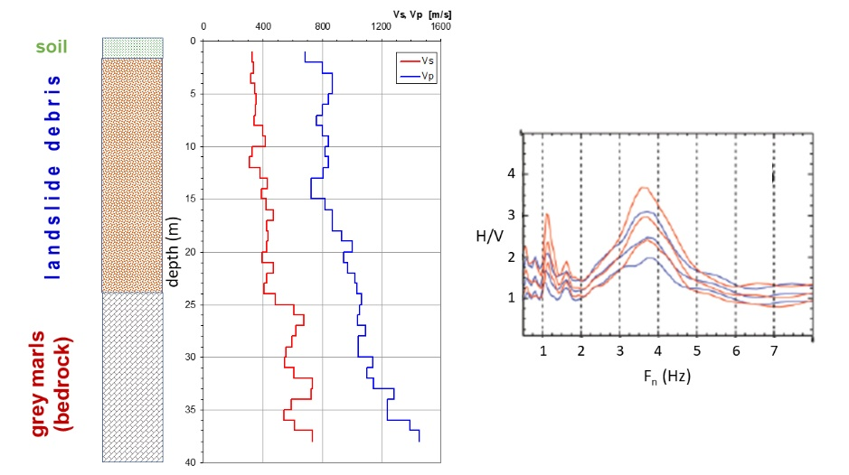
Figure 1. Comparison between stratigraphic log, Vs profiles from down-hole and ambient noise in an Apennines site characterised by debris cover (landslide) on marly geological substratum [modified from 10].
Similar cases are frequent in the Apennines.

2. Useful documents
The first step in the recognition of the seismic bedrock is to reconstruct the geological model. The deep geological cross-sections are essential in order to identify the geological substratum.
The sheets of the Geological Map of Italy 1: 50.000, and related sketches, explanatory notes, and cross-sections, are available on the website of the Geological Survey of Italy: https://www.isprambiente.gov.it/Media/carg/. Some sheets of plain areas are accompanied by subsoil maps, which represent the main buried geological elements (roof of the sandy/gravelly horizons, unconformities, tectonic structures, roof of the geological substratum, …).
As regards the first 500÷600 m of subsoil of the Po Plain valuable information is available in the studies carried out by Emilia-Romagna Region and Lombardy Region, in collaboration with ENI, for the characterisation of the water resources [11, 12]. In these publications, maps of the isobaths and thicknesses of the main aquifers and cross-sections up to the geological substratum are available. A similar study, although with less detailed maps and geological cross-sections, was also carried out by the Piedmont Region, in collaboration with the CNR and the University of Turin [13].
The study on the aquifers of the Ferrara Province is a local update on the Po Plain subsoil [14].
The most important geological cross-sections (carried out by the regional Geological, Seismic and Soil Survey) and some geotechnical tests in the Emilia-Romagna plain are available on the Emilia-Romagna Region website https://geo.regione.emilia-romagna.it/cartografia_sgss/user/viewer.jsp?service=sezioni_geo.
Finally, useful information for the geological, geotechnical, and geophysical characterisation of the subsoil can be found in seismic microzonation studies. Italian seismic microzonation studies, carried out with the funds of Law 77/2009, art. 11, are available on the DPC website https://www.webms.it/, managed by CNR-IGAG. Seismic microzonation studies of Emilia-Romagna Region are also available on the website http://geo.regione.emilia-romagna.it/schede/pnsrs/

3. Geological framework
The Po Plain is the largest alluvial plain in Italy and is limited by the Southern Alps to the north, the Western Alps to the west, the Northern Apennines to the south and the Adriatic Sea to the east (Fig. 2). The Emilia-Romagna plain constitutes the central-southern and eastern sectors.
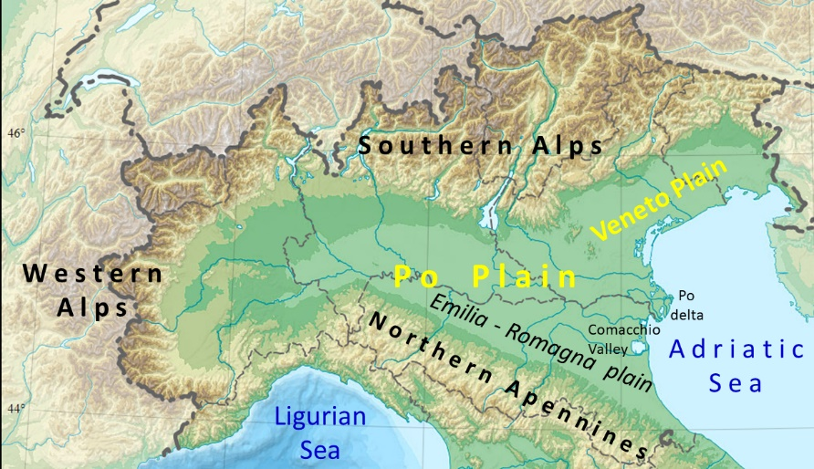
Figure 2. Geographical framework of the Po Plain.
The Po Plain represents the foredeep of two chains with opposite vergence. The Northern Apennines, south side, are north-verging, and their front does not coincide with the morphological transition from the hill to the plain but is made up of buried thrusts (Fig. 3) belonging to the Emilia Folds and Ferrara Folds [15]. The Southern Alps, north side, have vergence towards the south and the front is also buried by the alluvial deposits. So, the subsoil of the Po Plain is structured into anticlines and synclines and the thickness of alluvial sediments is very variable, even in the distal areas: from over 500÷600 m in the synclines up to a few tens of meters on the anticlines (Fig. 4).
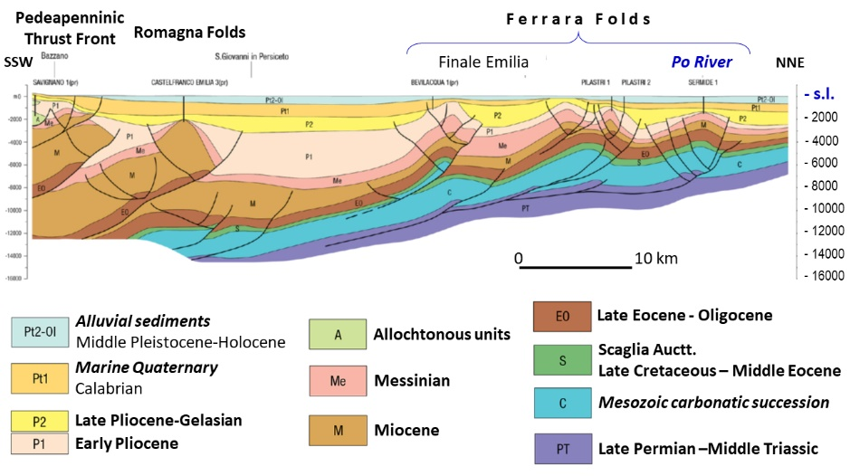
Figure 3. Geological cross-section from the Bologna Apennines to the Po River [16]); trace in Figure 4.
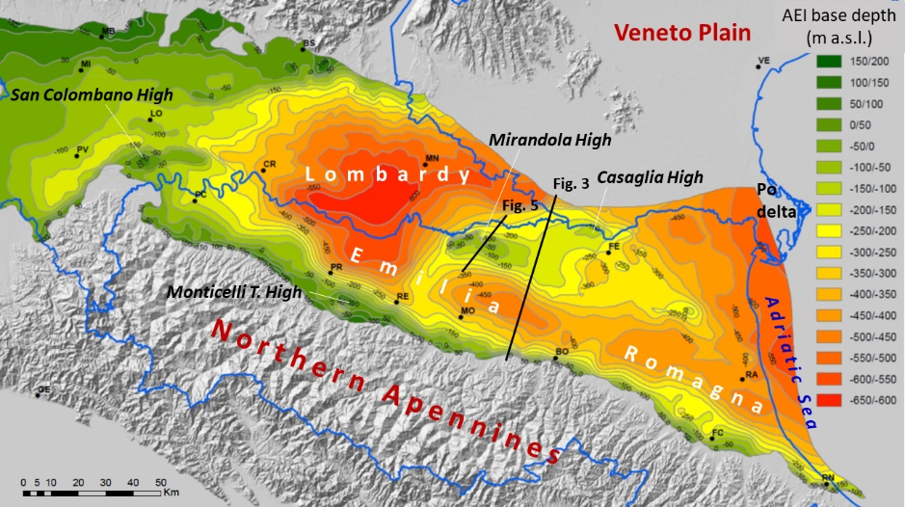
Figure 4. Map of the basal unconformity of the alluvial deposits in the Lombard and Emilia-Romagna plain (isobaths referred to the sea level) [modified from 11 and 12]; the black dots indicate the main cities.
The alluvial sediments of the Emilia-Romagna plain are the result of the depositional activity of the Po River and its right tributaries and can be divided into two main stratigraphic units (Fig. 5): the lower Emiliano-Romagnolo Synthem (0.65-0.45 Ma) and the Upper Emilia-Romagna Synthem (0.45 Ma - Present), both limited at the base by discontinuity surfaces [11]. The literature indicates these Synthems with the acronyms AEI and AES [11, 12; see also Geological Map of Italy: https://www.isprambiente.gov.it/Media/carg/emilia.html) or SERI and SERS [16, 17, 18]. Both Synthems can be divided into subunits made up of alternations of coarse (sands and gravels) and fine (clays and silts) sediments. The coarse sediments are obviously prevalent in the marginal areas while the successions of the distal areas, both in the synclines and on the anticlines, are made up of prevailing fine sediments (clays and silts), with intercalations of sandy horizons. The most superficial deposits, Holocene in age, are loose sediments; the consolidation degree of the underlying sediments increases with depth; however, the alluvial sediments of the Po Plain, even those at greater depth, are poorly consolidated and susceptible to subsidence.
Figure 5. Geological cross-section through the Modena plain and the Mantua Province south of the Po River [19).

The substratum is generally made up of transitional sands, Middle Pleistocene in age (Imola Sands, Yellow Sands, Costamezzana Synthem Auctt.), and marine sediments (alternating clay, marl, and sandstone), Pliocene-Lower Pleistocene in age (known as Argille Azzurre Auctt.), extensively outcropping in the Apennines hills [20, 11].
Apennines and Alps are still-forming chains, as evidenced by the frequent seismicity recorded on the front of the two chains [e.g., 18, 21]. So, the tectonic activity influenced the sedimentation of all geological units, whose basal discontinuity surfaces are characterised by angular unconformity, more evident at the basin margins and in the high structural areas (Fig. 5).

4. Case studies
Based on the variability of the thickness of the alluvial cover and the distribution of lithotypes, large alluvial basins can be divided into:
1) marginal area;
2) distal areas, which, if tectonically articulated, can in turn be divided into high structural areas (top of the anticlines) and other areas (limbs and synclines).
The Emilia-Romagna plain includes all areas indicated above. Thanks to the numerous studies of the site seismic assessment carried out in the last 10 years, it is possible to illustrate examples of seismic bedrock determination in each of these areas.
In particular, the examples consider data and results from studies carried out for the characterisation of the environmental effects observed during the Emilia 2012 earthquake [3, 22, 23, 24, 25, 26] and the seismic microzonation for the reconstruction [19] and for the urban planning (see https: //geo.regione.emilia-romagna.it/schede/pnsrs/), as well as important studies for the evaluation of stability in seismic conditions of major works [27, 28, 29, 30, 31].
Figure 6 shows the locations of the case studies illustrated in this paper.
Figure 6. Location of the case studies (white dots). Larger symbols and blue toponyms indicate sites with geophysical/geotechnical tests and geological cross-sections); smaller symbols and black toponyms indicate sites with only geophysical tests.

4.1. Marginal area
The marginal area of the Emilia-Romagna plain is the southern zone, close to the Northern Apennines. The southern coast, between Rimini and the Gabicce promontory (Marche region), is also part of this area.
This sector is characterised by prevalently coarse sequences, made up of plurimetric gravelly horizons, generally amalgamated towards the mountain, where the thicknesses of gravels can also be decametric, and interbedded with sandy and silty horizons towards the plain. The geological substratum is usually made up of transitional sands of Middle Pleistocene age and/or marine clays and silts of Pliocene – Lower Pleistocene age.
Geophysical surveys indicate that, generally, in gravelly horizons Vs is greater than 400 m/s while the Vs in the first meters of the geological substratum is about 300÷400 m/s. Figure 7 shows an example of stratigraphic log and Vs profile (from down-hole test) in an alluvial fan of the Apennines-plain margin.
Figure 7. Example of stratigraphic log and Vs-Vp profiles (down-hole) in the foothills area (Santa Monica site, Misano Adriatico Municipality, Rimini Province).

Figure 8 shows a Vs profile (from a cross-hole test) in the southern area of the city of Forlì (from http://itaca.mi.ingv.it/ItacaNet_30/#/station/IT/FOR), where the subsoil is characterised by alluvial fan deposits (Montone, Rabbi and Bidente Rivers) and the geological substratum is deeper than 200 m. The figure shows that in the first gravelly horizon, between 12 and 15 m, Vs=400 m/s and in the second gravelly horizon, below the depth of 42÷43 m, Vs≥800 m/s. The ambient noise measurement shows a peak of the H/V spectral ratio around 1.7÷1.8 Hz, consistent with the Vs profile.
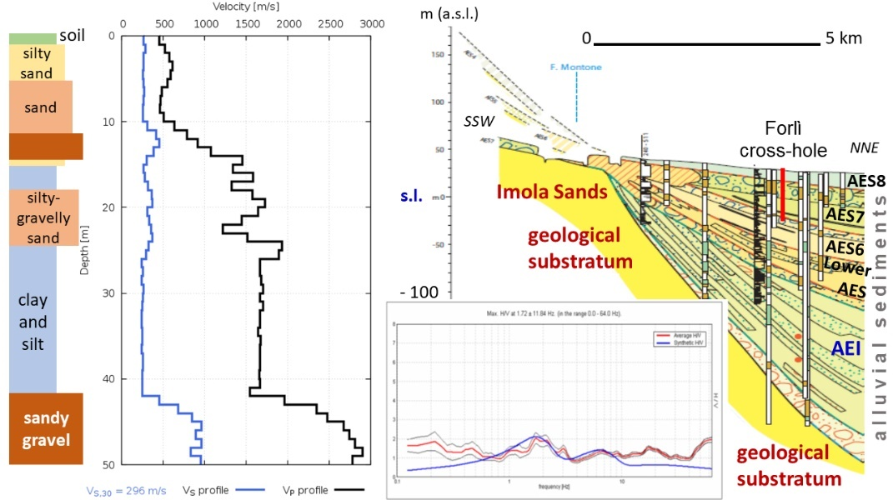
Figure 8. Stratigraphic log, Vs-Vp profiles (cross-hole, from http://itaca.mi.ingv.it/ItacaNet_30/#/station/IT/FOR, with modifications) and ambient noise measurement (from seismic microzonation, Forlì Municipality) in the Forlì station of the National Accelerometric Network; geological cross-section from CARG 1:50,000, sheet n. 240 "Ravenna".
Similar information derives from the cross-hole test carried out in Viserba (Rimini Municipality), in a 96 meters deep borehole (Fig. 9) in the alluvial fan of the Marecchia River [32]. The comparison between lithostratigraphy and Vs profile shows that all gravelly horizons have Vs greater (approximately double) than that of the sandy-silty and silty-clayey horizons, in which usually Vs≤300 m/s, and that Vs≥800 m/s in the gravels at a depth of 82÷83 m. In this site, the geological substratum is at a depth of about 250 m.
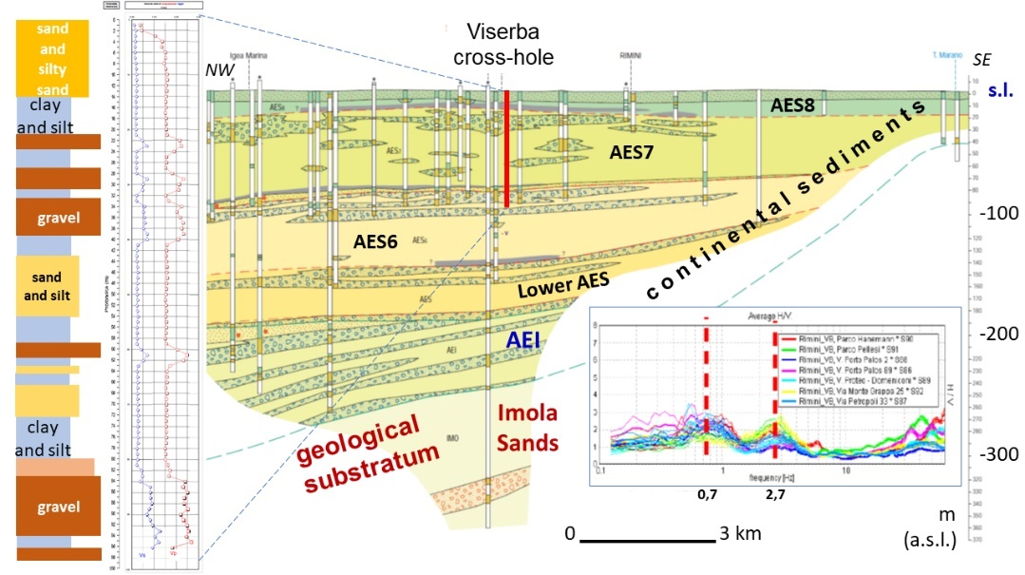
Figure 9. Stratigraphic log, Vs-Vp profiles and ambient noise measurements in Viserba (from seismic microzonation, Rimini Municipality [32, with modifications]); geological cross-section from CARG 1: 50,000, sheet n. 256 "Rimini".

Ambient noise measurements were carried out for the seismic microzonation of Rimini [33]. In the cross-hole area, the results show two peaks of the H/V spectral ratio, one at the frequency of 0.7÷0.8 Hz, the other at the frequency of 2.6÷2.8 Hz. The comparison between the ambient noise recordings, the Vs profile and the lithostratigraphy makes it possible to associate the peak at a frequency of 2.7 Hz to the roof of the first gravelly horizon, at a depth of about 20 m, while the peak at 0.7 Hz can be associated with the roof of gravels with Vs≥800 m/s, at a depth of 82÷83 m (Fig. 9).
High Vs values were also measured in the gravels of the alluvial fans of the Parma, Enza, Secchia and Panaro Rivers [27, 29]. Down-hole tests provided Vs>400 m/s already in the first gravelly horizons, at depths lower than 20 m, and higher Vs values, often greater than 600 m/s, in gravels at depths of 30÷40 m (Figs. 10 and 11).
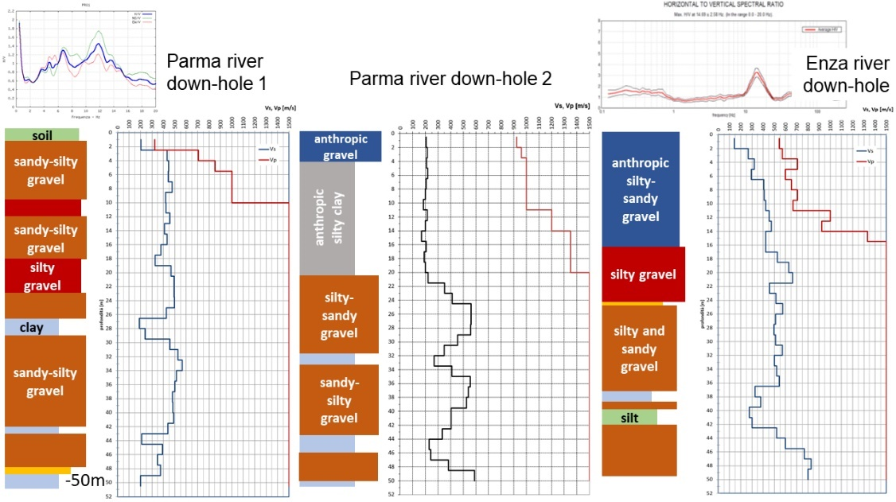
Figure 10. Stratigraphic logs and Vs-Vp profiles [27, with modifications] and ambient noise measurements (from seismic microzonations, Parma Municipality and Montecchio Emilia Municipality) in the alluvial fan areas of the Parma and Enza Rivers.
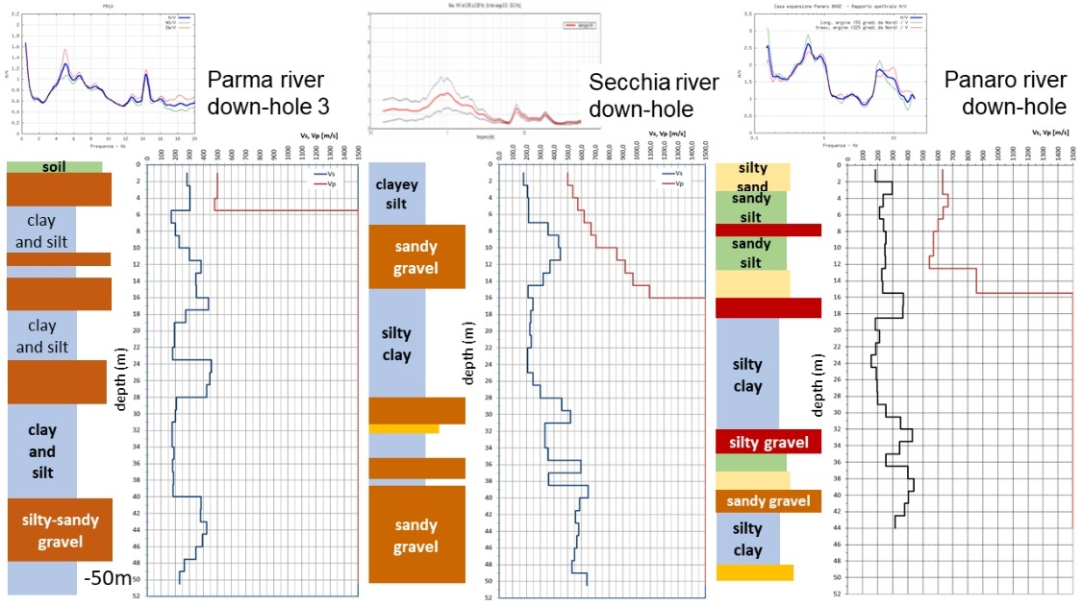
Figure 11. Stratigraphic logs and Vs-Vp profiles [27, with modifications] and ambient noise measurements from seismic microzonations, Parma Municipality, Campogalliano Municipality, and Modena Municipality) in the alluvial fan areas of the Parma, Secchia and Panaro Rivers.
The down-hole tests carried out in the Parma and Enza Rivers are both located on the top of a buried structural high (Monticelli Terme) where the thickness of alluvial sediments varies from about 60÷70 m to 100÷110 m (Figs. 12 and 13), whereas the down-hole tests relating to the Secchia and Panaro Rivers are in areas with high thicknesses of alluvial sediments, (about 300 m, Figs. 14 and 15).
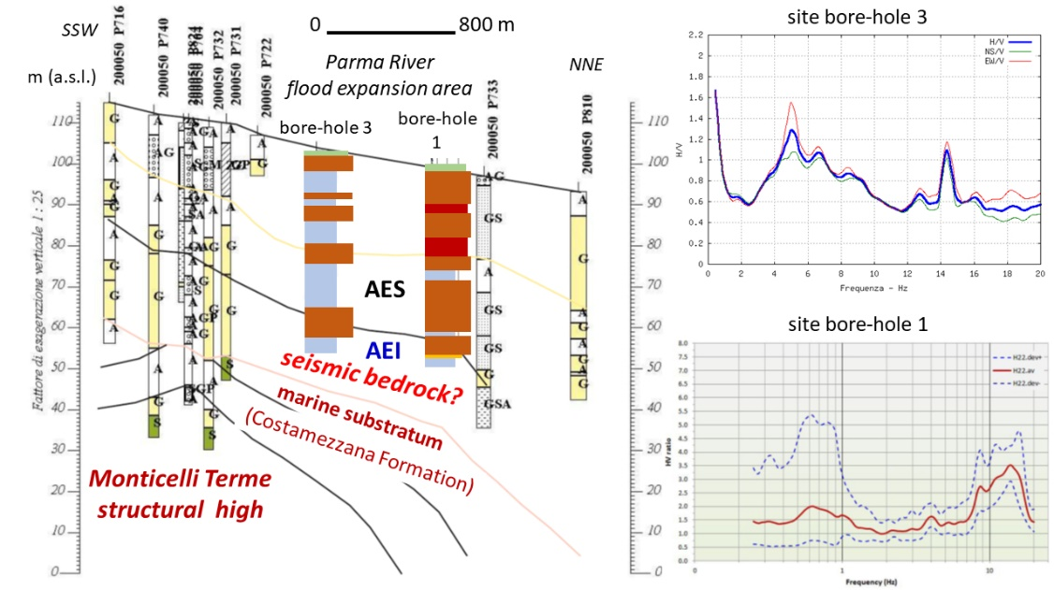
Figure 12. Geological cross-section [27, with modifications] and ambient noise measurements (from seismic microzonation, Parma Municipality) in the southern side of the Parma River alluvial fan.
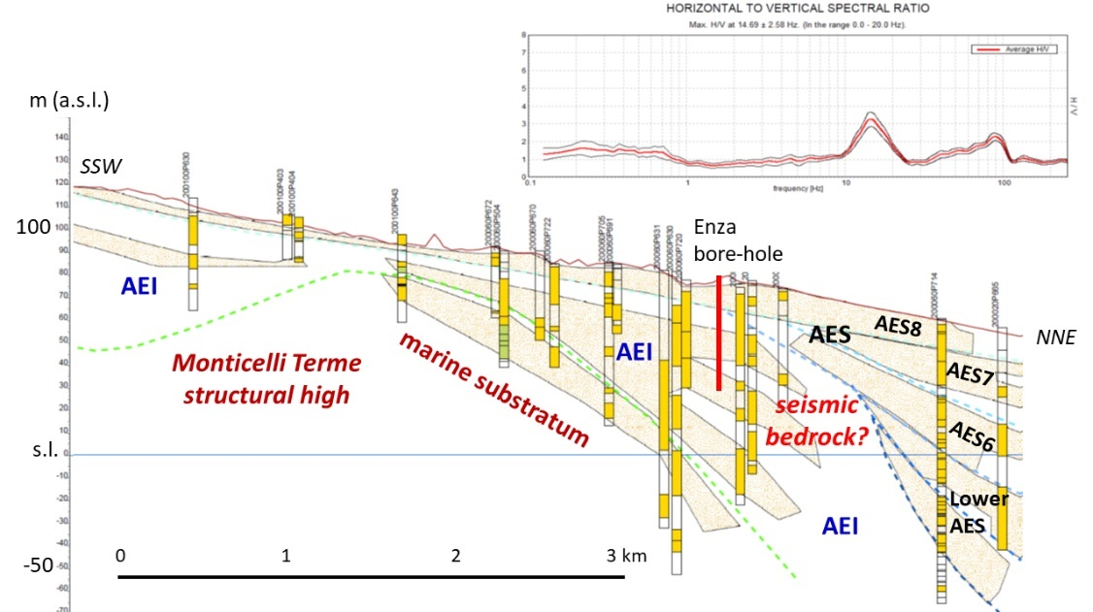
Figure 13. Geological cross-section (from https://geo.regione.emilia-romagna.it/cartografia_sgss/user/viewer.jsp?service=sezioni_geo) and ambient noise measurements (from seismic microzonation, Montecchio Emilia Municipality) in the Enza River alluvial fan.
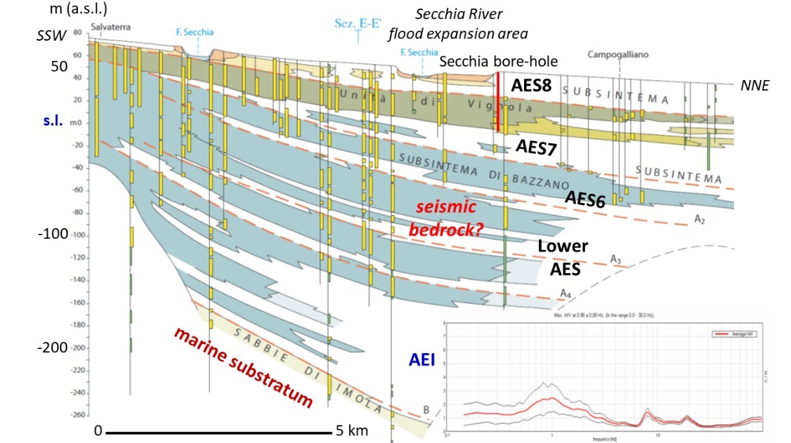
Figure 14. Geological cross-section (from CARG 1:50,000, sheet n. 201 “Modena”) and ambient noise measurements (from seismic microzonation, Campogalliano Municipality) in the Secchia River alluvial fan.
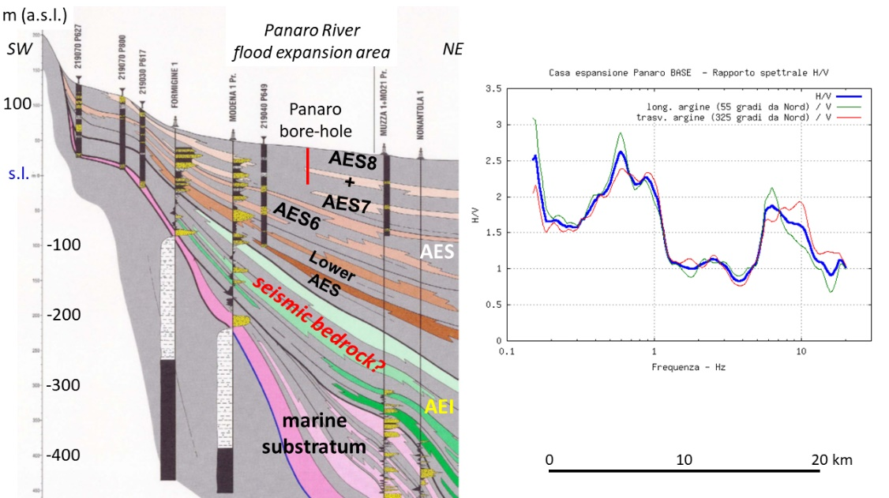
Figure 15. Geological cross-section [11] and ambient noise measurements (from seismic microzonation, Modena Municipality) in the Panaro River alluvial fan.

The ambient noise measurements show a single high frequency peak (Fn>10 Hz) where the succession is almost exclusively made up of gravels, indicating that the main Vs contrast surface is the roof of the first gravel horizon (Figs. 10, 12 and 13). Where the lithostratigraphic succession consists of gravelly and silty-clayey horizons (Figs. 11, 14 and 15) the ambient noise measurements show two peaks, the main one at lower frequencies and the secondary one at high frequencies (Fn>5 Hz, sometimes Fn>10 Hz), indicating that, in this case as well, the roof of the first gravelly horizon is an important impedance contrast surface, but the most important contrast surface of Vs is deeper.

4.2. Distal areas
The geological substratum of alluvial sediments in the Po Plain is structured in anticlines and synclines due to the activity of blind thrusts. This determines a high variability in the thickness of alluvial sediments: at the top of the higher anticlines, it is reduced to a few tens of meters (San Colombano al Lambro, Monticelli Terme, Mirandola) while in the synclines it exceeds 600 m (south-eastern Lombardy plain) (Fig. 4).
Measurement of ambient noise conducted along the Po River [28, 30] and in the epicentral areas of the Emilia 2012 seismic sequence [19, 22, 23] highlighted two resonance frequencies of the ground: one at 0.8÷0.9 Hz and the other at 0.25÷0.3 Hz, with the exception of the buried structural highs (Mirandola and Casaglia) where a single ground frequency was detected, ranging from 0.8 Hz to 1.4 Hz, with a peak of the H/V spectral ratio usually greater than 3 [see also 34].
Based on these observations, the description of the case studies in the Emilia-Romagna plain will be distinguished in high structural zones (top of the higher anticlines) and other areas (synclines, limbs, and lower anticlines).

4.2.1. High structural zones
In the Mirandola and Casaglia areas, located on the southern and northern buried ridges of the Ferrara Folds [16], boreholes were drilled up to the geological substratum of the alluvial deposits (Fig. 16), made up of pre-Quaternary marine sediments (marly clays of Pliocene age in the Mirandola site, marls of Tortonian-Messinian age in the Casaglia site). In both bore-holes the Vs was measured with cross-hole tests and the results indicate that in the geological substratum the Vs is significantly higher than that of the alluvial sediments and exceeds 800 m/s [19, 22].
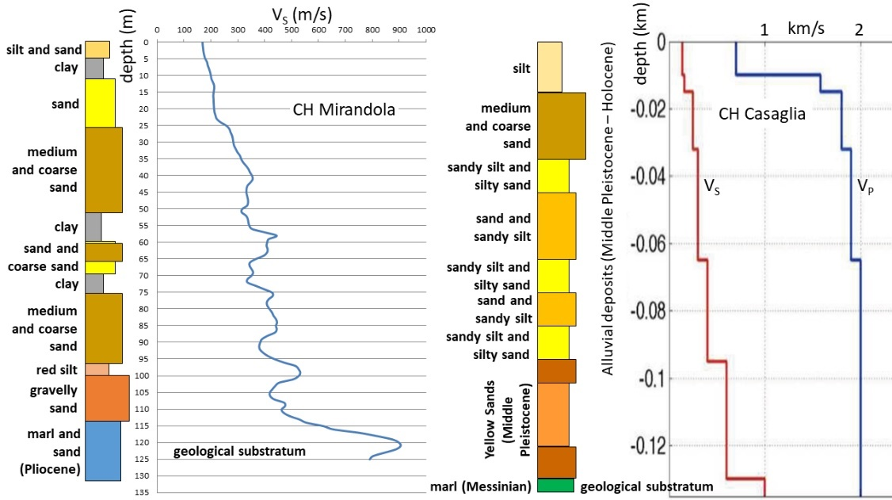
Figure 16. Stratigraphic logs and Vs profiles in Mirandola and Casaglia [19, 22].

Results of ambient noise measurements carried out next to the boreholes (Figs. 17 and 18) show, in both cases, a single peak of the H/V spectral ratio at a frequency of 0.9 Hz with high amplitude (19, 22, 23, 24., 34, 35).
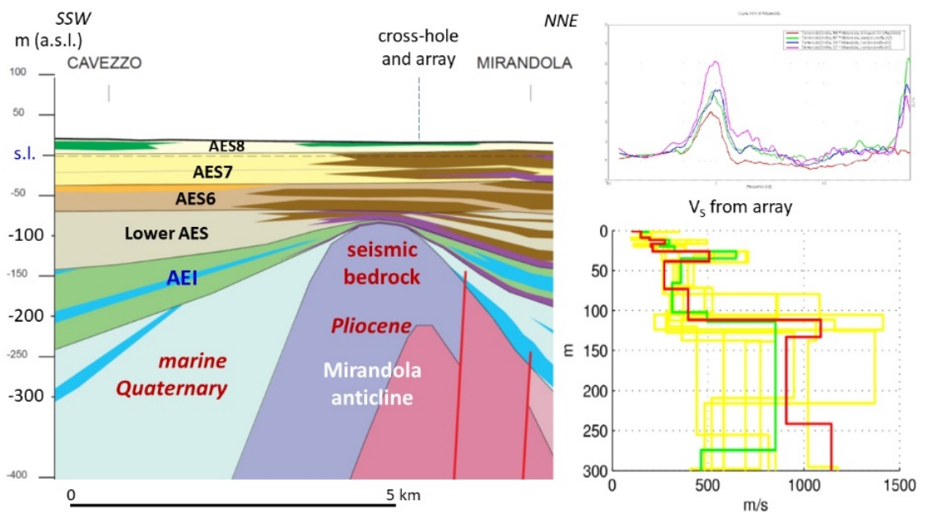
Figure 17. Geological cross-section across the Mirandola anticline, H/V spectral ratio and Vs profile from ambient vibration measurement (array) in the Mirandola urban area [19].
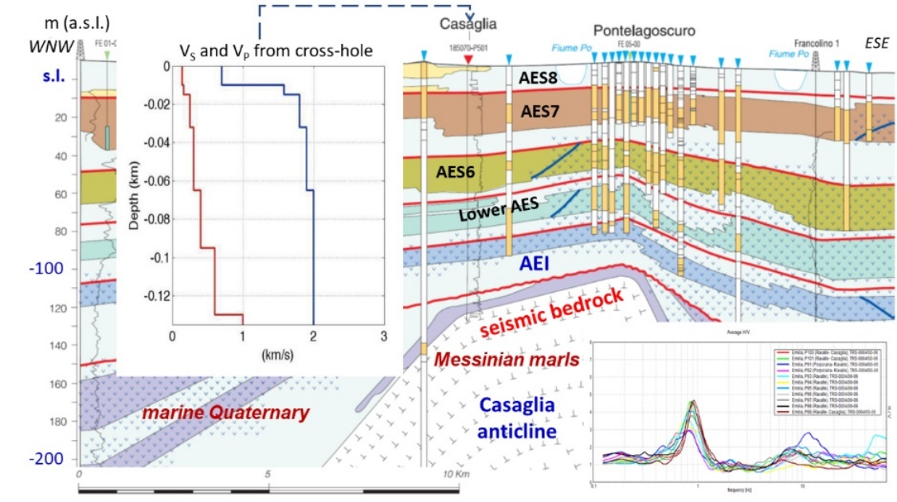
Figure 18. Geological cross-section across the Casaglia anticline [14], H/V spectral ratio [23, 28] and Vs profile from cross-hole in the Casaglia site [19, 22].
Moreover, ambient vibrations were recorded (single station and arrays mode) for the seismic microzonation aimed at supporting the Emilia 2012 post earthquake reconstruction. The tests carried out along the Mirandola buried ridge gave results consistent with the cross-hole test. The Vs profile from the Mirandola array shows an important Vs contrast at depth of about 110 m, below which Vs>800 m/s (Figs. 16 and 17).
In Novi di Modena, on the westward continuation of the ridge, the H/V ratio still shows a single peak of high amplitude at the frequency of 1.4 Hz and the Vs contrast was identified at a depth of about 70 m (Fig. 19).
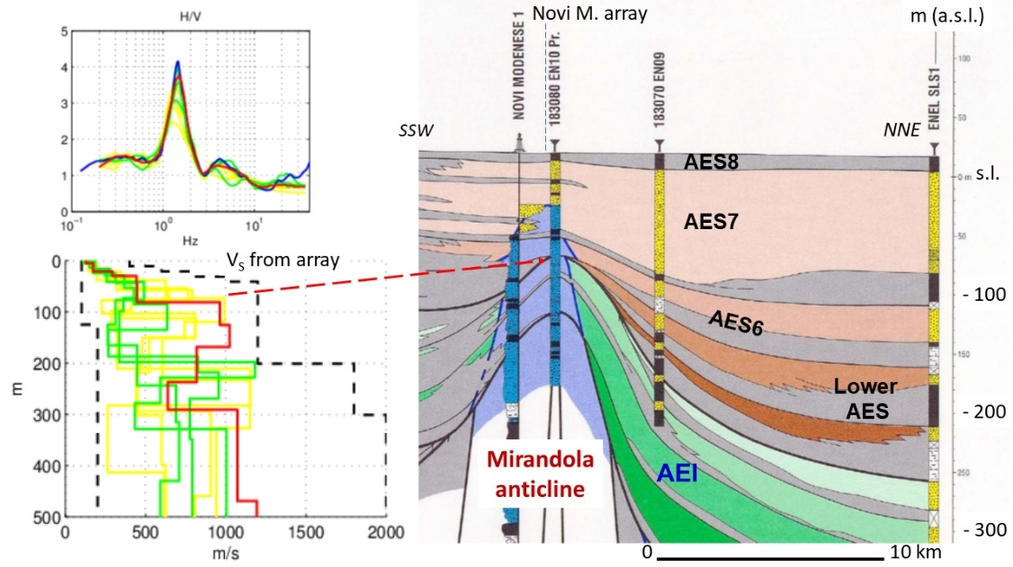
Figure 19. Geological cross-section across the Mirandola anticline in Novi di Modena area [11], H/V spectral ratio and Vs profile from ambient vibration measurement (array) in the Novi di Modena urban area [19].
In San Felice sul Panaro, on the eastward continuation of the ridge, the H/V ratio still shows a single peak, of smaller amplitude, at a frequency of 0.8 Hz and the Vs contrast was identified at a depth of about 120÷140 m (Fig. 20).
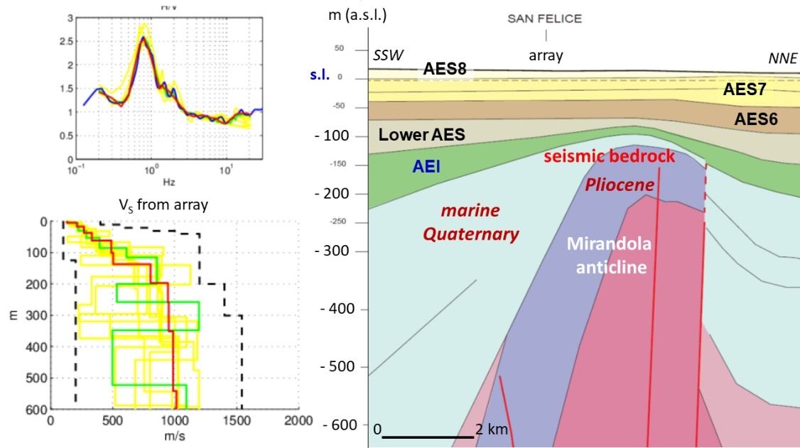
Figure 20. Geological cross-section across the Mirandola anticline in San Felice sul Panaro area, H/V spectral ratio and Vs profile from ambient vibration measurement (array) in the San Felice sul Panaro urban area [19].
Other measurements carried out along the buried ridge (Fig. 21) confirm the presence of a peak of the H/V spectral ratio around the frequencies of 0.8÷0.9 Hz, even if of lower amplitude, with the main Vs contrast deepening from west (San Possidonio and Concordia sulla Secchia arrays) to east (Finale Emilia array). it is important to note that the Concordia sulla Secchia and Finale Emilia measurements, located on the north limb, also show a peak at frequencies between 0.2 and 0.3 Hz and the reconstructed Vs profiles indicate important contrasts even at depths of about 300 m.
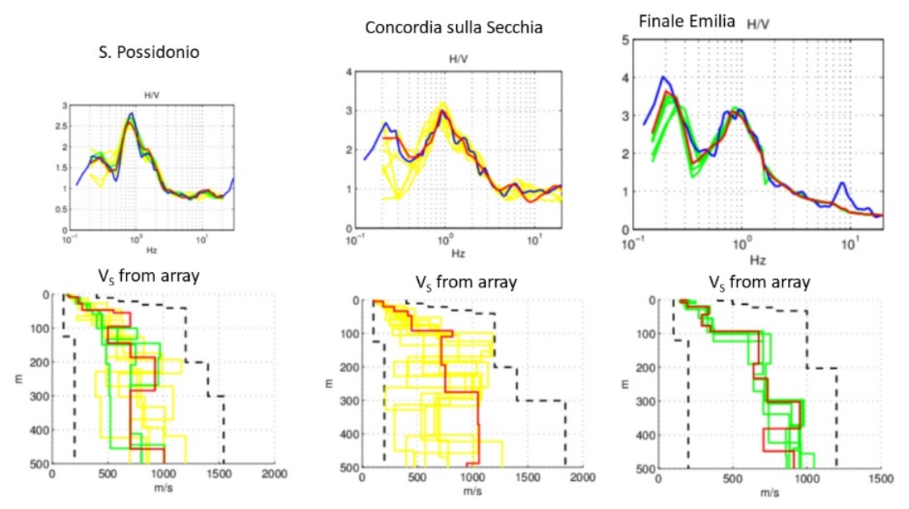
Figure 21. H/V spectral ratios and Vs profiles from ambient vibration measurement (array) around the Mirandola anticline area [19].
The arrays carried out in Bondeno and Scortichino, located on the intermediate buried ridge of the Ferrara Folds [16], show a single peak of the H/V spectral ratio at a frequency around 0.9 Hz and a sharp increase of the Vs in the first 50÷100 m (Fig. 22).
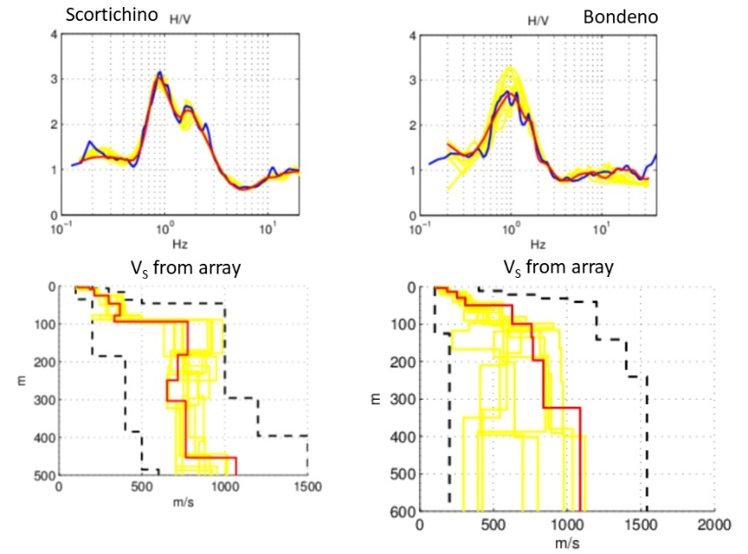
Figure 22. H/V spectral ratios and Vs profiles from ambient vibration measurements (array) on the intermediate structural high of the Ferrara Folds [19].

4.2.2. Other areas
In the Emilia-Romagna plain, direct measurements of Vs at depths greater than 50 m are almost non-existent (except for the high structural zones). Therefore, data for the identification of the seismic bedrock mainly derive from ambient noise measurements and comparisons with the geological cross-sections.
In the syncline and on the limbs, different tests for the estimation of Vs at high depths were carried out near Mirabello and in Cavezzo.
Minarelli et al. (2016) [36] performed Vs measurement with a down-hole test in a 300 m deep borehole, just south of Mirabello. The alluvial sediment base was recognised at a depth of about 290 m but the Vs measurement was carried out up to a depth of 265 m; therefore, direct Vs measurements in the geological substratum are not available. In any case, this down-hole provides important information on Vs in alluvial sediments. The records did not show important Vs discontinuities (Fig. 23): Vs gradually increases for the first 100 m, up to the AES6 base, and in the lower part of AES it is generally about 400 m/s. A Vs increase is observed at about 160 m, passing from AES to the underlying sediments (AEI): below this depth the Vs is generally between 400 and 500 m/s; the maximum value, Vs=525 m/s, was measured at about 260 m.
Ambient noise measurements (array mode), carried out just south and north of the borehole, are substantially consistent with the down-hole data (Fig. 23). These tests show peaks of the H/V spectral ratios at frequencies of 0.2÷0.3 Hz and 0.8÷1 Hz; the reconstructed Vs profiles indicate contrasts at depths between 180 and 230 m in Sant’Agostino and between about 100 and 120 m in San Carlo and Vigarano Mainarda. In these last two sites, Vs contrasts between 400 and 450 m were also detected, with Vs>800 m/s at depths greater than 400 m. Minor Vs contrasts are present at depths of a few tens of meters and about 60÷80 m.
Putting these results on a geological cross-section (Fig. 23), we can see that the Vs contrasts can be associated with the basal unconformities of the main stratigraphic units [see also 37].
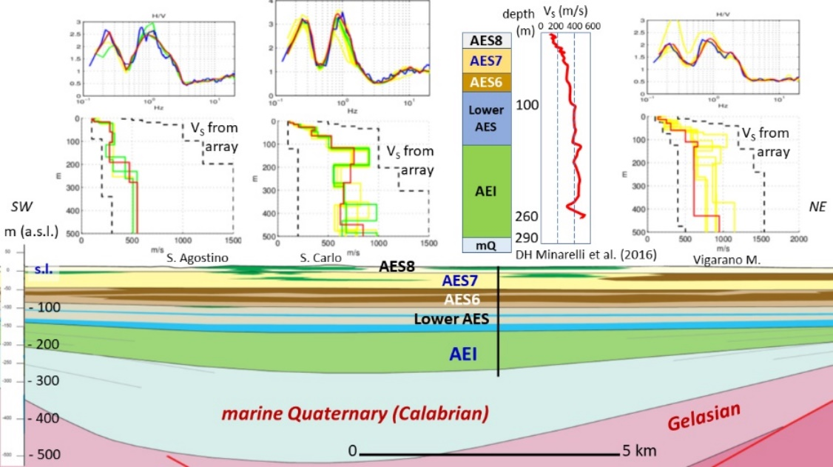
Figure 23. Geological cross-section from Sant’Agostino to Vigarano Mainarda, H/V spectral ratios and Vs profiles from ambient vibration measurements (array) [19] and Vs profile from Mirabello down-hole [36].
In the town of Cavezzo geophysical surveys were carried out by various Authors (Fig. 24); first for studies in support of post-earthquake reconstruction [19], then for a seismic microzonation pilot study, which was part of the LiquefAct project [26]. The first measurement consists of a ambient noise recording (array mode) in the south-east urban area. The result indicates two peaks of the H/V spectral ratio, at frequencies of 0.2 Hz and 0.8 Hz; the reconstructed Vs profile shows two contrasts, the first at a depth of about 80÷90 m and the second at a depth of about 240÷260 m. Vs reaches 800 m/s below 250 m. Following investigations consist of new ambient noise recordings (array mode), made by INGV in the west side of the urban area, and a high-resolution reflection seismic line, made by OGS just southwest of the INGV array. The Vs profiles reconstructed by OGS and INGV, in collaboration with EUCENTRE, show similar Vs values up to a depth of 170 m and indicate that up to this depth Vs≤500 m/s. Below this depth, the Vs profile proposed by INGV-EUCENTRE indicates Vs=800 m/s while the Vs profile reconstructed by OGS indicates Vs=500 m/s up to a depth of about 245 m, below which Vs>700 m/s (Fig. 24). The OGS profile is therefore consistent with the Vs profile resulting from the first investigation.

Figure 24. Geological cross-section from Cavezzo to Mirandola, H/V spectral ratio and Vs profile from ambient vibration measurement (array) in the Cavezzo urban area [19] and Vs profiles from Cavezzo seismic microzonation [26].
Comparison between other ambient noise recordings (array mode) and geological cross-sections allows further observations in other distal areas of the Emilia-Romagna plain. Figures 25, 26 and 27 show Vs-stratigraphy comparisons for the Crevalcore, Cento and Poggio Renatico urban areas. In all of these sites, at least two peaks of the H/V spectral ratio are observed: one at a frequency of 0.2÷0.25 Hz and one between 0.7 Hz and 1.1 Hz. It should be noted that in Crevalcore two distinct peaks are observed at frequencies of 0.7 and 1.1 Hz (Fig. 25), respectively. In all of these urban areas, important VS discontinuities are identifiable at the base of alluvial deposits (or roof of the marine Quaternary), at depths varying between 250 and 350 m and of about 150÷200 m; in the Crevalcore and Cento subsoil minor Vs discontinuities are present at a depth of about 50÷70 m.
Figure 25. Geological cross-section from Castelfranco Emilia to Crevalcore (from Geological Map of Italy, sheet no. 202 “S. Giovanni in Persiceto”), H/V spectral ratio and Vs profile from ambient vibration measurement (array) in the Crevalcore urban area [19].
Figure 26. Geological cross-section from Cento to Dosso (Sant’Agostino), H/V spectral ratio and Vs profile from ambient vibration measurement (array) in the Cento urban area [19].
Figure 27. Geological cross-section from Pieve di Cento to Poggio Renatico (from Geological Map of Italy, sheet no. 203 “Poggio Renatico”), H/V spectral ratio and Vs profile from ambient vibration measurement (array) in the Poggio Renatico urban area [19].
Two peaks of the H/V spectral ratio, very similar in frequency and amplitude to those recognised in the sites illustrated above, also result from the ambient noise recordings in Reggiolo and Camposanto (Fig. 28). For these sites, geological cross-sections or stratigraphic logs are not available. So, preliminary considerations are possible only by comparing these data with the available maps of the main stratigraphic unconformities [11, 16]. Based on the average Vs values in alluvial sediments, it can be assumed that the discontinuity responsible for the peak at 0.8÷0.9 Hz can be localized at depths of about 150÷200 m, while the discontinuity responsible for the low frequency peak (0,2 Hz) can be located at depths of about 500 m.
Figure 28. H/V spectral ratios and Vs profiles from ambient vibration measurements (array) in Reggiolo and Camposanto urban areas [19].
To the west of the areas above described, the geological substratum deepens, and the thickness of the alluvial succession exceeds 500 m (Fig. 6). Single station and array ambient noise measurements carried out in Boretto [28] identify a peak of the H/V spectral ratio at a frequency around 0.6÷0.8 Hz (Fig. 29). The reconstruction of the velocity profile indicates a Vs contrast at a depth of about 70 m and the comparison with the available lithostratigraphic data allows the location of this Vs contrast at the top of the coarse horizon which constitutes the upper part of AES6. Unfortunately, the tests did not allow us to determine the Vs profile at greater depths and therefore to identify the seismic bedrock. According to [11], the geological substratum in this site is at a depth of about 550÷600 m.
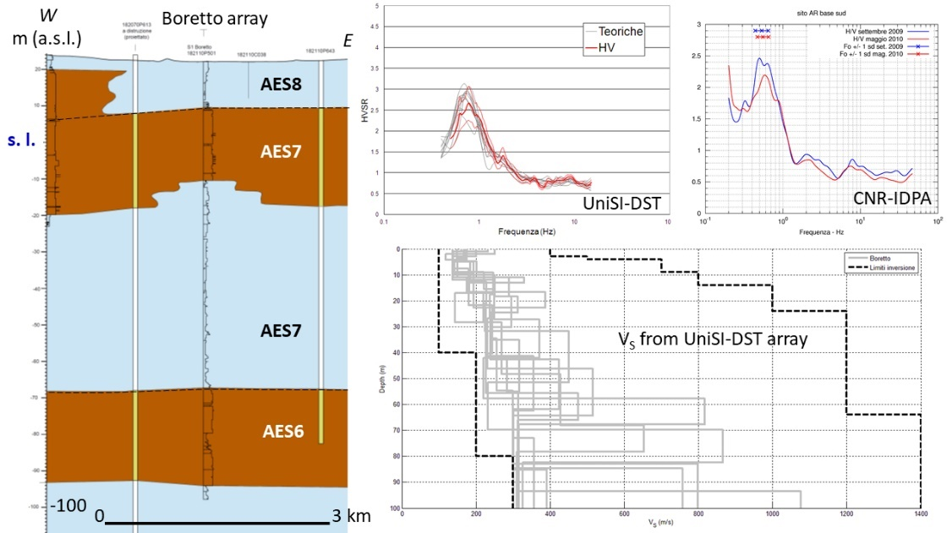
Figure 29. Geological cross-section from Brescello to Boretto, H/V spectral ratios and Vs profiles from ambient vibration measurements in the Boretto area [28]; ambient vibration measurements carried out by University of Siena (Earth Sciences Department, UniSI-DST), and National Research Council (Institute for the Dynamics of Environmental Processes, CNR-IDPA).
A specific discussion should be reserved for the coast north of Rimini, from Cesenatico to the Po delta. This sector is characterised everywhere by poorly consolidated sediments for at least 300 m and the AEI base is, almost throughout the whole sector, at depths greater than 450 m (Figs. 5 and 30÷33).
Ambient noise measurements, both in single station and in array mode, do not show peaks of the H/V spectral ratio in the frequency range between 0.2 and 10 Hz (Figs. 30÷34) and, therefore, important Vs discontinuities were not detected in first 300÷400 m.
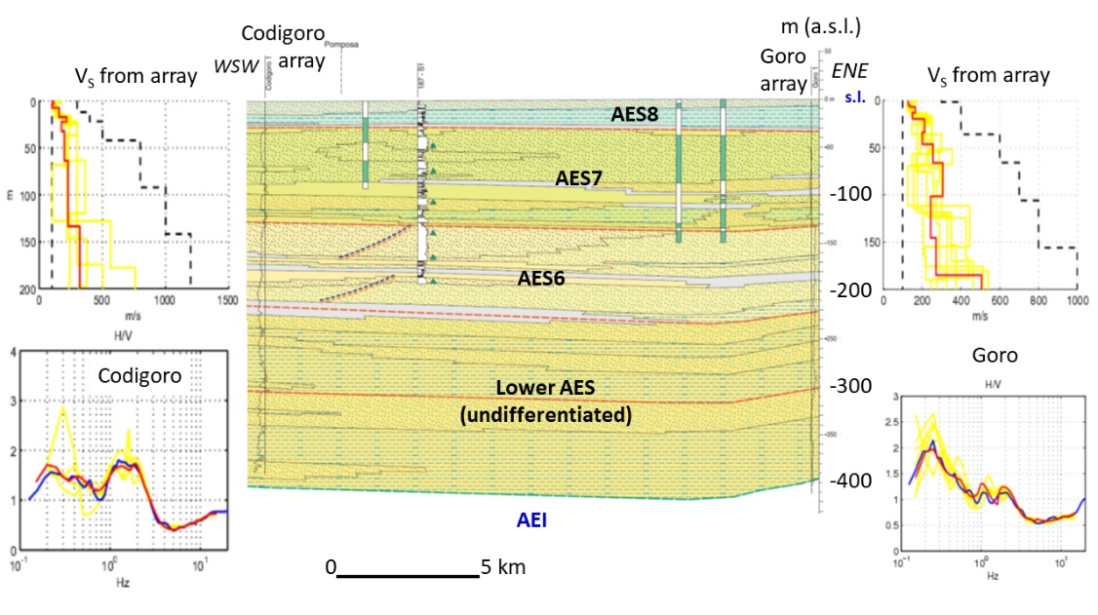
Figure 30. Geological cross-section from Codigoro to Goro (from Geological Map of Italy, sheet no. 187 “Codigoro”), H/V spectral ratios and Vs profiles from ambient vibration measurements (array) in the Codigoro and Goro urban areas (unpublished data).

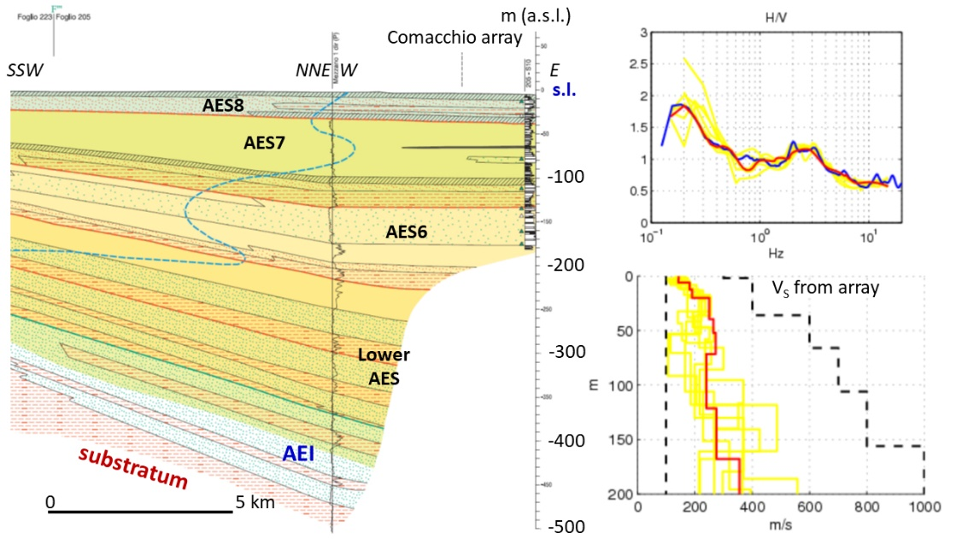
Figure 31. Geological cross-section across the Comacchio Valley (from Geological Map of Italy, sheet no. 205 “Comacchio”), H/V spectral ratio and Vs profile from ambient vibration measurement (array) in the Comacchio urban area (unpublished data).

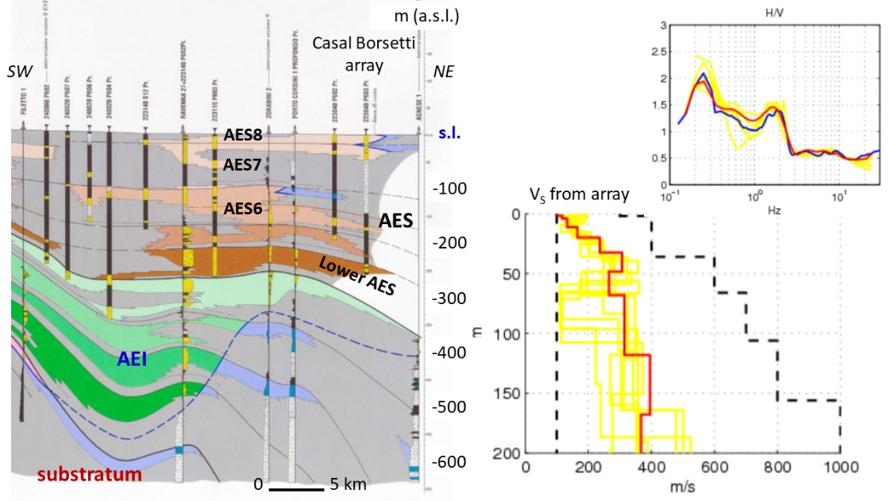
Figure 32. Geological cross-section between Forlì and the north Ravenna coast [11], H/V spectral ratio and Vs profile from ambient vibration measurement (array) in the Casal Borsetti area (unpublished data).

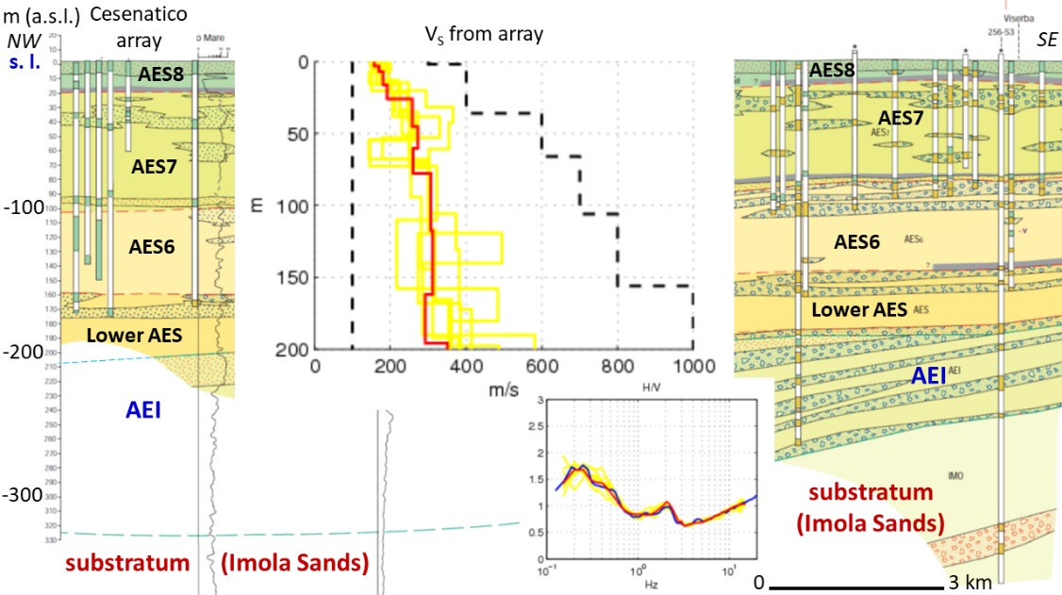
Figure 33. Geological cross-section along the coast from Cesenatico to Viserba (from Geological Map of Italy, sheet no. 256 “Rimini”), H/V spectral ratio and Vs profile from ambient vibration measurement (array) in the Cesenatico urban area (unpublished data).

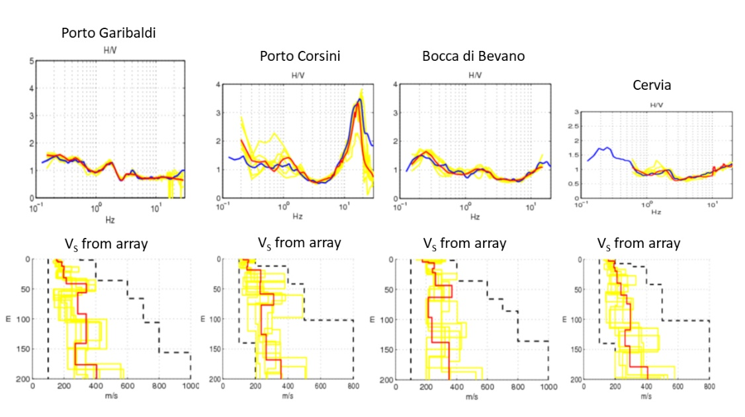
Figure 34. H/V spectral ratios and Vs profiles from ambient vibration measurements (array) along the coast from Porto Garibaldi to Cervia (unpublished data).

5. Results
For the determination of the seismic bedrock, it is also important to consider recent tectonics and how this affected the stratigraphic evolution of the basin.
The Po Plain is an active foredeep basin; so, sedimentation and post-sedimentary evolution of the alluvial units have been affected by the tectonic deformation. The main stratigraphic units, AEI and AES, and related subunits, are in fact bounded by discontinuity surfaces, the oldest of which also show evidence of angular unconformity (Figs. 4, 8, 9, 12, 13, 15). The maps of these surfaces [11, 16] highlight important tectonic deformation at least up to the AES6 (Bazzano subsynthem, 0.230÷0,125 Ma). This can explain the differences in the densification of the sediments and the impedance contrasts observed at the boundary surfaces of the main alluvial units.
The case studies illustrated in the previous chapters suggest the following considerations.
The subsoil of the foothills is characterised by plurimetric and decametric horizons of coarse deposits (gravels, sandy and silty gravels) of alluvial fan (Figs. 6÷11). The roof of the Upper Pleistocene coarse horizon often constitutes a Vs contrast surf÷ace and the underlying gravels often have Vs higher than that of the geological substratum, sometimes reaching and exceeding 800 m/s. In general, it is difficult to identify the seismic bedrock in the foothill areas, but from the comparison between geophysical data and geological cross-sections it emerges that, in the proximal areas, the seismic bedrock commonly consists of a coarse horizon belonging to the alluvial sequence, at depths of few tens of meters (Figs. 8, 9, 10, 12 and 13), while in the external areas the seismic bedrock is located at depths greater than 100 m and can be associated with the lower horizons of AES or AEI (Figs. 14 and 15). In these contexts, the seismic bedrock is not as deep as the geological substratum.
In the distal areas, where the alluvial sequence consists of fine and poorly consolidated sediments (alternating sands, silts, and clays), direct measurements indicate that the Vs is never high (Vs<500 m/s) and reaches 800 m/s only in correspondence of the geological substratum (Figs. 16 and 23).
At the top of the main buried structural highs, where the thickness of alluvial sediments is less than 150 m, the ambient noise measurements indicate a single and clear Vs contrast. In these environments, the seismic bedrock is generally easily identifiable and coincides with the geological substratum (Figs. 16÷20).
In the other areas of the Emilia-Romagna plain, where the thickness of alluvial sediments is greater than 150 m (regardless of the geometry of the geological substratum), the geophysical measurements usually show two Vs contrasts (Figs. 23÷27): the shallower one is always associated with a basal unconformity of an alluvial unit, while the second is often associated with the roof of the geological substratum or at greater depths. In these contexts, for the correct calculation of the expected shaking on the surface, the seismic bedrock can be ascribed to the geological substratum, but the presence of important Vs contrasts in the overlying succession must always be evaluated.
In the Po delta and along the Adriatic coast, where the thickness of alluvial sediments is greater than 300 m everywhere, geophysical measurements indicate the absence of significant velocity contrasts and the Vs seems to gradually increase with depth. Vs values tend to be low in the upper alluvial cycle (AES, see Figs. 30÷34). The seismic bedrock is at a depth of at least 350÷400 m and coincides with the first alluvial cycle (AEI) or with the geological substratum.
Table 2 summarizes the main geological and geophysical characteristics recognized in the Emilia-Romagna plain and described above.
Table 2. Main geological and geophysical characteristics of the Emilia-Romagna plain
Zones  Main characteristics | Marginal area | Distal areas
Zones  Main characteristics | Marginal area | Top of the main structural highs | Other areas
Zones  Main characteristics | Marginal area | Top of the main structural highs | Synclines, limbs, and minor anticlines | Coast and Po delta
Geological features | Alluvial sequence made up of plurimetric and decametric coarse horizons | Thickness of the alluvial sequence H≤150 m | Thickness of the alluvial sequence H>150 m | Thickness of the alluvial sequence H>300 m
Ground frequencies | Fn>5 Hz | Fn=0,8÷1,4 Hz | Fn=0,2÷0,3 Hz; Fn=0,7÷1 Hz | No Fn in the 0,2÷10 Hz range
Seismo-stratigraphic discontinuities | Top of the shallower plurimetric coarse horizon (usually Upper Pleistocene age) | Top of the geological substratum | Basal unconformities of the main alluvial units (e.g., AES6, AES, AEI) | No seismo-stratigraphic discontinuities
Seismic bedrock (Vs_{bedrock}/Vs_{cover}>2 or Vs≥800 m/s) | Plurimetric/decametric coarse horizon (Middle Pleistocene age), usually at depth between 40 m and 100 m | Geological substratum | Lower alluvial cycle (AEI) or geological substratum | Lower alluvial cycle (AEI) or geological substratum

The data presented are in good agreement with the ground frequencies map and the seismic bedrock map proposed by Mascandola et al. (2019) [3]. The comparison between the data presented and the Figure 9 by Mascandola et al. (2019) highlights that the depth indicated by these Authors as the roof of the seismic bedrock certainly corresponds to the depth of the main impedance contrast observed but does not always correspond to the roof of rocks characterised by Vs≥800 m/s (“engineering bedrock”). In any case, the map proposed by Mascandola et al. (2019) remains the best reference for the estimation of the main Vs discontinuity in the Po Plain.

6. Conclusions
Where the thickness of unconsolidated sediments is high and it is not possible to measure the Vs with direct investigations up to the seismic bedrock, the least expensive way to identify the latter is by comparing the results of the ambient noise measurements (preferably in array), the derived Vs profiles, and the available lithostratigraphic data (borehole logs and geological cross-sections).
This approach was tested in the Emilia-Romagna plain and produced the following results (see also Table 2):
- In the foothills, where the coarse deposits of alluvial fan are prevalent, the seismic bedrock is sometimes difficult to identify; the roof of the first coarse horizon from the surface often constitutes an important velocity discontinuity and Vs already exceeds 800 m/s in the gravel horizons at a depth of a few tens of meters;
- In the distal areas, where the alluvial sequence is made up of fine sediments (alternating sands, silts, and clays), the Vs of alluvial deposits is generally less than 500 m/s; in this context, 3 typical situations were recognised:
- at the top of the higher buried ridges, where the thickness of alluvial sediments is less than 150 m, the seismic bedrock is generally well recognizable and tends to coincide with the geological substratum;
- in the other areas of the Emilia-Romagna plain, the thickness of alluvial sediments is greater than 150 m and the geophysical data usually indicate two important Vs contrasts: the first generally corresponds to the basal unconformity of one of the alluvial units (AES6 or AES), while the second generally corresponds to the base of alluvial deposits (or the roof of the geological substratum); in these successions the seismic bedrock seems to correspond to the lower alluvial cycle (AEI) but it cannot be excluded that it is deeper and coincides with the geological substratum;
- along the Adriatic Coast and in the Po delta the thickness of alluvial sediments is greater than 300 m everywhere and the geophysical data indicate the absence of significant velocity contrasts; Vs is generally low in the whole upper alluvial cycle and reaches 800 m/s at depth of at least 350-400 m; in this context as well, the seismic bedrock seems to correspond to the lower alluvial cycle (AEI) or to the geological substratum.
Finally, based on the presented data, the map of the seismic bedrock depth proposed by Mascandola et al. (2019) does not always seem to indicate the roof of the “engineering bedrock” (Vs≥800 m/s) but rather the depth of the main Vs contrast surface. In spite of that, the work of Mascandola et al. (2019) remains a fundamental reference for site seismic assessment in the Po Plain.

References
- Seed, H.B.; Idriss, I.M. Influence of soil conditions on ground motion during earthquakes. Journal of soil mechanics and foundation division, ASCE, 1969, Vol. 95, N. SM1.
- Seed, H.B.; Romo, M.P.; Sun, J.I.; Jaime, A.; Lysmer, J. The Mexico earthquake of September 19, 1985 – Relationships between soil conditions and earthquake ground motions. Earthquake Spectra, 1988, vol. 4, no. 4.
- Mascandola, C.; Massa, M.; Barani, S.; Albarello, D.; Lovati, S.; Martelli, L.; Poggi, V. Mapping the Seismic Bedrock in the Po-Plain (Italy) through ambient vibration monitoring. Bull. Seism. Soc. Am., 2019, 109 (1), 164-177. doi: 10.1785/0120180193
- Nakamura, Y. A method for dynamic characteristics estimation of subsurface using microtremors and the ground surface. Q. Rept. RTRI Japan, 1989, 30, 25-33.
- Bonnefoy-Claudet, S.; Cotton, F.; Bard, P.Y. The nature of noise wavefield and its applications for site effects studies. A literature review. Earth-Science Reviews, 2006, 79, 205–227
- SM Working Group. Guidelines for Seismic Microzonation. Conference of Regions and Autonomous Provinces of Italy – Civil Protection Department, Rome, 2015. http://www.protezionecivile.gov.it/httpdocs/cms/attach_extra/GuidelinesForSeismicMicrozonation.pdf?
- Deliberazione di Giunta della Regione Emilia-Romagna n. 630, 29/4/2019: Atto di coordinamento tecnico sugli studi di microzonazione sismica per la pianificazione territoriale e urbanistica (artt. 22 e 49, L.R. n. 24/2017). Boll. Uff. Regione Emilia-Romagna, 6/5/2019, n. 143 (parte seconda). https://ambiente.regione.emilia-romagna.it/it/geologia/sismica/indirizzi-per-studi-microzonazione-sismica
- Decreto Ministero delle Infrastrutture e dei Trasporti 17/01/2018: Aggiornamento delle “Norme Tecniche per le Costruzioni”. G. U. Repubblica Italiana, 20/2/2018, n. 42, Suppl. Ordin. n. 8. Ist. Polig. e Zecca dello Stato, Roma. https://www.gazzettaufficiale.it/eli/gu/2018/02/20/42/so/8/sg/pdf
- EN 1998-1: Eurocode 8: Design of structures for earthquake resistance – Part 1: General rules, seismic actions and rules for buildings. The European Union Per Regulation 305/2011, Directive 98/34/EC, Directive 2004/18/EC. https://www.phd.eng.br/wp-content/uploads/2015/02/en.1998.1.2004.pdf
- Bordoni, P.; Haines, J.; Di Giulio, G.; Milana, G.; Augliera, P.; Cercato, M.; Martelli, L.; Cara, F.; and the Cavola Experiment Team. Cavola experiment site: geophysical investigations and deployment of a dense seismic array on a landslide. Annals Geophysics, 2007, vol. 50, n. 5, 627-649.
- Regione Emilia-Romagna; ENI Agip Divisione Esplorazione e Produzione. Riserve idriche sotterranee della Regione Emilia-Romagna. Di Dio, G.M., ed.; S.EL.CA., Firenze, 1998; pp 120.
- Regione Lombardia; ENI divisione Agip. Geologia degli acquiferi padani della Regione Lombardia. Carcano, C., and Piccin, A., eds; S.EL.CA., Firenze, 2002; pp 132.
- Irace, A.; Clemente, P.; Natalicchio, M.; Ossella, L.; Trenkwalder, S.; De Luca, D.A.; Mosca. P.; Piana, F.; Polino, R.; Violanti, D. Geologia e idrostratigrafia profonda della Pianura Padana occidentale. Regione Piemonte - Direzione Ambiente, CNR – Istituto di Geoscienze e Georisorse – U. O. Torino, Università degli Studi di Torino – Dip. Scienze della Terra. La Nuova Lito Firenze, 2009; 126 pp. ISBN 978-88-904554-0-7
- Molinari, F.C.; Severi, S.; Boldrini, G.; Dugoni, G.; Rapti Caputo, D.; Martinelli, G.; Colombani, N.; Gargini, A.; Mastrocicco, M.; Messina, A. Risorse idriche sotterranee della Provincia di Ferrara. Regione Emilia-Romagna - Servizio Geologico Sismico e dei Suoli, Provincia di Ferrara - Servizio Politiche della Sostenibilità e Cooperazione Internazionale, Università degli Studi di Ferrara - Dipartimento di Scienze della Terra; DM Map, Firenze, 2007; pp 80,
- Pieri, M.; Groppi, G. Subsurface geological structure of the Po Plain (Italy). C.N.R., Prog. Fin. Geodinamica, 1981, Pubbl., 414, 1-13.
- Martelli, L.; Bonini, M.; Calabrese, L.; Corti, G.; Ercolessi, G.; Molinari, F.C.; Piccardi, L.; Pondrelli, S.; Sani, F.; Severi P. Carta sismotettonica della Regione Emilia-Romagna e aree limitrofe, scala 1:250.000 (edizione 2016). Regione Emilia-Romagna-SGSS, CNR-IGG sez. FI, Università degli Studi di Firenze-DST, INGV sez. BO. D.R.E.AM. Italia, 2017; https://ambiente.regione.emilia-romagna.it/it/geologia/pubblicazioni/cartografia-geo-tematica/carta-sismotettonica-della-regione-emilia-romagna-e-aree-limitrofe-edizione-2016
- Boccaletti, M.; Martelli, L. (eds). Carta sismotettonica della Regione Emilia-Romagna, scala 1:250.000. Regione Emilia-Romagna–SGSS, CNR-IGG. SELCA, Firenze, 2004. https://ambiente.regione.emilia-romagna.it/it/geologia/pubblicazioni/cartografia-geo-tematica/carta-sismotettonica-della-regione-emilia-romagna
- Boccaletti, M.; Corti, G.; Martelli, L. Recent and active tectonics of the external zone of the northern Apennines (Italy). Int J Earth Sci (Geologische Rundschau), 2011, 100, 1331–1348 doi:10.1007 /s00531-010-0545-y
- Martelli, L.; Romani, M. (eds.). Microzonazione sismica e analisi della condizione limite per l’emergenza delle aree epicentrali dei terremoti della pianura emiliana di maggio-giugno 2012 (Ordinanza del Commissario Delegato – Presidente della Regione Emilia-Romagna n. 70/2012). Final Report and Annexes, 2013. http://ambiente.regione.emilia-romagna.it/geologia/temi/sismica/speciale-terremoto/sisma-2012-ordinanza-70-13-11-2012-cartografia.
- Cremonini, G.; Ricci Lucchi, F. (eds). Guida alla geologia del margine appenninico-padano. Società Geologica Italiana, Guide Geologiche Regionali, 1982, pp. 247
- Rovida, A.; Locati, M.; Camassi, R.; Lolli, B.; Gasperini, P.; Antonucci, A. Italian Parametric Earthquake Catalogue (CPTI15), version 3.0. Istituto Nazionale di Geofisica e Vulcanologia (INGV), 2021. https://doi.org/10.13127/CPTI/CPTI15.3
- Laurenzano, G.; Priolo, E. Studio sismologico per la caratterizzazione della risposta sismica di sito ai fini della microzonazione sismica di alcuni comuni della Regione Emilia-Romagna. Relazione sull’attività svolta. OGS-CRS, 2013. Annex 1.8 of “Microzonazione sismica e analisi della condizione limite per l’emergenza delle aree epicentrali dei terremoti della pianura emiliana di maggio-giugno 2012 (ordinanza del commissario delegato – presidente della Regione Emilia-Romagna n. 70/2012)” http://ambiente.regione.emilia-romagna.it/geologia/temi/sismica/speciale-terremoto/sisma-2012-ordinanza-70-13-11-2012-cartografia.
- Paolucci, E.; Albarello, D.; D’Amico, S.; Lunedei, E.; Martelli, L.; Mucciarelli, M.; Pileggi, D. A large scale ambient vibration survey in the area damaged by May-June 2012 seismic sequence in Emilia Romagna, Italy. Bull. Earthquake Eng., 2015, 13 (11), 3187-3206, DOI: 10.1007/s10518-015-9767-5.
- Laurenzano, G.; Priolo, E.; Mucciarelli, M.; Martelli, L.; Romanelli, M. Site response estimation at Mirandola by virtual reference station. Bull Earthquake Eng., 2017, 15, 2393–2409 DOI 10.1007/s10518-016-0037-y
- Klin, P.; Laurenzano, G.; Romano, M.A.; Priolo, E.; Martelli, L. ER3D: a structural and geophysical 3D model of central Emilia-Romagna (Northern Italy) for numerical simulation of earthquake ground motion. Solid Earth Discuss., 2019 https://doi.org/10.5194/se-2019-1
- Lai, C.G.; Poggi, V.; Famà, A.; Zuccolo, E.; Bozzoni, F.; Meisina, C.; Bonì, R.; Martelli, L.; Massa, M.; Mascandola, C.; Petronio, L.; Affatato, A.; Baradello, L.; Castaldini, D.; Cosentini, R.M. An inter-disciplinary and multi-scale approach to assess the spatial variability of ground motion for seismic microzonation: the case study of Cavezzo Municipality in Northern Italy. Engineering Geology, 2020, 274:5 https://doi.org/10.1016/j.enggeo.2020.105722
- Autorità di Bacino del fiume Po. Verifiche tecniche delle vasche di laminazione sugli affluenti del fiume Po. Progetto S.I.S.M.A. (Stabilità all’Input Sismico dei Manufatti Arginali), 2011. http://www.adbpo.it/download/Sismica/Casse_Espansione/
- Autorità di Bacino del fiume Po. Progetto strategico per il miglioramento delle condizioni di sicurezza idraulica dei territori lungo l’asta medio-inferiore del fiume Po. La verifica sismica. Autorità di Bacino del fiume Po e Dipartimento della Protezione Civile “Argini del fiume Po – Progetto Sismica”, Accordo di Programma tra Autorità di Bacino del fiume Po, Regione Emilia-Romagna, Regione Lombardia e Agenzia Interregionale per il fiume Po, 2014. https://adbpo.gov.it/argini-del-fiume-po-progetto-sismica/
- Pergalani, F.; Compagnoni, M.; Madiai, C.; Simoni, G.; Vannucchi, G.; Martelli, L. Seismic vulnerability of the embankments of reservoir basins for flood reduction located on the tributary streams of the Po river (Italy). Ingegneria Sismica, 2013, vol. 30 (1-2), 67-93, ISSN:0393-1420
- Martelli, L.; Severi, P.; Biavati, G.; Rosselli, S.; Camassi, R.; Ercolani, E.; Marcellini, A.; Tento, A.; Gerosa, D.; Albarello, D.; Guerrini, F.; Lunedei, E.; Pileggi, D.; Pergalani, F.; Compagnoni, M.; Fioravante, V.; Giretti, D. Analysis of the local seismic hazard for the stability tests of the main bank of the Po river (Northern Italy). Boll. Geofis. Teor. Appl., 2014, 55, 119-134. DOI 10.4430/bgta0094
- Lai, C.G.; Bozzoni, F.; Famà, A.; Zuccolo, E. Rapporto tecnico. Valutazione del potenziale di liquefazione al porto di Ravenna. Convenzione n. 134/2017, EUCENTRE - Ente Autorità di Sistema Portuale del Mare Adriatico Centro-Settentrionale, 2017, 83 pp.
- Copioli, C.; Carlini, R.; Albarello, D.; Filippini, M.; Martelli, L. Relazione di microzonazione sismica di secondo livello. Quadro Conoscitivo PSC, Sistema Ambientale e Naturale, 2011. https://www.comune.rimini.it/sites/comune.rimini.it/files/b.rel_.sis_.1304501251.pdf
- Albarello, D.; Lunedei, E.; Pileggi, D.; Copioli, C.; Filippini, M.; Martelli, L. Extensive ambient vibration survey supporting a “Level 2” seismic microzoning of an urban area: the case of Rimini. 30° GNGTS, sess. 2.2, Trieste 14-17/11/2011
- Tarabusi, G.; Caputo, R. The use of HVSR measurements for investigating buried tectonic structures: the Mirandola anticline, northern Italy, as a case study. Int. J. Earth Sci., 2016, 106, 341-353, doi: 10.1007/s00531-016-1322-3
- Garofalo, F.; Foti, S.; Hollender, F.; Bard, P.Y.; Cornou, C.; Cox, B.R.; Ohrnberger, M.; Sicilia, D.; Asten, M.; Di Giulio, G.; Forbriger, T.; Guillier, B.; Hayashi, K.; Martin, A.; Matsushima, S.; Mercerat, D.; Poggi., V.; Yamanaka, H. InterPACIFIC project: Comparison of invasive and non-invasive methods for seismic site characterization. Part I: Intra-comparison of surface wave methods. Soil Dynamics and Earthquake Engineering, 2016, vol. 82, 222-240, doi: 10.1016/j.soildyn.2015.12.010i.
- Minarelli, L.; Amoroso, S.; Tarabusi, G.; Stefani, M.; Pulelli, G. Down-hole geophysical characterization of middle-upper Quaternary sequences in the Apennine Foredeep, Mirabello, Italy. Annals of Geophysics, 2016, 59(5), S0543, ISSN: 2037-416X, doi:10.4401/ag-7114.
- Mantovani, A.; Abu-Zeid, N.; Bignardi, S.; Tarabusi, G.; Santarato, G.; Caputo, R. Seismic noise-based strategies for emphasizing recent tectonic activity and local site effects: the Ferrara Arc, Northern Italy, case study. Pure Appl. Geophys., 2019, 176, 2321-2347, doi: 10.1007/s00024-019-02120-8

