Terrain Proxy-Based Site Classification for Seismic Zonation in North Korea within Geospatial Data-Driven Workflow
Han-Saem Kim, Chang-Guk Sun, Moon-Gyo Lee and Hyung-Ik Cho

We truly thank the reviewers for their feedback which helped us improve the quality of the manuscript as we made revisions in response to reviewer comments. The modified and added statements were highlighted using “Track Changes” function in Microsoft Word. At the Below each reviewer comment the corresponding modifications and additions made in the manuscript are described. In addition, reviewer contributions have been acknowledged in the revised manuscript.
For the comments raised by the reviewers, we have provided the followings:
a - Point by point response to comments,
b - Revised manuscript with highlighted changes
c - Revised manuscript without highlighted changes.

Reviewer 3
 | Comment | Response
 | The manuscript entitled “Terrain Proxy-Based Site Classificationfor Seismic Zonation in North Korea within Geospatial Data-Driven Workflow”, by H.-S. Kim, C.-G. Sun, M.-G. Lee and H.-I.Cho, presents an interesting work.  In general, the manuscript should be acceptable for publicationbut some serious problems must be repaired prior to publication.It needs some significant improvement. Some suggestions areas follows: | Thank you for your valuable comments. The original manuscript has been revised thoroughly considering the three reviewers’ comments.
1 | Please use different terms in the “Title” and the “Keywords”. | The keywords were modified in response to the reviewer’s comment.  [Keywords]  “digital terrain model; proxy; site classification; seismic site effect; V_{S30}; regression model; Geographic Information System; North Korea”
2 | The abstract should state briefly the purpose of the research, the principal results and major conclusions. An abstract is often presented separately from the article, so it must be ableto stand alone. | Thank you for your helpful suggestion. We agreed on the purpose of the abstract for pertinent overview of the work. The entire abstract was revised to represent the background, methods, summary of the main findings, and conclusions of the study.
3 | The English language usage should be checked by a fluentEnglish speaker. It is suggested to the authors to take theassistance of someone with English as mother tongue. | We identified grammatical errors despite using Editage's premium proofreading service. The manuscript has been re-edited for language and to better communicate modifications, and a certificate of this edit is attached below.  [Certificate of 1st proofreading]  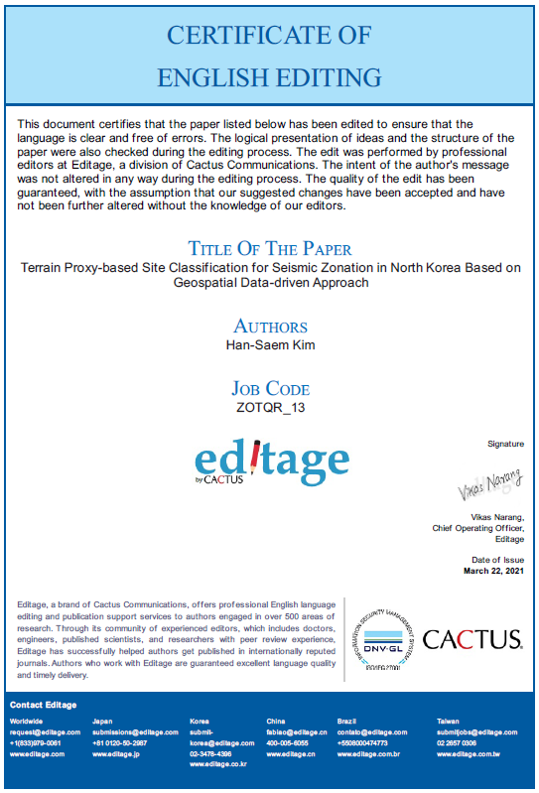  [Certificate of 2nd proofreading]  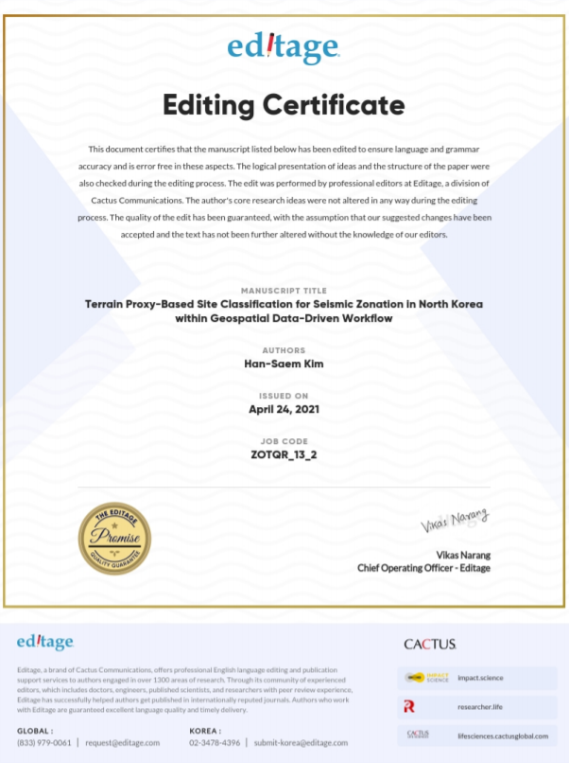
4 | You could enrich the scientific literature. | We agree with your comment about the scope for additional scientific literature. In response to comment #4 and #5, the recommended article and related literatures were supplemented in the revised manuscript. (Lines 73-91, page 2 in the revised manuscript).  Additional references (19 articles) have been added to the revised manuscript.
5 | The authors could take into account the following publication:  -Chousianitis et al. (2016): Assessment of earthquake-induced landslide hazard in Greece: From Arias Intensity tospatial distribution of slope resistance demand. B SeismolSoc Am, 106 (1): 174 – 188.  -Okada et al. (2021) The Potential Role of News Media toConstruct a Machine Learning Based Damage MappingFramework. Remote Sens. 2021, 13, 1401. | Likewise revision for comment #4, the recommended two articles were considered in the literature review in the Introduction section.
6 | In the P21 L646, please correct the name of journal from“C.A.T.E.N.A.” to “Catena” | The typo was corrected and the revised word reads “Catena”.

