Dear Editor and reviewers,
Thank you for your letter dated April 20. We sincerely thank the editor and reviewers for the time and effort in reviewing our manuscript entitled “How loneliness worked on suicidal ideation among nursing home residents: Roles of depressive symptoms and resilience”. Your suggestions have enabled us to improve our work.
The manuscript has been carefully rechecked and appropriate changes have been made in accordance with the reviewers’ suggestions. Based on the instructions provided in your letter, we uploaded the file of the revised manuscript. Accordingly, the responses to their comments have been prepared and attached herewith. The revised text is indicated using the "Track Changes" function in Microsoft Word in the manuscript. Appended to this letter is our point-by-point response to the comments raised by the reviewers.
If you have any other questions or concerns, please do not hesitate to contact us. We are looking forward to the next stage in the review of this manuscript.
Sincerely yours,
Rui Wang
On behalf of the authors

Response to Reviewer#2 comments:
Keypoint
- The main concern is the innovation and significance of this study. It is unclear how the study results add value to the existing literature
[Response]: Thank you for the constructive comment. We have added a brief description about the deficiencies of previous studies and put forward our aims and hypothesis which may help cover the shortages ((P3, L9-15; P4, L9-P18, L3; P5, L14-21). We have supplemented the discussion about the example of resilience training and findings combined with Chinese policy and cultural factors of nursing homes (P19, L22-P20, L5; P20, L1-5), and proposed the suggestion of suicidal prevention on the basis for our findings of nursing home residents through summarizing the previous studies on resilience intervention conducted in different samples (P21, L1-21).
- The theoretical framework of this study is not clear, although the author offered many frameworks
[Response]: Regarding the suggestion about the theoretical frameworks, we deleted the contents on the “ideation-to-action” framework as suicidal ideation is different from suicidal behavior, and clarified the remaining two frameworks (i.e., Interpersonal-Psychological Theory of Suicide and the Protective Factor Model of Resilience) about how they guided our hypotheses (P3, L5-15; P4, L22-P5, L4, 9-21).
3. Given that the study sample is not nationally representative. How the study results applied to the places with similar contexts or cultures? This is not discussed
[Response]: Thank you for underlining this deficiency. Shandong is a typical agricultural and industrial province with the largest ageing population in China, the birthplace of Confucian culture. Jinan, where we conducted the study, is the provincial capital of Shandong. Even though the study sample is not nationally representative, the results derived from the nursing home residents in Jinan may be useful for the northern area in China, or many Asian regions influenced by Confucianism to some content. We have supplemented the basic information of the locality and nursing homes in the method for reference (P6, L14-P7, L9).
In addition, we have discussed this point in the limitation and suggested the multicenter studies to be conducted for further research (P22, L16-19).
4. The English writing style shall be improved, there are several places with grammar errors.
[Response]: We have proofread the article again with the assistance of the native English speakers. The manuscript has been carefully checked, and grammatical errors and inappropriate expression have been modified.
Abstract: Relevant statistics associated with the results (e.g., coefficients of direct, indirect results, and point estimates) shall be reported.
[Response]: Thank you for your kind advice. We have added these information in the abstract.
Introduction:
- The ‘ideation-to-action’ framework may not be relevant, as this study.
The introduction introduced a lot of theoretical frameworks. It is unclear how they integratively guide the study hypotheses
[Response]: We are grateful for the suggestion. The “ideation-to-action” framework was not appropriate for this study through reviewing the its conceptions and studies, and therefore it was deleted to avoid confusion.
We have supplemented the contents about how the theoretical frameworks (i.e., IPTS and the Protective Factor Model of Resilience) guided our hypotheses according to the comment (P3, L5-15; P4, L22-P5, L4, 9-21).
- Some of the hypotheses have been studied and documented in numerous studies. But not the innovation of this study.
[Response]: Regarding the suggestion about the innovation of this study, we have added the description on the deficiencies of previous studies and the novelty of sample in our study (P3, L9-15; P4, L9;18; P5, L14-21).
- Medical Disorders Scale was later introduced in the Methods, but it is unclear why the authors transition to measure the medical disorder. The hypothesis related to medical disorders is not discussed either.
[Response]: Thanks for your kind advice. According to our previous study conducted in Chinese rural nursing homes (Zhang et al., 2017), comorbidities could indirectly affect depressive symptoms and suicidal ideation. Therefore, we measured this variable through the Medical Disorder Scale, and controlled it as a covariate during the analyses. We have clarified this point through adding a covariate part in the methods (P8, L4-14).
Reference:
Zhang, D., Yang, Y., Sun, Y., Wu, M., Xie, H., & Wang, K., et al. (2017). Characteristics of the chinese rural elderly living in nursing homes who have suicidal ideation: a multiple regression model. Geriatric Nursing, 38, 423-430. doi: 10.1016/j.gerinurse.2017.02.005
- What makes the nursing homes in china different from other countries? Can the authors add more culturally relevant factors that make this study unique?
[Response]: According to your suggestion, more cultural information of Chinese nursing homes (i.e., the influence of Confucianism on the aged individuals’ ways of thinking, their attitude towards nursing homes, and psychosocial reactions to live in nursing homes) has been provided in the manuscript (P2, L6-19).
Design:
- The criteria for recruitment of the study sites are not clear.
[Response]: Thanks a lot for the helpful comment. In fact, we first sampled the seven district in Jinan according to the different levels of economic development, and then nursing homes from 7 districts with over one hundred beds and in a occupancy rate over 60% were selected using a randomized number. The information has been supplemented in methods (P7, L14-18).
- What are the socioeconomic contexts of the nursing homes? How is the capacity of nursing homes? These are important factors related to suicidal ideation but not reported.
[Response]: Thank you for your kind suggestion. We employed the stratified random sampling and the first layer is divided according to administrative regions with different levels of economic development. Of each district we selected the same proportion of nursing homes, so as to control the influence of socioeconomic factors on the results to the greatest extent. The relevant information about the location and the capacity of nursing homes has been added in the methods (P7, L7-9). However, we did not employ a specific scale to measure the socioeconomic contexts of nursing homes, we have added this point in the limitation and will pay attention to it in the future studies (P22, L16-19).
Data collection:
- “answer a package of questionnaires during the interviews conducted in their single rooms” -- what is the package of questions?
[Response]: I am sorry there may be confusion about our expression. We have rephrased this sentence into “answer every question of each scale during the survey conducted in their single rooms”.
- The author did not report or test the validity and reliability of the translated version. The authors did not report the psychometric properties of the Chinese measures among the elderly in this study sample.
Thanks for underlining this deficiency. Psychometric information for each Chinese measure has been added in the methods (P8, L16- P11, L15).
Statistical analysis:
- The authors did not sufficiently discuss their approach of dealing with missing data and attrition
[Response]: Thank you for your suggestion. Once older adults have finished their questionnaire, we would check and confirm all the options on the spot, so that there were no missing data in this study.
As for the attrition, before the investigation we would first contact the manager of each nursing home to determine the participants according to the inclusion and exclusion criteria. Then we approached the qualified older adults and asked if they were willing to participate in this study. Of 562 nursing home residents including 21 refused and 3 excluded (i.e., one for dementia, cognitive impairment and hearing loss respectively), a total of 538 older adults completed this study eventually without attrition.
In order to facilitate the understanding of the study design, we have provided the above relevant information in the methods section (P7, L18-20; P11, L19-21).
- Page 5 - is “Model 59” a typo?
[Response]: I am sorry for not explaining Model 59. Model 59 is a code indicating the moderated mediation model whose all three paths of the mediation model are moderated by the moderator.
Hayes, the founder of PROCESS, has published the models and its corresponding code in his book, and some models that are similar with model 59 have been presented as follows. We also provided the part of “Using PROCESS” from the book as the supplementary file to ease interpretation.
Reference:
Hayes, A, F.. (2013). Introduction to mediation, moderation, and conditional process analysis: A regression-based approach (2nd ed.). ISBN: 9781609182304
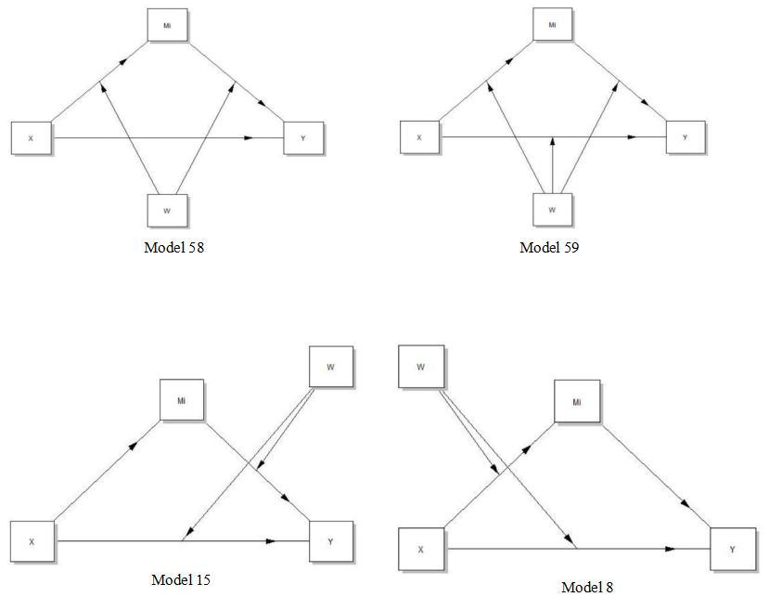
Results:
- Figure 2 has a max y-axis of “.00”, which is not possible?
[Response]: I am sorry for the mistake that the number “1” was missed. The corresponding figures (Figure 2 and 3) has been revised.
2.“Conditional effect and confidence bands of resilience”: resorts of results are confusing. It is unclear what each of Figures 2-4 represent
[Response]: We have rewritten this part and added the interpretation of Figures 2 to 4 (P17, L1-11). For easy understanding, the title of the Figures 2 to 4 have been modified according to the way Hayes named it, and added the legends about the lines (Page: 18). More contents on the Johnson-Neyman technique has also been provided in the methods part (Page: 12, L20-P13, L8).
Discussion:
- The first paragraph, the author mention the study findings may have a theoretical foundation implication, while it is unclear which theory it is based on.
[Response]: We have deleted this inappropriate sentence according to the comment, and discussed the results found in this study based on IPTS and the Protective Model of Resilience (P19, L10-P20, L5, L8-10).
- Since this is a cross-sectional study in China, the authors may want to discuss the results more related to Chinese culture
[Response]: Thank you for your suggestion. We have added the discussion on the results combined with Chinese culture (P20, L10-16).
- One big concern is that the resilience scale is originally developed for Western adults. It is not clear how the scale performs when applied to the Chinese elderly.
[Response]: We have supplemented the contents on the psychometric information of the Chinese version of resilience scale when applied to the Chinese older adults (P10, L12-P11, L5).
- Limitation: the authors did not address the sample selection, measures validity, and representation of the study.
[Response]: Thanks for your suggestion. We have added the above information in the limitation (P22, L13-P23, L9).
- The authors did not offer what kinds of clinical interventions can be derived from the results. 1-2 examples can help the readers understand.
[Response]: Regarding the suggestion about the implication for clinical interventions, we supplemented contents about the resilience training for children and adolescents, and put forward our suggestion on resilience intervention for nursing home residents through our results and reviewing the previous studies. We suggested that caregivers in nursing homes can be trained on the resilience intervention techniques so as to provide the resilience training for older adults in their daily care (P21, L1-20).
- There were no discussion on the mechanisms that may confound the results.
[Response]: We have supplemented the limitation on the contents of the generalization, recall and reporting bias, two different management of questionnaire administration, and the cross-sectional nature of this study (P22, L13- P23, L9).
The authors may need to consider adjusting the decimal points. Also, format Table 1 clearly with left alignment.
[Response]: The decimal points as well as the format of Table 1 have been modified.

