Response to Reviewer 2 Comments

Please note that number lines correspond to Ms word whenever track changes in enabled.

Point 1: Overall, the topic is considered to be relevant and of interest to the readership of the Pharmaceuticals special issue on Biosimilars. The objective of the review, exploring biosimilar incentive design and how this can stimulate biosimilar use, is considered valuable. The current organization of the review and the content that is presented does however not fulfil the full potential of the paper. The manuscript will need to undergo structural changes, in terms of both organization and content presented. Currently, the content presented in the body of the manuscript is insufficiently aligned with the title and aims presented in the abstract. As reader, you would expect specific information on biosimilar incentive design. This is however currently not comprehensively described in the text.
Response 1: We have clarified the goal of the paper in Abstract lines 14-17 and Introduction lines 32-40, making it clear that our concern are the barriers found in the implementation of incentives in Spain. As the model of clinical governance is of great interest and has be extensively discussed in Spain, we are particularly interested in barriers to incentives in this framework. Incentives and clinical governance are certainly intertwined as we clarify in Section 2.
Incentives are easier to implement in well-organized broader contexts such as health services following the lines of what is known as “clinical governance”, concept explained also in section 2.

Point 2: Section 3 presents barriers for clinical governance, rather than barriers for incentive design or biosimilar incentive design. The information is presented in a biosimilar a specific manner. The section would benefit from positioning the barriers for clinical governance more in the biosimilar context.
Response 2: We have clarified and reorganized Section 3. As we are particularly interested in barriers to incentives in the framework of a model of clinical governance and both questions are strongly related, we present here different barriers encountered in Spain that we have been found relevant for both concepts. The order of the barriers has also been modified to highlight barriers immediately opposing incentives. And in each subsection, we explicitly indicate why the barrier is relevant for incentives.

Point 3: Section 4 presents various barriers to the use of biosimilars in general, rather than discussing biosimilar in the context of stakeholder motivation and incentive design. The section would benefit from more focused information on biosimilar incentive design.
Response 3: We believe the comment above also answers this request.

Point 4: Section 4 presents various barriers to the use of biosimilars in general, rather than discussing biosimilar in the context of stakeholder motivation and incentive design. The section would benefit from more focused information on biosimilar incentive design.
Response 4: The focus of this section is barriers according to stakeholders, not biosimilar incentive design that is out of the scope of the paper. Nevertheless, in the introduction we have introduced a small table with the main findings on incentive design for biosimilars in (Lobo and del Río, 2020). We focus on main European markets EU5 (excluding Spain) following the advice of reviewer #3 in line with this point.

Lines 153-155.
Some biosimilar prescribing incentives have been put in place in Europe. Although it is not the scope of this research, we summarize in Table 1 the more relevant initiatives to our view, being the British experiences those closer to our approach of clinical governance.
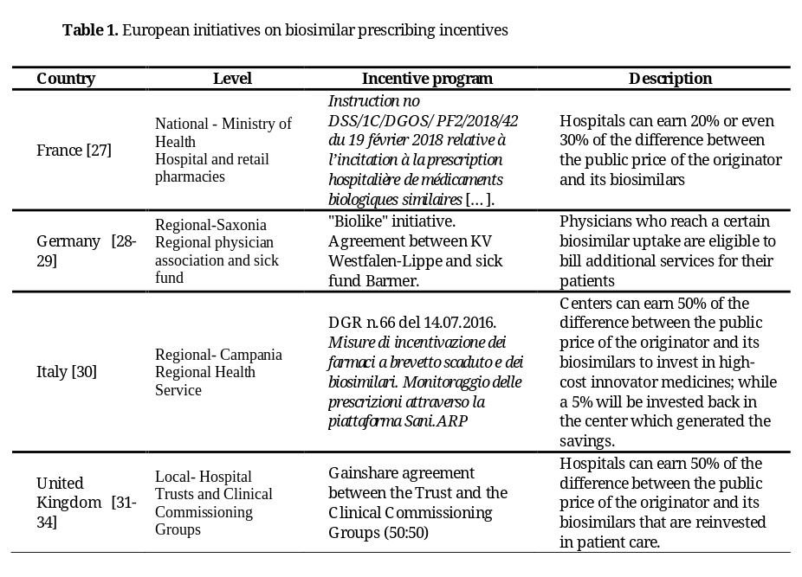
Point 5: Due to this structuring, the manuscript currently does not fulfil its preamble of discussing (barriers to) biosimilar incentive design in Spain. The abstract indicates that the study identifies barriers to the establishment of incentives for biosimilars in Spain from two perspectives: (i) based on the nature of the barrier and (ii) based on the stakeholder involved. The body of text however rather describes (i) barriers to the establishment of clinical governance in Spain (in a biosimilar a-specific context) and (ii) barriers to biosimilar use in general (non-incentive specific). Information on biosimilar incentive design should be overall expanded in the second section (now a variety of elements is discussed). The link between the first (clinical governance barriers in Spain) and second (biosimilar incentive possibilities in Spain) section should be more clearly described.
Response 5: Most of this comment has been already answered in previous responses. It is true that it can be difficult to draw a solid line between barriers to biosimilar use in general (non-incentive specific) and incentive specific barriers. But we deal with this problem in lines 350-352. (We point at “Another review aimed at identifying the barriers to the use of biosimilar in Europe medicines point out that physicians act as a barrier to biosimilars in several ways (Moorkens et al. 2016).…”… the absence of incentives or benefits for prescribing lower-cost medicines that would compensate the effort they make when explaining to the patient the switch to a biosimilar medicine.” We have introduced the explanation that “pharmaceutical companies… support for clinical research and continuous education…” is an opposite incentive that hinders biosimilars adoption.

Point 6: The manuscript currently presents mainly policy information from a theoretical point of view (especially so in the section on clinical governance). The manuscript can be improved by contextualizing the topic more in the published scientific literature regarding biosimilar incentive design. Information and appropriate references to related work on biosimilar incentive design should be added. References about initiatives in other European countries would be of specific interest: what are examples of successful biosimilar incentive design in other countries and how could these be translated to the Spanish context? How can incentive design in Spain be informed by previous studies? What type of incentives exist? A short reference is made to France and Germany. It would be interesting to expand on this: which development and examples are available in other countries and can inform Spanish policy initiatives?
The following references are suggested to include:
- Scotland: Plevris, N.; Jones, G.R.; Jenkinson, P.W.; Lyons, M.; Chuah, C.S.; Merchant, L.M.; Pattenden, R.J.; Watson, E.F.; Ho, G.-T.; Noble, C.L., et al. Implementation of CT-P13 via a Managed Switch Programme in Crohn’s Disease: 12-Month Real-World Outcomes. Digestive Diseases and Sciences 2019, 64, 1660-1667, doi:10.1007/s10620-018-5406-8
- Chan, A., Kitchen, J., Scott, A., Pollock, D., Marshall, R. and Herdman, L. 2019. Implementing and delivering a successful biosimilar switch programme—the Berk- shire West experience. Future Healthc J. 2019. Jun; 6(2):143-145. doi: 10.7861/ futurehosp.6-2-143.
- Chung, L., Arnold, B., Johnson, R. et al. OC-038 Making The Change: Switching to 1 Infliximab Biosimilars for IBD at North Bristol NHS Trust. Gut 2016;65:A22-A23.
- France, example of incentive design: Athémane Dahmouh (DREES), 2019, « Médicaments biosimilaires : l’hôpital, premier vecteur de leur diffusion », Études et Résultats, n°1123, Drees, septembre.
- Stakeholder insights on stakeholder motivation to use biosimilars and different types of biosimilar incentive design: Barbier, L., Simoens, S., Vulto, A.G. et al. European Stakeholder Learnings Regarding Biosimilars: Part II—Improving Biosimilar Use in Clinical Practice. BioDrugs 34, 797–808 (2020)
- Regression model analysis that demonstrated that incentive policies were correlated to biosimilar uptake: Key drivers for market penetration of biosimilars in Europe. Rémuzat C, Dorey J, Cristeau O, Ionescu D, Radière G, Toumi M.
- Study discussing incentives in 10 European Member States: Cécile Rémuzat, Anna Kapuśniak, Aleksandra Caban, Dan Ionescu, Guerric Radière, Cyril Mendoza & Mondher Toumi (2017) Supply-side and demand-side policies for biosimilars: an overview in 10 European member states, Journal of Market Access & Health Policy, 5:1, 1307315

Response 6: These comments have been also dealt with in previous responses. We are convinced that this short paper with this limited purpose is of interest on itself. Our concern are the barriers found in the implementation of incentives in Spain. Incentive design is out of the scope of the paper. The book explains all the points made by the reviewer (Lobo and del Río, 2020)
Nevertheless, the references provided above are of great interest and have been included either in Table 1 or in lines 153-155.

Point 7: The manuscript is presented as a Review (selected article type). No information is included on the type of review (is it a narrative review?) and methodology. Authors state in the manuscript: This is a pioneering analysis, as the research literature on this topic is very scarce.” (line 67-68). It would be helpful to explain how the pioneering analysis was conducted or what it entailed. Authors present a categorization of barriers but currently it is unclear how this categorization was obtained (section 3). Also for section 4, it is unclear how the categorization of barriers for biosimilar use in general was derived. As the authors mention, the manuscript is based on a broader Spanish report about prescribing incentives for biosimilars in the context of clinical governance. (Reference 13, Lobo, F.; del Río, I. Gestión Clínica, Incentivos y Biosimilares. 1st ed. Díaz de Santos, Madrid, Spain, 2020). What was the methodology followed? In the broader report, the authors also provided a comprehensive classification of incentives and detail past European experiences associated to the incorporation of these incentives. It would be relevant for the reader to include this information on past European experiences with the implementation of incentives within Section 4.

Response 7: past European experiences with the implementation of incentives has been included in the introduction (new Table1). Few studies have been included as there is little evidence of biosimilar prescribing incentives in the broader context of clinical governance in Europe.

Regarding the type of review, in Lobo, F.; del Río, I. Gestión Clínica, Incentivos y Biosimilares. 1st ed. Díaz de Santos, Madrid, Spain, 2020 a literature search was conducted using as keywords clinical governance, clinical management, biosimilar, biosimilars, incentive, incentive (period 2009-2019). Spanish and international / life sciences and economic databases were searched. The result of this search (n=361) was filtered and classified (finally n=29)
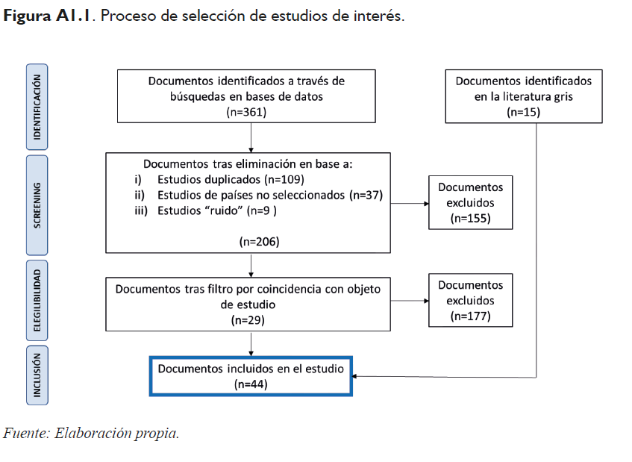
The information was enriched with manual searches (literature grey), personal communications (international experts) and a focus group (national experts).
In summary, this is not a systematic review itself although we believe that is wider and richer in knowledge and evidence than a narrative review.

Point 8: The concept of incentives is currently used as a container term in the manuscript. Different types of incentives could be explored, and different stakeholder groups could be targeted. The manuscript would benefit from explaining different incentive options and referring to other European biosimilar incentive experiences. (see suggested references in the above paragraphs)
Response 8:

Firstly, we now clearly define what we understand by incentive, lines 108-114

Before moving on, it should be noted that in this study we refer to a very narrow definition of incentive. Specifically, financial incentives that are not necessarily monetary or exclusive to the prescribing physician. This is critical since many studies about European biosimilar landscape refer to “incentive policies” that are not necessarily financial incentives. For instance, educational campaigns, quotas or tendering practices are considered incentive tools to increase the uptake of biosimilars and financial incentive would be just another mechanism for that purpose [18-21].

We think we have provided the essential information on types of incentives in the new table and paragraph (lines 153-154) now included in the Introduction.
Some biosimilar prescribing incentives have been put in place in Europe. Although it is not the scope of this research, we summarize in Table 1 the more relevant initiatives to our view, being the British experiences those closer to our approach of clinical governance.

Point 9: In section 2. Incentives and Clinical Governance, the authors signal: “Incentives are easier to implement in well-organized broader contexts such as health services following the lines of what is known as clinical governance”, ‘clinical governance opens good possibilities to the efficient use of effective and good quality biosimilars…’. The authors also indicate that important structural reforms of the Spanish NHS are required to overcome barriers limiting the implementation of biosimilar prescribing incentives. These reforms would require to address, in the long-term, aspects such as the rigidity and bureaucracy in management, the clinical and health systems disintegration, the current NHS relations model and the current organization of the payment and governance systems. It would have been interesting to couple this comprehensive analysis of long-term challenges with an analysis of the feasibility of implementing prescription incentives for biosimilars in the near future. Aspects such as which incentive programs are more likely to be implemented based on the current structural organization of the NHS remain unaddressed. This is of interest based on the intention of policy- and decision-makers to incentivize the use of biosimilars within a short time frame (lines 63-66).
Response 9: We take into account the short and the long run in the full study and, to some extent, in this paper. We understand this is also a good suggestion and we have included new sentences in lines 525- 530.
In the long run, structural reforms of the Spanish NHS are required to overcome other barriers to biosimilar prescribing incentives in the context of clinical governance. We refer to rigidity and bureaucracy in management; clinical and health services disintegration; NHS labour relations model; payment systems and governance. Nevertheless, we think that in the short run there is room for new limited experiences, particularly with non-monetary incentives and the gain-sharing design, that will incite less opposition.

Point 10: It is considered valuable that the authors end the manuscript with specific recommendations for Spain to overcome the barriers to implement incentives for biosimilars (title of section 5). The recommendations presented here are however not specific to overcoming barriers to incentive implementation. It is suggested to make these more specific and as well practical. Currently, it is unclear what the authors put forward as possible incentive routes to explore in Spain: would a financial compensation for biosimilar prescription quota, or rather a gainsharing initiative of interest?
Response 10: Now there is a specific recommendation (lines 525- 530) for new limited experiences, particularly with non-monetary incentives and the gain-sharing design, that will incite less opposition.
In the long run, structural reforms of the Spanish NHS are required to overcome other barriers to biosimilar prescribing incentives in the context of clinical governance. We refer to rigidity and bureaucracy in management; clinical and health services disintegration; NHS labour relations model; payment systems and governance. Nevertheless, we think that in the short run there is room for new limited experiences, particularly with non-monetary incentives and the gain-sharing design, that will incite less opposition.

Gain-share agreements were already mentioned in line 129.
A gain-sharing incentive system (also called gainshare agreement) is based on sharing savings associated with more efficient use of medicines at the same time as any efficien-cies made will be invested back into patient care to improve their health outcomes [24].

Point 11: In section 1 (introduction) and section 2 (incentives and clinical governance), it would be beneficial to structure the text differently. Currently, the concepts of ‘incentives’ and ‘clinical governance’ are alternatingly discussed, which can be confusing for the reader. In addition, the definition on clinical governance should be made more clear. The authors may want to acknowledge that there is no consensus definition for clinical governance (Line 101). It is suggested to define more clearly what are the main elements and the implications of a clinical governance system in the context of this study.
Response 11: We think both concepts are now clearer with the new additions (already mentioned in our response to point 1) and the new presentation of the dimensions of clinical governance lines 140-151.

Point 12: Please explain in the introduction why incentive design is chosen as main policy action to focus on to stimulate biosimilar use in Spain. Several policies have been reported as potential drivers of biosimilar uptake and might explain observed differences in biosimilar uptake across EU countries, such as physician and patient trust in biosimilars, pricing and reimbursement policies, and procurement policies. It would be helpful to explain the importance or opportunity for biosimilar incentive design in the introduction.
Response 12: a explanation has been included in lines 32-40
This paper is aimed at identifying the barriers that incentives to prescribe biosimilars might encounter in Spain. Incentives were chosen as one of the main policy actions to stimulate biosimilar use in Spain because they have an important potential leverage, they are relatively underdeveloped in Spain, and they may be controversial in promoting pre-scription patterns.
We particularly focus on incentives in the framework of clinical governance as they are intertwined concepts. Clinical governance would be impossible to implement without incentives, and incentives, if not impossible, would be difficult to establish in different frameworks.
Overall recommendation
In summary, this is an interesting and informative manuscript, but structural changes are needed to enrich the information on biosimilar incentive design prior to acceptance.

Line-by-line remarks

Line 36 – ‘high variability between molecules’ likely needs to be ‘high variability in uptake between molecules’
Corrected (line 51)

Line 44 – here it is mentioned that biosimilar uptake is below average compared to other European countries. It would be helpful to explain why it is important to stimulate biosimilar use. In the previous lines, authors explain that substantial savings have already been made, regardless of the low uptake. It would be useful if authors can add some information about the importance to create a sustainable market climate for biosimilars. It could also be useful to explain that driving biosimilar uptake is not a goal in itself from a societal perspective, but is needed to stimulate competition, which in turn leads to the desired healthcare system benefits.
References included to support this.
We have now mentioned price competition in line 43. We explain why it is important to stimulate biosimilar use extensively in six paragraphs starting in line 50. The references included are: ([9]Hygeia consulting, 2020); ([8]AIReF, 2020); National Health Strategy for 2018-2022 ([10]); (Ministry of Health, 2019 [11]); (Congress of Deputies, 2020 [13]).

Line 45 – “This is observed in three of the six active ingredients”. Please specify which ones.
It has been specified in line 60 that information refers the antiTNF group, epoetin and human growth hormone.

Line 58 – it would be helpful in the introduction to provide some key information about healthcare organization in Spain. Here for example it would be useful to explain about the Autonomous Communities
Explanation in lines 75-80
This two-level (national and regional) approach is because the Spanish NHS is a decen-tralized system, since health competences are transferred to the 17 Autonomous Commu-nities. Coordination, strategy for pharmaceutical policy and medicine pricing and fi-nancing decisions, among others, lie essentially with the Ministry of Health, and with Autonomous Communities when it comes to budgeting, purchasing and provision [12].

Line 64 – different type of policy avenues can be explored and stimulated in the context of biosimilars. In this manuscript, the choice is made to focus on incentives. It would be useful if authors explained the choice of focus.
It has been addressed in the introduction section. In the Abstract lines 14-17 and in the Introduction lines 32-40

Line 69 – authors mention that literature on the topic is scarce. Is more literature available about incentive design in healthcare in general which can be useful to take into account here?
Our scope is not fully review incentives design since, for the case of biosimilars, experiences similar to those based on gainsharing agreements (addressed in the revised Ms-table 1) have already shown to be effective.

Line 102 – the term micro-management might lead to misunderstanding. It is suggested that authors explain what they understand under micro management in this context or select another term. Micromanagement is generally considered to have a negative connotation.
Micromanagement term has been replaced with micro-level term.

Line 108 – ‘A good example was the Área del Corazón’. Is this the only example? How has this initiative evolved in time? It would be useful to explain the example: what did the initiative entail? Is it a good case on incentive design from which other centers in Spain can learn?
To our knowledge this the only precedent, at least reflected in the literature, in Spain. Of course, there is evidence about other initiatives in clinical governance but not including saving reinvestment (for instance: Corbella et al. 2012. Alternatives to conventional hospitalization for improving lack of access to inpatient beds: a 12-year cross-sectional analysis. Journal of Hospital Administration. 2) or financial incentives to prescribe generics (for instance: Costa and Puig-Junoy. 2005. The Pharmaceutical Market Regulation in Spain. J Pharm Finance, Econ & Policy. 13. 33-49) but not linked to the concept of clinical governance. The example of Área del Corazón meet both incentives (in the shape of sharing savings) and clinical governance framework.
Some additional information has been included to support the citation of Área del Corazón experience in lines 160-173

The project starts from willingness to cooperate of the cardiology and cardiac surgery services. This clinical management model was based on four elements: i) Process stand-ardization; ii) Strengthening of information systems; iii) Use of diagnosis-related groups as patient classification systems and iv) Self-evaluation. The management of the human and material resources and the control over the budget appear to be determinant for the development of this autonomy-based model. The results were very positive. Activity and care indicators improved, and savings were invested back in human resources, making it possible to staff the new intermediate care unit.
Although this initiative is no longer running, tThere is no doubt that clinical govern-ance opens good possibilities to the efficient use of effective and good quality biosimilars by giving priority to health outcomes, motivation, quality of care processes and efficient use of resources. Actually, we might be talking about one of the first gainshare agreements in Spain. It could be a substantial enough precedent to pilot a gainshare agreement in Spain like those successfully implemented in the United Kingdom [34]

Line 117 – what did the draft Royal Decree of 2015 entail? It is mentioned to be an interesting initiative, but it is not clear from the current text why.
Additional information has been included lines 267-278
In Spain clinical governance is not regulated by law. The draft Royal Decree RD/ /2015 laying down the basis for the implementation of Clinical Management Units in the Health Services [46] was an interesting initiative. In the interests of a high-quality, safe and integrated healthcare, the draft suggested providing professionals in the NHS with greater levels of autonomy and responsibility in their clinical decision-making. It included governance-related terms such as planning, incorporation of new technologies and knowledge management, all from a perspective of "decentralisation of the organisation" as well as continuous evaluation of results. Although promising in terms of progress, it was finally rejected by the Council of State because it had to be passed as a law by Parliament. The opposition from trade unions and certain professional spheres, the lack of sufficient support from the autonomous communities and the political instability of the past years made it difficult for the draft Decree to become a Law.
Table 1, first line – Political instead of policies? (See line 185).
Corrected

Table 1 and Figure 1 – the link between the barriers specified in Table 1 and Figure 1 is not always evident.
Figure 1 has been removed. The score given to each barrier is indicated in another column in new Table 2 and additional info has been included in text to make the section easier to read lines 303-309

These barriers were also classified according to priority. To this end a group of 72 health professionals and managers with previous experience in clinical governance was asked to grade each of the barriers on a scale of 0 to 5 (being 5 the highest) not in absolute values but in comparison with others. The highest barrier was the labour framework, followed by the lack of political will and the regulatory framework. Figure 1. summarises the order and extent of these assessments.

Figure 1- The barriers to the establishment of CGUs identified by AMPHOS (reference 33) have been classified according to priority. Although the prioritization scoring procedure may be clearly explained in the AMPHOS report, this is not clear from solely Figure 1, e.g. what does the 3-5.25 scoring system mean? What is the professional profile
of the participants that have taken part in the prioritization exercise?
The barriers were classified according to priority on a scale of 0 to 5 (being 5 the highest)
A group of 72 health professionals and managers with previous experience in clinical governance was asked to rate each of them not in absolute value, but in comparison with the others.
This info has been included in text (see response immediately above)

Figure 1 typo in statement 11 ‘labour framwwork’
Corrected

Table 1 and Figure 1 are referenced. It is not clear of these figures are part of the author’s own work or reproduced from someone else and if so, if this is done with permission of the original author.
Figure 1 has been removed. See new Table 2. Line 312

Line 214 interesting remark, but suggest rewording to clarify the statement as not everyone will understand it now. Maybe it can be explained here that questions about the regulatory evaluation have largely settled now, but that challenges still exist on how to best implement biosimilars and leverage biosimilar competition at member state level.
A clarification has been made in the sense. Lines 335-336

Line 256 – Authors may want to consider to include a short definition on the nocebo effect, as not everyone may be informed about this.
A short definition has been included. Lines 461-462

Line 260 Misinformed patients and mistrust towards biosimilars – the role of patient advocacy groups and organizations could be described in more detail (lines 268-269). Also, patients are not the only stakeholder group that may be struggling with biosimilar concepts (and biological medicines in general). In the context of biosimilar misinformation, this may be a useful reference: Cohen, H.P., McCabe, D. The Importance of Countering Biosimilar Disparagement and Misinformation. BioDrugs 34, 407–414 (2020). The paper Barbier, L., Simoens, S., Vulto, A.G. et al. European Stakeholder Learnings Regarding Biosimilars: Part I—Improving Biosimilar Understanding and Adoption. BioDrugs 34, 783–796 (2020) provides insight and recommendations on how to overcome stakeholder misunderstanding about biosimilars
Both references have been cited to support this. Line 418 and line 402, respectively

Table 2. It would be more relevant to include a table on possible biosimilar stakeholder incentives and possibly examples in other countries. Table 2 now presents information on topics to communicate to patients, which is considered to be somewhat off topic here.
A table describing incentives in other countries have been included (new table 1) and this table has been removed. We agree that it provided a very detailed information for the scope of this work.

Table 2 appears to be a Table from a previously published paper.
It is unclear if the table is reproduced with permission of the original author or not
Table 2 has been removed.

Lines 325- 328 – ‘The health service that decides to promote clinical governance must allocate additional funds to pay for these incentives. This position is clearly contrary to the establishment of, for example, gain-sharing programmes which have been successfully established in other countries. Would it not be feasible then to introduce any form of gainsharing in the near future? It would be interesting to talk about possible avenues to overcome this barrier (cfr earlier remark). Plus it would be helpful to introduce and explain the concept of gainsharing, and discuss this incentive in the context of other possible stakeholder incentives. Authors mention that gainsharing programmes have been
successfully established in other countries. It would be interesting for the reader to expand on this.
Additional information has been included at different points. Definition is included in Lines 129-131

Line 341, Physicians and other health professionals – The role of other participating stakeholders (e.g., patient advocacy groups, pharmacists, nurses, hospital managers) is not included in the manuscript. The authors may consider that this information is not relevant for the review. If this is the case, it would be interesting to explain why.
In our opinion other stakeholders are also represented in our work:
Section 4.2. Misinformed patients and mistrust towards biosimilars (now including a joint statement by several patient associations)
Hospital managers are widely addressed in section 3. due to their role in clinical governance, including the establishment of incentives.

Line 350 ‘according to the analysis just made we XXX’ – suggest to reword this sentence, in line of article type (review/..)
Rewording made.

Line 370 please add that BioSim is the Spanish Biosimilar Medicines Association
The full name has been added.

Line 341 – section 4.5: it would be of interest in this section to be more specific about what the misalignment between the goal of the system and of the healthcare professional entails. Do ‘informal’ incentives play an important role in Spain (e.g. informal financial contribution, research support … of pharmaceutical companies that steers physician prescribing?)
It is widely known that some HCP have ties to originator’s companies (clinical trials, educational programs, etc.). While being well-intentioned, they may lead misaligned prescription patterns. However, this is not reflected in any publication and hence we make a general approach of this barrier.
We do believe it also happens in other western countries where pharma companies have made big efforts in scientific training and research at the public setting and hence it s worth it to be included here.

Line 348 – section 5: not all recommendations appear to be focused on barriers to specifically implement incentives for biosimilars. What type of incentive could be explored in Spain? Maybe a pilot project could be initiated? It would be the overall suggestion to make the recommendations more specific and aligned with the aim. Are there examples of biosimilar incentives already taking place in Spain?
We have focused the last recommendation towards gainsharing starting in line 528.
Nevertheless, we think that in the short run there is room for new limited experiences, particularly with non-monetary incentives and the gain-sharing design, that will incite less opposition.

Minor spelling remarks: (e.g., line 225 ‘point out’, line 316 ‘this eexists’, Figure 1 ‘11. Labour framwwork, 1. Institutional suppor’)
Corrected

