Article
Thidiazuron induced high-frequency callus induction of wild strawberry (Fragaria vesca) and subsequent plant regeneration through organogenesis
Hsiao-Hang Chung * and Hui-Yao Ouyang
Department of Horticulture, National Ilan University, Yilan 26047, Taiwan
* Correspondence: hhchung@niu.edu.tw
Received: date; Accepted: date; Published: date
Abstract: Strawberry belonged to Fragaria genus is an important crop that produces popular fruits globally. F. vesca, known as wild strawberry, has great characteristics such as robust and powerful aroma, making it become an important germplasm resource. The present study aims to establish an efficient regeneration method for in vitro propagation. Firstly, leaf explants were used to induce callus formation on an Murashige and Skoog medium with combinations of cytokinins (thidiazuron, TDZ and 6-benzylaminopurine, BA) and auxin (2,4-dichlorophenoxyacetic acid, 2,4-D). Among them, 0.45-4.54 µM TDZ combined with 0.45-4.53 µM 2.4-D exhibited a high induction rate after 4 weeks of culture. Different explants were examined for the ability to form callus, and whole leaves on the medium containing 2.27 µM TDZ and 2.27 µM 2,4-D showed the highest callus induction rate at 100% after 2 weeks of culture in darkness. The highest shoot regeneration ability through organogenesis from callus was obtained at 0.44 µM BA. After 2-week culture, the shoot regeneration rate and shoot number per explant were 96% and 19.4 shoots on an average, respectively. Rooting of shoots was achieved using IBA or NAA-containing medium, and the resulting plantlets were acclimatized successfully and formed flowers eventually. In this report, we demonstrated that shoot organogenesis was derived from the meristematic cells of calli and by transferring the induced calli to 0.44 µM BA medium, the regeneration period can be shortened greatly. A protocol for efficient regeneration for wild strawberry was established, and it might be useful in large-scale propagation or obtaining transgenic plants in the future.
Keywords: Wild strawberry; Fragaria vesca ; Plant regeneration; Plant growth regulator

Abbreviations: 2,4-D (2,4-dichlorophenoxyacetic acid), BA (6-benzylaminopurine), IBA (indole-3-butyric acid), KIN (kinetin), MS (Murashige and Skoog medium), NAA (α-naphthaleneacetic acid), PGRs (plant growth regulators), TDZ (thidiazuron)

1. Introduction
Strawberry classified in the genus Fragaria (Rosaceae family) is one of the most economically important and popular crops worldwide for fresh fruit market as well as in the fruit processing industry, such as jams, juices, and jellies. Due to the delicate flavor, aroma and nutritional value, the demand of strawberries has dramatically increased in the past decades [1]. According to the latest data from Food and Agriculture Organization of United Nation, the annual world production of strawberries in 2018 had reached 8.3 million tons which is almost double amount compared to 2000 (4.5 million tons) [2].
The nutritional composition and relevant bioactive compounds of strawberries have been well characterized [3]. The high vitamin C content was found and the serving of 10 strawberries can provide 95% of the recommended dietary requirement [1]. Citric acid is the major organic acid which composed 88% of the total acid in strawberries [4]. Folate belonging to vitamin B group is also an essential nutrition for human and 250 g of strawberries contain ~ 60 μg of folate which can supply 30% of recommended daily intake [3]. Regarding the phenolic compounds, the major class is represented by flavonoids which can be further divided into major anthocyanins and relatively minor flavonols and flavanols. The vivid red or pink color of strawberries is mainly contributed by anthocyanin and more than 25 different anthocyanin compounds have been identified from different varieties [5]. Pelargonidin- and cyanidin-type of anthocyanin pigments were identified in strawberry which shows the reddish color and Pelargonidin-3-glucoside is the dominant one [5-7]. However, no delphinidin-type of blue-purple anthocyanin pigment has been reported in strawberry. The anthocyanin contents of various strawberries ranged from 150 to 800 mg/kg of fresh weight [8-9]. Other flavonoids such as catechin and derivatives of quercetin and kaempferol were also found in various strawberry species [6,10]. Regarding the health-promoting properties of strawberries, the antioxidant abilities from different cultivars were reported [10]. Many studies also demonstrated the potential health benefits of anthocyanins, including antioxidative effects, anticancer, antidiabetes, anti-obesity, prevention of cardiovascular disease and improved visual health, etc [11-16].
Conventionally, the propagation of strawberry is achieved by vegetative approach using runners which is labor intensive, timing consuming and can cause the transmission of viral diseases [17]. Therefore, the healthy plantlets form micropropagation technology has become one of the best substitutions. Several studies revealed that micropropagated strawberry plants had the better characters including crown size, runner number, flowering time and yield of berries [18-20]. Many studies on micropropagation of strawberry had been reported which demonstrated various morphological development, such as cullus induction, shoot regeneration, rooting, protoplast culture and somatic embryogenesis [21-24]. Adventitious shoot organogenesis is the most common regeneration pathway in the strawberries. Different explants and plant growth regulators (PGRs) have been applied on various genotypes. The previous studies demonstrated that different cultivars have distinct response to PGRs, explants and environmental factors [17, 21, 25]. Thus, each cultivar might need to be characterized under different factors and conditions for the most efficient regeneration rate. Thidiazuron (TDZ) was first reported by Arndt et al. [26] as a cotton (Gossypium hirsutum) defoliant. Because of its efficient role in plant tissue culture, TDZ has been wide use during past decades and shown both auxin- and cytokinin-like effects [27]. Several reports on strawberry regeneration also indicated the high efficiency of TDZ [21, 25, 28, 29] which was considered as a great PGR for this study.

Today, Fragaria × ananassa (octoploid) and its derived varieties are the most important commercial cultivated strawberries which are derived from the hybrid of F. chiloensis (octoploid) and F. virginiana (octoploid) [1]. However, there are still many wild and ancient species with the distinct characteristics. The wild specie F. vesca (diploid) which was used as plant materials in this study has much stronger aroma than the current cultivated types [30]. Olefinic monoterpenes and myrtenyl acetate are major volatile compounds from F. vesca fruits but could not found in cultivated species [31]. Therefore, wild F. vesca specie is one of the important germplasm resources for strawberry breeding in the future. The aim of this study was to establish an efficient and reliable system for inducing calli by dedifferentiation of explants, subsequent shoot and root organogenesis and eventually obtaining viable plantlets of F. vesca.

2. Results

2.1. Callus induction from whole leaf explants under combination treatments of cytokinins and 2,4-dichlorophenoxyacetic acid (2,4-D)
The whole strawberry leaves were used as the explants, and different combinations of growth regulators, i.e., thidiazuron (TDZ) or 6-benzylaminopurine (BA) plus 2,4-D were used to induce the callus. The results of 4-week culture are shown in Table 1. Whether under light or darkness, the explants on hormone-free or 2,4-D only media did not form any callus or other morphogenesis and showed higher browning rate. Similarly, the explants on cytokinin only media had very low induction regardless of the concentration. The best callus induction rates were obtained in the combinations of TDZ 2.27 µM and 2,4-D 0.45-4.53 µM, with an average of 97.3% in darkness and even get 100% callus induction in light condition (Table 1). Through the microscopic observation, it was observed that the callus tissues appeared compact (Figure 1A), and many calli were induced from the leaf edge (Figure 1B).
However, in the treatments of BA and 2,4-D, only the combinations with a higher 2,4-D concentration showed better callus induction rates, such as BA 2.22 µM + 2,4-D 4.53 µM, BA 4.44 µM + 2,4-D 2.27 µM and BA 8.88 µM + 2,4-D 2.27 µM, which achieved an average induction rate of 88% in darkness; 92% callus induction was obtained on the media of BA 2.22 µM + 2,4-D 4.53 µM in light condition. It was also found that the explants got very high browning rate on BA-only, 2,4-D-only and BA +2,4-D combinations in the light (Table 1). Regarding the regeneration of buds, no buds were formed after 4-week treatment whether in the darkness or light (data not shown). Above all, the results showed that the combination of TDZ and 2,4-D would induce callus regeneration more efficiently than the combination of BA and 2,4-D. In addition, no adventitious shoot and root were observed during the 4-week culture.

Table 1. Effects of the combination of thidiazuron (TDZ) or 6-benzylaminopurine (BA) plus 2,4-dichlorophenoxyacetic acid (2,4-D) on strawberry (Fragaria vesca) leaf explants after 4-week culture.
PGR combination (µM) |  |  |  | Callus induction rate (%) |  |  |  |  | Browning rate (%)
TDZ | BA | 2,4-D |  | Dark |  | Light |  |  | Dark |  | Light
0 |  | 0 |  | 0±0 | e | 0±0 | e |  | 12±8 | bc | 100±0 | a
0 |  | 0.45 |  | 0±0 | e | 0±0 | e |  | 96±4 | a | 100±0 | a
0 |  | 2.27 |  | 0±0 | e | 0±0 | e |  | 4±4 | c | 0±0 | d
0 |  | 4.53 |  | 0±0 | e | 0±0 | e |  | 100±0 | a | 100±0 | a
0.45 |  | 0 |  | 48±16 | d | 24±10 | e |  | 4±4 | c | 24±10 | bc
0.45 |  | 0.45 |  | 88±8 | abc | 100±0 | a |  | 0±0 | c | 0±0 | d
0.45 |  | 2.27 |  | 92±5 | ab | 92±5 | abc |  | 0±0 | c | 0±0 | d
0.45 |  | 4.53 |  | 92±5 | ab | 96±5 | ab |  | 0±0 | c | 0±0 | d
2.27 |  | 0 |  | 68±16 | bcd | 16±12 | e |  | 0±0 | c | 4±4 | d
2.27 |  | 0.45 |  | 96±4 | a | 100±0 | a |  | 0±0 | c | 0±0 | d
2.27 |  | 2.27 |  | 100±0 | a | 100±0 | a |  | 0±0 | c | 0±0 | d
2.27 |  | 4.53 |  | 96±4 | a | 100±0 | a |  | 0±0 | c | 0±0 | d
4.54 |  | 0 |  | 0±0 | e | 16±7 | e |  | 28±19 | b | 0±0 | d
4.54 |  | 0.45 |  | 76±19 | abc | 100±0 | a |  | 4±4 | c | 0±0 | d
4.54 |  | 2.27 |  | 96±4 | a | 84±16 | abc |  | 4±4 | c | 0±0 | d
4.54 |  | 4.53 |  | 100±0 | a | 80±20 | abc |  | 0±0 | c | 20±20 | bcd
 | 2.22 | 0 |  | 0±0 | e | 0±0 | e |  | 4±4 | c | 100±0 | a
 | 2.22 | 0.45 |  | 0±0 | e | 0±0 | e |  | 28±19 | b | 100±0 | a
 | 2.22 | 2.27 |  | 76±10 | abc | 0±0 | e |  | 0±0 | c | 100±0 | a
 | 2.22 | 4.53 |  | 100±0 | a | 92±5 | abc |  | 0±0 | c | 4±4 | d
 | 4.44 | 0 |  | 20±11 | e | 0±0 | e |  | 0±0 | c | 80±13 | a
 | 4.44 | 0.45 |  | 16±12 | e | 8±5 | e |  | 12±8 | bc | 24±7 | bc
 | 4.44 | 2.27 |  | 84±4 | abc | 72±10 | c |  | 0±0 | c | 0±0 | d
 | 4.44 | 4.53 |  | 64±12 | cd | 52±15 | d |  | 0±0 | c | 36±17 | b
 | 8.88 | 0 |  | 0±0 | e | 0±0 | e |  | 16±10 | bc | 100±0 | a
 | 8.88 | 0.45 |  | 4±4 | e | 0±0 | e |  | 8±5 | bc | 100±0 | a
 | 8.88 | 2.27 |  | 80±9 | abc | 76±7 | bc |  | 0±0 | c | 16±7 | cd
 | 8.88 | 4.53 |  | 68±10 | bcd | 0±0 | e |  | 0±0 | c | 100±0 | a
a Means ± standard error of 5 replicates with the same letters are not significantly different at p < 0.05 (Duncan, 1955).
b The cultures were in the dark or under a 16:8 h photoperiod at 3,500 lux.

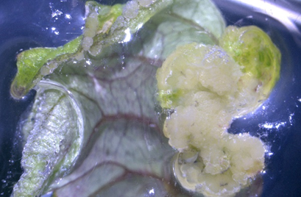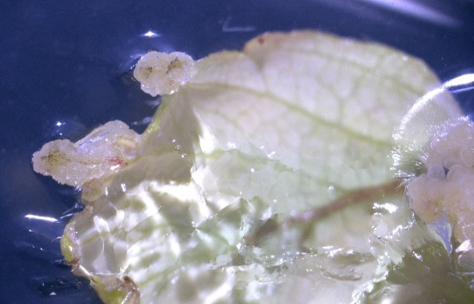
B
A
Figure 1. Callus induction from leaf culture of strawberry after 4-week culture (bar). (A) Thidiazuron (TDZ) 2.27 µM and 2,4-dichlorophenoxyacetic acid (2,4-D) 0.45 µM combination (1 mm); (B) TDZ 4.54 µM and 2,4-D 2.27 µM combination (1 mm).

2.2. The effect of different plant explants under 2,4-D and TDZ

In this part of study, we observed the callus regeneration after 2-week culture (Figure 2A-B) and both calli and shoots were found after 4-week culture (Figure 2C-F). A similar result was obtained that the combination of cytokinin TDZ and auxin 2,4-D can induce more calli than those without adding any growth regulators and using cytokinin or auxin alone. We observed that the callus induction rate in whole leaf explants reached 100% only after 2 weeks in the medium with TDZ 2.27 µM and 2,4-D 2.27 µM (Table 2). The higher TDZ (4.54 µM) dose combined with 2,4-D 0.45 µM treatment also exhibited the high induction percentage of 92%, but no shoot regeneration was found. After 4-week culture, 100% callus induction could be also achieved from the intact leaves treated with TDZ 4.54 µM + 2,4-D 0.45 µM, the basal blades treated with TDZ 2.27 µM + 2,4-D 0.45 µM and TDZ 4.54 µM + 2,4-D 0.45 µM, and the petioles treated with TDZ 2.27 µM + 2,4-D 2.27 µM in darkness (Table 3). Basically, the high induction rate of callus could be observed by adding TDZ 0.45-4.54 µM and 2,4-D 0.45-4.53 µM after 4-week culture in the dark, especially whole leaf and basal blade explants. In this test, we also found the shoot regeneration occurred in the medium to which TDZ 2.27 µM + 2,4-D 0.45 µM and TDZ 4.54 µM + 2,4-D 0.45 µM were added, though regeneration rate was only around 12-16% of in whole leaf and basal blade explants (Table 4).

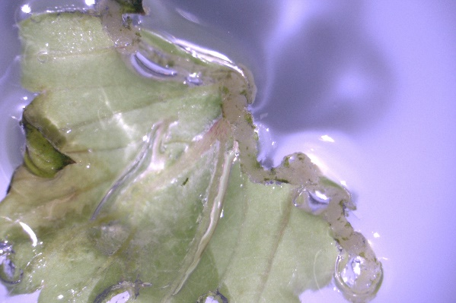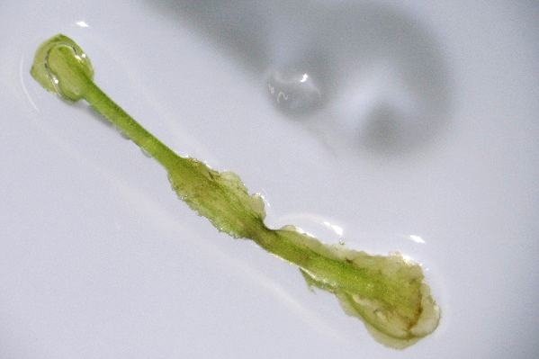
A
B
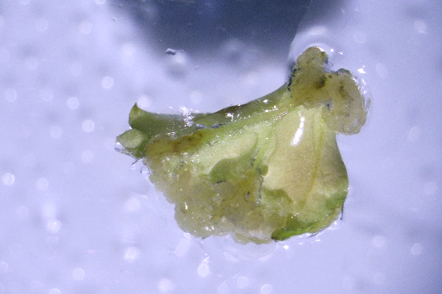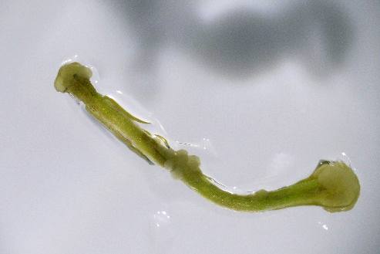
D
C
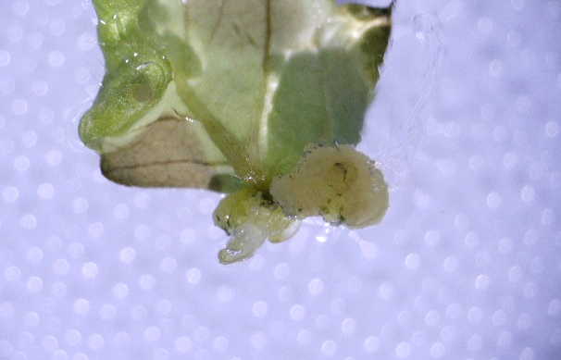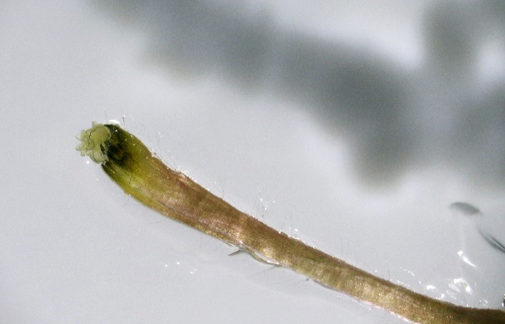
F
E

Figure 2. Callus induction and shoot regeneration using different explants (bar). After 2-week culture, calli were found on (A) whole leaf and (B) petiole explants under thidiazuron (TDZ) 4.53 µM and 2,4-dichlorophenoxyacetic acid (2,4-D) 2.27 µM combination (1 mm) in dark condation. After 4-week culture, both calli and shoots were observed. More calli were seen in (C) whole leaf and (D) petiole explants culture under TDZ 2.27 µM and 2,4-D 2.27 µM combination (1 mm). The shoots started to develop in (E) whole leaf and (F) petiole explants culture under TDZ 4.54 µM and 2,4-D 0.45 µM combination (1 mm).

Table 2. Effect of thidiazuron (TDZ) and 2,4-dichlorophenoxyacetic acid (2,4-D) combination on callus induction rate from different strawberry (Fragaria vesca) explants after 2-week culture.
PGR combination (µM) |  |  | Whole leaf  (%) |  |  | Tip blade  (%) |  |  | Basal blade  (%) |  |  | Petiole  (%)
TDZ | 2,4-D |  | Dark | Light |  | Dark | Light |  | Dark | Light |  | Dark | Light
0 | 0 |  | 0±0 h | 0±0 c |  | 0±0 e | 0±0 b |  | 0±0 c | 0±0 d |  | 0±0 c | 0±0 b
0 | 0.45 |  | 0±0 h | 0±0 c |  | 0±0 e | 0±0 b |  | 0±0 c | 0±0 d |  | 0±0 c | 0±0 b
0 | 2.27 |  | 4±4 gh | 12±8 c |  | 0±0 e | 0±0 b |  | 0±0 c | 0±0 d |  | 4±4 c | 0±0 b
0.45 | 0 |  | 24±7 fg | 5±4 c |  | 8±5 e | 0±0 b |  | 28±10 b | 0±0 d |  | 4±4 c | 0±0 b
0.45 | 0.45 |  | 52±10 de | 16±12 c |  | 72±10 bc | 32±16 b |  | 84±12 a | 28±20 cd |  | 4±4 c | 0±0 b
0.45 | 2.27 |  | 40±13 ef | 64±12 ab |  | 80±6 ab | 70±10 a |  | 88±5 a | 72±8 ab |  | 12±8 c | 8±5 ab
2.27 | 0 |  | 32±10 ef | 24±12 c |  | 12±5 e | 0±0 b |  | 36±12 b | 4±4 d |  | 8±5 c | 0±0 b
2.27 | 0.45 |  | 76±7 bc | 80±9 ab |  | 96±4 a | 32±12 b |  | 80±13 a | 30±10 cd |  | 36±10 b | 4±4 b
2.27 | 2.27 |  | 100±0 a | 80±9 ab |  | 16±7 e | 76±15 a |  | 72±10 a | 84±12 a |  | 88±8 a | 16±7 a
4.54 | 0 |  | 0±0 h | 25±10 c |  | 56±13cd | 8±5 b |  | 28±5 b | 12±8 d |  | 5±4 c | 4±4 b
4.54 | 0.45 |  | 92±8 ab | 88±5 a |  | 40±13 d | 32±20 b |  | 84±10 a | 48±21 bc |  | 44±7 b | 12±5 a
4.54 | 2.27 |  | 64±10 cd | 60±9 b |  | 40±6 d | 30±13 b |  | 76±7 a | 80±11 a |  | 48±12 b | 16±12 a
a Means ± standard error of 5 replicates with the same letters are not significantly different at p < 0.05 (Duncan, 1955).
b The cultures were in the dark or under a 16:8 h photoperiod at 3,500 lux.

Table 3. Effect of thidiazuron (TDZ) and 2,4-dichlorophenoxyacetic acid (2,4-D) combination on callus induction rate from different strawberry (Fragaria vesca) explants after 4-week culture.
PGR combination  (µM) |  |  | Whole leaf  (%) |  |  | Tip blade  (%) |  |  | Basal blade  (%) |  |  | Petiole  (%)
TDZ | 2,4-D |  | Dark | Light |  | Dark | Light |  | Dark | Light |  | Dark | Light
0 | 0 |  | 0±0 c | 0±0 c |  | 0±0 f | 0±0 b |  | 4±4 c | 0±0 e |  | 0±0 c | 0±0 d
0 | 0.45 |  | 0±0 c | 0±0 c |  | 20±6 ef | 0±0 b |  | 0±0 c | 0±0 e |  | 0±0 c | 0±0 d
0 | 2.27 |  | 12±8 c | 20±13 c |  | 4±4 f | 4±4 b |  | 4±4 c | 0±0 e |  | 40±9 b | 4±4 d
0.45 | 0 |  | 44±13 c | 20±6 c |  | 8±5 ef | 0±0 b |  | 40±9 b | 0±0 e |  | 0±0 c | 0±0 d
0.45 | 0.45 |  | 92±5 a | 24±19 c |  | 80±6 ab | 60±11 a |  | 92±5 a | 40±18 d |  | 32±14 b | 4±4 d
0.45 | 2.27 |  | 84±7 a | 92±5 a |  | 95±4 a | 70±10 a |  | 88±8 a | 84±10 ab |  | 80±6 a | 72±14bc
2.27 | 0 |  | 48±10 c | 24±7c |  | 32±14de | 4±4 b |  | 40±14 b | 8±5 e |  | 4±4 c | 8±8 d
2.27 | 0.45 |  | 88±8 a | 88±8 a |  | 96±4 a | 68±16 a |  | 100±0 a | 55±10 cd |  | 92±8 a | 24±12 d
2.27 | 2.27 |  | 100±0 a | 96±4 a |  | 48±12cd | 80±13 a |  | 96±4 a | 100±0 a |  | 100±0 a | 100±0 a
4.54 | 0 |  | 4±4 c | 55±13 b |  | 60±14bc | 16±7 b |  | 40±11 b | 12±8 e |  | 10±4 c | 8±8 d
4.54 | 0.45 |  | 100±0 a | 96±4 a |  | 48±10cd | 48±22 a |  | 100±0 a | 68±16 bc |  | 92±5 a | 60±14 c
4.54 | 2.27 |  | 84±7 a | 72±7 ab |  | 60±6 bc | 55±10 a |  | 84±7 a | 95±4 a |  | 84±7 a | 84±7 ab
a Means ± standard error of 5 replicates with the same letters are not significantly different at p < 0.05 (Duncan, 1955).
b The cultures were in the dark or under a 16:8 h photoperiod at 3,500 lux.

Table 4. Effect of thidiazuron (TDZ) and 2,4-dichlorophenoxyacetic acid (2,4-D) combination on shoot regeneration from different strawberry (Fragaria vesca) explants after 4-week culture.
PGR combination  (µM) |  |  | Whole leaf  (%) |  |  | Tip blade  (%) |  |  | Basal blade  (%) |  |  | Petiole  (%)
TDZ | 2,4-D |  | Dark | Light |  | Dark | Light |  | Dark | Light |  | Dark | Light
0 | 0 |  | 0±0 | 0±0 b |  | 0±0 b | 0 |  | 0±0 b | 0 |  | 0±0 b | 0
0 | 0.45 |  | 0±0 | 0±0 b |  | 0±0 b | 0 |  | 0±0 b | 0 |  | 0±0 b | 0
0 | 2.27 |  | 0±0 | 0±0 b |  | 0±0 b | 0 |  | 0±0 b | 0 |  | 0±0 b | 0
0.45 | 0 |  | 0±0 | 0±0 b |  | 0±0 b | 0 |  | 0±0 b | 0 |  | 0±0 b | 0
0.45 | 0.45 |  | 0±0 | 0±0 b |  | 0±0 b | 0 |  | 0±0 b | 0 |  | 0±0 b | 0
0.45 | 2.27 |  | 0±0 | 0±0 b |  | 0±0 b | 0 |  | 0±0 b | 0 |  | 0±0 b | 0
2.27 | 0 |  | 0±0 | 0±0 b |  | 0±0 b | 0 |  | 4±4 b | 0 |  | 0±0 b | 0
2.27 | 0.45 |  | 12±12 | 4±4 a |  | 0±0 b | 0 |  | 0±0 b | 0 |  | 4±4 ab | 0
2.27 | 2.27 |  | 4±4 | 0±0 b |  | 0±0 b | 0 |  | 4±4 b | 0 |  | 0±0 b | 0
4.54 | 0 |  | 0±0 | 0±0 b |  | 0±0 b | 0 |  | 0±0 b | 0 |  | 0±0 b | 0
4.54 | 0.45 |  | 12±5 | 0±0 b |  | 8±8 a | 0 |  | 16±7 a | 0 |  | 8±5 a | 0
4.54 | 2.27 |  | 0±0 | 0±0 b |  | 0±0 b | 0 |  | 0±0 b | 0 |  | 0±0 b | 0
a Means ± standard error of 5 replicates with the same letters are not significantly different at p < 0.05 (Duncan, 1955).
b The cultures were in the dark or under a 16:8 h photoperiod at 3,500 lux.

2.3. Shoot regeneration from calli using different cytokinin treatments

For the shoot regeneration, the calli were used as explants in this study for 2-week culture. In general, more shoots could be induced in light than in darkness. The callus treated with BA 0.44 µM under light condition gave the highest shoot induction rate of 96%, though it was not the statistically higher than the treatment of TDZ 0.45 µM and kinetin (KIN) at all concentrations at the second week (Table 5). However, the number of induced buds was 19.4 per explant which was significantly higher (p < 0.05) than all treatments, except KIN 2.33 µM. This efficient regeneration rate will be an ideal treatment for mass propagation in the future. Although the high induction rate was found TDZ 0.45 µM treatment in the dark, the pale green color of buds was not considered to be healthy as those in light condition. By histological analysis, the meristematic cells were observed on the edge of callus explants (Figure 3A&C). These cells exhibited the smaller size and obviously densely stained when compared to the original callus cells. The leaf primordium and shoot apical meristem developed from the meristematic cells were also observed (Figure 3B) which revealed the adventitious shoot organogenesis from calli of wild strawberry (Figure 3D). No somatic embryogenesis was found in this study.

Table 5. Effect of thidiazuron (TDZ), 6-benzylaminopurine (BA) and kinetin (KIN) on shoots regeneration from strawberry (Fragaria vesca) callus explants after 2-week culture.
Cytokinin (µM) |  |  |  | No. of inducted shoots |  |  | Shoot induction rate (%) |  |  | Browning rate (%)
TDZ | BA | KIN |  | Dark | Light |  | Dark | Light |  | Dark | Light
0 | 0 | 0 |  | 1.2±0.6 cd | 9.2±1.5 bc |  | 16± 7 de | 64± 4 abcd |  | 0 | 0
0.45 |  |  |  | 9.4±1.3 a | 11.6±1.6 b |  | 92± 5 a | 88± 5 ab |  | 0 | 0
2.27 |  |  |  | 4.4±0.9 b | 9.0±3.5 bc |  | 56±12 b | 56±16 bcd |  | 0 | 0
4.54 |  |  |  | 1.0±0.6 d | 3.8±2.1 c |  | 12± 5 de | 36±19 d |  | 0 | 0
9.08 |  |  |  | 2.4±1.0 bcd | 4.2±0.8 c |  | 36±12 bcd | 64±12 abcd |  | 0 | 0
 | 0.44 |  |  | 8.0±1.3 a | 19.4±1.4 a |  | 88± 8 a | 96± 4 a |  | 0 | 0
 | 2.22 |  |  | 0.4±0.2 d | 4.6±0.5 c |  | 8± 5 e | 48± 5 cd |  | 0 | 0
 | 4.44 |  |  | 0.4±0.2 d | 4.8±1.0 c |  | 8± 5 e | 48±10 cd |  | 0 | 0
 | 8.88 |  |  | 1.6±0.7 cd | 4.4±1.7 c |  | 20± 8 cde | 56±20 bcd |  | 0 | 0
 |  | 0.47 |  | 4.4±0.9 b | 9.0±1.3 bc |  | 48±10 bc | 80± 6 abc |  | 0 | 0
 |  | 2.33 |  | 2.0±1.0 bcd | 13.8±3.5 ab |  | 24±10 cde | 88± 8 ab |  | 0 | 0
 |  | 4.65 |  | 2.2±0.9 bcd | 12.2±2.6 b |  | 24± 7 cde | 88±12 ab |  | 0 | 0
 |  | 9.30 |  | 3.8±0.4 bc | 9.4±1.6 bc |  | 60± 6 b | 80± 9 abc |  | 0 | 0
a Means ± standard error of 5 replicates with the same letters are not significantly different at p < 0.05 (Duncan, 1955).

b The cultures were under a 16:8 h photoperiod at 3,500 lux.

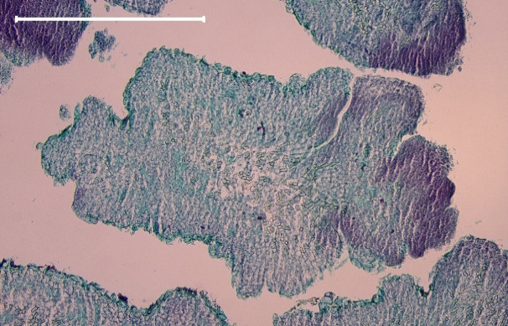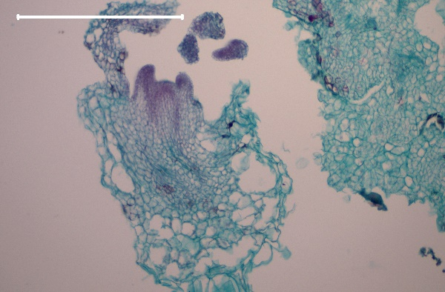
LP
SAM
B
A
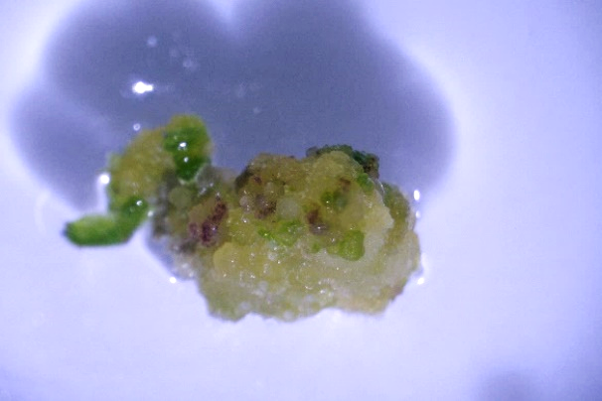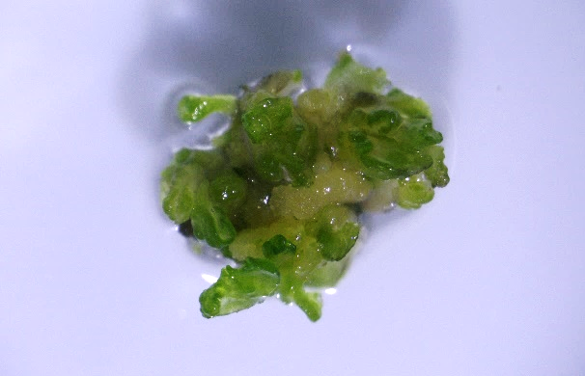
AS
AS
D
C

Figure 3. Histological observation of shoot regenration from wild strawberry (Fragaria vesca) calli after 2-week culture and their corresponding development stages (bar). (A) Meristematic cells originated from the cells of callus explants (500 μm); (B) shoot organogenesis with leaf primordium (LP) and shoot apical meristem (SAM) (500 μm); (C) the corresponding developmental stage of callus explants to panel A (1 mm); (D) the stage of adventitious shoot (AS) development corresponding to panel B (1 mm).

2.4. Root induction from shoot explants using different auxins

In the study of root induction, we found that IBA showed the better induction rate than NAA. The higher browning rate and lower root induction rate were observed under the light condition, demonstrating that the dark condition is more suitable for root induction. In darkness, the rooting rates of IBA 0.41 µM, IBA 4.14 µM and IBA 8.28 µM were 12%, 8% and 4%, respectively (Table 6). After 8-week culture, better induction ratio and root numbers were observed in IBA 0.41 µM treatment under dark condition and followed by IBA 1 mg/L treatment (Figure 4).

Table 6. Effect of indole-3-butyric acid (IBA) and 1-naphthaleneacetic acid (NAA) on roots induction from strawberry (Fragaria vesca) shoot explants after 8-week culture.
Auxin (µM) |  |  | No. of induced roots |  |  | Root induction rate (%) |  |  | Browning rate (%)
IBA | NAA |  | Dark | Light |  | Dark | Light |  | Dark | Light
0 |  |  | 0.0±0 | 0.0±0 |  | 0±0 b | 0±0 |  | 0± 0 | 20± 6
0.41 |  |  | 0.6±0.4 | 0.0±0 |  | 12±8 a | 0±0 |  | 4± 4 | 12± 8
1.03 |  |  | 0.0±0 | 0.0±0 |  | 0±0 b | 0±0 |  | 0± 0 | 20± 6
2.07 |  |  | 0.0±0 | 0.0±0 |  | 0±0 b | 0±0 |  | 0± 0 | 8± 4
4.14 |  |  | 0.6±0.4 | 0.0±0 |  | 8±5 ab | 0±0 |  | 0± 0 | 12± 8
8.28 |  |  | 0.4±0.4 | 0.0±0 |  | 4±4 ab | 0±0 |  | 0± 0 | 12±12
 | 0.48 |  | 0.0±0 | 0.2±0.2 |  | 0±0 b | 4±4 |  | 12±12 | 8± 5
 | 1.20 |  | 0.0±0 | 0.2±0.2 |  | 0±0 b | 4±4 |  | 4± 4 | 0± 0
 | 2.40 |  | 0.0±0 | 0.0±0 |  | 0±0 b | 0±0 |  | 0± 0 | 16± 7
 | 4.80 |  | 0.0±0 | 0.0±0 |  | 0±0 b | 0±0 |  | 4± 4 | 20± 9
 | 9.60 |  | 0.0±0 | 0.0±0 |  | 0±0 b | 0±0 |  | 8± 8 | 12± 5
a Means ± standard error of 5 replicates with the same letters are not significantly different at p < 0.05 (Duncan, 1955).
b The cultures were under a 16:8 h photoperiod at 3,500 lux.

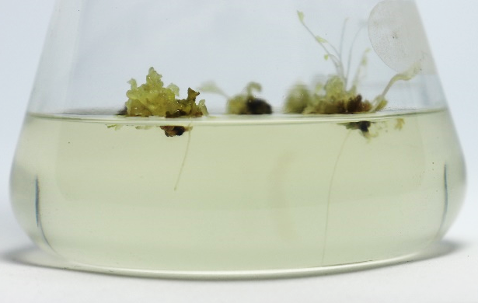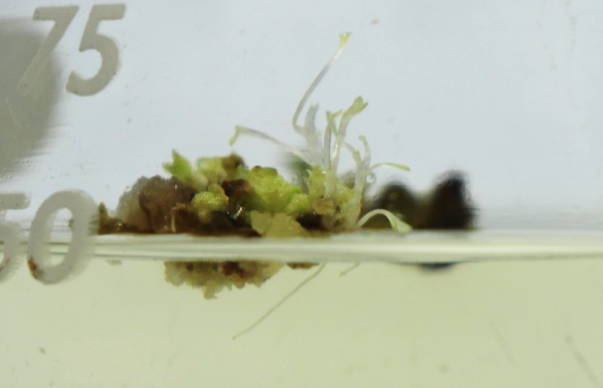
B
A

Figure 4. Root induction from wild strawberry (Fragaria vesca) shoots under dark condition after 8-week culture (bar). (A) Indole-3-butyric acid (IBA) 0.1 mg/L treatment (10 mm); (B) IBA 1 mg/L treatment (5 mm).

2.5. Plant acclimatization

The 5-cm size of strawberry plants with intact root system were moved out from in vitro system without the remaining medium, and were planted in three-inch pots containing the mix medium of peat soil, pearlite and vermiculite with the ratio of 1:1:1 in volume. Strawberry plants were then acclimated in a low-light shading house for two weeks. The acclimatized strawberries were transfered into the five-inch pots after one month. The strawberries without the formation of running stem developed white flowers (Figure 3).

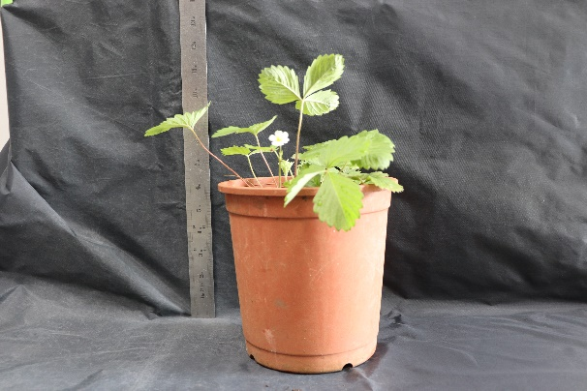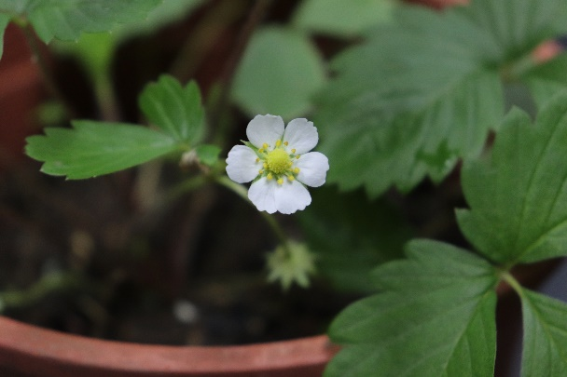
B
A
A

Figure 5. Acclimatization of wild strawberry (Fragaria vesca) plants. (A) The strawberry after three months of cultivation; (B) Flowers blooming after strawberry cultivation.

3. Discussion
Regarding in vitro morphogenesis of strawberry, both somatic embryogenesis and organogenesis have been described in different strawberry cultivars [22]. Different factors including explants (e.g. runner, nodal, stem and leaf), plant growth regulators (e.g. BA, TDZ, NAA, IBA and 2,4-D), and environmental conditions have been reported. Wild strawberry (F. vesca) was the first domesticated strawberry in the Europe and acquired popularity in the 1500’s and 1600’s [1]. Although it is an old specie, several great characteristics, such as robust and powerful aroma, making it as a great source for strawberry breeding in the future. Therefore, we established a serial regeneration method for wild strawberry in this study.
The present research used leaf as the explant which is the most abundant tissue in a plant and the less harmful for plant when it is excised. In the first test, the combination of two cytokinins (TDZ and BA) and one auxin (2,4-D) were applied for regeneration of wild strawberry. We observed that only callus tissues were formed after 4-week culture and the efficiency of TDZ was better than BA (Table 1). Browning rate of leaf explant was high in the light condition without adding TDZ. Cappelletti et al. [32] showed that the callus induction rate of Fragaria × ananassa `Calypso’ reached to 100% in the combination of TDZ 1.0 mg/L + 2,4-D 0.2 mg/L and TDZ 0.5 mg/L + 2,4-D 0.02 mg/L after 42 days. Our wild strawberry gave a similar result with `Calypso’ and our induction rate reached to 100% after 28 days. In general, one of key factors for regeneration is to utilize the combination of cytokinin and auxin in the culture medium. Cappelletti et al. [32] have successfully induced the shoots at 80% of regeneration rate in `Sveva’ cultivar by using IBA 3.0 mg/L and BA 0.2 mg/L. In `Chandler’ cultivar, the combination of 2,4-D 1.0 mg/L and BA 0.1 mg/L in MS medium was able to prompt the callus formation rate up to 90% [33]. Biswas et al. [34] showed that application of NAA 4.0 mg/L and BA 1.5 mg/L in three strawberry (Fragaria sp.) clones could induce the callus formation from 72 to 89% using different explants including leaves, runners and nodal segments. According to the previous studies above, different concentrations of PGRs and different strawberry cultivars showed the variability in the regeneration rate, indicating that each genotype has specific requirements for regeneration.
Type of explant was also the important factor for successful plant regeneration. A broad range of explants have been characterized in strawberry, e.g. leaves [35-37], petioles [36, 38], stems [39], peduncles [40], stolons [40], stipules [38, 41], roots [38, 41], anthers [42] and sepals [43]. Whole leaf, tip blade, basal blade and petiole tissues were also examined for callus induction. In general, four types of explants exhibited the high induction percentages with TDZ and 2,4-D in the dark culture, especially after 4-week culture (Table 3). However, for tip blade, the induction rate dropped to 48-60% when a higher dose of TDZ (4.54 µM) applied and the browning phenomenon occurred prevailingly in tip blade explants at all PGR combinations (data not shown). The shoot organogenesis could be also observed in few combinations. For callus induction from leaves, the best and quicker condition was found in the medium with TDZ 2.27 µM and 2,4-D 2.27 µM and incubated in the dark. Shoots will form if the culture is kept in the same condition. However, the larger number of shoots were obtained in the following treatment.
For shoot regeneration from callus tissue, Rugini and Orlando [41] found that 84-96% of callus explants from Fragaria x ananassa Duch. induce 4-8 shoots per explant in the medium containing BA and IBA. In our experiment, three types of cytokinins, i.e. TDZ, BA and KIN, were applied. In contrast with callus induction, higher shoot regeneration rates were observed in the light condition. After 2-week culture, regeneration rate of 96% with 19.4 shoots per explant was observed in BA 0.44 µM (Table 5) and number of shoots increased to 52 after 4-week culture (data not shown) which is the optimum PGR concentration in this part of work. Compared with shoot regeneration rate in the callus inducing medium after 4-week culture (Table 4), only 4-12% was observed. Less efficient result was seen in root induction, being 12% induction rate in the IBA 0. 41 µM medium (Table 6).
In conclusion, we established a simple and efficient regeneration protocol for wild strawberry (F. vesca) by using leaf explants. Calli of wild strawberry can be formed in 2 weeks from leaf explants in the medium containing TDZ 2.27 µM and 2,4-D 2.27 µM in the dark. Then, the calli are cultured on shooting medium with BA 0.44 µM for another 2 weeks in the light condition. Numbers of shoots can be obtained within a month. Sarker et al. [28] showed that the shoots of F. vesca cv. Baron Solemacher were regenerated from leaf explants via callus stage after 6-9 weeks in the same medium. Therefore, to shorten the regeneration period, application of the shooting medium could be essential. This protocol can be useful for rapid and large-scale shoot propagation and might be applied for generation of transgenic plant in future. However, regarding rooting, it still should be improved by applying other types of auxin or environmental conditions.

4. Materials and Methods
4.1. Plant material and in vitro seed germination
Wild strawberry (Fragaria vesca) seeds were purchased from Known-You Seed Co. Ltd., Taiwan. Seeds were sterilized by soaking in 0.5% NaClO (sodium hypochlorite) solution with 10 mg L⁻¹ Tween-20 (Sigma-Aldrich Inc, USA) for 10 minutes and then rinsed with 75% ethanol for 1 minute. Finally, all seeds were washed 3 times with sterile ddH₂O to remove any traces of ethanol and dried on the sterilized Petri dish in the biosafety cabinet. Sterilized seeds were placed on 1/2 MS medium (Duchefa Biochemie B.V., Netherlands) [44] containing 30 g L⁻¹ sucrose (Taiwan Sugar Corp., Taiwan) and 3 g L⁻¹ phytagel (Sigma-Aldrich Inc, USA) at pH 5.7, which was autoclaved at 121˚C at 15 psi pressure for 30 minutes in 500 mL flasks. All seeds and seedlings were incubated in a growth chamber under a 16/8-h (light/dark) photoperiod at photon flux density of 28–36 μmol m⁻²s⁻¹ (daylight fluorescent tubes FL-30D/29, 40 W, China Electric Co., Taipei, Taiwan) and temperature of 25 ± 2 °C. In vitro seedlings were subcultured to the same medium every 2 months.
4.2. Effect of 2,4-D and cytokinins on callus induction using whole leaf explants
Fully expanded leaves (around 1 cm) were excised from in vitro seedlings (about 3-4 cm in height) as explants. For induction of calli, the leaf explants were cultured under different PGR combinations and light conditions. The combinations of 2,4-D (0, 0.45, 2.27, 4.53 µM) with TDZ (0, 0.45, 2.27, 4.54 µM) or BA (2.22, 4.44, 8.88 µM) were added to the 1/2 MS basal medium mentioned above. The leaf explants were placed on the culture medium in the 90 × 15 mm Petri dishes under darkness or light condition at the same photoperiod and intensity described above. All explants were cultured at temperature of 25 ± 2 °C. Five dishes (replicates) each contained 5 explants were utilized in this experiment. Data were collected after 4 weeks.
4.3. Effect of explants on callus induction
Different explants, i.e. whole leaves, leaf tip blades, leaf basal blades and petioles, were excised from in vitro seedlings and placed on the 1/2 MS basal medium supplemented with PGR combination of 2,4-D (0, 0.45, 2.27 µM) and TDZ (0, 0.45, 2.27, 4.54 µM). The dark and light conditions described above were also examined for different explant types and temperature was kept at 25 ± 2 °C. Five 90 × 15 mm Petri dishes (replicates) each containing 5 explants were used in this experiment. Data were collected after 2 and 4 weeks.
4.4. Effect of different cytokinins on shoot regeneration using callus explants
For preparing callus explants, one of the best PGR combinations (2.27 µM TDZ and 2.27 µM 2,4-D) for callus induction was applied using whole leaf explants. After 4 weeks culture, induced calli were cut into small clumps (around 0.5 cm³) and incubated on the 1/2 MS basal mediums containing TDZ (0, 0.45, 2.27, 4.54, 9.08 µM), BA (0.44, 2.22, 4.44, 8.88 µM) or KIN (0, 0.47, 2.33, 4.65, 9.30 µM). The dark and light conditions were also examined. Five 55 × 15 mm Petri dishes (replicates) each containing 5 explants were used in this experiment. Data were collected after 2 weeks.
4.5. Root induction
After shoot regeneration, shoots were examined for the root induction rate using different auxins and concentrations. Auxins, IBA (0, 0.41, 1.03, 2.07, 4.14, 8.28 µM) and NAA (0.48, 1.20, 2.40, 4.80, 9.60 µM), were added to the 1/2 MS medium. Five shoot explants were incubated in a 125 mL flask as 1 replicate and 5 replicates were applied for each treatment. The effect of dark and light conditions were examined in the study. Data were collected after 8 weeks.
4.6. Acclimatization of regenerated plants
After 6 months of root induction, plantlets around 5 cm in height with well-developed shoots and roots were transplanted into 3-inch plastic pots with potting mix (peat moss: vermiculite: perlite = 1: 1: 1). The plantlets were incubated in a shaded greenhouse under natural photoperiod and temperature for acclimatization.
4.7. Histological analysis
For histological observation, tissue samples were fixed in FPA (formaldehyde: propionic acid: glycerol: 95% ethanol: distilled water = 1: 1: 3: 7: 8 in volume) solvent for 48 hours and dehydrated through a tertiary butyl alcohol series. After removing water, samples were infiltrated with liquid paraffin at 65 °C in the oven and embedded in paraffin wax. The embedded tissue wax blocks were trimmed and sectioned at 10 μm using a rotary microtome (Leica RM2125 RT). The tissue sections were serially mounted on the glass slides and stained with 1% safranin-O (Sigma-Aldrich Inc, USA) for 30 minutes followed by 5% fast green (Sigma-Aldrich Inc, USA) for 10 seconds. After washing out the residual stain, sections were permanently mounted on slides for observation.
4.8. Statistical analysis
All experiments in this study were designed with a randomized complete block design. The morphogenesis of tissue explants was observed under a stereomicroscope (SDPTOP SZN71). Five replicates were taken for each treatment, and 5 explants were planted in each culture dish or flask. Data represented the mean ± standard error of replicates. One way analysis of variance (ANOVA) for data evaluation and Duncan’s multiple range test (Duncan 1995) with a 0.05 level of probability were performed using the SPSS PASW Statistics 18.0 software.

Author Contributions: Conceptualization, HHC; methodology, HHC and HYO; validation, HHC and HYO; formal analysis, HHC and HYO; investigation, HYO; resources, HHC; data curation, HHC and HYO; writing—original draft preparation, HHC; writing—review and editing, HHC; visualization, HHC; supervision, HHC; project administration, HHC; funding acquisition, HHC. All authors have read and agreed to the published version of the manuscript.
Conflicts of Interest: The authors declare no conflict of interest.

References
- Hummer, K.E.; Hancock, J. Strawberry Genomics: Botanical History Cultivation, Traditional Breeding, and New Technologies. In Genetics and Genomics of Rosaceae; Folta, K.M., Gardiner, S.E., Eds.; Springer: New York, USA, 2009, pp. 415-435.
- FAO. Food and Agriculture. http://www.fao.org/faostat/en/#data/QC 2020, Accessed 2 June 2020.
- Giampieri, F.; Tulipani, S.; Alvarez-Suarez, J.M.; Quiles, J.L.; Mezzetti, B.; Battino, M. The strawberry: composition, nutritional quality, and impact on human health. Nutrition 2012, 28, 9-19.

- Green, A. Soft Fruits. In The Biochemistry of Fruits and Their Products vol.2.; Hulme, A.C. Ed.; Academic Press: New York, USA, 1971, pp. 375–410.
- da Silva, F.L.; Escribano-Bailón, M.T.; Alonso, J.J.P.; Rivas-Gonzalo, J.C.; Santos-Buelga, C. Anthocyanin pigments in strawberry. LWT-Food Science and Technology, 2007, 40, 374-382.
- Aaby, K.; Ekeberg, D.; Skrede, G. Characterization of phenolic compounds in strawberry (Fragaria × ananassa) fruits by different HPLC detectors and contribution of individual compounds to total antioxidant capacity. Journal of Agricultural and Food Chemistry, 2007, 55, 4395-4406.
- Cerezo, A.B.; Cuevas, E.; Winterhalter, P.; Garcia-Parrilla, M.C.; Troncoso, A.M. Isolation, identification, and antioxidant activity of anthocyanin compounds in Camarosa strawberry. Food Chemistry, 2010, 123, 574-582.
- Clifford, M.N. Anthocyanins–nature, occurrence and dietary burden. Journal of the Science of Food and Agriculture, 2000, 80, 1063-1072.
- Garcia‐Viguera, C.; Zafrilla, P.; Tomás‐Barberán, F.A. The use of acetone as an extraction solvent for anthocyanins from strawberry fruit. Phytochemical Analysis, 1998, 9, 274-277.
- Kelebek, H.; Selli, S. Characterization of phenolic compounds in strawberry fruits by RP-HPLC-DAD and investigation of their antioxidant capacity. Journal of liquid chromatography and related technologies, 2011, 34, 2495-2504.
- Wang, H.; Cao, G.; Prior, R.L. Oxygen radical absorbing capacity of anthocyanins. Journal of agricultural and Food Chemistry, 1997, 45, 304-309.
- Wang, L.S.; Hecht, S.S.; Carmella, S.G.; Yu, N.; Larue, B.; Henry, C.; McIntyre, C.; Rocha, C.; Lechner, J.F.; Stoner, G.D. Anthocyanins in black raspberries prevent esophageal tumors in rats. Cancer prevention research, 2009, 2, 84-93.
- Takikawa, M.; Inoue, S.; Horio, F.; Tsuda, T. Dietary anthocyanin-rich bilberry extract ameliorates hyperglycemia and insulin sensitivity via activation of AMP-activated protein kinase in diabetic mice. The Journal of nutrition, 2010, 140, 527-533.
- Kwon, S.H.; Ahn, I.S.; Kim, S.O.; Kong, C.S.; Chung, H.Y.; Do, M.S.; Park, K.Y. Anti-obesity and hypolipidemic effects of black soybean anthocyanins. Journal of medicinal food, 2007, 10, 552-556.
- Rechner, A.R.; Kroner, C. Anthocyanins and colonic metabolites of dietary polyphenols inhibit platelet function. Thrombosis research, 2005, 116, 327-334.
- Shim, S.H.; Kim, J.M.; Choi, C.Y.; Kim, C.Y.; Park, K.H. Ginkgo biloba extract and bilberry anthocyanins improve visual function in patients with normal tension glaucoma. Journal of medicinal food, 2012, 15, 818-823.
- Kadhimi, A.A.; Alhasnawi, A.N.; Mohamad, A.; Yusoff, W.M.W.; Zain, C.R.B.C.M. Tissue culture and some of the factors affecting them and the micropropagation of strawberry. Life Science Journal, 2014, 11, 484-493.
- Karhu, S.; Hakala, K. Micropropagated strawberries on the field. ISHS Acta Horticulture, 2002, 2: 182
- Mahajan, R.; Kaur, R.; Sharma, A.; Sharma, D.R. Micropropagation of strawberry cultivar Chandler and Fern. Crop Improvement, 2001, 28, 19-25.
- Mohan, R.; Chui, E.A.; Biasi, L.A.; Soccol, C.R. Alternative invitro propagation: use of sugarcane bagasse as a low cost support material during rooting stage of strawberry cv. Dover. Brazilian Archives of Biology and Technology, 2005, 48, 37-42.
- Debnath, S.C.; Teixeira da Silva, J.A. Strawberry culture in vitro: applications in genetic transformation and biotechnology. Fruit, Vegetable and Cereal Science and Biotechnology, 2007, 1, 1-12.
- Nishi, S.; Ohsawa, K. Mass production method of virus-free strawberry plants through meristem callus. Japan Agricultural Research Quarterly, 1973, 7, 189-194.
- Nyman, M.; Wallin, A. Plant regeneration from strawberry (Fragaria x ananassa) mesophyll protoplasts. Journal of plant physiology, 1988, 133, 375-377.
- Donnoli, R.; Sunseri, F.; Martelli, G.; Greco, I. (2001) Somatic embryogenesis, plant regeneration and genetic transformation in Fragaria spp. Acta Horticulturae, 2001, 560, 236-240.
- Landi, L.; Mezzetti, B. TDZ, auxin and genotype effects on leaf organogenesis in Fragaria. Plant Cell Report, 2006, 25, 281–288
- Arndt, F.R.; Rusch, R.; Stillfried, H.V.; Hanisch, B.; Martin, W.C. A new cotton defoliant. Plant Physiology, 1976, 57, S-99.
- Guo, B.; Abbasi, B.H.; Zeb, A.; Xu, L.L.; Wei, Y.H. Thidiazuron: a multi-dimensional plant growth regulator. African Journal of Biotechnology, 2011, 10, 8984-9000.
- Sarker, B.C.; Archbold, D.D.; Geneve, R.L.; Kester, S.T. Rapid in vitro multiplication of mon-runnering Fragaria vesca genotypes from seedling shoot axillary bud explants. Horticulturae 2020, 6, 51, doi:10.3390/horticulturae6030051
- Yildirim, A.B.; Turker, A.U. Effects of regeneration enhancers on micropropagation of Fragaria vesca L. and phenolic content comparison of field-grown and in vitro-grown plant materials by liquid chromatography-electrospray tandem mass spectrometry LC–ESI-MS/MS. Horticulturae, 2014, 169, 169–178.
- Hirvi, T.; Honkanen, E. The volatiles of two new strawberry cultivars, ‘Annelie’ and ‘Alaska Pioneer’, obtained by backcrossing of cultivated strawberries with wild strawberries, Fragaria vesca, Rügen and Fragaria virginiana. Zeitschrift für Lebensmittel-Untersuchung und Forschung, 1982, 175, 113-116.
- Aharoni, A.; Giri, A.P.; Verstappen, F.W.; Bertea, C.M.; Sevenier, R.; Sun, Z.; Jongsma, M.A.; Schwab, W; Bouwmeester, H.J. Gain and loss of fruit flavor compounds produced by wild and cultivated strawberry species. The Plant Cell, 2004, 16, 3110-3131.

- Cappelletti, R.; Sabbadini, S.; Mezzetti, B. The use of TDZ for the efficient in vitro regeneration and organogenesis of strawberry and blueberry cultivars. Sci. Hortic. 2016, 207:117-124.
- Palei, S.; Rout, G.R.; Das, A.K.; Dash, D.K. 2017. Callus induction and indirect regeneration of strawberry (Fragaria × Ananassa) Duch. CV. Chandler. IJCMAS, 2017, 6:1311-1318.
- Biswas, M.K.; Hossain, M. Callus culture from leaf blade, nodal, and runner segments of three strawberry (Fragaria sp.) clones. Turkish Journal of Biology, 2010, 34: 75-80.
- Sorvari, S.; Ulvinen, S.; Hietaranta, T.; Hiirsalmi, H. Preculture medium promotes direct shoot regeneration from micropropagated strawberry leaf disks. HortScience, 1993, 28:55-57.
- Debnath, S.C. Zeatin overcomes thidiazuron-induced inhibition of shoot elongation and promotes rooting in strawberry culture in vitro. Journal of horticultural science and biotechnology, 2006, 81, 349-354.
- Husaini, A.M.; Abdin, M.Z. Interactive effect of light, temperature and TDZ on the regeneration potential of leaf discs of Fragaria × ananassa Duch. In vitro cellular and developmental biology – plant, 2007, 43:576-584.
- Passey, A.J.; Barrett, K.J.; James, D.J. (2003) Adventitious shoot regeneration from seven commercial strawberry cultivars (Fragaria × ananassa Duch.) using a range of explant types. Plant Cell Reports, 2003, 21:397-401.
- Graham, J.; McNicol, R.J.; Grieg, K. (1995) Towards genetic based insect resistance in strawberry using the cowpea trypsin inhibitor gene. Annals of Applied Biology, 1995, 127:163-173.
- Lis, E.K. Strawberry plant regeneration by organogenesis from peduncle and stolon segments. Acta Horticulturae, 1993, 348:435-438.
- Rugini, E.; Orlando, R. High efficiency shoot regeneration from calluses of strawberry (Fragaria × ananassa Duch.) stipules of in vitro cultures. Journal of Horticultural Science, 1992, 67:577-582.
- Owen, H.R.; Miller, A.R. (1996) Haploid plant regeneration from anther cultures of three North American cultivars of strawberry (Fragaria × ananassa Duch.). Plant Cell Reports, 1996, 15:905-909.
- Debnath, S.C. Strawberry sepal: Another explant for thidiazuron-induced adventitious shoot regeneration. In Vitro Cellular and Developmental Biology – Plant, 2005, 41, 671-676.
- Murashige, T.; F. Skoog. A revised medium for rapid growth and bioassays with tobacco tissue cultures. Physiol. Plant, 1962, 15, 473-497.

Publisher’s Note: MDPI stays neutral with regard to jurisdictional claims in published maps and institutional affiliations.
 | © 2020 by the authors. Submitted for possible open access publication under the terms and conditions of the Creative Commons Attribution (CC BY) license (http://creativecommons.org/licenses/by/4.0/).

