Reviewer #2
In my opinion, the article would be improved with a better review of the art, emphasizing similar or international works that address similar topics,and similar international experiences and problems. (Simmons, 1994; Marrocu and Paci, 2011; Lime and McCole, 2001 ... for example). It would be interesting a review of Dwyer, L., Forsyth, P., & Spurr, R. (2004).

Thanks for your suggestions. Although the previous literature review of this paper has sorted out the relevant contents of the study, it is necessary to add some relevant studies. Your suggestions provide information for the review of the literature on ascension. Therefore, we have followed your advice and appropriately added some relevant research discussions. The specific modifications are as follows.

There are few studies of the direct impact of tourism economic contact on the development of tourism, and most existing studies have explored the impact of tourism economic contact on the development of the tourism industry from the outside. Simmons (1994) proposed the relationship between local residents' participation in community tourism development and their tourism development. Dwyer, Forsyth and Spurr(2004) explored the economic benefits of tourism economic industry and proposed CEG model as a potential model to analyze the economic impact of tourism. Marrocu and Paci (2011) explored the relationship between new information, tourism flow and product efficiency in Europe and proposed that tourism could help improve regional efficiency. Jiang (2017) proposed that with the rapid development of the economy and the Internet, regional links will become closer and more efficient, which will promote the rapid expansion of the tourism market [24]. Chen et al. (2009) and Gavilán et al. (2015) discussed the impact of tourism cooperation and the spatial structure of the tourism economy on the development of the tourism industry [25,26]. Ye and Wang (2019) and other scholars believe that the improvement of regional accessibility has a connection with the tourism economy, promotes scientific and rational allocation, integrates and optimizes various elements in a regional tourism system, drives the improvement of the efficiency of tourism spatial cooperation, and ultimately enables the common and high-quality development of a regional tourism economy [10]. Liu, Lu (2015) and other scholars have posited that the development efficiency and growth quality of the tourism industry are the primary conditions for tourism sustainable development and that strengthening the exchange and cooperation of key elements of regional tourism development, such as information, technology and talents, will be beneficial to realize the regional sharing of tourism elements and can effectively improve the overall efficiency of tourism industry development [27].

New reference:
David, G. Simmons. Community participation in tourism planning. Tourism Management. 1994, 15, 98-108.
Larry, Dwyer.; Peter, Forsyth.; Ray, Spurr. Evaluating tourism's economic effects: new and old approaches. Tourism Management. 2004, 25, 307-307.
Emanuela, Marrocu.; Raffaele, Paci. They arrive with new information. Tourism flows and production efficiency in the European regions. Tourism Management. 2011, 32, 750-758.
For a better understanding of the study area I would add a situation map, for those who do not know China in depth it would be very useful, as well as the distances between cities. Sometimes the geographic analysis adds a plus of understanding and interest.
Thanks for your suggestions. After discussion with other authors, we feel that your suggestion will help readers better understand the research area and improve the readability and interest of the paper to some extent. Therefore, we add a map to the paper, as shown below.

3. Research Design
3.1. Study Areas
This study takes 20 cities in he West Coast of the Strait urban agglomeration, China, as the study site, and Figure 1 indicates the 20 cities it contains. The West Coast of the Strait urban agglomeration, also known as the West Strait Economic Zone, is located in Southeast China. According to the Coordinated Development Plan for the Cities Group on the West Bank of the Straits, the city group is a national-level city cluster with Fuzhou, Xiamen, Quanzhou, Shantou and Wenzhou as the core of the five major central cities, with a total of 20 prefecture-level cities. With a total land area of 270,000 square kilometers and a regional GDP of more than 587.2345 billion yuan in 2018, it is one of the most dynamic areas in China, with a high level of transportation development. The tourism resources of the 20 cities in the West Coast of the Strait urban agglomeration are extremely rich and highly complementary, and it is one of the most mature regions for tourism development in China.
——Insert Figure 1 here——
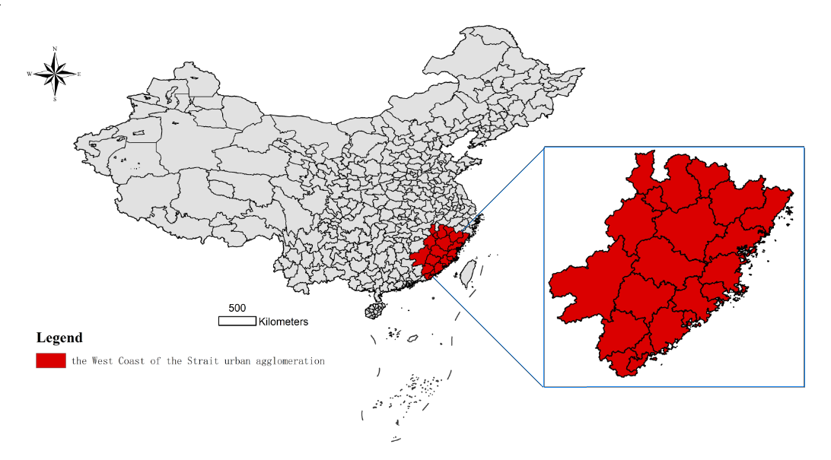
Figure 1. Study site map.
3.2. Research Methods
3.2.1. Gravity Correction Model
Various elements between regions are constantly flowing and exchanging, with the cities as carriers. Therefore, this study uses a gravity correction model to measure the intensity of tourism economic contact in the West Coast of the Strait urban agglomeration [20]. Due to the inequality between the intensity of tourism economic contact in various regions and to show the directivity of the intensity of tourism economic contact, the proportion of tourism resource endowment stakes is the sum of the tourism resource endowments between two associated cities. This study measures the amount of tourism economic contact for a city by summing the amount of tourism economic contact between the city and all other cities in the region [30]. The relevant formulas are as follows……

Map source:
Standard Map Service of Ministry of Natural Resources of China. Available online: http://bzdt.ch.mnr.gov.cn/ (accessed on 28 June 2020).

