Response to Reviewer 3 Comments

Point 1: line73-line76: Currently, it is not clear which TALE sequences have been used as baits in this analysis. The TALE sequences retrieved from the specified databases should be included in a multiple FASTA file in the supplements. In addition, the IDs of these sequences need to be given.
Response 1: We used TALE sequences of 6 species (Arabidopsis thaliana, Eucalyptus grandis, Populus trichocarpa, Malus domestica, Vitis vinifera and Solanum lycopersicum) as baits and provided a multiple FASTA file in the supplements. In addition, the IDs of these sequences have be given in the supplements.

Point 2: The authors downloaded ‘genome data’ and performed a BLASTp. It is not clear which annotation version was used for this analysis. In addition, the authors need to explain why BLASTp and not HMMER was used for the identification of candidates. Using an e-value cutoff for the identification is not the best approach. The authors should build a phylogenetic tree with all possible candidates and decide about TALE family membership based on this tree. What is about genes that are not included in the annotation? The authors should consider approaches like tBLASTn to find such genes in the genome sequence. For the readers, could be adequate to clarify the name of the genes when they are named the first time.
Response 2: Our annotation version was GCA_002864125.1_ASM286412v1_genomic.gff.gz. We are sorry we wrote the genome data version was wrong, and now it modified as ‘ASM286412v1’. In addition, in our manuscript, we used two methods including HMMER and BLASTp to identify candidates. 16 candidate members of the TALE gene family were identified by HMMER, the target protein domain was detected by SMART and CDD, and all candidate proteins were identified to belong to the TALE protein family. In BLASTp, we used ‘E-value < 1e-5, identity > 50%’ to identify 23 candidates. Furthermore, to confirm the accuracy of the identified results, the target protein domain was detected by SMART and CDD, While Pg001623.1, Pg009439.1, Pg011532.1, Pg017964.1, Pg017965.1, Pg022249.1 and Pg027515.1 were removed because they did not contain TALE conserved domain (not incomplete domain). I'm sorry that there are some unclear presentations, so we have revised the manuscript. In addition, A. thaliana contains a member of the TALE gene family KNATM without homeodomain, we added a pomegranate gene homologous to KNATM [32,33]. Therefore, a total of 17 genes (not 16) of pomegranate TALE family were identified and analyzed in pomegranate, we have revised our manuscript, including contents and figures.
Based on your suggestion, we built a phylogenetic tree (MAFFT for the alignment and RAxML -NG for the construction of a phylogenetic tree) with all possible candidates. The phylogenetic tree showed that the TALE superfamily genes were clustered into two families (BELL and KNOX family), all genes are included in the annotation.

32. Magnani, E., Hake, S. KNOX lost the OX: the Arabidopsis KNATM gene defines a novel class of KNOX transcriptional regulators missing the homeodomain. Plant Cell 2008, 20, 875-887, doi: 10.1105/tpc.108.058495.
33. Hamant, O., Pautot V. Plant development: A TALE story. C. R. Biologies 2010, 333, 371-381, doi: doi.org/10.1016/j.crvi.2010.01.015.

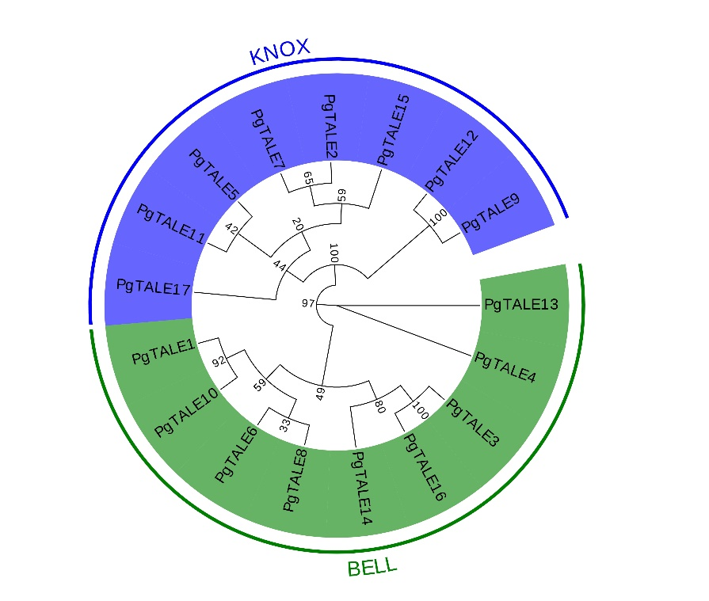
We used pomegranate protein sequences (GCA_002864125.1_ASM286412v1_protein.faa.gz) for the identification of members of the TALE family, so we did not use approaches like tBLASTn to find such genes in the genome sequence. In addition, we clarified the name of the genes when they were named the first time, and provided a list with abbreviations and their full names in the supplements.

Point 3: line86: Incomplete sequences can still be bona fide members of a gene family. These pseudogene candidates should be included in the analyses to understand their loss of function.
Response 3: We modified as ‘The sequences without the TALE domain were removed.’ Incomplete sequences were included in the analyses.

Point 4: line93-98: The authors should try and evaluate different tools for the construction of the phylogenetic tree. MAFFT for the alignment and RAxML for the construction of a phylogenetic tree would be a good alternatives. Was there partitioning used for the different domains in the TALEs? How was the phylogenetic tree ‘optimized’?
Response 4: Based on your suggestion, we used MAFFT for the alignment and RAxML for the construction of a phylogenetic tree. In addition, there was not partitioning used for the different domains in the TALEs. TALE gene family were divided into two families (KNOX and BELL family). In fact, what we wanted to express was to beautify the phylogenetic tree (font, color, etc), not optimized it. We didn't express our meaning clearly, so we modified as ‘Then the phylogenetic tree was beautified by using the online software tool EvolView (http://www.evolgenius.info/)’.

Point 5: line103: This perl script should be made available. Uploading to an established repository like github would be the best solution. Inclusion in the supplements would be an alternative.
Response 5: Perl scripts were not written by us, it were provided by the teacher. So, we provided the scripts in the supplements.
Point 6: Parameter and a proper reference are required for PlantCARE.
Response 6: In PlantCARE, there is no option to set parameters. We added a proper reference (Lescot, M., Dhais, P., Thijs, G., Marchal, K., Moreau, Y., Peer, Y.V., Rouz, P., Rombauts, S. PlantCARE, a database of plant cis-acting regulatory elements and a portal to tools for in silico analysis of promoter sequences. Nucleic Acids Res. 2002, Jan 1, 30, 325-327, doi:10.1093/nar/30.1.325.
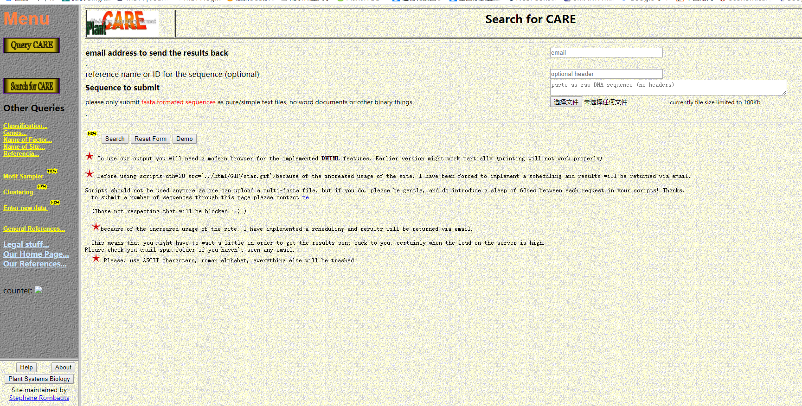

Point 7: There are currently 125 RNAseq data sets of Punica granatum at the Sequence Read Archive. The authors should include all of them to investigate the expression of these TALEs in a broad range of tissue and conditions. The list of samples could be moved to the supplements. Comparison of different sequencing technologies is tricky though. The authors should comments on potential limitations when comparing Illumina and 454 data sets. A co-expression analysis might be useful to predict potential target genes.
Response 7: We selected representative material data for analysis. If all the data are downloaded for analysis, the amount of data is too large and some materials are sequenced repeatedly (for example, SRX5244061, SRX5244062, SRX5244063). According to your suggestion, we added comments on potential limitations when comparing Illumina and 454 data sets. The added contents were ‘However, due to the inconsistency of some sequencing platforms (Illumina and 454) in RNA-seq data, to a certain extent, it may lead to the uneven sequencing depth among tissue samples and the gap in reading length, which has a certain impact on the analysis results, while the difference in pomegranate varieties also has a certain error on the expression analysis results. After the normalization of RNA-seq data, the error may be reduced.’
Additionally, we added a co-expression analysis. From the figure of gene co-expression, we can see the level of co-expression of KNAT1/KNAT3/KNAT6/STM/BEL1/BLH6/ATH1 and other genes. Among them, KNAT1 and KNAT6, KNAT1 and STM were higher than that of other genes. They may participate in or respond to a biological or abiotic stress process, and it may be inferred that PgTALE2 / PgTALE5 / PgTALE11 may also have similar functions.
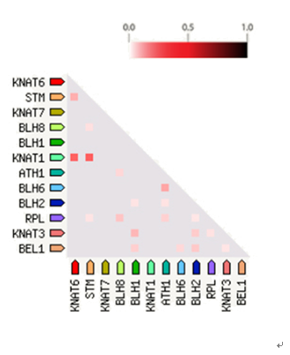
Point 8: It seems that BLASTp was not relevant as all genes were already detected by HMMER. The authors might want to check this and write the manuscript more concisely.
Response 8: We used two methods, BLASTp and HMMER to identify candidates of the TALE family. On the other hand, BLASTp can further confirm the accuracy of our screening potential genes by HMMER.

Point 9: The properties of the encoded peptides of the candidate genes were predicted not analyzed. The authors need to clearly distinguish between genes and proteins in their manuscript. It is very important to clearly state that only predictions were made here. line151 generates the impression that the TALE localisation was actually studied. The authors need to rephrase that sentence.
Response 9: Thanks for your patience to correct, we checked this throughout the manuscript, and the sentence has been rewritten as “Subcellular localization predicted that all PgTALE proteins were distributed on the nucleus.”

Point 10: line152-line154: Is it possible that this paragraph is part of the initial template and should be removed from the manuscript?
Response 10: We removed this paragraph from the manuscript.

11: A new phylogenetic tree with all closely related species should be constructed to infer conclusion about duplications/deletions in comparison to these related species.
Response 11: Thanks, we have constructed a new phylogenetic tree that added Populus trichocarpa and Vitis vinifera and infer conclusion about duplications/deletions in comparison to these related species. In our manuscript, we modified as ‘Multiple sequence alignments of candidate proteins with A. thaliana, E. grandis, P. trichocarpa and V. vinifera TALE gene family proteins were performed using MAFFT [47]. The phylogenetic tree was constructed by using RAxML -NG [48] with Bootstrap 1000 repeats and best model of JTT+F+I+G4 selected by ModelFinder [49]. Then the phylogenetic tree was beautified by using the online software tool EvolView (http://www.evolgenius.info/) [50].’
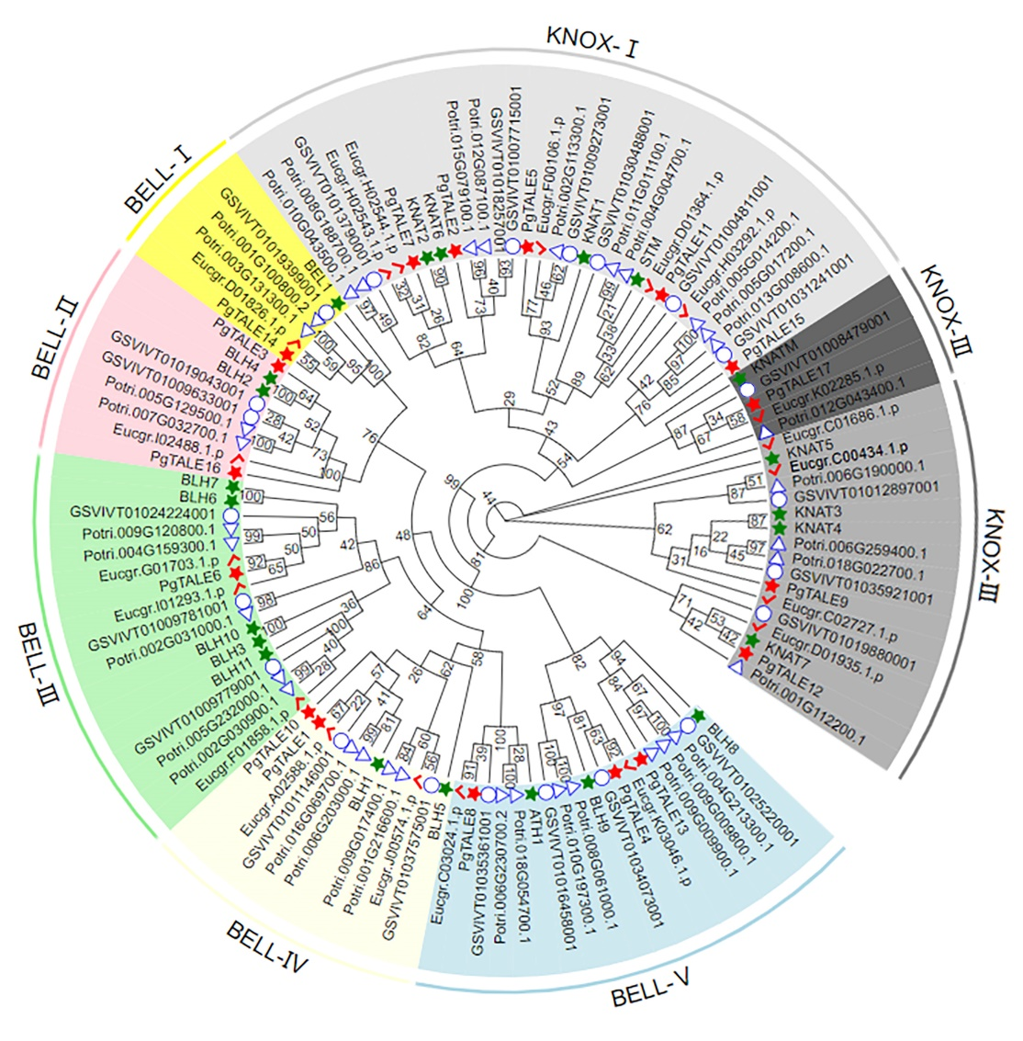
12: Finding similarity through reference-based modeling is not 'remarkable significant', but an inherent bias of the method. Such a model with always show a high similarity despite differences in the sequences. The authors should rephrase this paragraph.
Response 12: We revised as ‘The spatial structure of proteins plays a role in the biological function of proteins. The tertiary structure of the protein was analyzed, which found that the structure of the PgTALE family members was similar’.

13: Ramachandran plot is not an assessment of the model quality, but displays protein properties (line203). The authors might want to rephrase the sentence.
Response 13: Thank you, we modified as ‘The calculation test showed that the Ramachandran Favoured value of the PgTALE family was above 90%, and PgTALE2 and PgTALE15 reached 100%, except PgTALE9 was only 87.27%. The results showed that the PgTALE protein had a stable spatial structure.’

14: The authors need to express the certainty of their findings clearly. The function prediction does not "reveal" a function, but only "predicts" a function (line211). The authors might want to rephrase the entire paragraph.
Response 14: We have revised as ‘Protein function predicted that PgTALE2, PgTALE7 and PgTALE15 played roles in meristem function, contributing to the shoot apical meristem (SAM) maintenance and organ separation. Also, they may involve in maintaining cells in a meristematic state. In addition, PgTALE14 might involve in the regular pattern of organ initiation. PgTALE11 may be required for SAM formation in embryogenesis. PgTALE12 may be involved in secondary cell wall biosynthesis. PgTALE13 might be required for the SAM to respond appropriately to floral inductive signals.’

15: The authors should analyse protein-protein interaction with respect to BELL-KNOX heterodimers. These are mentioned in the introduction and could be very interesting.
Response 15: We modified the figure and added ‘In addition, BEL1 can form heterodimers with KNAT1, it predicted that PgTALE14 (BELL family) may interact with PgTALE5 (KNOX family) to form heterodimers.’
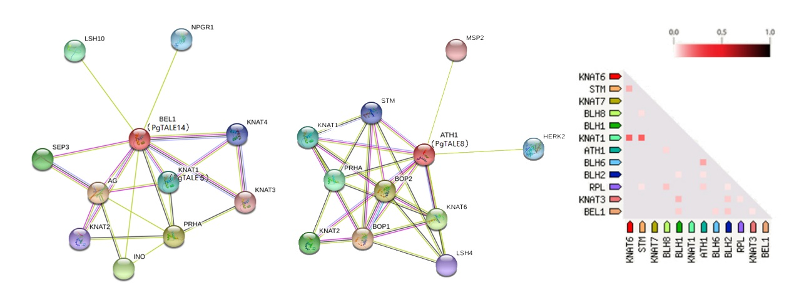

16: Tool names and technical details of the analysis should only be presented in the method section and not in the results (e.g. line227-line228).
Response 16: Thanks, we removed ‘and the cis-elements function was predicted by plantCARE’. In addition, we have revised the results section based on your suggestion.

17: Many cis-regulatory elements occur frequently in the genome sequence just by chance. The authors might want to integrate an analysis (e.g. a comparison to random sequences of the genome) to indicate the relevance of their findings. Are there actually more cis-regulatory elements in these promoters than elsewhere?)
Response 17: Thanks, in fact, there are more cis-regulatory elements in these promoters than elsewhere, such as some cis-regulatory elements (GT1-motif, ACE) involve in light responsiveness. We selected some elements related to pomegranate growth and development and analyzed them.

18: line278-line290 should be moved to the introduction. This is general background about TALEs. The authors should focus on their own results in the discussion and put them into context with existing studies.
Response 18: We moved line278-290 to the introduction. Furthermore, according to the content in the introduction, we have made corresponding modifications.

19: line291-line294: Similar protein properties are a consequence of overall sequence similarity. Therefore, this finding is trivial and should not be presented in detail. If there are interesting differences between the predicted protein properties in this species and previous published work, the authors could focus on these differences.
Response 19: Thanks, we removed some details ‘it was found that the protein molecular weight and an amino acid number of different members of the PgTALE are quite different. In addition’.

20: The authors presented different classification systems for the TALE gene family members. Why was the system with 6 groups selected in this study?
Response 20: Based on the classification of Arabidopsis thaliana TALE gene family (BELL and KNOX family), we reclassified and subdivided the KNOX family, the KNOX family into 3 subfamilies: KNOX-Ⅰ, KNOX-Ⅱ, KNOX-Ⅲ, the BELL family were classified into 5 subfamilies: BELL-Ⅰ, BELL-Ⅱ, BELL-Ⅲ, BELL-Ⅳ and BELL-Ⅴ. Therefore, there were 8 subfamilies in pomegranate.

21: line298-line315: Additional analysis are required to allow conclusions about an enrichment of hormone-regulated elements.
Response 21: Thanks, we removed ‘62.50% of the PgTALE gene contains abscisic acid response element ABRE, indicating that the TALE family has an essential role in plant drought and stress response. The PgTALE also has elements such as TGA-element, TATC-box, TGACC-motif, and TCA-element, indicating that the PgTALE gene may be regulated by auxin, gibberellin, jasmonic acid, and salicylic acid. These plant hormones are all regulated by participating in the process of the plant stress response.’ and modified the related contents.

22: Where is the evidence for "It has also been objectively confirmed that PgTALE has a particular role in maintaining flower organ and fruit development." (line325-line327)?
Response 22: This is a prediction, we are sorry that our description is too absolute. We have revised as ‘It is predicted that PgTALE may have a role in maintaining flower organ and fruit development.’

23: The authors might want to check which cis-regulatory element is missing in the PgTALE13 promoter compared to closely related species. Finding a mechanism responsible for the inactivity of this gene would be really interesting. What is the function of PgTALE13 and why is this function not required in P. granatum?
Response 23: Thanks, it is a good suggestion. We looked up the relevant references and asked some experts. It was difficult to find a mechanism in a short time. In order to make the paper more accurate, we deleted the content " Interestingly, PgTALE13 is expressed in trace or even little expression in the tissues of several pomegranate varieties, which may be that PgTALE13 is pseudo-geneticized during the expansion and evolution of the PgTALE gene and became non-functional [51]. In the same way, PgTALE1 was highly expressed in the corresponding tissues of all pomegranate varieties, which may be caused by the functional mutation during the expansion and evolution of the gene which has evolved new functions. It may be a new result of functionalization."

Minor comments:

- line19: PgTALE is not the name of one gene. A number might be missing here.
Response: We modified ‘most of PgTALE were involved in the growth and development of pomegranates and stress.’
- line 23-25: This sentence needs to be rephrased as a gene family and not a single gene was studied here.
Response: We modified as ‘gene family’.

- line31: 'folded in three dimensions' should be removed as all proteins are folded in 3D
Response: We removed ‘folded in three dimensions’.

- line50: rephrase the sentence to better explain 'it'
Response: We modified as ‘After binding to the OVATE protein, the BELL-KNOX dimer protein is reversely transferred from the nucleus to the cytoplasm to negatively regulate ovule development’.

- line67: ‘genomic’ > genome sequence
Response: We modified as ‘genome sequence’.

- line73: genome > genome sequence; transcriptome > transcriptome sequence
Response: We have revised as ‘genome sequence’ and ‘transcriptome sequence’ based on your suggestion.

- line90: performed > predicted
Response: We modified as ‘performed’.

- line 115-116: "The possible cis-elements in the promoter region were found." this would be a sentence of the results section
Response: We have put this sentence, ‘The possible cis-elements in the promoter region were found.’ in the results section.

-line 140: Arabidopsis > Arabidopsis thaliana (check this throughout the manuscript)
Response: We modified as ‘Arabidopsis thaliana’ and checked this throughout the manuscript.

- line159: species names need to be written in italics (check this throughout the manuscript)
Response: Revision has been made based on your comment.

- line338: The authors might want to check if there are two spaces between "conclusions are"
Response: There are two spaces between "conclusions are", we removed one space.

- line336: structure of the subfamily > structure of all members of the subfamily
Response: We replaced ‘structure of the subfamily’ with ‘structure of all members of the subfamily’.

