Dear Reviewer:
Thank you for reviewing our manuscript. Your comments really helped us to revise and improve the paper. We considered your comments carefully and made corrections accordingly. In addition, we had the revisions edited by a professional science editor to improve the writing.
Please see below for responses to each comment.
C 1:
“L12-17: This sentence is too long and unclear. Please write it into several sentences.”
Response: Thank you for the comment. We have broken the sentence into several sentences as follows:
lines 12 - 16:
“It takes some time to have changes in ecosystem services, and trade-offs occur on the process of changes. As opposed to a point in time, we use data spanning the years 2000-2005, 2005–2010, and 2010-2015 to study this research. After quantifying types of ecosystem services, this paper uses spatial correlation analysis and root-mean square deviation (RMSD) method to explore the relationships among ecosystem services, calculate the degree of spatial trade-offs (DT).”

C 2:
“L14-15: “kinds of models and methods” is not necessary.”
Response: Thank you for the comment. We have deleted this text.

C 3:
“L18: What is “trade-offs degree”? How did you define it?”
Response: In our research, the trade-off relationship may refer to the ever-evolving competition relationship. The degree of trade-off between ecosystem services refers to the strength of this competition. A higher degree of trade-off corresponds to a stronger competition. We also made these clarifications in the manuscript.
lines 41 - 48:
“Ecosystem services are diverse, with varying status such as trade-offs or synergies [7, 8]. The trade-offs status may refer to the ever-evolving competition status. Trade-offs will occur when a particular ecosystem service captured by one stakeholder at the expense of another, as multiple ecosystem services are competitively used [9]. There are four basic categories about trade-offs: spatial trade-offs, temporal trade-offs, trade-offs between beneficiaries, and trade-offs among ecosystem services [10]. The degree of trade-offs (DT) among ecosystem services equates to the strength of the ever-evolving competition. The higher the DT, the stronger the competition.”

C 4:
“L21: “in a certain range” is very ambiguous.”
“L294-299: “a certain threshold”, “a certain level”, and “a certain range” are very ambiguous.”
“L358. It seems that threshold impacts of IA on trade-offs degree is an interesting finding in this study. I was wondering why its analysis is suggested as the next research although “threshold dynamics” are discussed in this study. Please provide an in-depth analysis of the threshold dynamics found in this study.”
Response: Thank you for the comment. The data samples are too few to support and verify the range of this threshold. More data and cases are thus needed to verify the accuracy and rationality of the specific threshold at which IA in construction land begins to affect the DT among ecosystem services. In future research, we will strive to obtain more samples for verification. We have added a discussion of this limitation in the revised manuscript.
lines 362 - 374:

“4.4. Limitations
In summary, this paper has analyzed spatial ecosystem service trade-offs in Golden Triangle of Southern Fujian, calculated the DT among ecosystem services, found the hotspots of spatial trade-offs and analyzed the relationship between increasing area (IA) and DT in ecosystem services pairs. This led to practical advice for urban planners and other decision makers. However, in common with applied research more generally, this research is not without its limitations and addressing these limitations could be fruitful terrain for future research. First, there is ample scope to consider a broader indicator set, to incorporate uncertainty analysis into the quantitative methodology employed, and augment the research design by instigating a mixed-methods approach which uses qualitative data and techniques to tackle the issues and questions explored herein. Second, the data samples were too few to support and verify the threshold at which IA in construction land begins to affect the DT among ecosystem services. More data and cases are needed to verify the accuracy and rationality of the specific thresholds.”

C 5:
“L34: Quality and value of what?”
Response: Thank you for the comment. We have modified the manuscript as follows: “These increasing associated impacts have a substantial impact on ecosystem services in terms of their structure and function, also influences the quality and value of ecosystem services, creating the decline of ecosystem services.”

C 6:
“L37: Before “significant”, please put a period.”
Response: Thank you for the comment. The modification has been made.
lines 35-38:
“The Golden Triangle of Southern Fujian was a typical marine-terrestrial interlaced zone urban agglomeration with rapid urbanization in recent years. Significant amounts of agricultural land and forest areas have been lost because of urbanization with varying impacts on ecosystem services per se [4].”

C 7:
“L46: What types of decisions?”
Response: Thank you for the comment. We have modified the manuscript as follows: “Managers and planers often make programming or policy decisions on a regular basis without the explicit consideration of these ecosystem services trade-offs or synergies”. Thus, the decisions were about programming or policy.

C 8:
“L48: delete “,””
“L56: delete “, et al””
Response: Thank you for the comment. We have made the modifications.

C 9:
“L57-59: This sentence does not seem grammatically correct. / From now on, English grammar issues will not be pointed out. However, they need to be resolved. Since I am a researcher whose first language is not English, I do not feel that I am the best person who raises this issue. However, this issue prevents the novelty of the research conducted in this study from being appreciated and acknowledged. Also, it blocks readers/reviewers from fully understanding and following the study.”
Response: Thank you for your kind advice. We have enlisted the aid of a professional science editor to improve the writing, especially for the revised parts.

C 10:
“Figure 1: It is difficult to read texts in the satellite image.”
Response: Thank you for the comment. We have deleted the text in the satellite image (Fig 1.A) and have inserted a separate panel in the figure (Fig 1.B), as shown below.
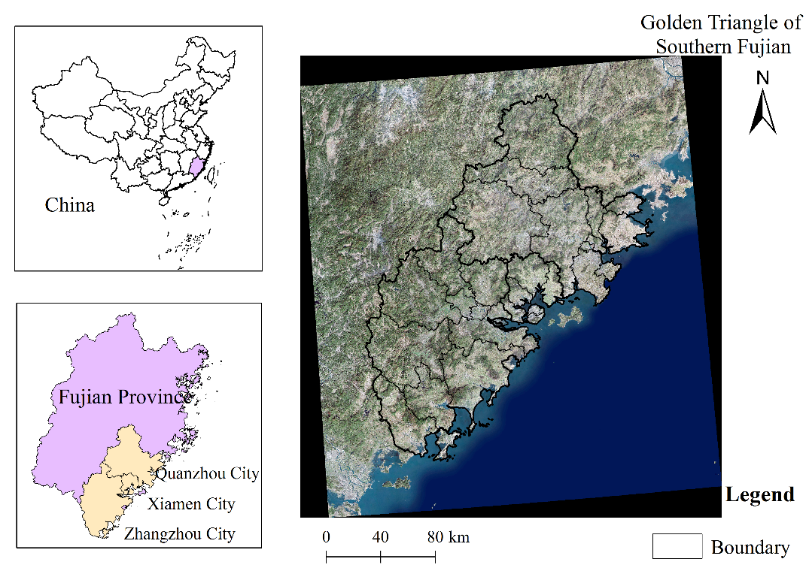
Figure 1. Geography of the Golden Triangle of Southern Fujian (A)
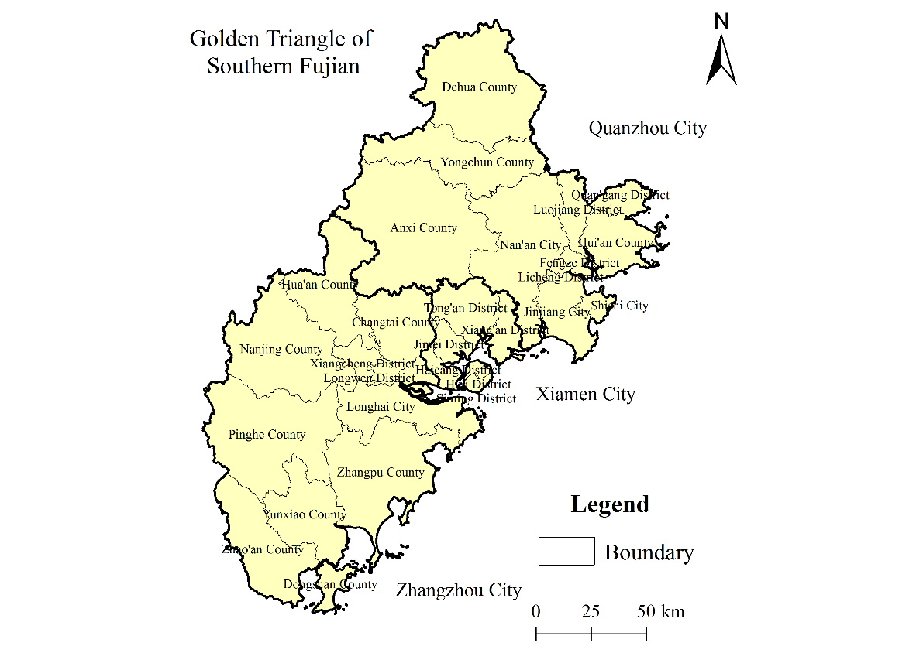
Figure 1. Geography of the Golden Triangle of Southern Fujian (B)
C 11:
“Table 1: In weather data and other data, what are “etc”?”
“Table 1: In other data, what are references? Please specify them.”
Response: Thank you for the comment. Please excuse the “etc.,” which was unintended and is now deleted. The “other data” refers to the data from others works that are cited in the methods section.

C 12:
“L84: Where did you conduct the predictions of future land use changes in this study?”
Response: We find no predictions of future land-use changes in our study, so we deleted this sentence. Thank you for your careful review.

C 13:
“Equation 2: What is Ai? Is it total land area? Is the unit of L in % because of 100? What does it mean?”
“Table 2: “Note: The index of classification is different to the code of land use classification”? If so, please explain why they are different.”
Response: The quantity $A_{i}$ is not the total land area but a classification index referring to the type of land use. So it is an index whose value designates the actual use of various types of land. The quantity $L$ is the degree of land use in percent. It is a dimensionless indicator that refers to the scale and scope of human use of land for economic activity such as development, consolidation, and planning. The higher the degree of land use, the more extensive is the human use of the land for economic purposes.

C 14:
“L111: food supply indicator (FS); L114: climate regulation (CS); L115: water retention (WR); Please explain why recreation services (RS) and landscape aesthetics (LA) were chosen as important indicators.”
Response: Thank you for your comment. We have added an explanation about why recreation services (RS) and landscape aesthetics (LA) are important indicators.
lines 122-126:
“The ecosystems could provide people with cultural-services, such as recreation (RS), relaxation, and experience of nature [33]. These services are important in urban ecosystems with significant economic value because they can improve human welfare in cities. Meanwhile, some ecosystems could produce landscape aesthetic benefits, and potentially valuable in landscape aesthetics (LA).”

C 15:
“Table 3: In habitat quality, there is Qx but not Qxj; and Dx but not Dxj.”
“Table 3: There should be descriptions for each column at the top of the table.”
“Table 3: Where do the equations come from? Need citations.”
“Table 3: In water retention, K is already used as dynamic degree of land use type. Please use a different symbol for hydraulic conductivity. “from the literature”: Please provide citations.”
Response: Thank you for these useful comments. We have made modifications according to each comment. The quantities $Q_{x}$ and $D_{x}^{z}$ are the real wright. The descriptions have been added at the top of the table, the citations are all provided, and “$K$” has been changed to “$U$”.

C16:
“Table 5: Please describe them in unit of km2 (not number of grids) and provide the sum of each column and row.”
“Table 5: What do you mean by saying “watershed”? The definition of watershed is an area of land that separates waters flowing to different areas. Is it a type of land? / Based on this table, it seems that watershed, construction land, and unused land increased in 2015 compared to 2000. I was wondering why watershed and unused lands increased over the study period.”
Response: Please excuse our mistake. After checking the data, “grids” was changed to “ha” and the sum of each column and row was added to the table. In addition, “watershed” was changed to “water area”. The watershed, construction land, and unused land increased in 2015 compared with 2000 because of the increase in government and public emphasis on environmental protection. Areas that were originally converted from water areas or unused lands into farmland or construction land have gradually been recovered as water areas or unused lands over the last 10 years in the Golden Triangle of Southern Fujian.
lines 185-189:
“Among these areas, the water areas and unused land also increased during the study period, which is attributed to the deepening of the government and public emphasis on environmental protection. Many areas that were originally converted from water areas or unused lands into farmland or construction land have gradually been recovered as water areas or unused lands over the last 10 years.”

C17:
“Figure 3. Please remove the outer box. What is “value” in the y-axis? What do you mean by saying “degree”?”
Response: Thank you for the advice, we have modified the outer box and changed “value” to “Land-use degree (L),” which refers to the intensity with which humans use the land. It may be higher than the original status.

Figure 4. Index of overall land use degree between 2000-2015 (The unit are dimensionless)
C18:
“L190: HQ-NPP do not have a negative correlation coefficient.”
Response: Please excuse the mistake. The text should read “RS-NPP” and not “HQ-NPP.” We have made the necessary modification.

C19:
“L208: “less” to “lower than””
Response: Thank you for the advice, we have made the modification.
lines 233-235:
“For the food supply-recreation service (FS-RS) in 2000-2005, the DT in Zhangzhou was substantially lower than those found in Xiamen and Quanzhou.”

C20:
“Figure 4: The legend can be placed at the right corner so that “RS & NPP” can be in line. What is “VALUE”?”
Response: Thank you for the advice, we have made the modification, as shown below.
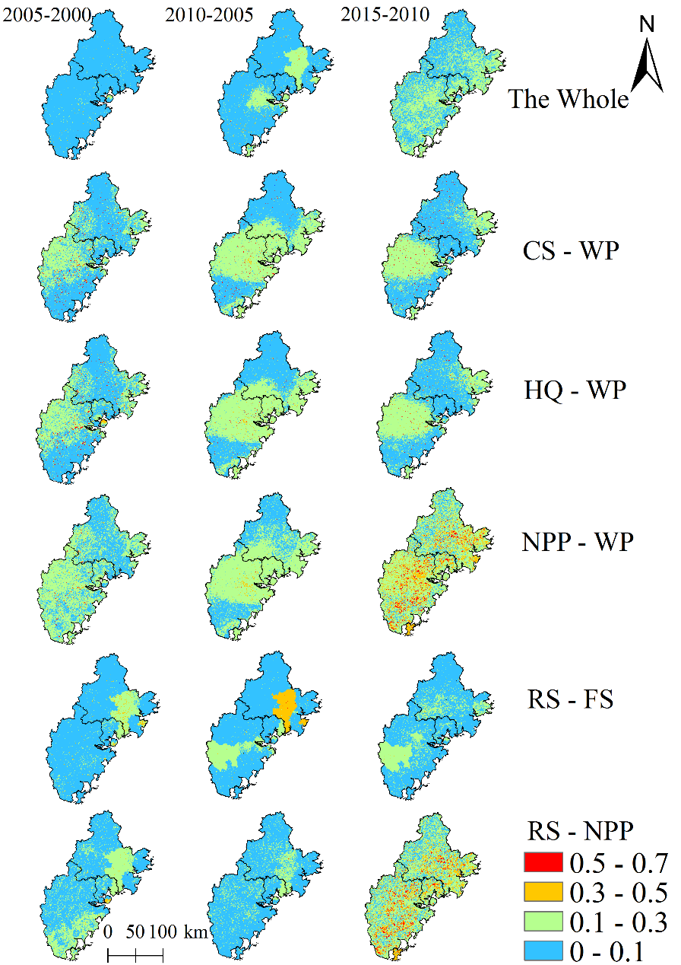
Figure 5. Spatio-temporal differences in trade-offs degrees between ecosystem-service pairs (dimensionless)
C21:
“L215: How was the hotspot analysis conducted?”
Response: The hotspot analysis was done by using the ArcGIS platform Spatial Statistics Tools-Hot Spot Analysis (Getis-Ord Gi*).
lines 242-243:
“To determine the key areas of higher DT between ecosystem-service pairs, we apply a hotspot analysis through the ArcGIS platform Spatial Statistics Tools-Hot Spot Analysis (Getis-Ord Gi*).”

C22:
“L223-224: I was wondering why the hotspots were mainly distributed in coastal areas. Please explain reasons for this finding.”
“L274: Why the trade-offs between them are larger in 2010-2015 than 2000-2005?”
Response: Thank you for the comment. The trade-offs between ecosystem services in 2010–2015 was clearly greater than that in 2000–2005, and the changes were mainly located in coastal areas. This is attributed to a significant increase in human demand for recreation services and willingness to pay for leisure and entertainment that stems from the increase in income in coastal areas. Thus, the potential value of ecosystem recreation service increased, but the net primary productivity could not keep up with demand, leading to higher trade-offs in coastal areas.
lines 300-308:
“The present results mainly reveal the influence of trade-offs between the pairs WP-NPP and RS-NPP, the DT between ecosystem services in 2010–2015 was clearly larger than that in 2000–2005, and the changes mainly occurred in coastal areas, which is attributed to human demand for recreation services and a willingness to pay for leisure and entertainment that greatly increased due to the increased income in coastal areas (the Gross Domestic Product per capita increased by 66% in 2010–2015, which is far exceeds the 23% in 2000–2005). Thus, the potential value of ecosystem recreation service increased. However, the net primary productivity could not keep up with demand, leading to higher trade-offs in 2010–2015 within coastal areas.”

C23:
“Figure 5: Legend can be put together.”
Response: Thank you for the advice, we have made the necessary modifications, as shown below.
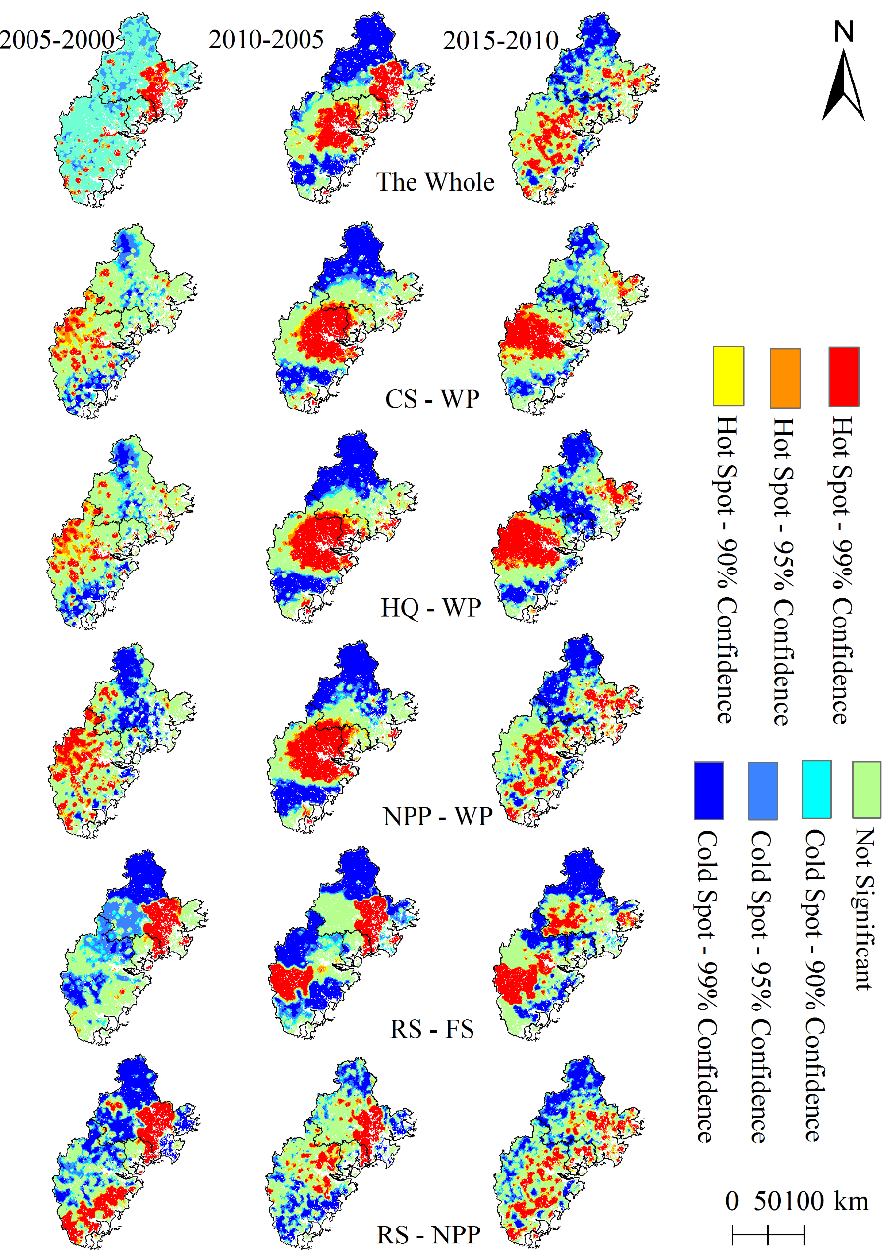
Figure 5. Hotspots of trade-offs degree with different confidence levels among ecosystem services

C24:
“L230: What is a coupling model? How did you conduct the coupling degree? Is it a method or model?”
Response: The coupling model is a method, details of which we have added in the Methods section. In addition, we explain this method in more detail in a separate publication [41]. The coupling degree reflects the strength of interaction between increasing area (IA) of construction land and degree of trade-off between ecosystem services. A greater extent of coupling corresponds to a stronger interaction between the two [43].
[40] Salvati, L.; Carlucci, M. The economic and environmental performances of rural districts in Italy: Are competitiveness and sustainability compatible targets? Ecol. Econ. 2011, 70, 2446–2453.
[41] Chen, H.; Tang, L.; Qiu, Q.; et al. Coupling between Rural Development and Ecosystem Services, the Case of Fujian Province, China[J]. Sustainability, 2018, 10(2), 524.
[42] Wu, D.; Li, C. Chen, L. Principles and Application of Synergetics; Huazhong University of Science and Technology Press: Wuhan, China, 1990; pp. 9–17.
[43] Liu, D.; Yang, Y. Coupling coordinative degree of regional economy-tourism-ecological environment: A case study of Anhui province[J]. Resource Environment Yangtze Basin, 2011, 20: 892-896.
lines 151-158:
“From the synergetic’s perspective, the coupling degree could determine the order and structure of the system when it reaches a critical region, or the tendency of the system to go from disorder to order [40,41]. The key of the system from disorder to order lies in the synergy between the order parameters in the system, and this synergy influences the characteristics and laws of the phase transition. The coupling degree is just a measure of this synergy [42]. We used the coupling method to reflect the strength of interaction between increasing area (IA) of construction land and the DT between ecosystem services. The greater the extent of coupling, the stronger the interaction between the two [43].”

C25:
“L238: Is urbanization rate of 80% low? It seems really high. What criterion was used to define high and low here?”
Response: In the study area, the urbanization rate of all districts in the city’s central area is much greater than in the none central area in Quanzhou, Zhangzhou, and Xiamen City. In 2015, the urbanization rates of districts in the city’s central area all exceed 80%. Thus, we use an urbanization rate of 80% in 2015 as the dividing line to make the analysis.

C26:
“L256: What are “et al”?”
Response: This word seems to be a bit redundant. Our idea was that more forest land corresponds to higher habitat quality and net primary productivity, but less surface water. Or the higher food supply capacity, the fewer recreation services. In the end, we deleted the confusing terminology “et al.”

C27:
“L297: Appendix figure should be numbered separately. (e.g., Fig A1)”
“Fig.6: Subpanels should be described in the caption, not with “Note:””
Response: Thank you for the kind advice. The original intention of displaying the figures together was to facilitate observation and comparison. Instead of explaining each figure panel in the caption, we now place legends in each panel to facilitate comprehension (see below).
Appendix 1
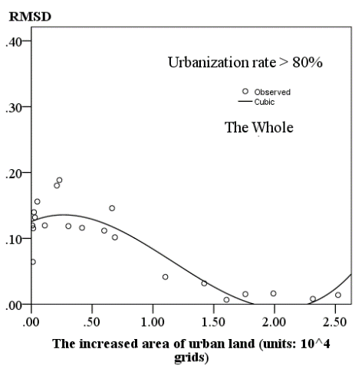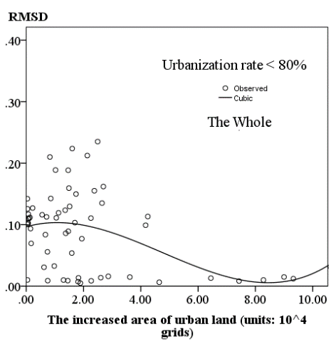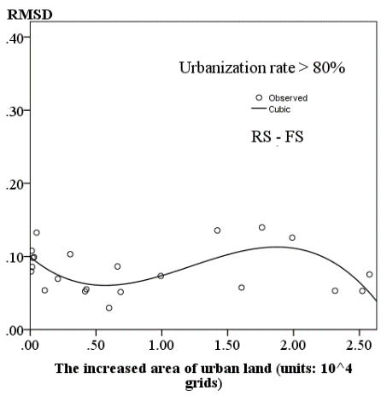
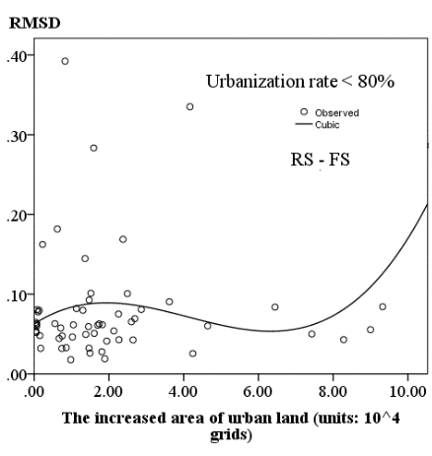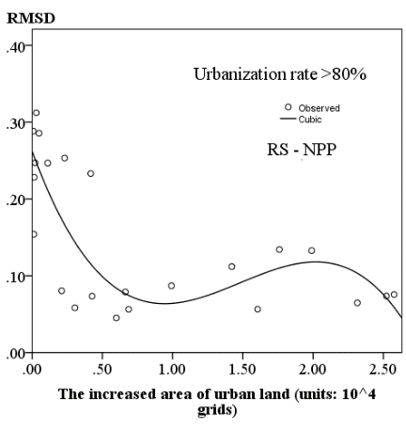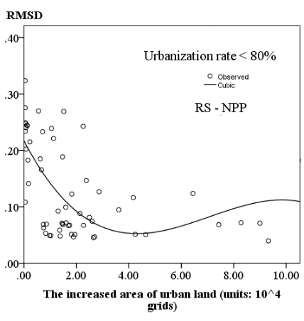
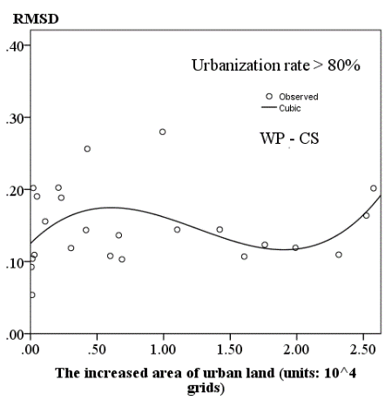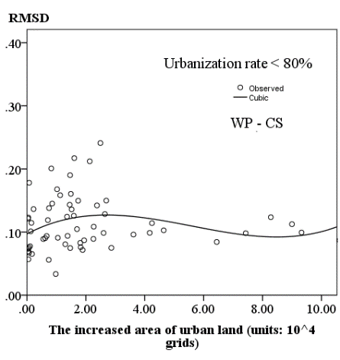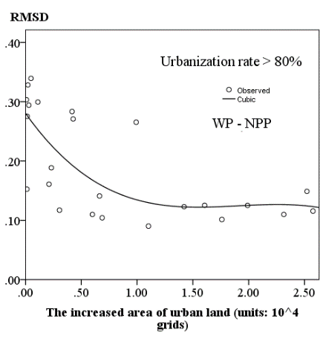
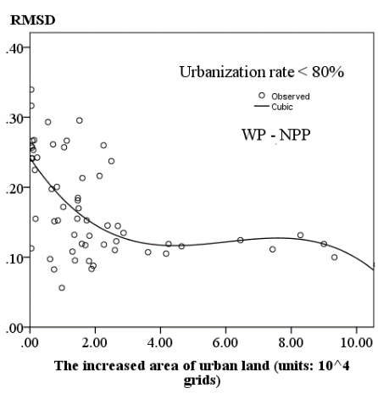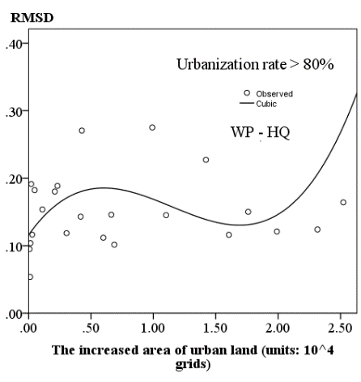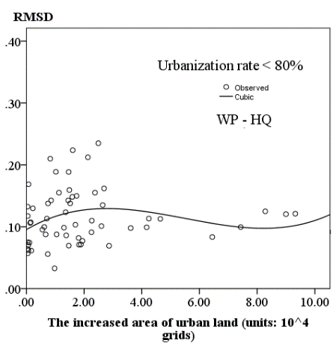
Fig.6 Scatter plots between increasing areas (IA) of construction land and trade-offs degree (DT) among ecosystem services for counties that urbanization rates < 80% and > 80%

C28:
“L328-331: They are not necessary. However, these can be limitations of this study.”
Response: Thank you for the comment. After consideration, we deleted these sentences because they are not the necessary for this paper. Thank you for your comment.

Please note that other modifications are highlighted in the text.
Thank you again for reviewing our manuscript so earnest! We look forward to your feedback once more.
Best regards.

