Comments and answers
Reviewer 3#
In this manuscript, the authors have presented the results of their studies on the effect of Yucca liquid plus supplementation on poultry performance, biochemical paremeters, gut microbial flora and nitrogen excretion.
The presented data are sound. However, there are a few points that need to be addressed
The hypothesis and aim of the present work was not clearly stated in the abstract or introduction. The knowledge gap of the present work is not clearly mentioned.
Relevant statistical analysis should be mentioned as footnote of tables and figures.
Done
Authors are suggested to change the format of Tables to the journal format. Authors should elaborate the abbreviations at its first appearance in the manuscript. Example: BWG.
Corrected
Authors are suggested to include recent references in the manuscript instead of old references. Following references are my suggestions to include instead of 18, 19, and 20 references.
Ok all references have been added
Lavanya et al., 2012. Acetone Extract from Rhodomyrtus tomentosa: A Potent Natural Antioxidant. Evidence-Based Complementary and Alternative Medicine. 8, 2012.
Added
Manubolu et al., 2014. Protective effect of Actiniopteris radiata (Sw.) Link. against CCl4 induced oxidative stress in albino rats. Journal of Ethnopharmacology. 153 (3): 744-752.
Added
Lavanya et al., 2019. Protective Effects of Ammannia baccifera Against CCl4-Induced Oxidative Stress in Rats. International journal of environmental research and public health. 16 (8). 1440.
Added
Do the yucca liquid plus (commercially available?!) contain glycofraction and saponins?
Yes, Yucca plus liquid is commercially available as mentioned in the section of material and methods with the following composition:
Each 1 ml contains:
Yucca schidigera 0.1 ml
Vitamin A 1250 IU
Vitamin E 2.5 mg
Vitamin C 10 mg
Vitamin K3 0.6 mg
Propylene glycol 50 mg
Purified water up to 1 ml
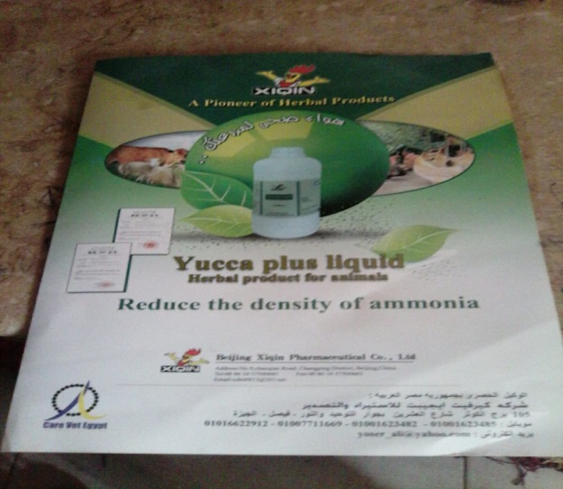
Do the authors analyzed or determined the composition of yucca liquid plus by analytical methods to confirm the yucca liquid composition?
Unfortunately, we did not analyze the yucca liquid plus, but we depend on the previous studies related to our study.
Authors are suggested to include few more evidences /references implying the non-toxicity nature of saponins and glycofractions in the introduction section.
We added some useful information about yucca and saponin. Thank you very much for your observation.
Statistical representation as footnote under tables is not clear. Should present it clearly.
Done
Authors are suggested to include in materials and methods section how they have determined the dosage of yucca liquid for supplementation to animals. How do authors provide a statement that yucca liquid supplementation increases the nitrogen intestinal absorption in animals without proper experimental evidence. Authors should justify this.
The dose of yucca supplementation was given according to the previous studies and company recommendation. Again, we already stated the previous studies dealing with the same dose and we focused on the effect of yucca supplementation on gut microbes, antioxidant and immune status of birds. Regarding intestinal absorption, it is clear from the results of litter analysis that, nitrogen excretion was decreased gradually with increasing level of yucca supplementation which indicates the enhancement of intestinal absorption.
Does the excess nitrogen retention in poultry products effect human when consumed?
Excess nitrogen retention is important for both economy and clean environment. Regarding human health, I think it depends on many factors but it may be useful for human that production of poultry meat of high protein content may give us a new avenue to decrease the amount of meat consumption/individual/day which consequently affect positively on the national income.
I think, increasing nitrogen retention in poultry products will improve the public health and is a good strategy for humans.
Authors are suggested to include organoleptic tests to determine the quality of chicken or poultry products supplemented with yucca liquid for human consumption. Authors should discuss the role of antioxidant parameters and lipid peroxidation and compare their results with others work in discussion part.
All these parameters related to antioxidants have been discussed. Hope this form is suitable for publication.
Other citations are needed to strengthen the importance and relevance of the present results in the discussion section.
We added some relevant references in introduction and discussion to improve the paper quality…thanks a lot for your great efforts and help.
The format of references is not uniform. Need to check for typographical errors, plagiarism, punctuation, and grammar throughout the manuscript.
Done… several improvements have been made in the revised version….Hope this version is proper for publication.

