Article
Laser-assisted surface texturing of Ti/Zr multilayers for osteoblast cell response
Suzana Petrović ¹*, Davor Peruško ¹, Evangelos Skoulas ², Janez Kovač ³ , Miodrag Mitrić ¹, Jelana Potočnik ¹, Zlatko Rakočević ¹ and Emmanuel Stratakis ²
¹ Vinča Institute of Nuclear Sciences, University of Belgrade, P.O.Box 522, 11001 Belgrade, Serbia, office@vin.bg.ac.rs
² Institute of Electronic Structure and Laser (IESL), Foundation for Research and Technology (FORTH), N. Plastira 100, Vassilika Vouton, 70013 Heraklion, Crete, Greece, iesl@iesl.forth.gr
³ Jožef Stefan Institute, Jamova 39, 1000 Ljubljana, Slovenia , info@ijs.si
* Correspondence: spetro@vin.bg.ac.rs ; Tel.: +381 11 3408560
Received: date; Accepted: date; Published: date
Abstract: The formation of an ordered surface texture with micro and nanometer features on the Ti/Zr multilayers is studied for better understanding and improvement of the osteoblast integration. Nanocomposite in form 30x(Ti/Zr)/Si thin films were deposited by ion sputtering on Si substrate for biocompatibility investigation. Surface texturing by femtosecond laser processing made possible to form the laser-induced periodic surface structure (LIPSS) in each laser-written line. At fluence slightly above the ablation threshold, beside the formation of low spatial frequency-LIPSS (LSFL) oriented perpendicular to the direction of the laser polarization, the laser-induced surface oxidation was achieved on the irradiated area. Intermixing between the Ti and Zr layers with the formation of alloy in sub-surface region was attained during the laser processing. The surface of Ti/Zr multilayer system with changed composition and topography was used to observe the effect of topography on the survival, adhesion and proliferation of the murine MSCs cells. Confocal and SEM microscopy images were shown that cell adhesion and their growth improve on these modified surfaces, with tendency of the cell orientation along of LIPSS in laser-written lines.
Keywords: multilayer thin films, Ti-based alloy, ultrafast laser-modification, cell response

1. Introduction

Thin films and coatings are considered as very applicable for biomaterials, since surface properties are a key factor in the interaction of materials with the biological environment. Surface composition and morphology regulate surface bioactivity and other biofunctionalities, in terms of the adsorption of proteins on the material surface, which is determinant for the subsequent processes of cell growth, differentiation, and extracellular matrix formation [1-3]. Titanium-based materials are nowadays well integrated into the body, due to high specific strength, excellent corrosion resistance, and good biocompatibility [4,5]. Currently, one of the main task is development of the Ti-based alloys with a high concentration of β-stabilizer elements (β phase of titanium), and to provide compliance between the elasticity of the implant and the surrounding hard tissues (bones). The most suitable alloying elements to be added in these new alloys are niobium, tantalum, zirconium, and molybdenum, as they do not exhibit any cytotoxic reaction in contact with cells [6]. The admissible way for preparation Ti-based alloy coatings could be deposition of multilayer structure with alternate distribution of Ti and other (Zr, Ta, Mo, Nb) components in thin films. The superior biocompatibility of Ti-based coatings originates from easy formation of outer Ti- oxide layer with a negative charge at physiological pH and protects dissolving of metallic components into biological fluids [7]. One of promising candidate for alloying is Zr, which is act as neutral element when dissolved in Ti and it can improve mechanical properties of alloys [7]. From the biomedical point of view, Zr is fully soluble in both allotropic phases of Ti, improving the mechanical strength, corrosion resistance, and biocompatibility of Ti alloys [8]. Zirconium (Zr) has received special attention as an alloying element in Ti-based alloys, because it acts like non-toxic and non-allergenic elements, thereby avoiding the stress shielding effects and implant failure [9]. Binary Ti-Zr alloy have exhibited a good combination of mechanical properties, with the advantage of easy manufacturing, in comparison to multicomponent, Ti-based alloys. Additional, Zr with the lower elastic modulus (~80 GPa) can contribute to reducing stress shielding, which is reason for the biomechanical incompatibility between the pure Ti-based implant and the bone [10].

Currently, more sophisticated and versatile methods/tools for surface engineering and synthesis of nanoscale facilities for biomedical applications are needed. In traditional chemical and physical methods, although the microstructure can be controlled to some extent, the specific shape and size in some particular applications cannot be precisely controlled. The most of the traditional methods have the disadvantages, such as low efficiency, high cost and difficult-to-machine. In the contrary, the laser processing can easily form and control desired complicated topography with high resolution and high economic efficiency [11,12]. Techniques based on laser surface modification has advantages such as less debris contamination, reproducibility, precision and minimal heat affected zone, which can create a controlled surface texture in specific, localized areas in the short time period [13]. Femtosecond laser texturing is a mask free contactless technology, fully adaptable for 2D and 3D shapes on almost all materials [14]. The surface modification of the biomaterial has aim to create specific chemical and physical properties that offer a favorable cellular response [15,16]. On the other hand, ultrafast laser surface modification is unique method, which allows production of bioactive surface with formation of the desired oxide and alloy, creation of nano/micro textures and change wettability of the surface. Surface topographies with defined micro- and nanometer features generated by irradiation with linearly polarized laser radiation are well-known as laser-induced periodic surface structure (LIPSS). These surface structures are appeared in two forms as low spatial frequency LIPSS (LSFL) and high spatial frequency LIPSS (HSFL) [17]. The LSFLs usually have a spatial period close to the irradiation wavelength, oriented perpendicularly to the polarization vector. For the formation of LSFL is generally accepted to originate from the interaction of the incident laser beam and electromagnetic wave scattered at the surface with possibility to involve the excitation surface plasmon polariton. On the other hand, the HSFLs, oriented parallel to the polarization vector, are characterized with significantly lower periodicity than the irradiation wavelength. Several physical mechanisms have been proposed to explain the formation of HSFLs induced by laser pulses, such as self-organization, second harmonic generation, excitation of surface plasmon polaritons, and Coulomb explosion, but none have been proven fully yet [18]. The initial interactions between osteoblasts and nano-modified polymeric, ceramic and metallic substrates have indicated that nanoscale roughness can significantly affect cell adhesion, proliferation, and spreading. A few studies have indicated that increased osteoblast proliferation on the nanostructured surfaces coincided with an increase in alkaline-phosphatase synthesis, increased Ca-containing mineral deposition, and higher immunostaining of osteocalcin and osteopontin [19]. Recently, it has been demonstrated that osteointegration can be accelerated if the titanium surface is pre-treated to have a specific topography containing both micro- and nano-scale features [13]. In vivo experiments have shown that titanium and zirconium implants exhibit good osteointegration and that both elements have high degree of bone-implant contact [20,21].

The aim of this paper is to study the relationship between laser processing and osteoblast-like cell response on titanium-zirconium multilayer thin films. The formation of an ordered surface line-texture with micro and nanometer features was achieved by optimizing the laser parameters, including applied laser fluences, number of pulses and scanning rate. The micro/nano patterns distribution with changed composition and surface topography is evaluated in aim to determining their influence on cell adherence, cell morphology and the possibility of cell orientation along laser-induced periodic structure.

2. Materials and Methods

The titanium-zirconium multilayer thin films were deposited in a Balzers Sputtron II system, using 1.3 keV argon ions and 99.9% pure Ti and Zr targets. Before deposition the chamber was evacuated to the base pressure of 1x10⁻⁶ mbar, while the Ar partial pressure during deposition was 1x10⁻³ mbar. Silicon wafer Si (100) is used as substrate, which was cleaned by etching in HF and immersion in deionized water before mounting in the chamber. The deposition of multilayers was performed in a single vacuum run, at deposition rate of 0.17 nm s⁻¹ for both Ti and Zr components, without heating of the substrates. The complete multilayer structure is consisted of thirty (Ti/Zr) bilayers with total thickness of 1μm, where thickness of individual Ti and Zr layers were about 17 nm.

Ultrafast laser modification of the multilayer 30x(Ti/Zr) thin films was performed with the Yb:KGW laser source Pharos SP from Light Conversion. The surface of thin films was irradiated by focused linearly p-polarized pulses with follow characteristics: repetition rate of 1 kHz, pulse duration of 160 fs, central wavelength of 1030 nm and 43 µm Gaussian spot diameter in focus. Samples were laser processed in open air ambient environment and mounted on a motorized, computer controlled, X-Y-Z translation stage, at normal incidence to the laser beam. The irradiations were conducted at identical conditions, creating of lines on the surface of 5x5 mm at laser pulse energy of 60 μJ. In each line, energy per pulse was assumed to be constant, since the pulse energy deviation was less than 1%. The irradiation of the samples was performed in defocus mode by positioning the samples out of focus at 4 cm, thereby it was achieved a pulse fluence of 0.4 J cm⁻² with a spatial extension of the Gaussian beam profile. Indirectly, under the given laser irradiation conditions, the width of line with value of 75 μm is adjusted by defocusing of the laser beam, while distances between lines keep constant at value of 80 μm. The lines were direct laser writing at scan velocity of 2 mm s⁻¹ (Fig.1).

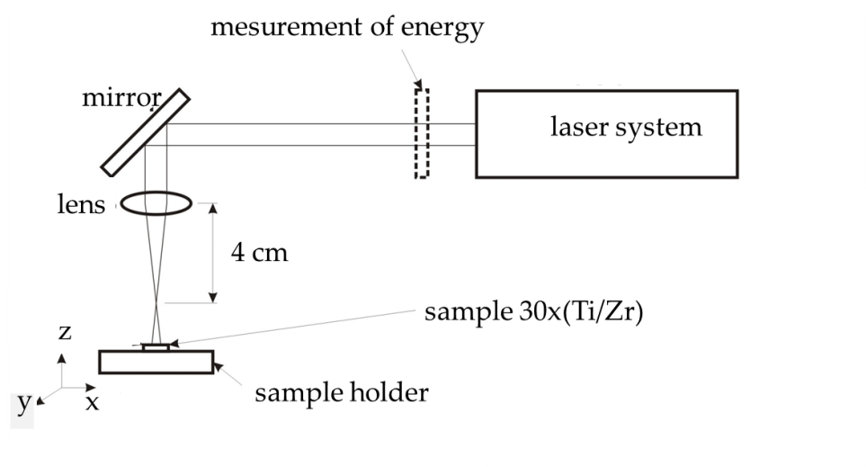

Figure 1. Schema of the experimental setup for laser processing.

Detailed surface morphology after irradiation was examined firstly by optical microscopy, and then by scanning electron microscopy (JEOL JSM-7500F) equipped with energy dispersive X ray spectroscopy (EDS) (Oxford Instruments INCA). Fracture cross section of irradiated sample was performed by FEI SCIOS 2 microscopy. The native cross-section of the sample was simply prepared by made fracture transversely to the laser-written lines. Phase composition and crystal structure analysis with X-ray diffraction, where the Cu Kα XRD pattern was collected by a Bruker D8 Advance Diffractometer. For these measurements, the Bragg-Brentano geometry with a step of 0.05° and the time interval of 30 s per step was used. The distribution of elements and interfaces of the multilayer 30x(Ti/Zr)/Si system were determined by Time of Flight SIMS instrument (Ion-TOF). For composition depth profiling high energy Ga⁺ pulsed primary source (25 keV) was combined with low energy sputter guns at 2 keV (Cs⁺ and O²⁺) at angle of 45° to sample surface.

Cell study under static in-vitro conditions was performed with the mouse Mesenchymal Stem Cells line (C57BL/6). MSCs cells were grown in cell culture flasks using Dulbecco’s modified Eagle’s medium [DMEM (Invitrogen, Grand Island, NY, USA) supplemented with 10% fetal bovine serum (Biosera, Sussex, UK)] in a 5% CO₂ incubator (Thermo Scientific) at 37 °C. Laser-processed samples were autoclaved and transferred into sterile wells of 24 well plates (Sarstedt; Numbrecht, Germany). Culture medium with 2 x 10⁴ cells were seeded onto the samples, where they were cultured in different time periods, ranging from one to three days in order to estimate the cell orientation, adhesion and proliferation. After each time points, the medium with MSCs cells were removed and the cultured samples were washed twice with 0.1 M sodium cacodylate buffer (SCB) and fixed with 2% glutaraldehyde (GDA) and 2% paraformaldehyde (PFA) in 0.1 M SCB for 30 minutes. Subsequently, samples were washed twice with 0.1 M SCB and dehydrated in increasing concentrations (from 30-100%) of ethanol. Finally, before the determination of MSCs osteoblast cell morphology, samples were dried in a critical point drier (Baltec CPD 030), sputter-coated with thin (10 nm) gold/palladium layer (Baltec SCD 050) and observed by Scanning Electron Microscope (JEOL JSM-6390 LV). The cytoskeleton, focal adhesion points and nucleus of MSCs were stained for actin filaments, vinculin and DAPI. Specifically, after one and three days of cell cultured, the samples were fixed with 4% paraformaldehyde (PFA) for 15 minutes and permeabilized with 0.1% Triton X-100 in phosphate-buffered saline (PBS) for 5 minutes. The non-specific binding sites were blocked with 2% Bovine Serum Albumen (BSA) in PBS for 30 minutes. Cell imaging was performed using a Leica SP8 inverted scanning confocal microscope with x40 objective.

3. Results and Discussion

The simultaneous creation of micro and nanometer morphological features on the surface of the multilayer Ti/Zr structure for biomedical application was achieved by laser writing of lines with a relatively wide laser beam (75 μm). Morphological shapes in micrometer dimensions consisted of 65 laser-written lines on surface of 5x5 mm, whereby the width of each line is approximately 40 μm and the distance between them is also 40 μm (Fig. 2a), as consequence of the Gaussian shape of the laser beam profile. In each laser-written line, the creation of the laser-induced periodic surface structure (LIPSS) has occurred, so that they are oriented normally to the direction of laser polarization (Fig. 2b and 2c). These ripple structures are attributed to well-defined low spatial frequency LIPSS (LSFL), as result of an interference of the incident laser beam with surface electromagnetic wave excited during the laser irradiation with possibility to involve the excitation surface plasmon polariton [22, 23]. Applying a laser fluence of about 0.4 J cm⁻², which is slightly higher than the ablation threshold for the Ti/Zr system (0.22 J cm⁻²), the LIPSS formation is accompanied by laser ablation of the multilayer 30x(Ti/Zr) thin films, as consequence of interpulse effect occurring between successive pulses [24]. LSFL ripples are not smooth, indicating the absence of any hydrodynamic effects during laser processing, but rather the dominant direct removal of thin film materials. The fragments are retained after laser ablation at the top of the LSFL ripples, where their appearance can indicate an unequal erosion of the layered structure (Fig. 2c). In the zone of laser-written lines, the regular LSFL ripples are appeared with a periodicity of approximately 800 nm. At given laser fluence, the ripple length ranges from quite small under 1 μm, to those whose length exceeds 7 μm (Fig. 2c). In the cracks between LSFL ripples, the formation of high spatial frequency LIPSS (HSFL) can be observed, which could be related to the decrease in energy distributed within the multilayer 30x(Ti/Zr) structure.

On the other hand, the HSFL ripples were formed in the zone between the two laser-written lines, as a result of the action and overlapping of the edge Gaussian profile, where the energy is expected to be quite low, below the ablation threshold (Fig. 2d and 2e). These HSFL ripples are oriented perpendicular to LSFL ripples with periodicity close to 200 nm, wherein the width of the individual HSFL ripple is below 100 nm. No ablation of the thin film materials was observed in this zone, so their formation can be attributed to the oxide phase upgrade or inducing the dewetting process [18, 25, 26]. On that occasion, the absorbed laser energy is induced the surface instabilities due to softening and perturbation of crystal and chemical bindings, as endorsement to the model of self-organized structure formation. [18]. The solid-state dewetting can be induced during the laser processing as spontaneous regrouping of surface material into small-sized ripples (similar to nanorods) on the hot surface but at temperatures lower than the Ti melting point (Ti is top layer) [27]. Moving away from the laser-written line, the HSFLs gradually disappear but not completely (Fig. 1e), as they become pronounced again from the middle of unmodified area, approaching to the next line.

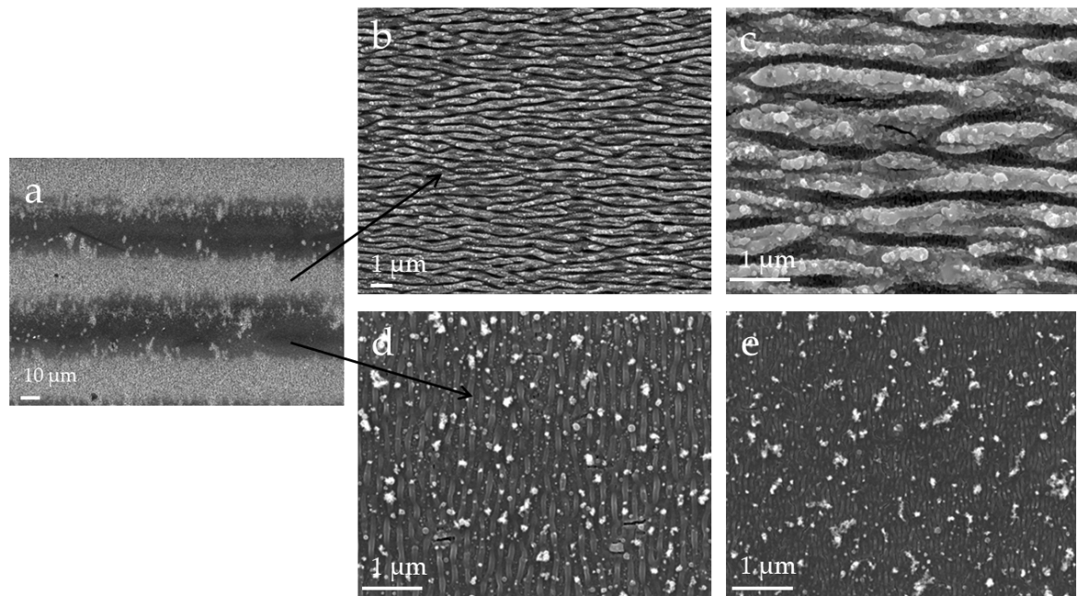

Figure 2. SEM microphotographs of the 30x(Ti/Zr)/Si multilayer system after laser processing at laser fluence of 0.4 J cm⁻²; (a) view of lase-written lines at magnification of 500, (b), (c) view of morphology inside of line with magnification 5 000 and 20 000, respectively and (d), (e) view of morphology between lines at 20 000 magnification.

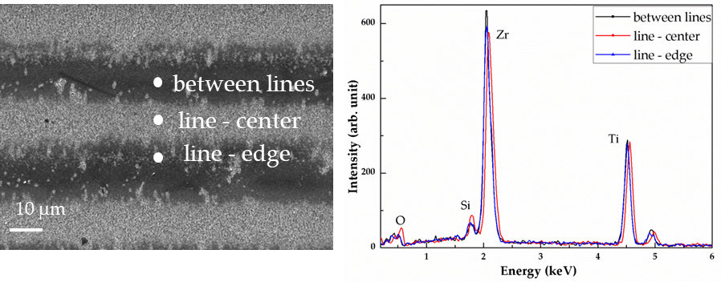

Figure 3. SEM microphotographs and EDS analysis of the 30x(Ti/Zr)/Si multilayer system after laser processing at laser fluence of 0.4 J cm-2; (a) view of lase-written lines at magnification of 500 with the positions of the recorded EDS spectra, and (b) EDS spectra

For the first rough check of the composition changes after laser treatment of 30x(Ti/Zr) system at the pulse fluence of 4 J cm⁻² was use EDS method. Despite the used instrument analytical accuracy of 2σ = 2%, the obtained results should be taken as semi-quantitative because of the small thickness of 30x(Ti/Zr) multilayer system [23, 24]. The elemental composition recorded by the EDS method at three different locations, in the center of the laser-written line, at the edge of this line and in the area of ​​the between lines, were compared in the spectra presented in Figure 3. Based on the obtained spectra, it can be concluded that there are no drastic changes in the concentrations for Ti, Zr, Si and O components, between the observed areas. It could be distinguished, that laser ablation of the Ti/Zr multilayer is registered in the area of the laser-written line, whereby the zirconium is more removed than titanium and concentration of silicon increased in this area. On the other hand, the surface oxidation can be observed as an effect of laser processing of the Ti/Zr system, which is reflected in the increasing of the oxygen concentration, especially in the area of the laser-written lines.

Cross-section view of 30x(Ti/Zr)/Si multilayer system was obtained with SEM microscopy on the broken sample, including the unmodified part and the irradiated area in a place normal to the laser-written lines (Fig.4 ). Inside of as-deposited 30x(Ti/Zr) multilayer thin films is composed of very well separated and alternately arranged Ti and Zr layers with almost identical thicknesses of individual layers (Fig.4a). The SEM cross-section view of 30x(Ti/Zr)/Si multilayer after laser processing in zone of laser-written lines (Fig. 4 b-d), confirms that the creation of periodical structure in form of LSFL ripples is accompanied by ablation of the material. However, laser ablation is quite unequal by making the number of the removed layers variable and ranged in interval of 8-15 layers (130 – 250 nm) when viewed at the top of the ripples. The depth of cracks between LSFL ripples are about 20 layers (350nm), while their repetition period is about 800 nm (Fig. 4b), which is consistent with the periodicity of the formed LSFLs. The spatial distribution of Ti and Zr components inside of laser-modified area retains in layered structure, with barely noticeable expansion of the interfaces between the Ti and Zr layers. Also, slight deformation or corrugating of the inner Ti and Zr layers can be observed, most likely by inducing internal stresses during the laser irradiation (Fig. 4d).

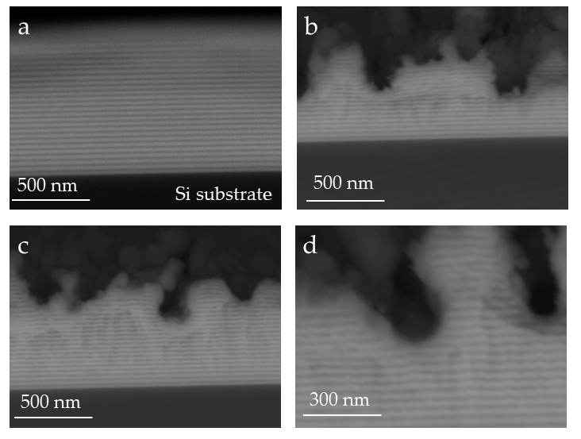

Figure 4. SEM cross-section view of the native broken 30x(Ti/Zr)/Si multilayer sample: (a) unmodified part at magnification of 120 000, (b) and (c), the irradiated area in a place normal to the laser-written lines at magnification of 120 000, and (d) part of laser-modified sample at 200 000 magnification.

The concentration depth profiles recorded by SIMS technique for the as-deposited and laser processed multilayer 30x(Ti/Zr)/Si system are presented in Figure 5. Results obtained by SIMS analysis of almost half of the as-deposited Ti / Zr multilayer structure have shown that the Ti and Zr layers are very well separated with clearly defined interfaces between them (Fig. 5a). After femtosecond laser processing of Ti/Zr multilayer structure, the distribution of the components cannot be accurately determined, since the roughness of the laser-modified surface is quite high. The differences in height higher than 300 nm are reached, especially at the crack locations between LSFL ripples. In these positions the Si substrate is relatively close to the surface, which can be reason for the appearance of Si component in the spectrum (Fig. 5b). In addition, it can be assumed that there was a possible diffusion of Si atoms from the substrate into a thin layer during laser irradiation [25]. The main components Ti and Zr are well intermixed, which is inconsistent with the result obtained by the SEM cross-section analysis, where the layered structure is retained after modification (Fig. 5b). These differences can be attributed to the fact that the signal in SIMS analysis is taken from a large sample surface, regardless of the morphological characteristics on it. However, the presence of oxide phases after laser modification can be determined by SIMS analysis with high accuracy. Laser-induced surface oxidation is reflected in the formation of ultra-thin oxide layers composed from both Ti and Zr oxide phases. The sub-surface layers of least the first few (4-5 layers based on the SEM cross-section image) were intermixed and both oxide phases (Ti-oxide and Zr-oxide) are existed on the contact surface, which is important for studying the cellular response. On the other hand, the pure oxygen signal is not registered in the spectrum, indicating that all the penetrated oxygen in the multilayer structure is in the form of compounds (oxides).

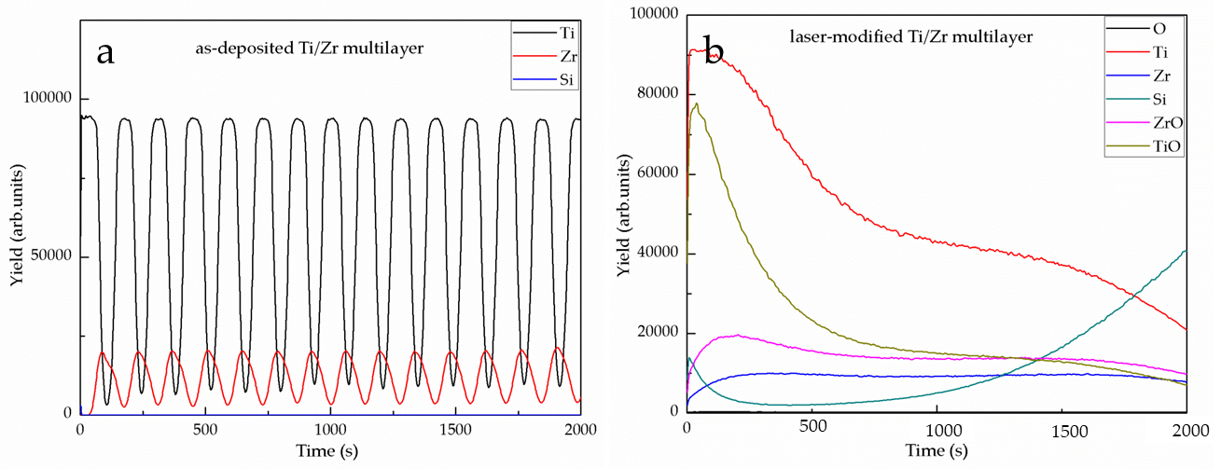

Figure 5. SIMS spectra before (a) and after (b) laser modification of 15x(Ti/Zr)/Si multilayer thin film.

Phase composition and crystal structure for as-deposited and laser-treated multilayer 30x(Ti/Zr)/Si system are determined by XRD technique, as presented in Figure 6. All diffraction lines for Ti and Zr components are overlapped, because these elements are situated in the same group of periodic system one under another. In XRD pattern for as-deposited 30x(Ti/Zr)/Si multilayer system is identified both α-Ti and β-Ti phases (Fig. 6a) at follow crystalline orientations α-Ti(100), β-Ti(110), α-Ti(102) and β-Ti(200) [28]. In this case, zirconium plays role as β-stabiliser element, which induces the formation of β-Ti phases during the deposition of thin Ti and Zr layers [4]. Comparing the XRD patterns obtained for as-deposited and after laser processing of Ti/Zr multilayer thin film, it can be observed that diffraction lines did not change positions. However, the intensities of these diffraction lines are changed, indicating that laser processing favored texture with dominant α-Ti(102) and β-Ti(200) crystalline orientation (Fig. 6b).

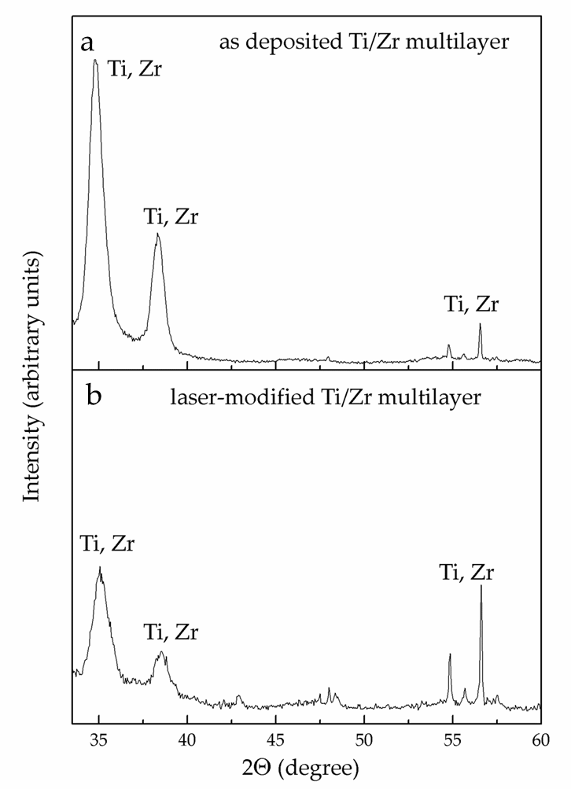

Figure 6. XRD patterns before (a) and after (b) laser modification of 15x(Ti/Zr)/Si multilayer thin film

Before cell seeding on laser-processed of the 30x(Ti/Zr)/Si systems, the wettability was estimated by measuring the contact angle for as-deposited and laser-modified samples (Fig 7). Contact angle for laser-modified Ti/Zr multilayer was greatly increased up to 136.28 ° value, which contributed to the achievement of a moderately hydrophobic surface. This increase in contact angle from the value of 80.68 ° for as-deposited sample is attributed to the formed surface topography in form of LIPSS with micro- and nanometer features, but also to the formation of Ti and Zr oxides on the contact surface [29]. Surface wettability can influence protein adsorption by controlling the total amount of proteins bound to the material, as well as their conformation and orientation after adsorption. The interaction between cells and Ti-based alloy can be considered through the dynamics of proteins when adsorbed onto the material surfaces. Proteins are structurally and chemically asymmetric, during their adsorption the specific orientation and conformation were determined, defining domain of the molecule which will interact and attach with the material [30] .

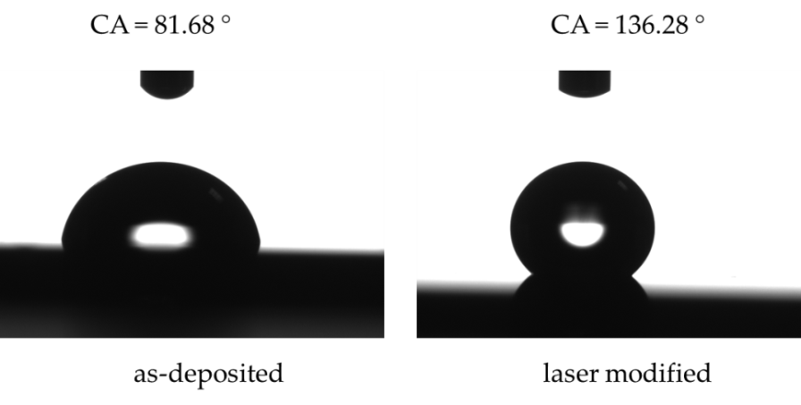

Figure 7. Contact angle measurements for as-deposited and laser modified surfaces of 30x(Ti/Zr) multilayer thin film.

The biocompatibility of the laser-modified Ti/Zr multilayers is reflected in cell adhesion and proliferation through contact, adhesion, and spreading in the initial phase of the cell-material interaction. Therewith, the laser-created surface topography with nano- and micro features plays a key role in further cellular behavior [31]. Morphological characteristics of MSCs cell proliferation on unmodified and laser-modified 30x(Ti/Zr)/Si multilayer surfaces was estimated by SEM and confocal analysis after one and three days cultivation. After one-day cultivation on the surface of both unmodified and laser patterned Ti/Zr multilayers, the MSCs cells have shown very good adhesion (Fig. 8). On the as-deposited 30x(Ti/Zr)/Si sample with flat surfaces, there is easily visible cell groups an arbitrary cell growth occurring in all directions (Fig. 8a and 8b), after one-day cultivation. On the other hand, under the same experimental conditions, on the 30x(Ti/Zr)/Si multilayer with laser-induced surface ripple morphology, the osteoblast cells adhered, with tendency for a growth along the ripples orientation (Fig. 8c and 8d). In addition to the evident directed growth of osteoblast-like cells on a laser-created surface topography, it can be observed that the ripple morphology induced better communication between cells, due to significantly elongated cell groups with the aim to connect (Fig. 8c and 8d). Statistically, a significantly larger number of cells per surface (250 x 250 μm) were attached on the laser-processed Ti/Zr multilayer (~ 80 cells) than to the flat as-deposited sample (~ 25 cells).

The proliferation of MSCs cells was achieved significantly, especially after three days when the number of cells is increased. Where almost whole surfaces are covered by cells for both as-deposited (flat surface) and laser-modified (ripple morphology) 30x(Ti/Zr)/Si samples after three-days cultivation (Fig. 9). The number of cells for laser-modified 30x(Ti/Zr)/Si samples were about 220 cells per surface of 250 x 250 μm, while a slightly smaller number of cells about 170 cells were present on a flat surface. Cell metabolic activities, determined by MTT method including the measurement of the optical density at 545 nm, were found to result in approximately similar but statistically significant values (~ 42 %) ​​for both laser-modified and unmodified samples. It can be observed that the surface topography including micrometer sized laser-written lines with nanometer sized ripples did not influence on the cell proliferation rate. These facts can contribute to the conclusion that Ti/Zr multilayer systems have satisfactory biocompatibility regardless of surface conditions (Fig. 9a and 9c). However, after three-day cultivation, the laser-modified surface was covered with a slightly larger number of smaller cells compared to as-deposited 30x(Ti/Zr)/Si multilayer, which is visible based on the osteoblast cytoskeleton (Fig. 9b and 9d). One of the most interesting findings is that osteoblast-like cells are oriented in all directions; they even had some kind of radial orientation in certain areas, in case of the as-deposited sample (Fig. 9b). While, on the surface topography with ripples has a cell tendency to grow towards the ripples direction, with clear proliferation between one to three days (Fig. 9d). Moreover, this study of the 30x(Ti/Zr)/Si multilayer demonstrated that in micro-line features, the ridge width is commonly larger than or equal to the size of a single cell, permissive for cell attachment and migration, as well as cell alignment following the geometrical guidance. In contrast, nano-ripple features are similar to the ECM (extracellular matrix) architectures and typically much smaller than a single cell, consequently inducing cell alignment in a more fundamental way such as mimicking or signaling the cell membrane receptors [32].

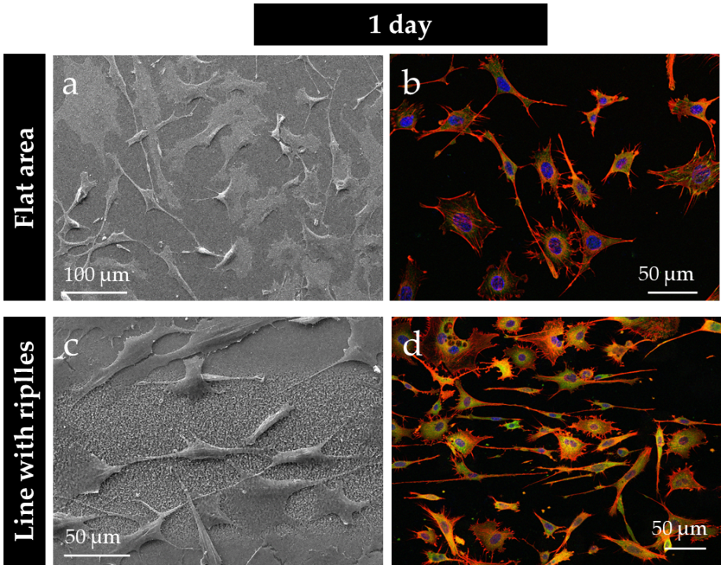

Figure 8. SEM and fluorescent images of MSCs osteoblast cultivated on the as-deposited (a) and (b), and laser-processed 30x(Ti/Zr)/Si multilayer thin film (c) and (d), for one-day cultivation, respectively

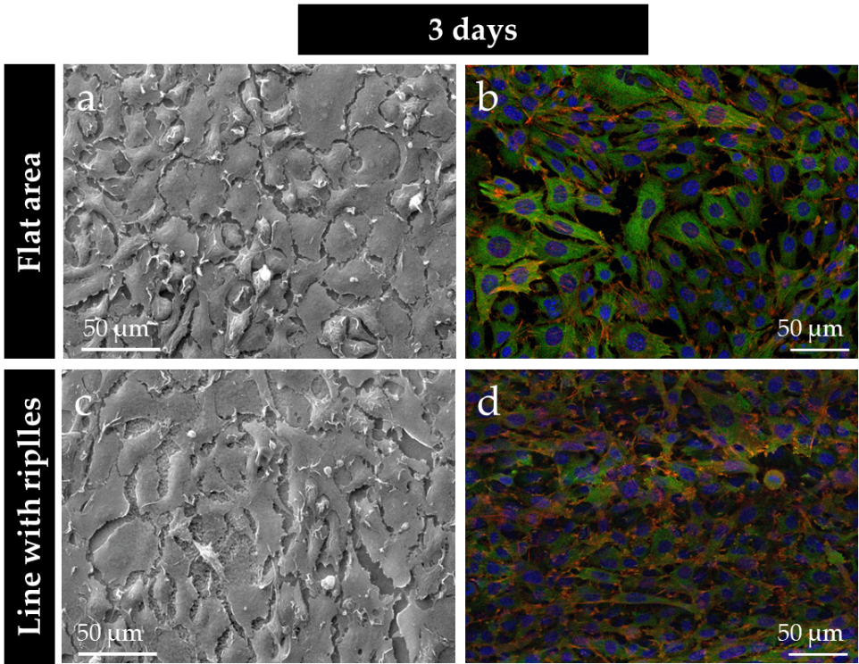

Figure 9. SEM and fluorescent images of MSCs osteoblast cultivated on the as-deposited (a) and (b), and laser-processed 30x(Ti/Zr)/Si multilayer thin film (c) and (d), for three-day cultivation, respectively

5. Conclusions

The surface functionalization of the Ti-based alloy in terms of improving the osteoblast cell response was achieved by the deposition of Ti/Zr multilayer structure and ultrafast laser processing. Adjusting the morphology and composition of physical vapor deposited 30x(Ti/Zr)/Si multilayer structure was achieved at optimal combination of laser parameters. The micro- and nanometer morphological features were obtained by laser writing micrometer sized lines on a relatively large 5x5 mm surface. In each laser-written line are created the laser-induced periodic surface structure defined as low spatial frequency LIPSS (LSFL) with the periodicity close to 800 nm oriented normal to the laser polarization. While the space between the lines is filled with high spatial frequency LIPSS (HSFL) oriented perpendicular to LSFL ripples with periodicity of about 200 nm. The desired chemical composition required for good biocompatibility of Ti-based alloys is provided by the formation of a very thin oxide layer composed of Zr and Ti oxides, as well as intermixing of these components in the sub-surface region.

The biocompatibility of the laser-processed 30x(Ti/Zr)/Si multilayers is confirmed by cultivation of MSCs established adherent mouse osteoblast cell line. The osteoblast cells adhered and proliferated on the 30x(Ti/Zr)/Si multilayers, regardless that the samples have been pre-laser treated to form specific surface topographies. However, after one- and three-day cultivation, the osteoblast cells have shown a growth along ripples with tendency to connection via their elongated parts, in case of laser-patterned samples. Bioactivation of this specific 30x(Ti/Zr)/Si multilayer system with laser surface texturing and adjusting of surface composition, could be potentially useful for tissue engineering and application this material as implant.

Author Contributions: The contributions by author are as follows: conceptualization, S.P.; methodology, D.P., E.S., and Z.R.; formal analysis, J.K., M.M., J.P. and Z.R.; investigation, S.P. and D.P.; writing—original draft preparation, S.P.; writing—review and editing, S.P.; supervision, E.S.;.

Funding: This research was funded by the EU‐H2020 research and innovation program under grant agreement N 654360 having benefitted from the access provided by Foundation for Research and Technology Hellas (FORTH) access provider (Institute of Electronic Structure and Lasers i.e. Institution) in Heraklion, Crete, Greece within the framework of the NFFA-Europe Transnational Access Activity. This research was sponsored by the Ministry of Education, Science and Technological Development of the Republic Serbia through projects No. OI 171023, III 45016 and III45005.

Acknowledgments: This research was sponsored by the Ministry of Education, Science and Technological Development of the Republic Serbia through projects No. OI 171023, III 45016 and III45005. This project has received funding from the EU‐H2020 research and innovation program under grant agreement N 654360 having benefitted from the access provided by Foundation for Research and Technology Hellas (FORTH) access provider (Institute of Electronic Structure and Lasers i.e. Institution) in Heraklion, Crete, Greece within the framework of the NFFA-Europe Transnational Access Activity.

Conflicts of Interest: The funders had no role in the design of the study; in the collection, analyses, or interpretation of data; in the writing of the manuscript, or in the decision to publish the results.

References

[1] Othman, Z.; Cillero Pastor, B.; Van Rijt, S.; Habibovic, P.; Understanding interactions between biomaterials and biological systems using proteomic. Biomaterials 2018, 167, 191-204

[2] Su, Y.; Luo, C.; Zhang, Z.; Hermawan, H.; Zhu, D.; Huang, J.; Liang, Y.; Li, G.; Ren, L.; Bioinspired surface functionalization of metallic biomaterials. Journal of the Mechanical Behavior of Biomedical Materials 2018, 77, 90-105

[3] Bose, S.; Robertson, S.F.; Bandyopadhyay, A.; Surface modification of biomaterials and biomedical devices using additive manufacturing. Acta Biomaterialia 2018, 66, 6–22

[4] Correa, D.R.N.; Kuroda, P.A.B.; Lourenço, M.L.; Fernandes, C.J.C.; Buzalaf, M.A.R.; Zambuzzi, W.F.; Grandini, C.R.; Development of Ti-15Zr-Mo alloys for applying as implantable biomedical devices. Journal of Alloys and Compounds 2018, 749, 163-171

[5] Rack, H.J.; Qazi, J.I.; Titanium alloys for biomedical applications. Materials Science and Engineering C 2006, 26, 1269-1277

[6] Donato, T.A.G.; De Almeida, L.H.; Nogueira, R.A.; Niemeyer, T.C.; Grandini, C.R.; Caram, R.; Schneider, S.G.; Santos Jr, A.R.; Cytotoxicity study of some Ti alloys used as biomaterial. Materials Science and Engineering C 2009, 29, 1365–1369

[7] Zhao, D.; Chen, C.; Yao, K.; Shi, X.; Wang, Z.; Hahn, H.; Gleiter, H.; Chen, N.; Designing biocompatible Ti-based amorphous thin films with no toxic element. Journal of Alloys and Compounds 2017, 707, 142-147

[8] Hsu, H.C.; Wu, S.C.; Sung, Y.C.; Ho, W.F.; The structure and mechanical properties of as-cast Zr–Ti alloys. Journal of Alloys and Compounds 2009, 488, 279–283

[9] Li,Y,; Yang , C.; Zhao, H.; Qu, S.; Li, X.; Li, Y.; New Developments of Ti-Based Alloys for Biomedical Applications. Materials 2014, 7, 1709-1800

[10] Aristizabala, M.; Jamshidib, P.; Sabooric, A.; Coxd, S.C.; Attallah, M.M.; Laser powder bed fusion of a Zr-alloy: Tensile properties and biocompatibility. Materials Letters 2020, 259, 126897

[11] Yu, Z.; Yang, G.; Zhang, W.; Hu, J.; Investigating the effect of picosecond laser texturing on microstructure and biofunctionalization of titanium alloy. Journal of Materials Processing Tech. 2018, 255, 129–136

[12] Sartinska, L.L.; Barchikovski, B.; Wagenda, N.; Rut, B.M.; Timofeeva, I.I.; Laser induced modification of surface structures. Applied Surface Science 2007, 253, 4296–4299

[13] Frostevarg, J.; Olsson, R.; Powell, J.; Palmquist, A.; Branemark, R.; Formation mechanisms of surfaces for osseointegration on titanium using pulsed laser spattering. Applied Surface Science 2019, 485, 158–169

[14] Berg, Y.; Kotler, Z.; Shacham-Diamand, Y.; Holes generation in glass using large spot femtosecond laser pulses. Journal of Micromechanics and Microengineering 2018, 28, 035009.

[15] Jenko, M.; Gorensek, M.; Godec, M.; Hodnik, M.; Setina-Batic, B.; Donik, C.; Grant, J.T.; Dolinar, D.; Surface chemistry and microstructure of metallic biomaterials for hip and knee endoprostheses. Applied Surface Science 2018, 427, 584–593

[16] Simitzi, C.; Ranella, A.; Stratakis, E.; Controlling the morphology and outgrowth of nerve and neuroglial cells: The effect of surface topography. Acta Biomaterialia 2017, 51, 21–52

[17] Gregorcic, P.;, Sedlacek, M.; Podgornik, B.; Reif, J.; Formation of laser-induced periodic surface structures (LIPSS) on toolsteel by multiple picosecond laser pulses of different polarizations. Applied Surface Science 2016, 387, 698–706

[18] Varlamova, O.; Costache, F.; Reif, J.; Bestehorn M.; Self-organized pattern formation upon femtosecond laser ablation by circularly polarized light. Applied Surface Science 2006, 252, 4702–4706

[19] Gittens, R.A.; Lachlan, T.M.; Olivares-Navarrete, R.; Cai, Y.; Berner, S.; Tannenbaum, R.; Schwartz, Z.; Sandhage, K.H.; Boyan, B.D.; The effects of combined micron-/submicron-scale surface roughness and nanoscale features on cell proliferation and differentiation. Biomaterials 2011, 32, 3395-3403

[20] Stanciuc, A.M.; Flamant, Q.; Sprecher, C. M.; Alini, M.; Anglada, M.; Peroglio, M.; Femtosecond laser multi-patterning of zirconia for screening of cell-surface interactions. Journal of the European Ceramic Society 2018, 38, 939–948

[21] Ohtsu, N.; Kozuka , T.; Yamane, M.; Arai, H.; Surface chemistry and osteoblast-like cell response on a titanium surface modified by a focused Nd:YAG laser. Surface & Coatings Technology 2017, 309, 220–226

[22] Bonse, J.; Koter, R.; Hartelt, M.; Spaltmann, D.; Pentzien, S.; Hohm, S.; Rosenfeld, A.; Krüger, J.; Tribological performance of femtosecond laser-induced periodic surface structures on titanium and a high toughness bearing steel. Applied Surface Science 2015, 336, 21–27

[23] Kirnera S.V.; Wirth,T.; Sturm, H.; Krüger, J.; Bonse, J.; Nanometer-resolved chemical analyses of femtosecond laser-induced periodic surface structures on titanium. Journal of Applied Physics 2017, 122, 104901

[24] Može, M.; Zupančič, M.; Hočevar, M.; Golobič ,I.; Gregorčič, P.; Surface chemistry and morphology transition induced by critical heat flux incipience on laser-textured copper surfaces. Applied Surface Science 2019, 490, 220–230

[25] Petrović, S.; Peruško, D.; Kovač, J.; Panjan, P.; Mitrić, M.; Pjević, D.; Kovačević, A.; Jelenković, B.; Design of co-existence parallel periodic surface structure induced by picosecond laser pulses on the Al/Ti multilayers. Journal of Applied Physics, 2017, 122(11), 115302

[26] Oh, H.; Pyatenko, A.; Lee, M.; Laser dewetting behaviors of Ag and Au thin films on glass and Si substrates: Experiments and theoretical considerations. Applied Surface Science 2019, 475, 740-747

[27] Abbott, W.M.; Corbett, S.; Cunningham, G.; Petford-Long, A.; Zhang, S.; Donegan, J.F.; McCloskey, D.; Solid state dewetting of thin plasmonic films under focused cw-laser irradiation. Acta Materialia 2018, 145, 210-219

[28] JCPDS - International Centre for Diffraction Data (ICDD), PCPDFWIN v. 2.00;1998.

[29] Bizi-Bandoki, P.; Benayoun, S.; Valette, S.; Beaugiraud, B.; Audouard, E.; Modifications of roughness and wettability properties of metals induced by femtosecond laser treatment. Applied Surface Science 2011, 257, 5213-5218

[30] Thevenot,P.; Hu,W.; Tang, L.; Surface chemistry influence implant biocompatibility. Curr Top Med Chem. 2008, 8(4), 270–280.

[31] Anselme K.; Osteoblast adhesion on biomaterials. Biomaterials 2000, 21 667-681.

[32] Babaliari, E.; Kavatzikidou, P.; Angelaki, D.; Chaniotaki, L.; Manousaki, A.; Siakouli-Galanopoulou, A.; Ranella, A.; Stratakis E.; ., Engineering Cell Adhesion and Orientation via Ultrafast Laser Fabricated Microstructured Substrates. International Journal of Molecular Sciences 2018, 19(7) 2053

